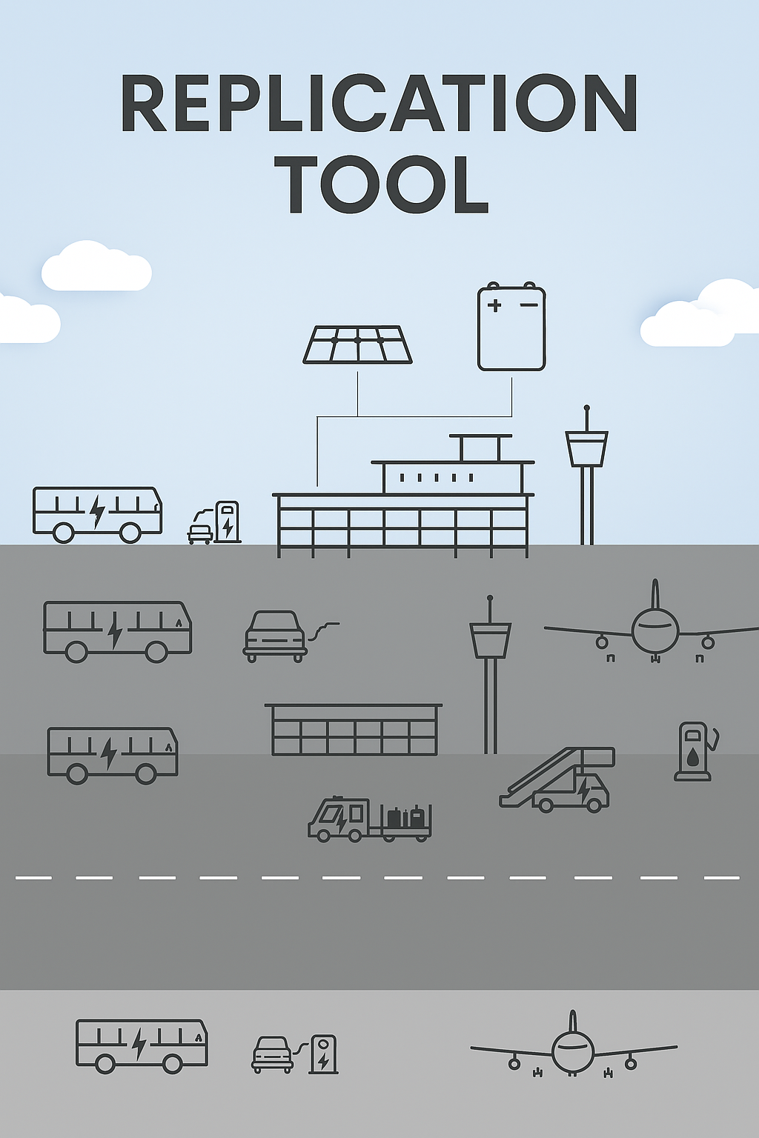
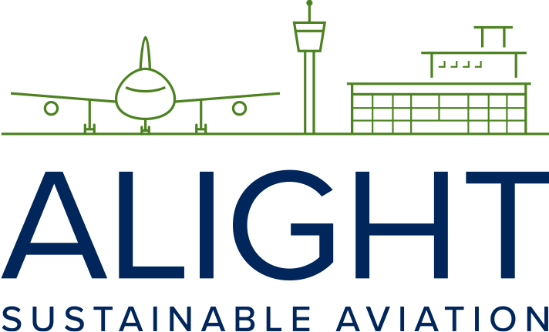
This project has received funding from the European Union’s Horizon 2020 research and innovation programme under grant agreement No 957824

Case study: Copenhagen Airport

Tool 2.5b

SAF usage case study – CPH
Executive Summary
This case study details the introduction and implementation of SAF blends at CPH. The airport relies heavily on a continuous supply of jet fuel to maintain safe and efficient operations. In 1961, the joint venture Braendstoflageret Københavns Lufthavn I/S (BKL) was established to manage the growing fuel demand. The fuel supply operations remained unchanged until 2023 when SAF was blended with CAF and introduced into CPH's infrastructure for the first time.
The document outlines the entire supply chain process, from planning to delivery, involving key stakeholders such as Air Greenland and DCC & Shell Aviation Denmark A/S (DCC). It emphasizes the importance of SAF in reducing CPH's scope 3 emissions and improving local air quality. Although traditionally, jet fuel procurement has not handled by the airport, the potential benefits of SAF have garnered CPH's active interest and support.
In 2023, CPH received its first SAF blend delivery, with Air Greenland being the primary initiator. Air Greenland's commitment to sustainability led to the decision to use SAF, aligning with their business plan and local community needs. DCC, with prior experience in SAF handling, facilitated the trade and ensured proper logistics and quality assurance. The SAF procurement involved various logistical considerations, including segregated delivery and co-mingling with CAF. CPH did not play a direct role in the procurement but supported the initiative due to its environmental benefits. Future plans include continuous SAF blend supply using existing infrastructure and involvement in various projects to support sustainable aviation.
This case study provides insights into the efforts and collaborations required to introduce SAF blends at CPH, highlighting the challenges, successes, and future directions for sustainable aviation at the airport.
1. Introduction
Operations at CPH require a constant supply of jet fuel of the right quantity and quality to ensure continuous and safe operations, a responsibility assumed by fuel suppliers and CPH’s fuel farm operator BKL. As air traffic movements increased through the years, so did the need for a more robust fuel supply infrastructure and in 1961, CPH fuel suppliers created the joint venture BKL, deciding to build a supply pipeline and hydrant infrastructure to manage the increased demand. Fuel supply operations remained unchanged until 2023, when SAF, blended with CAF, was introduced into CPH's fuel infrastructure for the first time.
This case study describes the set-up, key actors, and considerations and decisions taken by stakeholders along the entire supply chain to plan for and realize the use of a CAF/SAF blend at CPH. Actions regarding handling, logistics, sustainability certification, and quality assurance are also described in detail.
Though the purchasing of jet fuel has never been a matter handled by the airport, the potential for SAF to contribute toward CPH reducing scope 3 emissions and improve local air quality makes it an interesting initiative for the airport to follow and support closely. This case study also offers a deep dive on expected activities related to SAF usage at and by CPH, a look at regulation that will affect the uptake of SAF at the airport, and CPH’s plans to work on raising awareness about SAF among clients, passengers, and the public.
2. A bold step forward – incorporating SAF intro airport grounds
This section outlines the activities, decisions made, and stakeholders involved in delivery of the first SAF batch to CPH.
In 2019, it was anticipated that SAF would be gradually introduced at CPH for voluntary purchases, as aviation transitioned towards a more sustainable future. However, the COVID-19 pandemic drastically altered these plans, temporarily closing most airport operations. As a result, the global use and production of SAF took a step back. As the world and the aviation industry returned to business-as-usual post-pandemic, the momentum that had built up around SAF still struggles to regain its former strength.
Nonetheless, in 2023, the first delivery of a SAF blend to CPH took place. This voluntary SAF purchase required all involved parties to collaboratively address potential obstacles and new sustainability documentation requirements, which will be detailed in the following sections.
2.1 Decision making process and stakeholder engagement
Not until 2023 were the first volumes of SAF introduced to CPH, driven by demand from Air Greenland. Air Greenland, which operates from Greenland, serves as a vital connection point for European air travel across the Atlantic. The company has a strong commitment to contributing to the country’s sustainable development goals. Their sustainability agenda is embedded in their business plan and aligned with the needs of the local community, as well as the ambitious environmental protection demands of their customer base.
Though Air Greenland is a small-to-medium-sized airline, the company has worked to become a sustainable aviation operator by first tackling operational efficiencies and capacity building, making the use of SAF the obvious next step. Understanding the sustainable trend taking hold of the industry, the company realized that investing in SAF was a vital part of their transition. This realization led to an internal discussion between management and the board concerning future investments in alternative propellants. After six months of deliberations in 2021, a decision was made to position Air Greenland as a leader in voluntary SAF usage, with the aim of inspiring the rest of the aviation industry to join them in this journey.
In late 2021, Air Greenland began discussions with DCC to determine the process that would facilitate the voluntary purchase of SAF for use on their route to and from CPH.
2.2 Stakeholder engagement
Air Greenland’s preliminary search for SAF was facilitated by consulting the two largest fuel suppliers in CPH: AirBP and DCC. Since DCC had prior experience handling SAF at various locations in the Nordic region, including Denmark, they became the preferred choice for Air Greenland over other suppliers.
Additionally, Air Greenland holds an established purchase agreement for conventional aviation fuel with DCC, so for the purchase of SAF, they engaged directly with their existing account contact within the company to plan for the voluntary purchase of SAF.
DCC facilitated the trade through an international network of traders, selecting Neste as the SAF provider, with volumes purchased and planned for shipping according to the agreement between DCC and Air Greenland.
The engagement process with the supplier was conducted following the same procedures as for CAF.
3. SAF procurement: what, where, and how
The procurement and purchase of SAF was negotiated between Air Greenland and DCC throughout the entire process, with no other stakeholders involved.
Initially, Air Greenland showed interest in using e-fuels due to their higher GHG-reduction potential and sustainable feedstock sourcing. Through conversations with DCC, it became apparent that the purchase of e-fuels was not economically feasible, and the available volumes were limited compared to the needed quantities at the time. Consequently, the decision was made to purchase available second generation SAF.
DCC chose to use dedicated fuel tanks at Prøvestenen to store and deliver SAF blends to CPH and other customers. This enabled DCC to satisfy Air Greenland's SAF needs in accordance with the agreement and to deliver SAF to other airports as well.
The decision to deliver the SAF exclusively to CPH was made considering that DCC was already developing a new storage and supply line dedicated to SAF blends in Copenhagen. This was deemed a more feasible option, both logistically and economically, than delivering to Søndre Strømfjord/ Kangerlussuaq Airport (SFJ) in Greenland, where neither SAF storage nor production was available.
The first delivery of a SAF blend was transported by DCC from the blending facility to CPH, using segregated fuel trucks. The segregation allowed for better control and traceability of the SAF blend to ensure timely delivery of this milestone in Air Greenland’s path towards sustainable travel. Subsequent deliveries of SAF blends to the airport were transported co-mingled with CAF, utilizing existing fuel handling infrastructure.
3.1 SAF pathway and supplier
At the time of procurement negotiations, DCC had engaged with a fuel trading house to search the market for SAF, standard practice between fuel supplier and the market. Given the limited size of the SAF market in early 2021, the search concluded that the best option was for Air Greenland to purchase SAF volumes processed via the HEFA pathway, using primarily used cooking oil as feedstock, illustrated in the following figure:

Figure 33 - The HEFA process
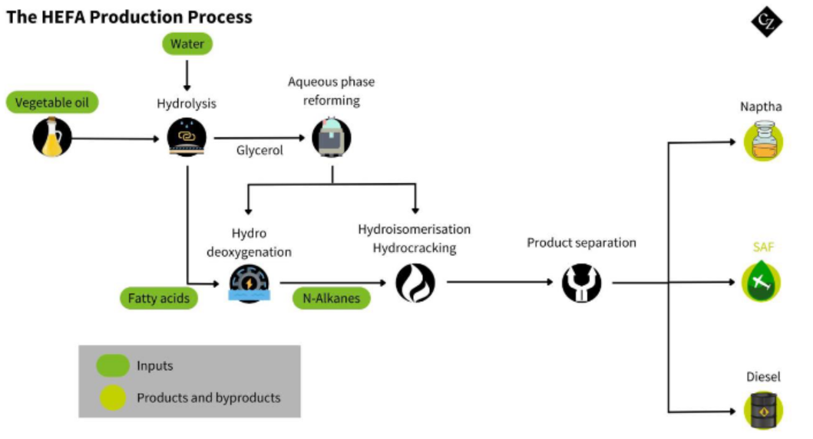
Source: adapted from CZ
3.2 Procurement process
Negotiations between Air Greenland and DCC run from late 2021 into 2022, a process that took little more than six months to settle on a final agreement. The possibility of delivering the fuel segregated was presented to Air Greenland, along with an undisclosed price, yet known to be higher than the price for CAF.
It was settled that the first delivery of the SAF blend would travel segregated in a DCC fuel truck from Belgium to Denmark and consequently delivered to BKL’s fuel farm at CPH. All subsequent deliveries would reach Prøvestenen port by ship and unloaded into DCC dedicated tanks. The SAF blend would reach BKL’s fuel farm at CPH from the port using the jetfuel pipeline. In both cases, the SAF blend would be delivered into plane via the hydrant system co-mingled with existing CAF volumes.
After securing the needed volumes, the greater part of procurement negotiations became the price of the SAF including DCC service fee. The final purchase agreement was for 5% SAF content on the total fuel volume needed to supply the flight route between SFJ and CPH for one year, amounting to 700,000 liters of neat SAF.
The entire process of engagement, negotiation, contracting, and procurement was conducted in the same manner as with CAF, except for the search on the type of SAF to purchase. The specific type of SAF purchase agreement has not been disclosed, but it is almost certain that it followed one of the types described under section 5 of this handbook - Procurement of SAF.

4. SAF handling and logistics
This section describes peculiarities related to the handling and logistics of the SAF blend to CPH airport, along with considerations on alternative delivery options.
The fuel supply at CPH airport is facilitated by BKL, which is an independent company owned by five fuel suppliers, who owns all infrastructure associated with fuel handling at the airport. BKL and two into-plane service providers are therefore responsible for all fuel operations at CPH.
Aviation fuel handling at CPH begins 7 kilometers away from the airport, at the import terminal at Prøvestenen port. The fuel arrives on barges, where it is tested to ensure compliance with established standards set by ASTM and JIG, before being offloaded into one of several fuel storage tanks. The fuel is then transported from the storage tanks through a single pipeline to the airport, where an intermediate fuel farm with smaller storage tanks for daily operations is located. At the intermediate fuel farm, several tests are conducted to ensure compliance with safety and JIG standards before distributing the fuel to the aircraft stands via the underground hydrant system. At the aircraft stands, a bowser truck connects to the hydrant system and delivers the required fuel to the aircraft. The following figure illustrates the aviation fuel handling practices at CPH:
Figure 34 - Aviation fuel supply handling and logistics at CPH
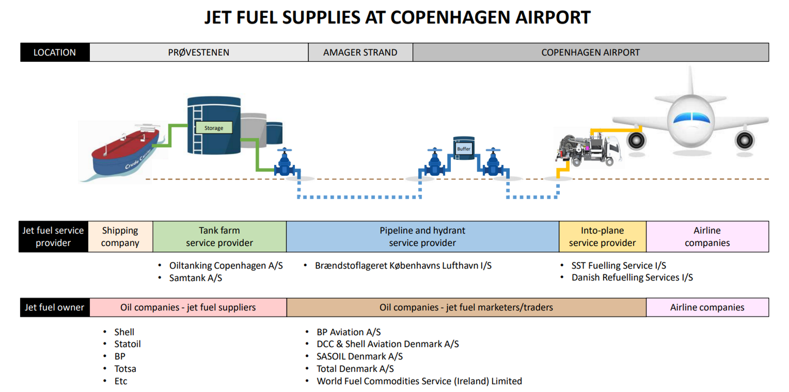
Source: CPH
The supply of the SAF blend to CPH was conducted in two theoretical scenarios:
- Scenario 1 - First SAF delivery,
- Scenario 2 – Continuous SAF deliveries
Scenario 1 marked a milestone both for CPH and Air Greenland as it was the first ever SAF supply at CPH. As stated earlier, the agreement specified that the first delivery would transport and supply the SAF blend segregated from all other aviation fuel to BKL’s fuel farm at CPH, primarily to ensure timely delivery of the right volumes only to Air Greenland aircraft.
All subsequent deliveries for daily use up to date use using existing fuel handling and storage infrastructure co-mingled with CAF from the port to CPH, aligned with scenario 2.
Scenario 1 – Semi-segregated supply
SAF was first introduced into CPH in March 2023, a historic moment for most everyone involved. Unlike all other fuel deliveries, the SAF blend was delivered by truck as it allowed to better accommodate any unforeseen circumstances or delays and deliver the fuel on time.
The SAF blend traveled from Belgium to Denmark segregated in a DCC fuel truck and after arrival at the CPH airport area, the SAF blend was checked for quality assurance in accordance with JIG standards. The truck unloaded the SAF blend into the airport fueling system at the intermediate fuel farm and fed into the hydrant system for uplift com-mingled with existing CAF volumes. The following figure illustrates the delivery processed followed:
Figure 35 - SAF blend delivery process Scenario 1
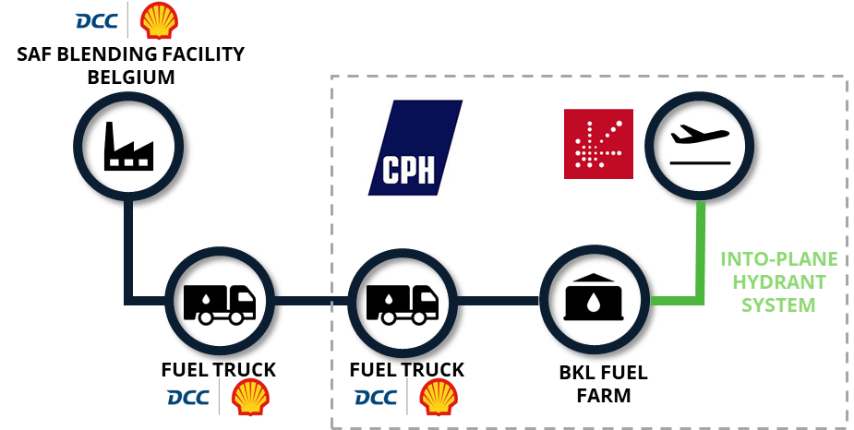
Source: CPH
Scenario 2 – Continuous long-term supply of SAF blends
After SAF blends arrive by ship to Prøvestenen. Since not all aircraft operators require the supply of SAF, DCC uses dedicated fuel tanks at Prøvestenen for storing SAF blends to facilitate its delivery only to clients who request it. SAF blends are transported from the port’s storage tanks to CPH using the existing jetfuel pipeline. As it reaches CPH’s fuel farm, from a logistics and handling point of view, the SAF blend is treated as CAF thereon. Delivery into-plane is conducted using the hydrant system. The following figure illustrates the delivery processed followed:
Figure 36 - SAF blend delivery process Scenario 2
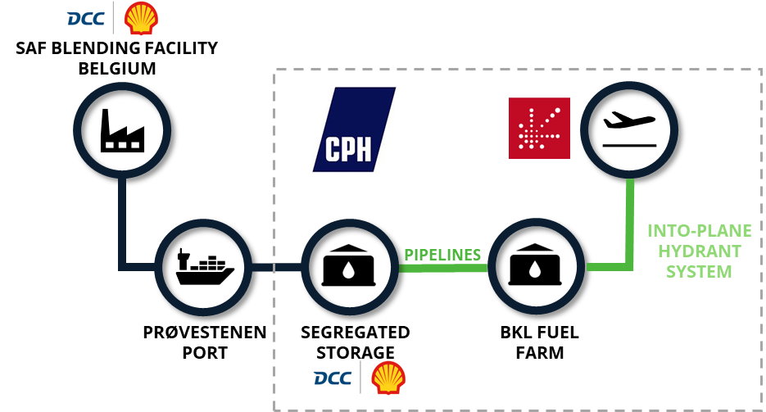
Source: CPH

4.1 Considerations taken before introduction into airport grounds
Several aspects were explored during procurement negotiations to understand the different options available to introduce SAF into CPH grounds for the first time. These were considered in preparation for Scenario 1 and included the following:
- Logistics
- Transport and storage
- Security and safety
Scenario 1
- Logistics
Scenario 1- The option to deliver the first SAF blend segregated using trucks meant careful planning was needed on time management, supply logistics, stakeholder engagement, and traceability of the SAF molecules for accounting and reporting purposes.
DCC managed all logistical aspects of the delivery to ensure the fuel was delivered on time, fit for purpose, and to the right customer.
- Transport and storage
Two transport options were considered, both built around the idea of keeping the SAF blend segregated while managing increased costs on transport and logistics.
Option I - Segregated supply of the SAF blend reaching the port via ship and offloaded into DCC’s dedicated storage tanks. Consequently, delivering the SAF blend segregated from the port dedicated fuel tanks to CPH using supply methods common to CAF supply: this would entail building a dedicated pipeline to run from the port to the airport’s fuel farm and install there a dedicated storage tank, a roughly estimated at 250 million DKK (€33,5 million).
Option II - Segregated supply of the SAF blend from Belgium to CPH using trucks: this involves the loading of dedicated trucks with the SAF blend from the blending facility in Belgium and transporting it to the intermediate fuel storage facility at CPH.
Option II initially seemed more manageable due to its much lower immediate costs. However, it was well understood that while this approach is feasible for handling smaller quantities of SAF blends, scaling up and keeping costs down to segregate larger volumes could prove difficult. This approach would yield questionable results compared to the efficiency of keeping the SAF blend co-mingled with CAF and fueling via the existing fuel pipeline. Fuel delivery by truck takes significantly longer than current fueling practices at CPH. If option II were adopted as the common practice for all SAF blend deliveries, it would most certainly result in increased turnaround times, affecting air traffic management. If future segregation of the SAF blend proves to optimize environmental benefits, building a parallel dedicated pipeline from the port to the airport’s fuel farm, as well as dedicated storage tanks, would be an option worth a more in-depth analysis.
Exceptionally, and only for the one-time delivery of the first-ever SAF blend into CPH grounds, the supply method chosen was option II, using trucks.
Since the SAF would arrive to CPH already blended and qualified as ASTM 1655, no special measures were planned for its storage at BKL’s fuel farm. the fuel.
- Security and safety
Although the use of trucks to deliver fuel is not common practice at CPH, it has been done before and there are specific JIG processes within the rulebook that describe actions needed to ensure security and safety. These JIG procedures were therefore considered for implementation when evaluating the delivery of the SAF blend using trucks. From a fuel safety point of view, no additional fuel safety measures were taken given that, from a fuel handler's perspective, ASTM D1655 qualified SAF blends that arrive at the airport are handled identically to CAF volumes.
Scenario 2
In contrast, no significant changes in logistics, storage and transport, and security and safety were explored to plan for the delivery of SAF blends under scenario 2. The only deviation for common practices took place at the fuel storage facility at Prøvestenen, where DCC again chose to dedicate a storage tank specifically to the SAF blend; a process that had been established during the first delivery of the SAF blend to CPH.
4.2 Supply method
This section explains more in detail every step along the fuel supply chain followed for delivery of the SAF blend to CPH for scenarios 1 & 2.
Scenario 1
DCC took the following considerations specific to steps along the supply chain to complete the first delivery of the SAF blend to CPH:
- Transport of the SAF blend from Belgium: since the SAF was already blended with CAF, fuel safety and quality checks followed the same procedures as those applied to CAF. The SAF blend was uploaded into dedicated fuel trucks that traveled from Belgium to Denmark, arriving at CPH.
- Upon the truck’s arrival to CPH, all quality and safety assurances were conducted treating the SAF identically to CAF, as described in ASTM 1655 and JIG standards. After entering airport premises, the truck off-loaded the SAF at the intermediate fuel farm storage tanks. The aircraft was fueled through the hydrant system, physically co-mingled with all other existing fuel in the farm, applicable to the mass balance chain of custody method. The SAF blend was delivered on time and in the agreed quantity.
Scenario 2
All subsequent deliveries up to today are performed following BAU fuel supply practices. SAF blends arrive by ship at Prøvestenen and once offloaded, they are tested to comply with safety standards before being stored into DCC’s dedicated tank, the latter being the only practice that deviates from BAU. The SAF blend reaches CPH fuel farm through the fuel pipeline co-mingled with CAF, and the uplift is conducted using the hydrant system; the chain of custody method used is mass balance.
5. Documentation
This section describes the documentation processes associated with the purchase of SAFfor delivery at CPH. Since CPH did not play a role in the procurement and use of SAF at the airport, the following mainly describes the interaction among DCC and Air Greenland in the documentation process.
Fuel delivery documentation is a collection of all the documents aviation fuel suppliers receive per fuel batch. The time required to deliver it to the client is in line with the standard practice of aggregating information from several batches and delivering it all at once, rather than processing documentation for each batch individually. Air Greenland requested documentation from DCC that is common to most fuel deliveries: a fuel ticket describing volume, quality, energy content, and price, among other details. Additionally, they requested the PoS, owned by DCC, a unique piece of documentation for SAF that allows the airline to report confidently on the carbon emission reductions achieved by using SAF for its flights. For more details on the PoS, revisit section 5.2.1 of this handbook.
Air Greenland received the fuel ticket and, instead of the PoS, DCC provided two distinct documents describing the environmental attributes of the purchased SAF: a “SAF sustainability statement” and a “SAF letter” from DCC. This is because, in preparation to the upcoming RFEUA regulation, DCC was aware that they would need to surrender the unique PoS to competent authorities as proof of compliance; providing Air Greenland with a “SAF sustainability statement” and a “SAF letter” was a feasible alternative.
In the “SAF sustainability statement,” the SAF component is described in two sections. Section one provides a general description of the purchased product, including the following data points:
SAF Sustainability Statement – section one
- Type of SAF product - pathway
- Quantity of SAF in m3 and tonnes
- Average life cycle GHG intensity
- Energy content presented in MJ
- GHG savings in relation to baseline of 94g. CO2/MJ
- Sustainability Certification mentioning the scheme used (RSB, ISCC, etc.)
- Status of compliance with EU RED criteria
- Chain of custody break point with responsible stakeholder.

Section two described each batch of delivery including the following data points:

SAF Sustainability Statement – section two
- Supplier sustainability certificate number
- Batch number
- Blending ratio
- Quantity in m3 and tonnes
- Energy content
- Actual density at 15˚C
- Amount in tonnes
- Conversion process
- Feedstock
- Country of origin of feedstock
- Lifecycle emission

The SAF letter confirmed the SAF purchase from Air Greenland in 2023.
The overall documentation process took longer than usual given the new documents and steps not commonly delivered when purchasing CAF. The expectation is that as SAF use increases and becomes ordinary, the entire process will be optimized for efficiency, in particular the delivery and format of the PoS (or similar document) to the SAF user to facilitate a more expedient claims process on emission reductions achieved.
5.1 Sustainability certification
The SAF product fueled at CPH was certified by under the ISCC SCS and was disclosed in both the SAF sustainability statement and the SAF letter.
The certification was compliant with REDIII criteria, ensuring the product complied with the criteria set for the EU’s definition of sustainable aviation fuels. This allowed Air Greenland to report their purchase as contributing to the national targets set in REDII and compliance with their obligations under EU ETS.
5.2 Quality assurance
The quality of the fuel was fully compliant with ASTM D1655 when it entered the airport, a must for all fuel that enters the airport either segregated via trucks or transported through the hydrant system at CPH.
The specific attributes of the fuel were documented in accordance with the applicable JIG standard as it is done with all CAF entering European airports. The documentation process for quality assurance of the SAF blend therefore followed usual disclosure practices common to any CAF delivery at CPH.
6. Leadership and communications at CPH
CPH has committed to becoming a Net-Zero airport by 2050, and as various roadmaps were investigated, it became clear that such a commitment required the leadership of every stakeholder in and around the airport. Several initiatives were started, including the sustainable design of new and existing buildings, increased recycling of waste generated at the airport, and the electrification of vehicles, among others. SAF is one solution among a range of measures in this transition; IATA has estimated that approximately 62% of the industry’s sector-wide emission abatement could be achieved by using SAF. Yet, given its limited availability and price disparity with CAF, SAF remains a challenging solution for the entire industry to manage. Even though CPH does not participate in the procurement and handling of fuel, projects like ALIGHT show the need for the airport to play an active role in other areas of fuel handling processes to support the industry’s transition.
6.1 Lasting commitment to SAF usage at CPH
CPH initially took a reactive role during the introduction of the first-ever SAF blend into airport grounds. However, its significant volume of air traffic within Denmark and the Nordic region has driven CPH's management team to now lead efforts in reducing aviation emissions. While CPH plans to remain uninvolved in CAF transactions, it aims to contribute to SAF and alternative fuel development to support its clients and climate ambitions.
Furthermore, CPH participates in the Climate Partnership for Aviation, contributing to two working groups focused on reducing emissions: the low-aromatic jet fuel and SAF groups. The low-aromatic jet fuel group explores using passenger tax revenue to process jet fuel with reduced aromatic and sulfur content, improving air quality and potentially reducing climate impacts from contrails. The SAF group investigates using passenger tax revenue to support SAF production, with financial distributions planned from 2025 onward. Recommendations and a roadmap for climate-neutral aviation in Denmark are expected by October 2024.
CPH is also involved in the Mission Green Fuels Methanol-to-jet project, which aims to develop methanol as a feedstock for future SAF production. Additionally, CPH is a member of Project Skypower, an alliance supporting e-SAF projects to Final Investment Decision (FID) by the end of 2025. CPH’s participation in these projects ensures alignment across the aviation ecosystem and supports the development of the e-SAF industry, projected to reach 250 billion euros by 2050 and create almost 90,000 direct jobs.
6.2 Global, regional, and national regulation supporting the use of SAF
At the time of this case study, the EU had implemented the EU ETS and CORSIA. Linked to the ‘Fit for 55 Package,’ RFEUA legislative proposal was made in 2021 and published as regulation in October 2023.
EU ETS is a cornerstone of the EU’s policy to combat climate change and reduce GHG emissions in a cost-effective and economically efficient manner. Operating on a cap-and-trade principle since its establishment in 2005, the EU ETS sets a cap on the total amount of certain GHG that can be emitted by installations covered by the system. Companies receive or buy emission allowances, which they can trade with one another as needed. The cap is reduced over time, ensuring that total emissions fall. As it relates to aviation, the EU ETS covers flights within the EU and the EEA, as well as departing flights to Switzerland and the United Kingdom.
CORSIA is a global MBM developed by ICAO. CORSIA aims to stabilize CO2 emissions from international aviation at 2020 levels by requiring airlines to offset any growth in emissions above those levels. Airlines can achieve this by purchasing carbon credits from approved projects that reduce or remove emissions from the atmosphere. CORSIA complements other aviation in-sector emissions reduction efforts, such as technological innovations, operational improvements, and the use of SAF.
RFEUA aims to ensure that EU air transport meets the EU’s climate targets for 2030 and 2050. This regulation creates a strong and stable legal framework to promote the gradual supply and uptake of SAF in the EU. Enforcement of RFEUA started in 2025, whereby aviation fuel suppliers are required to supply a minimum of 2% SAF, which will gradually increase to at least 70% by 2050. The regulation also sets out rules for enforcement, reporting, and a new flight label to help consumers make informed choices regarding their transport options.
Denmark also took significant steps during this time period to support the use and supply of SAF. The Danish government has committed to becoming a Net-Zero airport by 2050 and has implemented several initiatives to achieve this goal. Additionally, Denmark has introduced a CO2 tax on aviation as part of its efforts to reduce GHG emissions and promote sustainable aviation. Starting in 2025, the CO2 tax will be gradually implemented, with the full tax payable by all from 2030 onwards. The tax applies to commercial aviation, including domestic flights, and is calculated based on the amount of fuel consumed. The revenue generated from this tax will be used to support the development and adoption of SAF and other renewable energy solutions. The Danish government aims to make all domestic flights green by 2030, aligning with its ambitious climate goals. This tax is part of a broader strategy to decarbonize the aviation sector and achieve Denmark's commitment to becoming a Net-Zero country by 2050.
CPH’s declaration in 2019 to becoming a Net-Zero airport by 2050 continues to show its unwavering support to the SAF industry considering that it is estimated that approximately 62% of the industry’s sector-wide emission abatement would be achieved by using SAF.
6.3 Public awareness and client uptake
The SAF initiative, primarily involving Air Greenland and DCC, was envisioned as a significant step forward towards net zero aviation by 2050. Air Greenland aimed to demonstrate its commitment to sustainability in a country known for its natural beauty and its aspiration to attract more tourists through sustainable transport. The decision to contribute to green transformation through the purchase of SAF was linked to the replacement of the company's Atlantic aircraft with an A330neo, which delivers 25% lower fuel burn compared to previous generation aircraft.
Recognizing the crucial role airports play in supporting the aviation industry's efforts to achieve net-zero by 2050, Air Greenland’s experience sparked action at CPH. In 2024, the airport joined the project “Sustainable Aviation Fuels: Passenger, Public, and Stakeholder Perceptions” (SAFE), which aims to provide the value chain with information on SAF demand among end-users, including airline companies, CPH at large, and passengers. The first study, due for publication when the project ends in late 2025, is expected to reveal SAF perceptions, knowledge, and demand among the Danish public through a multidisciplinary approach and field experiments. The project will use dedicated gate screens at CPH to communicate the sustainability of SAF as part of an experimental study investigating passengers’ willingness to pay for SAF.
SAFE will provide valuable insights into future SAF markets in the short and long term, enabling SAFE's commercial partners to act efficiently and strategically, support decision-making, and enhance sustainability communication to passengers and the value chain.
7. Conclusion
The introduction of SAF at Copenhagen Airport marks a pivotal step towards a more sustainable future in aviation. Air Greenland's commitment to sustainability and its collaboration with DCC has demonstrated the feasibility and benefits of incorporating SAF into existing fuel infrastructure, setting a precedent for future initiatives.
The case study highlights the comprehensive planning, stakeholder engagement, and meticulous execution required to successfully integrate SAF into CPH's operations. Despite the challenges posed by the COVID-19 pandemic and the logistical complexities of SAF procurement and delivery, the project has shown that with dedication and collaboration, significant strides can be made towards reducing the aviation industry's environmental impact.
Furthermore, the historic signing of a SAF agreement between Air Greenland, DCC & Shell Aviation Denmark in 2023 has meant a continuous supply of up to 5% of SAF to power flights between SFJ and CPH. The agreement signified the largest SAF supply commitment in terms of fuel proportion within Denmark and underlines the collaborative efforts of Air Greenland, DCC, and Shell to make Greenland a more sustainable travel destination while supporting the global push towards decarbonizing aviation by 2050.
While CPH did not play a direct role in the procurement and handling of SAF, the airport's support and interest in the initiative underscore the importance of collective efforts in achieving sustainability goals. The experience gained from this project has undoubtedly steered future SAF initiatives, not only at CPH but also at other airports globally.
As the aviation industry continues to seek solutions to its environmental challenges, the successful implementation of SAF at CPH serves as an encouraging example of how innovation, collaboration, and commitment can drive positive change. Moving forward, the continued support of key stakeholders, coupled with advancements in SAF technology and infrastructure, will be essential in realizing the vision of a more sustainable aviation industry.

Timeline – SCENARIO 1 – SAF blend reaches CPH SEMI-SEGREGATED
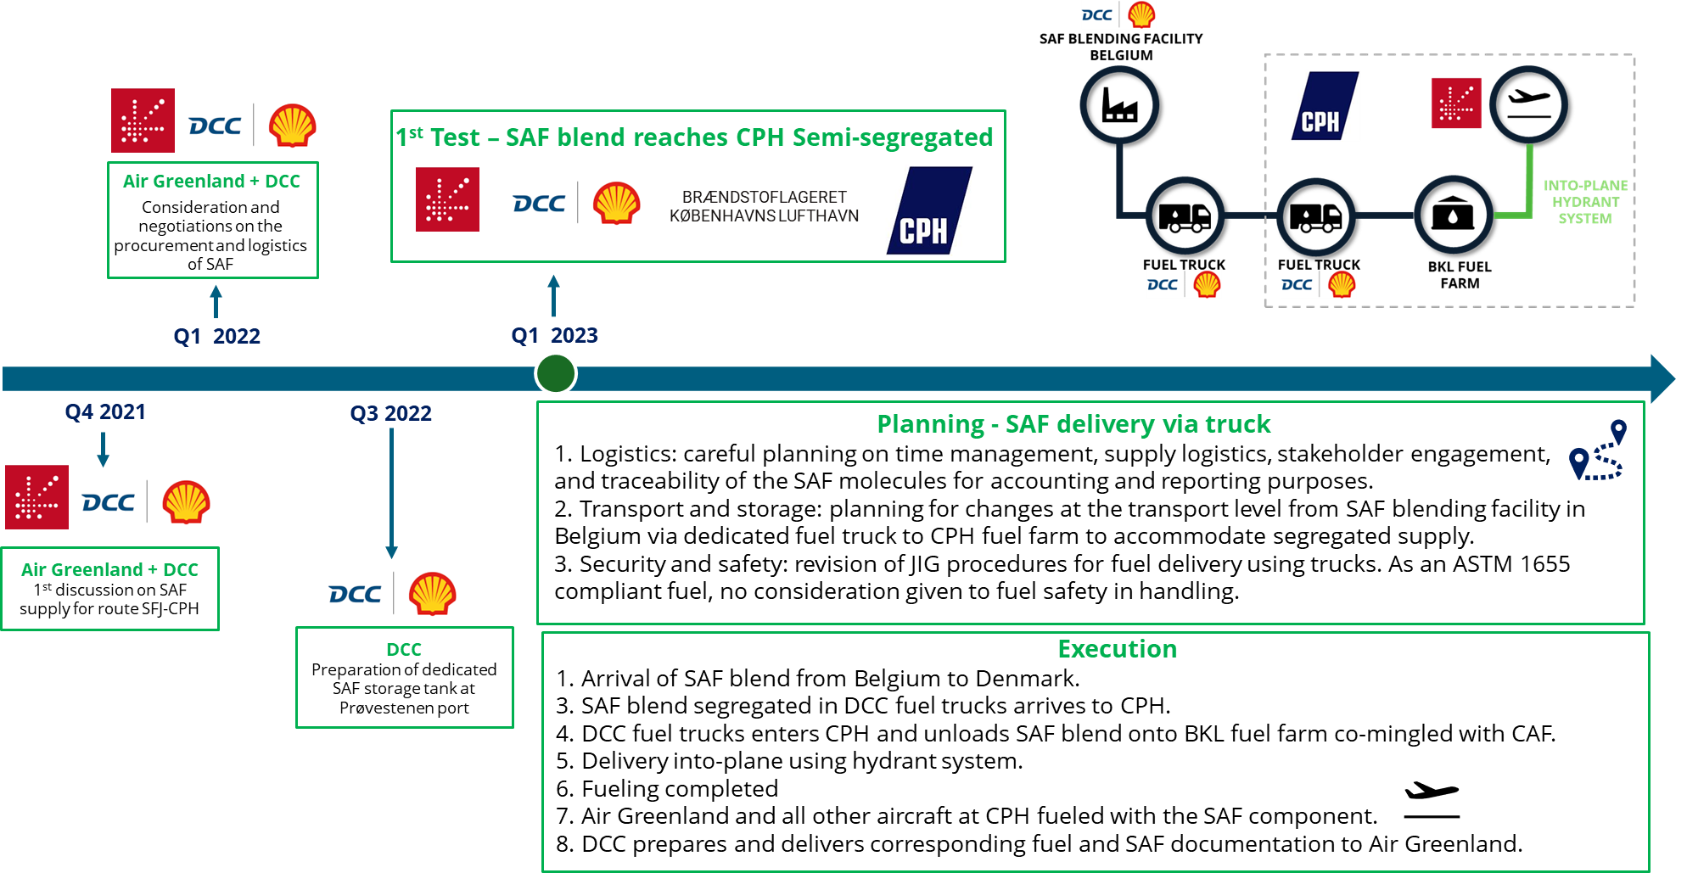

Timeline – SCENARIO 2 – Continuous Long-Term Supply of SAF Blends to CPH
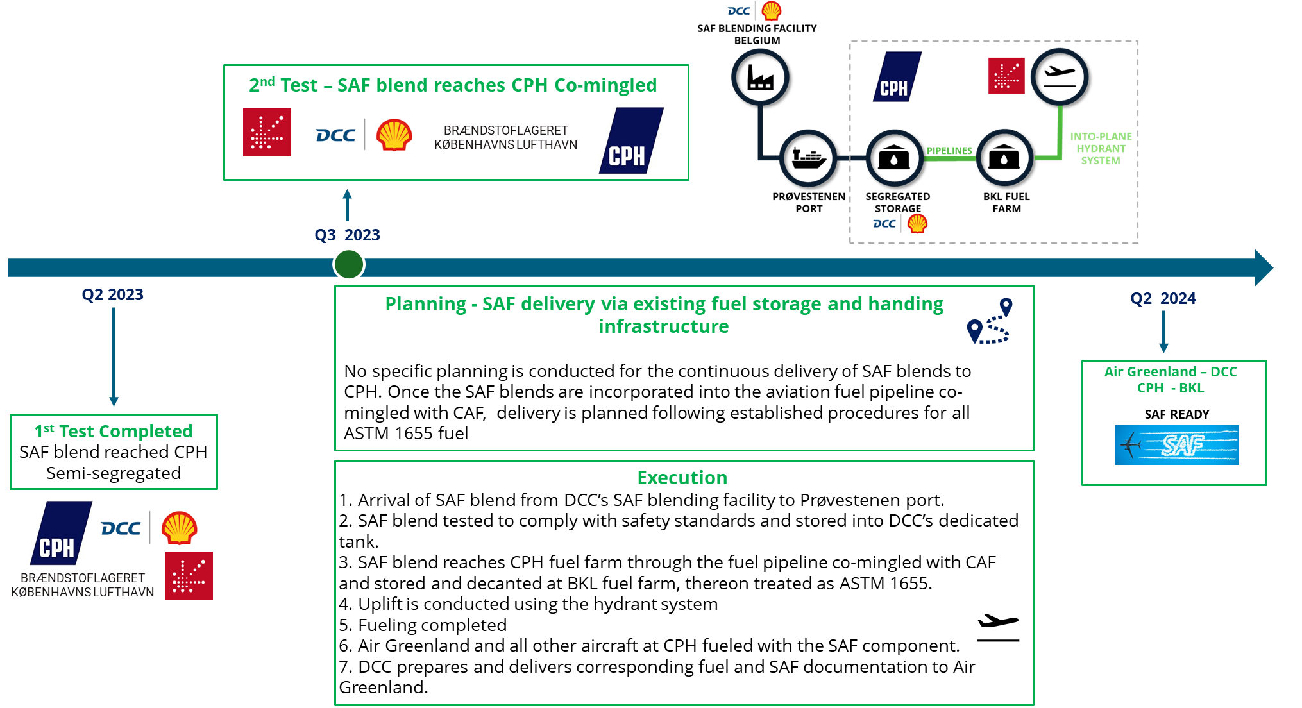

Czarnikow (CZ), 2024

