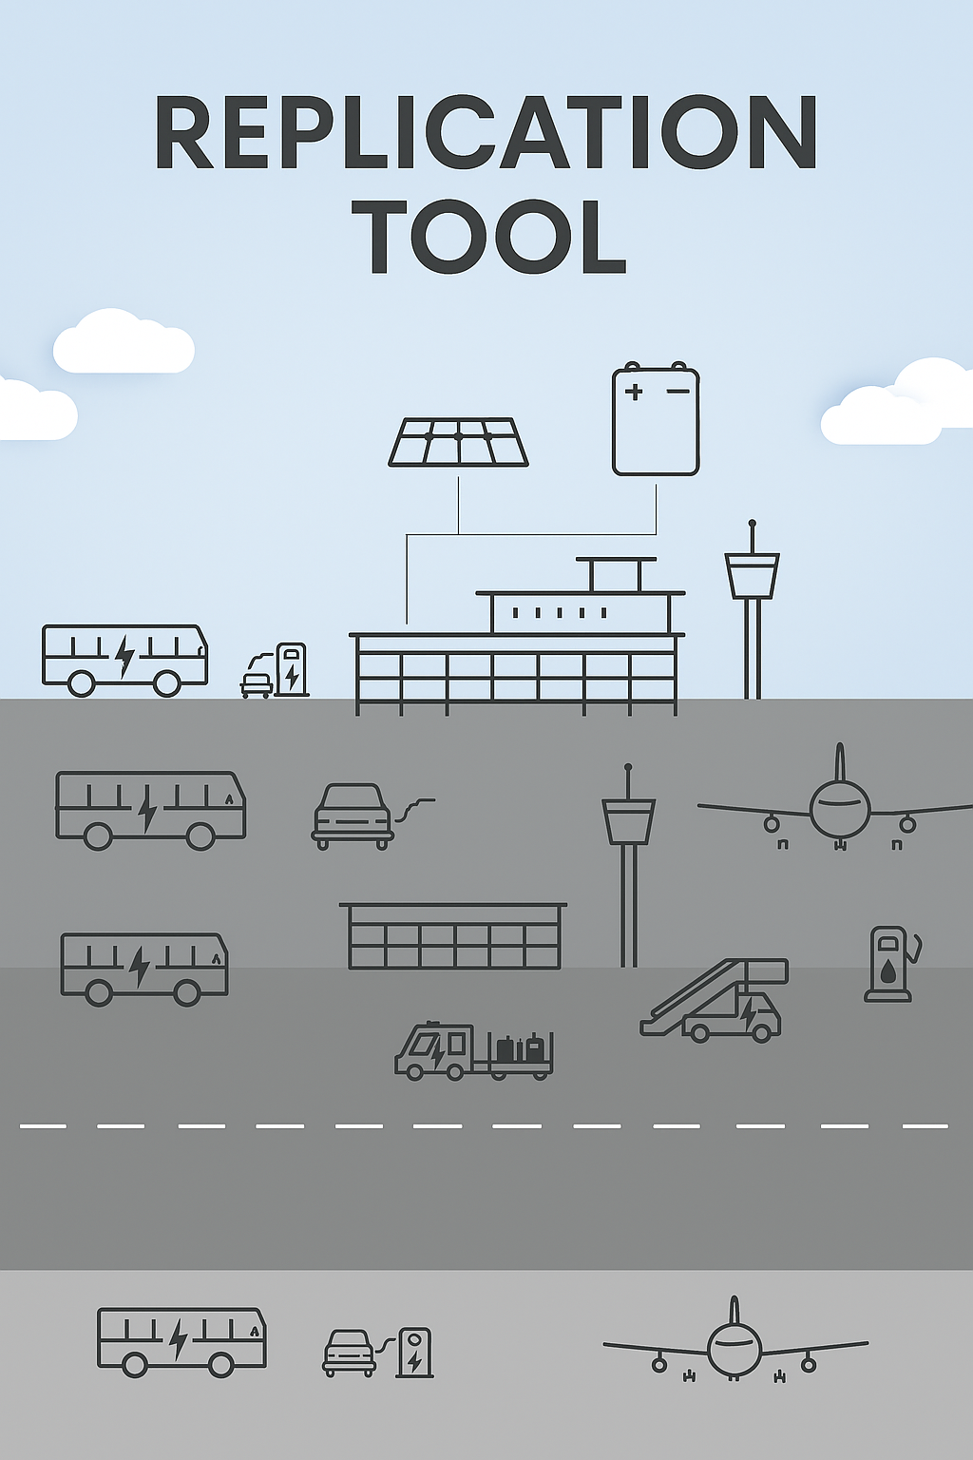
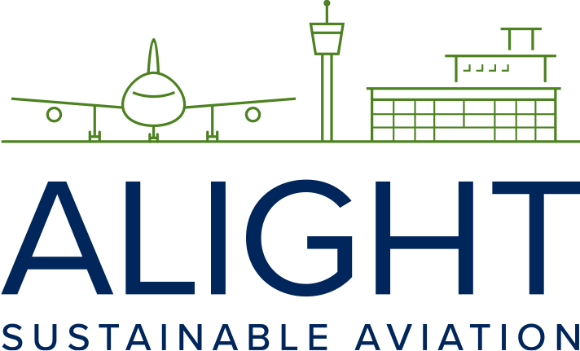
This project has received funding from the European Union’s Horizon 2020 research and innovation programme under grant agreement No 957824

Checklist of the origin, composition, and sustainability of SAF products

Tool 2.7

This checklist can be used to assess the origin, composition, and sustainability of SAF products briefly and accurately. It helps stakeholders – such as authorities, airlines, and suppliers – ensure that SAF meets environmental requirements, is produced from approved feedstocks, and complies with relevant standards and certifications.
1. Compliance | 
• SAF must comply with the sustainability criteria of the EU Renewable Energy Directive (RED II/III) and the RefuelEU Aviation Regulation.

• Lifecycle greenhouse gas reduction: Must deliver CO₂ reduction compared to fossil jet fuel, at least 65% if biobased and 70% if synthetic/RFNBO

• Renewable energy use in SAF production processes

• Certification: The fuel must be ISCC EU or RSB certified and registered in the EU Union Database (UDB).

• What is the aromatic content?

2. Sustainable feedstocks
• Do not compete with food production, harm biodiversity, or deplete water and soil resources.

• SAF may only be produced from approved raw materials (e.g., used cooking oils, forestry and agricultural waste, CO₂ from industry)

• Avoid feedstocks linked to deforestation, land-use change, fossil-based energy

• Life-cycle assessments (LCAs) to measure feedstock sustainability

• Has the choice of feedstock led to any risk of displacement?

3. Transparent and traceable supply chains
• Ensure SAF can be traced back to its origin to maintain accountability.

• Digital systems for tracking and reporting throughout the value chain

• Sustainability certification from recognized standards (e.g., ISCC, RSB)

• Regular third-party audits.

4. Technological and certification approval
• SAF must be approved according to the ASTM D7566 to be blended into conventional jet fuel.

• Approved pathways: HEFA (Hydro processed Esters and Fatty Acids), AtJ (Alcohol-to-Jet), PtL (Power-to- Liquid, eFuels or eSAF), FT-SPK (Fischer-Tropsch Synthetic Paraffinic Kerosene)

• All fuel products must meet JIG (Joint Inspection Group) 1 & 2 standards for airport handling.

5. Procurement model and contractual conditions
• Physical delivery (at a given airport, airplane)

• Mass balance model (delivery to agreed airport and multiple users)

• Book & Claim model (where CO₂ reduction is credited to the buyer without physical use of SAF)

• Long-term supply agreements (often with price hedging)

Contracts should ensure:

• Price fixing and indexation (SAF is more expensive than fossil jet fuel)

• Delivery commitments, time and volume (ensuring access to agreed SAF amounts)

• Sustainability certification documentation

6. Monitoring, Reporting, and Verification (MRV)
• Ensure accurate measurement and reporting of SAF’s sustainability performance.

• Demand data regarding certification, quantities, transport, delivery aligned with data to EASA/UDB

• Establish clear MRV protocols for GHG savings and sustainability metrics.

• Use third-party verification for data accuracy.

• Publish annual sustainability reports.

7. Economic and regulatory alignments
Buyers should examine economic and regulatory factors:

• Aligned, communicated and prepared in relation to EU and national mandates

• Subsidies or tax advantages in the EU or member states

• Quota obligations in the EU’s ETS (Emission Trading System)

• RefuelEU Aviation’s increasing SAF requirements (from 2% in 2025 to 70% in 2050)

• Advocate for standardized and improved SAF definitions and certifications

8. Economic viability, accessibility, and scalability
• Explain SAF use in an economically, future and sustainable perspective

• Get hold of prices, suppliers, qualities, sustainability angles, media follow-up and more

• Promote public-private partnerships to fund SAF projects.

• Develop infrastructure for SAF blending and distribution.

9. Public Awareness and Collaboration
• Build awareness and foster collaboration among stakeholders.

• Campaigns to promote SAF’s benefits.

• Engage with airlines, airports, and passengers on SAF adoption.

• Share best practices across the industry through forums and workshops

• Encourage government incentives and subsidies.

• Encourage private and public investments in sustainable solutions

10. Risk Management and Resilience
• Address risks related to feedstock availability, market volatility, and regulatory changes.

• Address risks related to feedstock sustainability and media, political, NGO’s and researchers’ views

• Develop risk mitigation strategies (e.g., diversified feedstock sources).

• Advocate for sustainability-, feedstock- and production-improvements

• Monitor regulatory landscapes and adapt quickly.

• Ensure business continuity through resilient supply chain planning.

