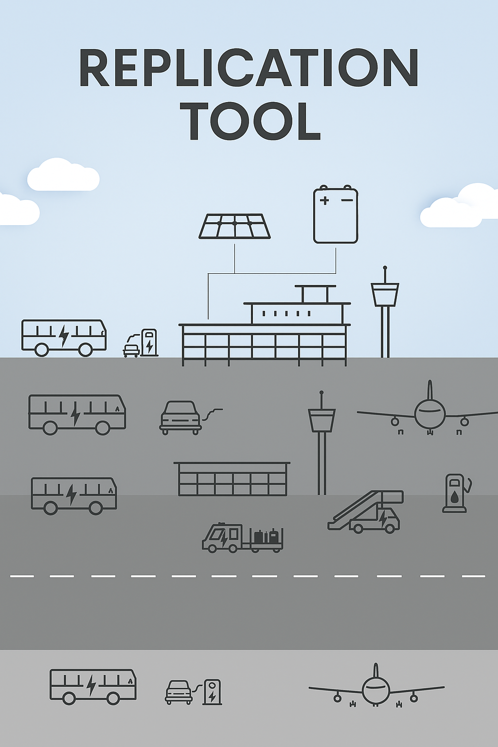
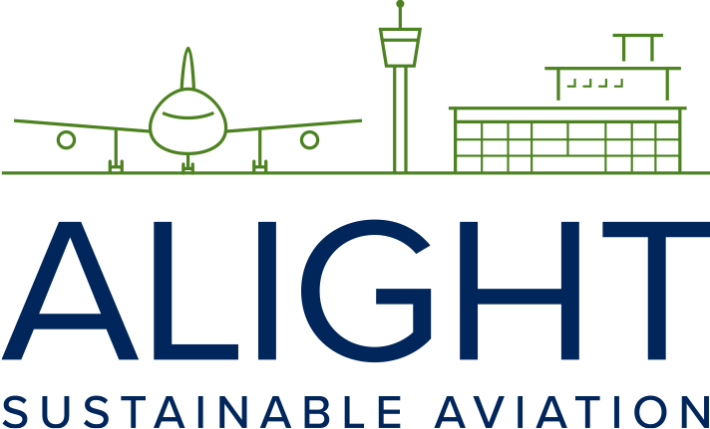
This project has received funding from the European Union’s Horizon 2020 research and innovation programme under grant agreement No 957824

Guideline for segregated SAF delivery and storage options (Non-co2)

Tool 2.13

This guideline can be used as a tool to assess and plan the use of separate SAF delivery systems, such as dedicated trucks or storage tanks. It supports decision-making by helping stakeholders evaluate when, where, and how targeted SAF delivery (high-blend or 100% SAF) can lead to greater climate impact, including the reduction of non-CO₂. The tool encourages strategic use of SAF on specific flights or routes, enabling deeper emission reductions than uniform blending across all aircraft.
Segregated delivery/storage
Deliveries of SAF blend-in through a mass balance system are the easiest and cheapest. Direct physical delivery of SAF blends to individual aircraft is an alternative option, which could also be established at most airports. At present, this can only be done with dedicated tanks on trucks or trains. This may be an option at airports where the tank, pipe or hydrant systems are out of service or undersized. If it is to be implemented regularly, possibly on dedicated flights, thorough prior analyses should be carried out to find out what benefits can be achieved, either with regular use of trucks/trains or with installing tanks for the specific purpose. Depending on the background and purpose of segregated SAF delivery, it also requires an analysis of which airports, and which flights can potentially achieve the most positive results, compared to doing nothing or finding completely different solutions.
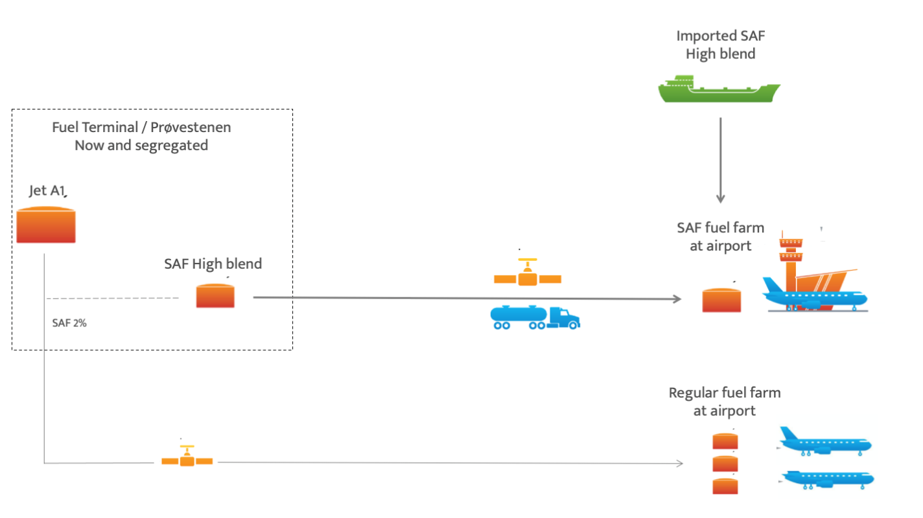
There may be several examples that can justify in-depth assessments of possible segregated deliveries. By separating the supply of, for example, high blend SAF to specific aircraft and/or designated long-haul routes, it could be possible to design the supply targeted at high-emission flights and thereby achieve greater emission reductions than an evenly distributed SAF percentage for all aircraft. A segregated supply of high blend SAF, possibly in the longer term as 100%, could contribute significantly to contrails avoidance and to reducing non-CO2 effects from aircraft as well as improving air quality at airports.

