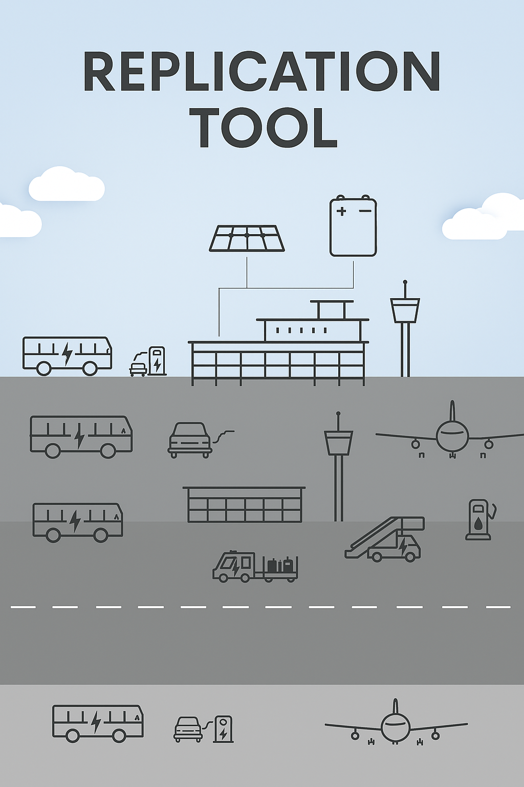

This project has received funding from the European Union’s Horizon 2020 research and innovation programme under grant agreement No 957824

Implementation plan for common eSAF recommendations based on national initiatives

Tool 2.14

There are many factors that must be included in a political implementation process related to aviation policy issues.
The first checklist supports the implementation plan by offering a step-by-step model for turning national sustainable aviation proposal, such as Denmark’s 2024 policy, into actionable measures. It is as a transferable template to help both public and private stakeholders to structure efforts, align goals, and coordinate roles in advancing eSAF adoption and broader aviation sustainability.
Step-by-Step implementation model
National sustainable aviation proposal – A transferable model
Objective: To demonstrate and promote a way to a more sustainable aviation through private end public support. Based on Danish governments aviation policy decisions 2024
Step | Element | Description | 
1 | Political anchoring | Identify sustainable aviation as a strategic objective in national climate plans or aviation strategies
2 | Definition of tender/project | Define route or technology, SAF/eSAF (electric-long term), climate emission reduction requirements, and minimum share of future operation
3 | Financing model | Clarify financial needs and identify support mechanisms: direct subsidies, charges, green fund, public-private partnership
4 | EU approval | Prepare state aid notification and engage with the EU Commission (DG COMP) – follow CEEAG rules
5 | Execution and partnership | Enter agreements with airlines, fuel producers, providers, airports, authorities, researchers, and specialists
6 | MRV and traceability | Implement Monitoring, Reporting, and Verification (MRV) systems and include use of the Union Database (UDB) for fuel traceability
7 | Evaluation and learning | Set up ongoing evaluation to support scaling up and transfer of knowledge national and internationally

The second checklist provides a structured approach by turning national initiatives into coordinated actions. It breaks the process into concrete steps, helping stakeholders plan, align, and track progress in the national implementation of eSAF recommendations.
Checklist for National Implementation
Area | Key question
Strategy | Is a future sustainable aviation anchored in national objectives?
Market | Are there operators, producers, and suppliers ready to participate?
Legislation | Is the national legal framework compatible with public tenders, project implementation models etc.?
Other aspects | Be aware of criticism and scepticism regarding SAF sustainability content etc.
Financing | Is there clarity on cost options, coverage and sources of funding, subsidies or?
EU Approval | Has the model, tender or project been notified and approved by the EU (DG COMP)?
Infrastructure | Is SAF availability, quality, certification, refueling, and logistics infrastructure in place, available or planned?
Data & MRV | Are there systems for monitoring and verification (MRV/UDB)?
Communication | Is the purpose clearly communicated to citizens and industry, media/PR?
Scaling Up | Are there plans for learning and replication to other airlines, airports, routes?
Technology development | Preparation of developments, investments, and prioritized areas of focus (SAF, eSAF, electrification etc.

