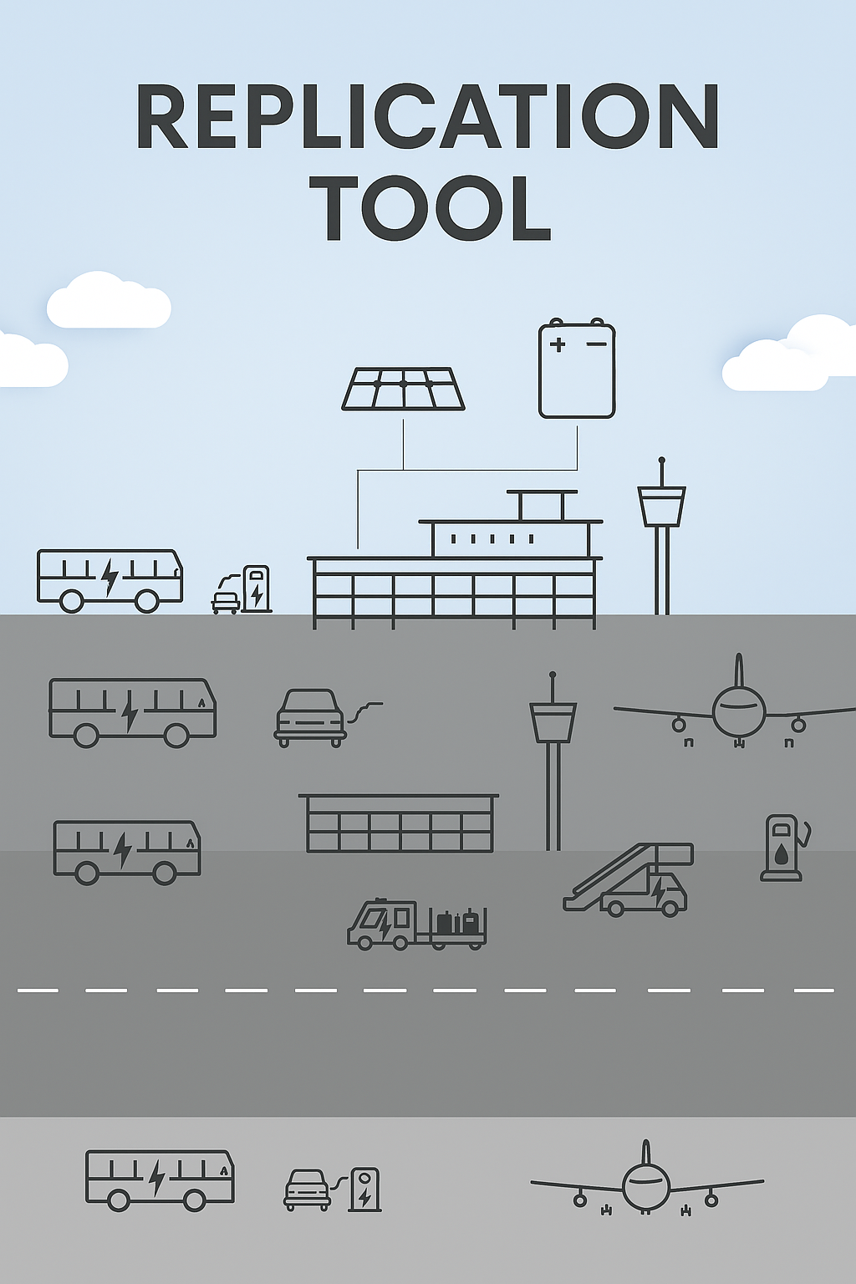
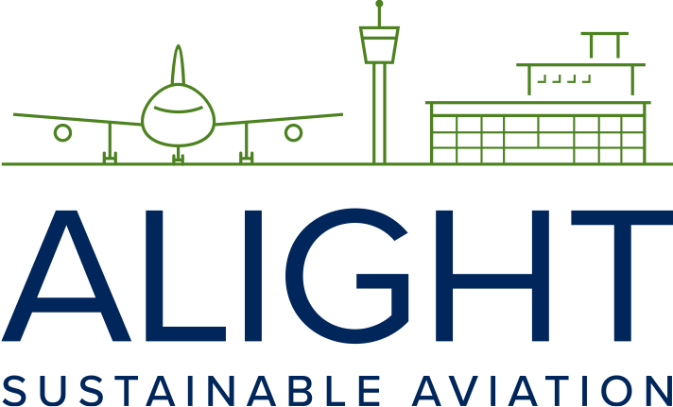
This project has received funding from the European Union’s Horizon 2020 research and innovation programme under grant agreement No 957824

Case study: Airport di Roma

Tool 2.5a

SAF usage cases study – Aeroporti di Roma
Executive Summary
ADR, the operator of Fiumicino (FCO) and Ciampino (CIA) airports, has taken a pioneering step in the decarbonization of aviation also by integrating SAF into its operations. This initiative is a cornerstone of ADR’s ambitious sustainability strategy, which aims to achieve carbon neutrality by 2030 and aligns with the broader objectives of reducing Scope 3 emissions—one of the most challenging aspects of airport environmental management. This effort complements other transformative initiatives, including the deployment of photovoltaic systems, the adoption of electric vehicles, and innovative energy storage solutions utilizing second-life automotive batteries.
In partnership with Eni, ADR introduced SAF through a strategic agreement launched in 2021, with the goal of promoting decarbonization across the aviation value chain. Two pilot tests conducted at FCO in 2021 and 2022 explored different SAF handling methods: segregated transport via truck and integration through existing fuel pipeline and hydrant systems. The first method, while operationally viable, revealed significant logistical challenges, requiring bespoke procedures, extensive coordination, and increased resource allocation. Conversely, the second method demonstrated the feasibility of seamlessly integrating SAF into existing infrastructure, proving to be more efficient, cost-effective, and less disruptive to daily airport operations.
Fiumicino Airport’s strategic location and advanced infrastructure make it an ideal testing ground for SAF supply chain implementation. Its proximity to the port of Civitavecchia and direct pipeline connections enables streamlined fuel transport, and greenhouse gas emissions. A market analysis conducted in collaboration with Eni and Roland Berger within the work done for the Decarbonization Pact further reinforced FCO’s suitability as a model for SAF adoption, highlighting the HEFA pathway as the most mature production technology in Italy.
These pilot tests confirmed that SAF can be safely and effectively managed using existing procedures and infrastructure, establishing a scalable and replicable model for decarbonizing aviation. This milestone positions ADR as a leader in sustainable airport operations, setting a benchmark for the integration of alternative fuels within the aviation sector. ADR’s experience underscores the critical importance of cross-sector collaboration, innovative supply chain strategies, and infrastructure readiness in achieving the ambitious goal of Net Zero emissions by 2050, in line with European and global decarbonization targets.
1. Introduction
The purpose of this document is to describe the experience of ADR, the society that manages FCO and CIA, with the first introduction of SAF into airport grounds. The report delves into the decision-making process for incorporating SAF into the fuel supply chain, highlighting the key factors and considerations that have guided this decision. Additionally, it examines the involvement of various stakeholders in the management of the new fuel and their contribution to the design and implementation of a SAF strategy and a functional supply chain.
ADR has set ambitious decarbonization goals, aiming to achieve carbon neutrality by 2030. This goal will be reached through a series of initiatives, including the installation of photovoltaic systems, the adoption of energy storage systems using second-life batteries from the automotive sector, the implementation of electric vehicles for the airport fleet, and the integration of low carbon propellants. These measures are a fundamental part of ADR's plan to promote sustainability and energy efficiency in the aviation sector, in which SAF plays a key role for the reduction of scope 3 emissions from airport operations. The following figure best exemplifies ADR’s achievements on sustainability commitments from 2000 through 2023:
Figure 37 - Aeroporti di Roma Sustainability Strategy
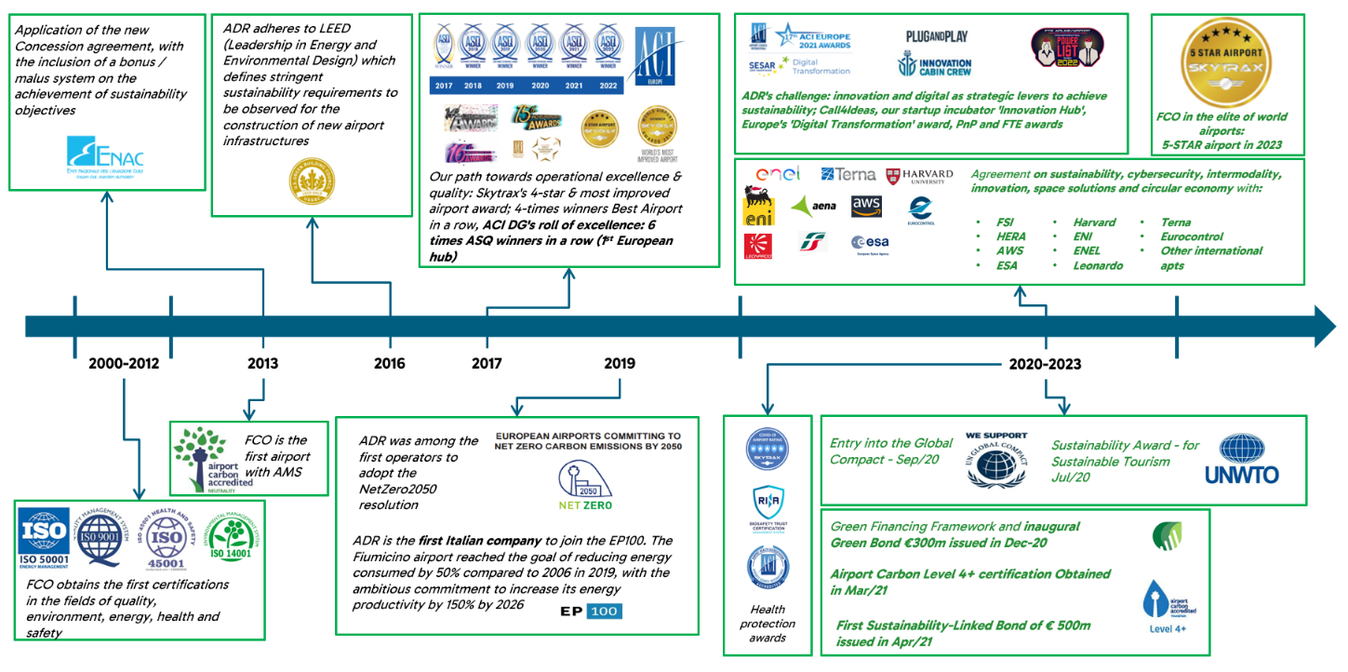Source: ADR
This case study aims to provide a comprehensive overview of the challenges that have emerged from the implementation of SAF at the airport, while also offering an assessment of the practices adopted to facilitate its penetration in the market.
2. A bold step forward – incorporating SAF intro airport grounds
ADR is strongly committed to take bold action against climate change. Both FCO and CIA airports are accredited at level 4+ “Transition” under the Airport Carbon Accreditation Europe scheme for direct and indirect CO2 emission reductions.
The company’s commitment does not stop there. Through the years ADR has implemented solutions and formed alliances with stakeholders along the value chain to find an efficient and meaningful path forward to reduce the environmental impact of its operations.
2.1 Decision making process and stakeholder engagement
In 2021, the Italian multinational energy company Eni S.p.A. (Eni) and ADR signed a strategic agreement to promote decarbonization initiatives in the aviation sector and accelerate the transition to Net Zero by 2050 of airports. The agreement provided for the development of decarbonization projects to encourage airports to transition to the “smart hubs” concept managed by ADR. Efforts focused on reducing scope 3 emissions, the airport’s greatest and most difficult environmental impact to tackle. In particular, the agreement saw the introduction of SAF for aircraft and lower carbon hydrogenated vegetable oil (HVO) for ground support equipment (GSE) as key actions to achieve its climate goals.
In 2022, ADR created the Pact for Decarbonization of Air Transport together with partners representing industry, institutions, associations, and academia. The Pact for Decarbonization of Air Transport was born with the aim to identify available solutions to reduce GHG emissions from aviation. Similarly, the Pact’s intention was to define the stages of the path toward implementing actions flanked by realistic policy proposals to help achieve the challenging environmental objectives. The Pact’s partners so far are listed in the following table:
Table 10 - Actual Partners – Pact for Decarbonization of Air Transport
Pact for Decarbonization of Air Transport Actual Partners
Industry |  | Institutions | Associations
Enel  Eni  Boeing  Airbus  Mundys  Neste  Swissport  SNAM | Gruppo SAVE S.p.a  ITA Airways  Aeroporto di Bologna  Intesa Sanpaolo  Aviapartner  Aviation Services  Italo  Aeroporti 2030 | Italian Civil Aviation Authority - ENAC | Asvis  Global Compact  Symbola  AICALF  IBAR  IATA
Ultimately, the intention was to jointly promote action and accelerate the implementation of solutions to achieve the sustainability objectives of air transport in the context of the SDGs and the 2030 Agenda, taking as reference the goal of Net Zero Emissions by 2050, and to prepare its airports for compliance with RFEUA requirements.
2.2 Stakeholder engagement
ADR took an active approach to the incorporation of a SAF blend into airport grounds, owning the process from the beginning in alliance with key stakeholders supporting actions at every stage of development.
The first experience where a SAF blend was incorporated into ADR administered airports was unique, both being the first time ever to have an alternative fuel to Jet-A used for jet engines at an Italian airport and having a supply chain which involved a much greater number of stakeholders when compared to the supply of conventional aviation fuel caused by the uncommon modality chosen to deliver the SAF blend in FCO that was different from the business as usual. ENI and ADR agreed to run two different tests to incorporate a SAF blend into FCO, primarily to better understand handling and fueling infrastructure needs at FCO; the tests took place in 2021 and 2022.
In October 2021, a SAF blend was introduced to FCO for the first time. Delivery was conducted using trucks which kept the SAF blend segregated from all other fuel within the airport. Key stakeholders were involved since the very early stages of planning to make the tests possible; these include the following:
- ENI, the fuel supplier […]
- ITA Airways, the airline company committed to fueling their flight with a SAF blend.
- SERAM, the company that manages fuel farms at FCO
- Guardia di Finanza, Italy’s financial police force, responsible for operations related to fuel clearance and seals removal.
- Levorato Marcevaggi (Levorato), the company in charge of the into-plane delivery of fuel.

The internal departments at ADR engaged for this test, involved in operations, those include the following:
- Post Holder Movement Area
- Energy Manager
- Security Manager
- Environment and sustainability department
- Innovation department
- Legal department

In March 2022, the second test took place. This time the delivery of the SAF blend to FCO was conducted following business as usual practices using the existing pipeline, fuel farm, and hydrant system for uplift to the aircraft. This time around, no more stakeholder compared to the one involved in the CAF delivery were involved, so:
- ENI, the fuel supplier
- ITA Airways, the airline company committed to fueling their flight with a SAF blend.
- SERAM, the company that manages fuel farms at FCO
- Guardia di Finanza, responsible for operations related to fuel clearance and seals removal.
- Levorato, in charge of the into-plane delivery of fuel
- ADR Post Holder Movement Area

3. SAF procurement: what, where, and how
In most instances, the procurement of a SAF blend does not follow the same path as that for CAF, primarily on the how and what. Differences lie on the type of purchase agreement to establish with the supplier, the variety of suppliers to procure from, and the documentation process, mainly the existence of the PoS certificate that users require to adequately account for and report environmental benefits achieved. There are several SAF pathways under production today, each with its own environmental profile, but production volumes remain low enough that the ‘what’ choice is limited to whatever the authorized fuel supplier for a given airport is willing to supply.
The process was no different for ADR at the time to choose how to procure, what type, and where to purchase SAF. With an increase in SAF production volumes worldwide, this may change where users may be given the option to choose the specific pathway or combination of pathways to procure in alignment with a desired environmental profile, but that was not the case when ADR begun planning the use of a SAF blend at FCO.
3.1 SAF pathway and supplier
Local, that was the variable ADR used to choose a SAF supplier and with it came the pathway. At the time the tests were conducted, ENI was the sole supplier of SAF in Italy, the only pathway available was co-processing of HEFA, and the choice of feedstock was UCO.
3.2 Procurement process
The procurement process for both tests using a SAF blend was atypical in every way when compared to the process that is normally followed for purchasing fuels at FCO, even beyond the differences illustrated above.
Usually, fuel purchases are handled by the airlines through purchase agreements directly with the oil companies, ADR does not enter the merits and is not required to become involved in any sense. Since the decision to test the use of a SAF blend at FCO was taken by ADR and supported by allied stakeholders, in this instance the procurement agreement for SAF to FCO was signed between Eni and ADR; also, the SAF blend purchased was intended for use only in a particular ITA aircraft departing from FCO vs. any and all flights as volumes would be used if the procurement had been for CAF. This procurement processed mirrored a lab test, were BAU changes dramatically to allow for the testing of an uncommon situation, limited in scope and under a controlled environment.
Another particular aspect in this procurement process was the absence of a plurality of suppliers from whom to purchase the SAF blend from; the agreement aimed at promoting the development and use of SAF was between ENI and ADR directly, so ENI became the default supplier.
4. SAF handling and logistics
As stated in the body of this handbook, SAF is defined as jet fuel derived from biomass or non-biomass waste that once blended with CAF, meets the relevant specification for use on an aircraft, such as ASTM D1655 or Def Stan 91-091. From a handlers’ point of view, no special attention nor additional processes are added when handling a SAF blend, it is carried out using existing JIG protocols.
Any deviation from existing handling and logistics protocols are usually taken when there is a specific interest to segregate SAF blend. The aim of segregating the SAF blend during the first test was mainly to demonstrate the feasibility of using SAF in small and medium airports like CIA.
In contrast, the SAF blend for test 2 was handled following the mass balance chain of custody approach. The objective was to demonstrate the feasibility of transporting and delivering a SAF blend using existing infrastructure and fuel handling procedures.
The following section explains more in detail handling and logistics processes specific to test 1 and test 2.
4.1 Considerations taken before introduction into airport grounds
Airports play a crucial role in the value chain to ensure sufficient volumes of SAF are available. This aids users and producers in complying with EU ETS and RFEUA regulations, facilitating a smooth transition despite current limitations in SAF volumes and higher prices compared to CAF. Similarly, within this transitional period, the European Commission is evaluating the establishment of a system of negotiable certificates for the supply and purchase of SAF. This would utilize a book & claim chain of custody model to address the limited supply of SAF in specific regions until the industry scales up.
In this context, both FCO and CIA were under consideration when ADR and Eni first begun evaluating where to run the two tests on SAF usage. Through a detailed decision process, FCO was selected as the airport of choice. The role that FCO plays in Italy to host the SAF value chain seemed more favorable considering the following:
- FCO serves as the principal hub for ITA Airways, the Italian flag carrier, and the largest airline in the country,
- The airport is located with strategic proximity to the sea and the port of Civitavecchia, directly connected via pipeline to the port’s fuel depots, which contributes toward reducing risks in safety and security as well as costs and GHG emissions on fuel transport and delivery.
- Unlike CIA, the SAF blend uplift at FCO can be conducted through the existing hydrant system as well as trucks, allowing for both delivery methods to be tested.
FCO seemed well suited to serve as the example to follow for all those other airports in Italy and abroad as the most efficient and cost-effective model to accommodate the supply of a SAF blend to immediately and efficiently help lower GHG emissions from the aviation sector.
In fact, to test the above assumptions, in 2023 ADR took the time and effort to evaluate the suitability of FCO to continue to play the role as study grounds for SAF usage among all other airports it administers. With the support of the consultancy firm Roland Berger, ADR and project partner Eni conducted a comprehensive market analysis of the entire SAF supply chain in Italy to set its own strategy towards establishing the optimal SAF supply chain compliant with RFEUA.
As expected, the study concluded that FCO was in fact a well-suited airport in Italy to begin building a strong and reliant SAF supply chain, considering distance to mayor fuel depots, ATM volumes, and average fuel consumption by type of aircraft.
Another important result of the study was the state of art of the different SAF production pathways in Italy, concluding that HEFA was the most mature technology at the time with production volumes at commercial scale, while other technologies such as AtJ, G-FT, and PtL seem to be less mature and production volumes very low or null. Furthermore, their growth was highly dependent on a significant increase in low-cost renewable energy production for feedstock processing and further development and optimization of processing technologies, which meant their availability at scale were not foreseen for the near future.
4.2 Supply method
For the first phase of planning, a working group was set up to verify important logistics, safety, and compliance aspects of the different scenarios. To arrange for the most efficient supply chain for SAF to reach FCO, the working group evaluated two supply scenarios: via truck and via pipeline.
Test 1: SAF delivery via truck
As per recommendations from the working group, the first introduction of a SAF blend into FCO was delivered via segregated supply using Eni's tank trucks. ADR organized the first delivery to FCO that took place on 15 October 2021, the process is illustrated in the following figure:
Figure 38 - SAF blend supply chain for Test 1
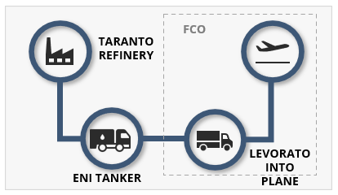
Source: ADR

The preparation phase for this first delivery was led by ADR’s Post Holder Movement Office, who collected necessary documentation related to access permits to the airside area for the driver of the Eni tanker. They also organized the preliminary meetings and briefings with the representatives of Eni, SERAM, and Levorato to jointly define the logistics, authorization, regulatory, and customs requirements of the SAF blend delivery from Civitavecchia port’s fuel depot to the aircraft. The outcome of these meetings was the establishment of a special procedure for the unloading and transfer of the SAF blend from the tanker to the aircraft.
Managers from the Safety Management System department at ADR met with SERAM’s counterparts to clarify the characteristics of the SAF blend and eventually its impacts on common fueling procedures. The aim was to confirm the following safety aspects of SAF and SAF handling:
- A SAF blend is to be considered equivalent and compatible with other A1 jet fuels.
- A SAF blend is already approved and regulated internationally according to ASTM D1655 and Def Stan 91-091.

Similarly, in the days preceding the first supply of the SAF blend to FCO, ADR's Security Manager took the important role to lead the security process and share with the Air Border Police the special procedures:
- Arrival of the Eni tanker at customs gate.
- Safety checks for the driver and the Eni tanker.
- A safety escort for the tanker formed by ADR Security and Guardia di Finanza (GdF) from the customs gate to SERAM’s site.
- The supervision by the GdF of the whole process involving the fuel transfer from the Eni tanker to Levorato’s into-plane vehicle after removing the seals.
- The return of Eni’s tanker to the customs gate and exit from the airport.

The day of the first test on 15 October 2021, ADR monitored operations to ensure compliance with the program agreed by all the stakeholders, taking care to communicate any changes on arrival time of the tanker and coordinating the operations under the profile of the agreements made with customs and GdF. The following paragraphs are dedicated to illustrating details on the special procedures followed as per the above bullet points to provide a more in-depth description of the actions taken and stakeholders involved:
The safety checks before the SAF blend were introduced into FCO grounds, specifically SERAM’s fuel depot, involved four steps:
- Safety briefing communicated to the driver.
- Verification of the integrity of the seals.
- Verification of customs documents.
- Verification of quality documents.

After completing the checks for each step with positive results, the tanker was taken to the weightbridge and weighted. The tanker was then escorted by ADR and SERAM’s personnel to the entrance, the customs gate and throughout its entire trajectory as required by the established security process. The tanker was then driven to SERAM’s airside fueling island parked in a concrete paved area following safety instructions given by SERAM’s staff, taking into consideration:
- Fire-fighting equipment.
- Entry inhibition.
- Spill containment.

SERAM’s staff took a sample of fuel from the Eni tanker to be subjected to common quality checks, bleeding of the tanker to verify the absence of water and measure the density of the fuel. After quality checks gave positive results, the tanker was prepared for decanting.
Decanting took place similarly to a "defueling" process and was coordinated jointly by the into-plane company Levorato and Eni. The removal of the seal of the defueling system, was carried out in the presence of an official from the GdF. At this point, the into-plane tanker was authorized to refuel the selected seven ITA Airways aircraft with SAF blend. The transfer was considered completed only after Eni’s SAF tanker was completely emptied and double checks confirmed that there were no residual volumes of fuel left inside. Eni’s SAF tanker was then escorted out via the customs gate and exited the airport.
The first ever introduction of SAF into FCO grounds was conducted successfully, the fuel segregated using trucks as the choice of supply method. The seven ITA Airways aircraft took off on the 15th of October during the morning from FCO, four of them were destined to Milan Linate Airport (LIN), one to Venice (VCE), one to Bologna (BLQ), and one to Amsterdam (AMS).
The following figure documents the planning process and delivery of a SAF blend segregated by truck to FCO:
Figure 39 - SAF blend delivered to FCO by truck
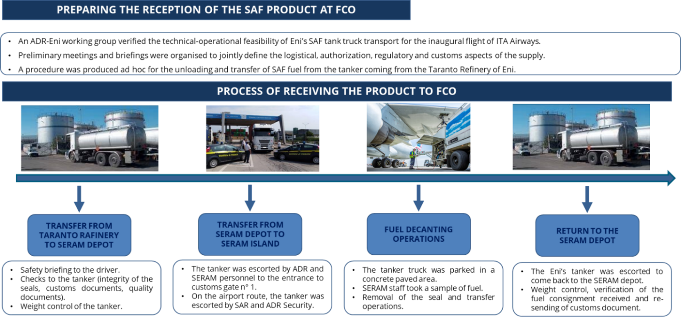 Source: ADR

Test 2: SAF delivery via pipeline
The second test on SAF use at FCO led ADR involved the delivery of a SAF blend via pipeline. The delivery took place in March 2022; the objective was to demonstrate how the SAF blend could be integrated in existing infrastructure following the same fuel handling and delivery procedures common to Jet A-1, as illustrated in the following figure:
Figure 40 - SAF blend supply chain for Test 2
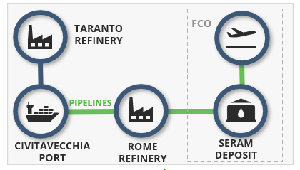
Source: ADR
FCO has access to two different pipelines for fueling: one connects the airport to Civitavecchia’s port, the other one to Fiumicino’s Port. The first one has been used for this test.
The ship coming from Eni’s refinery in Livorno loaded with about 3000 tons of SAF blended arrived at Civitavecchia Port; the fuel was unloaded at a coastal depot connected to FCO through a long network of pipelines. The SAF blend arrived to FCO following BAU procedures using existing fuel handling infrastructure, stored at FCO’s fuel farm managed by SERAM, and ultimately uplifted to selected ITA Airways aircrafts via a mass balance chain of custody approach through the hydrant distribution system.
Results for the second test allowed ADR, Eni, and ITA Airways to demonstrate the feasibility of transporting a SAF blend using existing pipelines and its successful delivery following a mass balance approach without having to increase costs associated with fuel transport, handling, storage, and delivery.
5. Documentation
Both tests at FCO were conducted for more than one purpose, yet the common objective was to understand fuel handling procedures for SAF at the airport, ultimately looking to reduce the environmental impact of aviation. The handling of documentation remained an important factor in both tests, aimed at determining differences among the CoC approaches selected, mainly the ease of traceability, accounting, and reporting on emission reduction claims gained via SAF usage handled via segregation and mass balance.
In addition to the issuance of the proper documentation to certify for the fuel’s quality assurance, the SAF procurement process must ensure that SAF suppliers provide specific documentation to enable airlines and their customers to claim the environmental attributes and prove they meet the eligibility criteria of specific regulatory schemes, financial incentive programs, and other carbon reduction programs in accordance with guidance set by GHGP. Without this documentation, the buyer lacks proof to credibly claim the environmental attributes associated with the SAF purchased.
5.1 Sustainability certification
As described at length under section 1.2.2 of this handbook, the sustainability certification of SAF involves evaluating the environmental, social, and economic aspects of the fuel production process to ensure that it meets specific sustainability criteria. Generally, it aims to ensure the following:
- Sustainability in feedstock production,
- Traceability and chain of custody of sustainable materials through the supply chain
- Verified reduction in life cycle emissions compared with conventional aviation fuel alternatives

For the tests at FCO, the sustainability certificate was issued by certification body 2BSvs + PRO04, utilizing the ISCC-EU certification scheme of raw material’s supplier. The PoS was issued by the fuel provider Eni, the following sustainability parameters reported:
- Type of product/input material: HVO (co-processed hydrotreated vegetable oil kerosene fraction)
  - Country of Production: Italy
- Raw material/s: Regenerated Used Cooking Oil
  - Country of origin: Italy
  - Harvest: N/A
- Total amount Jet A1+Eni SAF equal to 30,210 tons of which sustainable amount is 0,1396 tons; 42,8 MJ/Kg; energy content 5.974 MJ
- The biofuel has been produced from waste, residues or by-products, with by-products not arising from agriculture, forestry, fisheries or aquaculture.
- GHG Saving % of the bio component part of the SAF blend: 90,52 %
- Carbon intensity Total 8,9 g CO2eq/MJ
- Delivery based on the mass balance system pursuant to §30 European Directive 2018/2001/EU (“REDII” e ss.mm.ii.).

To ensure that a proper claim could be issued and avoid double claiming, the PoS also reported what would become the “identity” for this specific batch of SAF delivered, primarily as follows:

- Certification system/scheme | - Batch Number
- Certificate n° | - Supplier/Shipping Site
- Contact details of certificate issuer | - Buyer/Delivery site
- Issued by Rina Services S.p.A. | - Contract reference number
- Expiry date | - Delivery date
- Date of last verification | - Transportation mean
- Number of Sustainability Claim

This PoS therefore confirmed that the batch of SAF meet the requirements for sustainability and GHG emissions savings compliant with EU ETS and CORSIA; accounting, reporting and claim on achieved emission reductions for the SAF tests at FCO were made accordingly. Since for this scheme SAF is zero-rated, by evidencing its utilization, ITA was able to reduce requirement to surrender CO₂ allowances.
5.2 Quality assurance
As previously explained on section 3 of the handbook, technical documents demonstrating fuel quality must accompany the product to its destination. The most common of these documents are listed here:
- Refinery Certificate of Quality - RCQ
- Certificate of Analysis - COA
- Recertification Test Certificate - RTC

Since for both test 1 and test 2 the SAF was manufactured via co-hydroprocessing of esters and fatty acids in a conventional petroleum refinery, the quality assurance process of the aviation fuel followed the same procedures as it would have for documenting CAF. An RCQ was issued for the SAF blend by Eni following existing procedures, no extra steps and documents were issued for quality assurance purposes. The RCQ reported required data to ensure the safe use of the fuel, mainly the following parameters:
- Appearance | - Corrosion
- Particulate Contamination at Point of Manufacture | - Stability
- Composition | - Contaminants
- Refining Components at Point of Manufacture | - Water Separation Characteristics
- Incidental Materials | - Conductivity
- Volatility | - Lubricity
- Fluidity | - Additives
- Combustion

Unlike the certificate for a fossil fuel in pure form, the RCQ for a fuel that contains a bio-component must specify under the ‘Refining Components at Point of Manufacture’ and ‘Incidental Materials’ categories, the type, units (in %), limits, test method, and results specific to the bio-component.
The following was reported under the RCQ for the SAF test at FCO:
- Refining Components at Point of Manufacture: Hydroprocessed components including Co-hydroprocessed synthesized kerosene.
- Incidental Materials: FattyAcid Methyl Ester (FAME) - ASTM 07797

5.3 Quantifying SAF volumes reaching the airport
Usually, the purchase of SAF is a transaction conducted between the user, an airline, and the provider, a SAF supplier; it is not common practice for airports to get involved in the fuel procurement process.
This case study was exceptional in that sense since the initiative to introduce SAF into FCO came for a joint effort between ADR and Eni. This meant that the volumes of SAF that reached FCO for both tests were recorded and delivered to the buyer instead of the user, via the PoS where total tons of fuel delivered, and the proportion of the bio-component were clearly identified. Of course, no claim would have been possible unless ITA burned the SAF blend, yet ADR was involved in the process and was able to ascertain the potential for scope 3 emission reductions from SAF usage, crucial to help them achieve their commitment to reach its Net Zero commitment by 2030.
This scenario helps identify a not-too-distant obstacle Union airports may face under existing RFEUA provisions. As it stands today, and soon to come into force as of January 2025, aircraft operators shall report total amount of aviation fuel uplifted at each Union airport to the competent authorities and via the EASA Digital Reporting Tool. For fuel suppliers, RFEUA stipulates that they must implement a data collection and reporting mechanism enabling to monitor the effects of this regulation (see section 2.2.1). Union airports are to take all necessary measures to facilitate the access to aviation fuels for aircraft operators containing required minimum shares of SAF, seemingly no other involvement.
6. Leadership and communications at CPH
The Rome airport system is an engine for the development of the country and the territory surrounding the airports from an economic, environmental, and social point of view. ADR’s transition to sustainable development has and will continue to reach groundbreaking achievements, to name a few:
- Rome airports are the first European airports to obtain ACA 4+ certification
- By 2030 all new infrastructures such as terminals or piers that will be built or renovated will have to be designed according to the highest international sustainability standards (LEED and BREEAM)
- Ongoing key projects include the construction of different large multi-MW photovoltaic plants at FCO, securing SAF supply volumes, extending the supply of HVO to power ground support vehicles, and the development of a capillary network of recharging points for electric vehicles.

Already in 2020, actions taken to reduce its environmental footprint allowed ADR to generate Green Bonds worth € 300 million; leadership in environmental action and sustainable development is embedded within ADR’s business plan.
6.1 Lasting commitment to SAF usage by ADR
Since an airline’s scope 1 emissions embody an airport’s scope 3 emissions, actions on SAF usage represent an opportunity to further reduce the environmental impact of ADR's administered airport’s operations. Both SAF tests conducted by ADR in 2021 and 2022 have served to understand the operational and infrastructural needs that entail SAF usage at an airport. The experience and results obtained have shown that ADR is ready to provide SAF to its custom airlines.
ADR remains strongly committed to its environmental goals and is continuously analyzing the market and finding ways to support usage and raise awareness on the benefits of SAF usage.
6.2 Global, regional, and national regulation supporting the use of SAF
At the time of this case study, the EU had implemented the EU ETS and CORSIA. Linked to the ‘Fit for 55 Package,’ RFEUA legislative proposal was made in 2021 and published as regulation in October 2023.
EU ETS is a cornerstone of the EU’s policy to combat climate change and reduce GHG emissions in a cost-effective and economically efficient manner. Operating on a cap-and-trade principle since its establishment in 2005, the EU ETS sets a cap on the total amount of certain GHG that can be emitted by installations covered by the system. Companies receive or buy emission allowances, which they can trade with one another as needed. The cap is reduced over time, ensuring that total emissions fall. As it relates to aviation, the EU ETS covers flights within the EU and the EEA, as well as departing flights to Switzerland and the United Kingdom.
CORSIA is a global MBM developed by ICAO. CORSIA aims to stabilize CO2 emissions from international aviation at 2020 levels by requiring airlines to offset any growth in emissions above those levels. Airlines can achieve this by purchasing carbon credits from approved projects that reduce or remove emissions from the atmosphere. CORSIA complements other aviation in-sector emissions reduction efforts, such as technological innovations, operational improvements, and the use of SAF.
RFEUA aims to ensure that EU air transport meets the EU’s climate targets for 2030 and 2050. This regulation creates a strong and stable legal framework to promote the gradual supply and uptake of SAF in the EU. Enforcement of RFEUA started in 2025, whereby aviation fuel suppliers are required to supply a minimum of 2% SAF, which will gradually increase to at least 70% by 2050. The regulation also sets out rules for enforcement, reporting, and a new flight label to help consumers make informed choices regarding their transport options.
Between 2021 and 2023, Italy also made significant efforts to support SAF. ENAC played a key role by implementing policies and creating a roadmap for SAF usage. Italy transposed the EU Directive 2018/2001 (RED II) into national legislation through Legislative Decree 8/11/2021, which came into effect in December 2021. Furthermore, the Italian government participated in RFEUA and provided supported to research projects to improve SAF production processes and provided financial incentives for SAF adoption.
Individually, ADR has demonstrated a strong commitment to climate action through various initiatives and strategies aimed at reducing aviation’s environmental impact. In addition to the actions described in this cases study in support of SAF usage, ADR’s sustainability efforts also include the implementation of measures to improve energy efficiency, reduce FCO’s and CIA’s overall GHG emissions, and promote the use of renewable energy sources. ADR has achieved commendable milestones in reducing its carbon footprint by adopting the Airport Carbon Accreditation program and investing in sustainable infrastructure projects, such as solar panels and energy-efficient buildings. ADR also engages with stakeholders to promote environmental awareness and sustainable practices. Their commitment to sustainability includes reducing emissions, improving energy efficiency, and promoting renewable energy sources.
Overall, the Italian Government and ADR’s actions during this period demonstrated a strong commitment to promoting SAF usage in aviation, aligning with EU goals of reducing GHG emissions and achieving climate neutrality by 2050.
6.3 Public awareness and client uptake
To inform the public and raise awareness, the very first delivery of a SAF blend to FCO in 2021 was greatly disseminated trough articles on the national press and the local press as well as on some institutional websites like that for the Agenzia delle Dogane and on different LinkedIn posts. Furthermore, ADR created a footage of the delivery that showed in a few seconds the supply chain of the handling and delivery of the SAF blend from the beginning to the end.
To follow up on the success of the dissemination of the decarbonization projects, in the summer of 2022, ADR launched a survey with the scope of understanding passengers’ awareness about aviation’s commitment to decarbonization, and their role within the value chain. In total, 400 passengers responded to the survey revealing that 80% of them was not aware of the environmental efforts of the aviation sector.
The survey also tested passengers’ sensitivity to the topic, asking them if they would have liked to know more about the decarbonization strategy of the aviation industry. Half of respondents said they would, in fact, have liked to know more, choose announcements on the airplane or at the airport as their preferred communication channel
Results from the survey helped demonstrate that there was still more work to do in terms of communication and public awareness. Furthermore, according to passengers’ feedback, airports and airlines should play the main role in this challenge and cooperation among all the various stakeholders within the aviation industry is key to increase public awareness and gain their support and participation to reduce the environmental impact of the aviation industry.
7. Conclusion
This case study analyzed two different modes of transporting and handling SAF blends at an airport: segregated and via mass balance. The results of the tests clearly highlight the operational differences and logistical implications between the two chain of custody approaches.
In the first test, the SAF blend was transported segregated by truck from the port of Civitavecchia directly to FCO’s airport stand for uplift. This fuel handling process presented several operational complexities. It required the implementation of an ad hoc procedure, outside of regular airport operations. Managing the out-of-line fuel flows compared to established fuel handling procedures using the pipeline and hydrant system involved significant effort in terms of planning, coordination, and monitoring, making it less efficient and with a higher impact in terms of resources and operational costs. There were no safety nor infrastructural constraints for ADR to use the pipeline and the hydrant system for distribution. As a drop in fuel, the SAF blend posed no restrictions on using the same fuel handling infrastructure and JIG procedures as CAF. Yet, the objective of using SAF at ADR’s airports was to understand the needs in instance where the SAF blend needed full segregation, unlike in the second test where BAU practices were followed.
The second test helped to demonstrate that transporting the SAF blend from the port of Civitavecchia to FCO fuel farm via pipeline does not present any, significant differences compared to managing CAF. This approach allows for the SAF blend to be integrated within existing infrastructures and procedures, minimizing the need for extraordinary interventions or adjustments to daily operations. The test demonstrated that a SAF blend can be effectively managed through existing pipelines, thus facilitating a smoother delivery of SAF blends while reducing costs and operational complexities.
The experience of integrating SAF at ADR revealed several valuable lessons. First and foremost, the importance of leveraging existing infrastructure cannot be overstated. The second test, which utilized existing pipelines for SAF delivery, demonstrated the efficiency and cost-effectiveness of this approach compared to the segregated transport via truck. This highlighted that incorporating SAF into pre-existing systems minimizes operational disruptions and resource allocation, proving to be a more scalable and replicable model for broader implementation. Additionally, close collaboration with key stakeholders, including fuel suppliers, airlines, and regulatory authorities, was crucial in navigating the logistical and regulatory challenges associated with SAF handling and integration.
Another significant lesson was the necessity of comprehensive planning and coordination. The initial test using truck transport uncovered various logistical challenges that required bespoke procedures and extensive coordination. This experience underscored the need for meticulous planning and proactive stakeholder engagement to address unforeseen issues and ensure smooth operations.
In conclusion, for an airport like FCO, both tests helped demonstrate that it is safe, feasible, and cost and time effective to handle and deliver a SAF blend using the same procedures and infrastructure used for CAF. The lessons learned emphasize the critical role of infrastructure readiness, stakeholder collaboration, and regulatory frameworks in advancing SAF’s initiatives.
The following timeline provides an illustration of stakeholders involved, actions taken, and the evolution of this case study through time to serve as an example for other airports to follow:

TIMELINE – 1st TEST – SAF REACHES FCO SEGREGATED

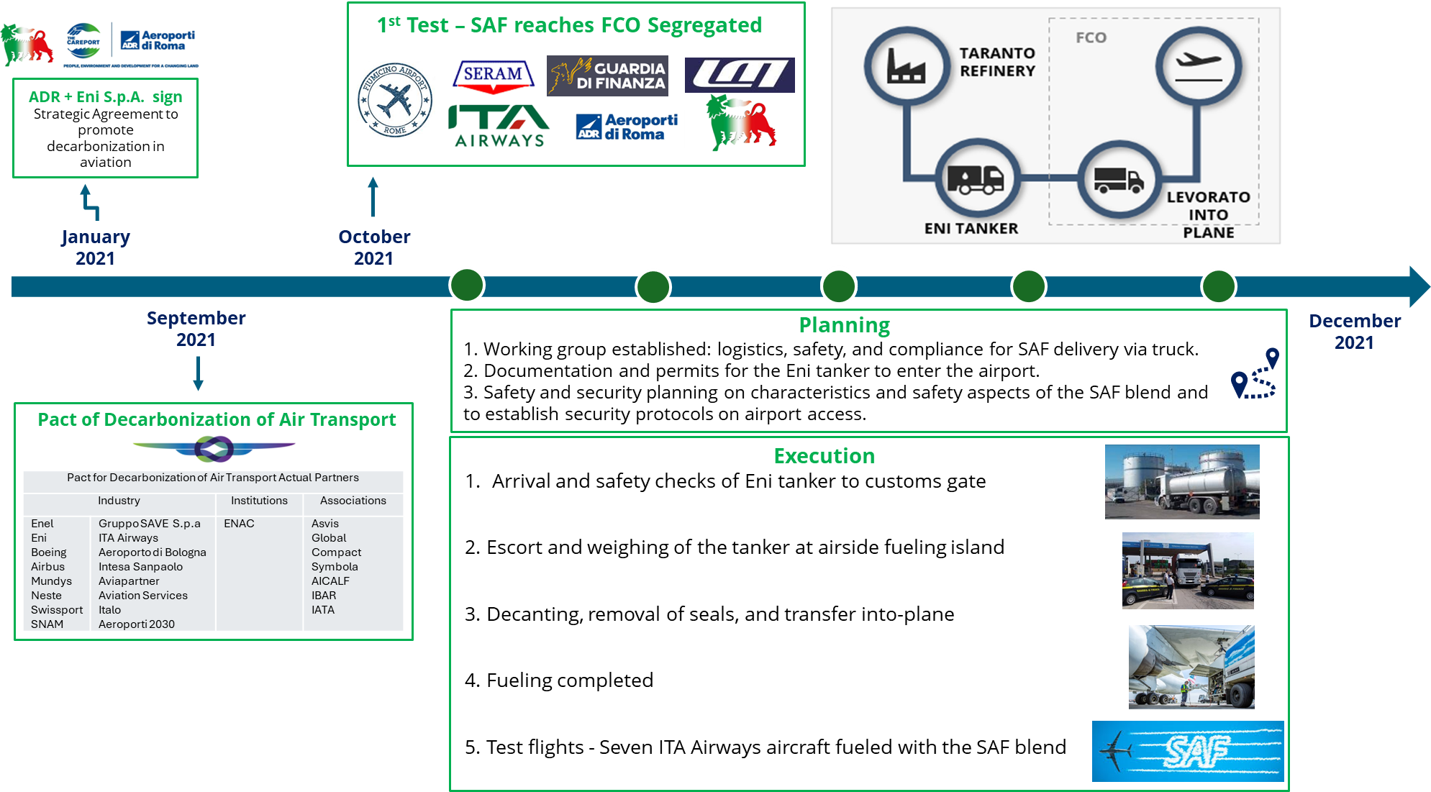

TIMELINE – 2nd TEST – SAF REACHES FCO CO-MINGLED
