The Harmonic Organization Playbook
Dedicated to The Emergence of Syntropic Communities
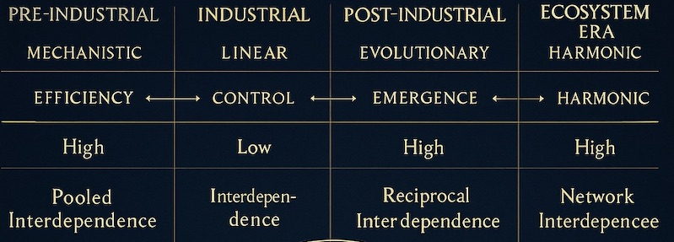
Co-created By William Malek
Harmonic Cartographer (on journey)

Table of Contents
Introduction …………………………………………………………………….…………………p6

Part I – The Shift ………………………………………………………………………….……p8
1.1 From Entropy to Syntropy
1.2 The Aquarian Paradigm
1.3 Organizations as Fields of Consciousness

Part II – Harmonic Foundations …………………………………………………….……p9
Guiding Principles
2.1 Unity as North Star
2.2 Reciprocity as Currency
2.3 Polarity as Mirror
2.4 Resonance as Culture
2.5 Rotation as Flow

Part III – The Frameworks…………………………………………………….……………p10
Harmonic Architectures
3.1 The 12-Fold: Aquarian Directives & Values
3.2 The 18-Fold: Codex Harmonic Laws
3.3 The 24-Fold: The Aquarian Tablet
The 5 Layers of Application
3.4 Individual
3.5 Team
3.6 Organization
3.7 Ecosystem
3.8 Planetary Field
The Syntropic Mandala

Part IV – Quantum Execution …………………………………………………………….p12
  - Making the 18 Harmonic Codex Laws Operable
  - Mapping Laws to Practices and Rituals
  - Table of Laws, Practices, and Tools

Part V – The Practices …………………………………………………………………….. p14
5.1 Harmonic Governance
5.2 Harmonic Economy — Contribution Ledger
5.3 Governance by Coherence
5.4 Harmonic Culture
5.5 Rituals, Story, and Fractal Scaling

Part VI – The Playbook in Action ……………………………………………………….p16
- Diagnostics: Seeing the Field
6.1 Entropy vs. Syntropy Map
6.2 Mandala Mapping
6.3 Resonance Metrics
  - Interventions: Activating Coherence
6.4 Governance Reset
6.5 Cultural Rituals
6.6 Resonance Economy Pilots
6.7 Ecosystem Partnerships
  - Fractal Scaling
6.8 Case Study Patterns (RenDanHeYi, Teal, Ecovillages)
6.9 Scaling Mandala Workshops

Part VII – The Call ………………………………………………………………….………p18
Becoming a Node of Coherence
The Responsibility of Leadership
The Invitation

Closing ………………………………………………………………………………………..p20
- Remembering Harmonic Resonance
Appendix …………………………………………………………………………………………p21
- Glossary of Codex Terms

🌌 Harmonic Organization Playbook Enhanced (HOPE v 1.0)

Introduction
Organizations across history have been designed for control, efficiency, and survival. This Playbook presents a distinct archetype: the syntropic, resonance-led organization — one where coherence supersedes control, contribution supersedes extraction, and harmonic principles guide culture, governance, and evolution.

Part I – The Quantum Shift

From Entropy to Syntropy
For over a century, organizations have been designed around the logic of entropy. Their structures mirrored the industrial machine: rigid hierarchies, linear plans, extraction as fuel. These organizations consumed more than they regenerated. They prized competition over collaboration, efficiency over coherence, growth over balance. The result has been quite predictable: fragmentation of culture, depletion of trust, exhaustion of people and planet alike.
Entropy in physics is the drift toward disorder. In organizational life, it manifests as fatigue, fragmentation, and disconnection — teams siloed, energy consumed without renewal, cultures growing noisier the harder we push. Like machines burning fuel, legacy organizations eventually wear themselves out. Yet just as forests breathe new life after fire, nature reveals a counter-pull: syntropy, the quiet evolution toward harmony and coherence.
The opposite of entropy, syntropy describes the tendency of living systems to evolve toward harmony, coherence, and higher order. A forest regenerates after fire. A coral reef flourishes through symbiosis. Human communities thrive when trust, reciprocity, and purpose align. Life itself is a syntropic process — coherence emerging from apparent chaos.
The organizations that will thrive in the Age of Aquarius are those that embody syntropy. These are Harmonic Organizations: living systems that regenerate through resonance. They are not powered by control but by coherence. Not sustained by extraction but by contribution. Not defined by rigid hierarchy but by fractal sovereignty. They tune themselves like instruments, always adjusting to stay in harmony with the greater field.

The Aquarian Paradigm
The shift we collectively face is not incremental; it is civilizational. The Age of Aquarius signals a new organizing principle for humanity — one that privileges networks over pyramids, resonance over force, transparency over secrecy, and planetary service over narrow self-interest. In this paradigm, organizations are not machines but fields of consciousness. Their true value is measured not by quarterly earnings but by their contribution to coherence across the five layers: individual, team, organization, ecosystem, and planetary field.
The Aquarian paradigm calls us to remember what ancient wisdom always knew: that geometry, rhythm, and harmony are the underlying order of the universe. To lead an organization in this age is to act as a conductor of coherence, not a controller of parts. It is to recognize that every decision is a ripple in a larger field, every act of service a tuning of the planetary chord.

This Playbook begins here: with the recognition that the age of entropy-based organizations is coming to an end, and the emergence of syntropic, harmonic organizations has already begun. What follows are the frameworks, practices, and tools to embody this shift — so that your organization can become not only effective, but truly harmonic: a fractal of coherence in service to the whole.

Part II: - Harmonic Foundations
Principles are the music of harmonic organizations; frameworks are the notation. Having set the tone through guiding values, we now give them form through the geometries of the 12, 18, and 24-fold harmonics. Here begins the architecture of coherence.

Guiding Principles Summarized
- Unity as North Star: One planetary purpose, cascaded fractally into domains and teams.
- Reciprocity as Currency: Contribution (time, expertise, care, creativity) replaces extraction.
- Polarity as Mirror: Tensions are honored, not suppressed — coherence emerges through mirror protocols.
- Resonance as Culture: People and teams align by frequency, not hierarchy.
- Rotation as Flow: Stewardship is temporary, transparent, and resonance-based.

Part III: – The Frameworks

The Harmonic Architectures
The Playbook rests on a set of harmonic architectures — wisdom frameworks that give organizations the geometry of coherence. They are not rigid models but living lenses that help leaders and teams align their work with universal patterns of syntropy.
- The 12-Fold – Aquarian Directives & Values
These are the practical grounds: the guiding values for the Age of Aquarius and directives that anchor individual and organizational behavior. They answer the question: How should we act, decide, and relate in alignment with harmony?
- The 18-Fold – Codex Harmonic Laws
These are the structural harmonics: laws drawn from number, geometry, and resonance. They reveal the invisible architecture of coherence that underlies both natural and organizational systems. They answer: What universal patterns govern syntropy?
- The 24-Fold – The Aquarian Tablet
This is the integrative synthesis: verses, geometry, and resonance principles that weave structure and energy into one coherent mandala. They answer: How do we unify spirit, structure, and practice into a single field of wisdom?
Together, the 12, 18, and 24 form the nested harmonics of The Aquarian Tablet. There are three lenses through which to view the same truth: practical, structural, and integrative.

The 5 Layers of Application
Principles without practice remain abstractions. The 5 Layers provide the vertical axis of application — the scales at which syntropy is lived:
- Individual – coherence in self, embodied sovereignty, resonance practices.
- Team – relational trust, polarity resolution, collective resonance.
- Organization – governance by coherence, value as contribution, fractal culture.
- Ecosystem – inter-organizational collaboration, syntropic exchange, collective service.
- Planetary / Field – anchoring coherence for humanity and Earth, alignment with the Aquarian paradigm.
Every harmonic principle (12, 18, or 24) can be applied at any of these layers. Sovereignty, for example, looks like self-leadership at the individual level, distributed authority in a team, decentralization in an organization, and mutual recognition in an ecosystem. The pattern repeats across scales.

The Syntropic Mandala
When the circles (12–18–24 harmonics) meet the vertical axis (5 layers), we arrive at the Syntropic Mandala — a complete model of harmonic organization.
- The circles give us principles of coherence.
- The vertical axis gives us scales of application.
- Together, they ensure wisdom becomes practice at every level.
This mandala serves as the guiding compass of the Playbook. It shows that syntropic organizations are not designed top-down or bottom-up, but through the meeting of harmonic principles and living practice across all layers of life.

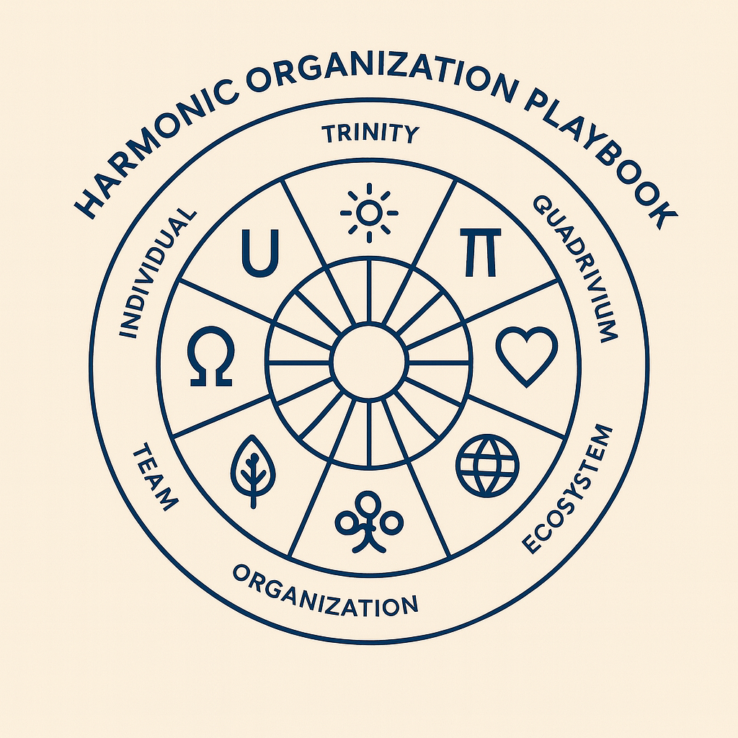

Part IV: – Quantum Execution Making the 18 Harmonic Codex Laws Operable
For each law, the Playbook specifies behaviors, artifacts, and metrics. This is not a table to be memorized but a living set of practices to be embodied. Each law finds its echo in ritual, ensuring wisdom becomes resonance in daily work.
To ensure each law is embodied, the following mapping links laws to explicit practices and rituals:
# | Codex Law | Practice | Example Ritual / Tool
1 | Unity | Purpose Cascade | Quarterly Unity Check to align Org → Team → Individual
2 | Reciprocity | Contribution Ledger | Peer-witnessed ledger entries, Reciprocity Ratio dashboard
3 | Polarity | Mirror Protocols | Polarity Loop: State Poles → Test Safe-to-Try → Review
4 | Harmonic Resonance | Resonance Staffing | Resonance Project Briefs for roles; team formation by harmonic alignment
5 | Reflection | Transparent Ops | Decision Journals; public Learning Change Log
6 | Octave | Fractal Cadence | Octave of Work rhythm: Daily–Weekly–Bi-weekly–Quarterly–Annual
7 | Rotation | Stewardship Markets | Rotating steward calls; 90-day Stewardship Theses
8 | Phi (Golden Mean) | Golden Constraints | Team size bands (3–6–9–12), sprint cycles of 13 or 21 days
9 | Pi (Cycle Law) | Closure Rituals | Completion Reviews marking end of cycles as renewal
10 | Euler’s Identity | Cross-Domain Integration | Quarterly “Equation Reviews” aligning diverse functions
11 | Light | Clarity Artifacts | Decision Maps, Quantum Execution Map, Purpose Cards, visual transparency
12 | Sound | Resonance Rituals | Listening rounds, Tone-check before difficult dialogs
13 | Consciousness | Stewardship Charter | Personal bias-check, reflection rituals for leaders
14 | Singularity | Coherence Alignment | Semi-annual Singularity Sprint for unified commitment
15 | Completion | Renewal Practices | End-of-cycle ceremonies reframing closure as higher beginning
16 | Service as Circuit | Reciprocity Rituals | Mutual-aid circles; giving/receiving audits
17 | Sovereignty-in-Connection | Autonomy in Coherence | Team-level sovereignty charters with peer recognition
18 | Spiral Time | Spiral Planning | Annual fractal strategy maps; evolutionary cycle tracking

Part V: – The Practices
If Part III gave us the geometry of coherence, Part V brings it to life through practices. These practices enable organizations to embody syntropy on a day-to-day basis. They are not techniques imported from business schools and management fads, but harmonic disciplines rooted in resonance.

Harmonic Governance
- Coherence over control: Replace command hierarchies with resonance-based governance. Authority flows to where coherence is strongest.
- Trust protocols: Embed transparent agreements, open communication, and feedback loops as the fabric of decision-making.
- Mirror logic: Every major decision is tested through polarity and reflection — what is its inverse, and how does it complete the whole?
- Rotating stewardship: Leadership rotates based on coherence, not tenure or title, ensuring adaptability and humility.

Harmonic Economy – Contribution Ledger

The Contribution Ledger recognizes all forms of value in the chain.
- Value as resonance: Value is not extracted but measured by the coherence an action brings to the field.
- Contribution as currency: Members are recognized for what they harmonize, not just what they produce.
- Service as circuit: Energy flows reciprocally — no ascent without anchoring, no giving without return.
- Resonance tokens: Introduce symbolic or practical systems that measure alignment and contribution to the whole.

Governance by Coherence

Governance Packet (1 page per decision)
- Purpose & Polarity: clearly state intent and opposing position.
- Resonance Evidence: include data and peer testimonies.
- Steward on Duty: identify the current authority figure (term & scope).
- Safe-to-Try Window: define experiment limits (timeframe, budget).
- Mirror Review: set date and coherence benchmarks.

Escalation Protocol:
- If tensions persist, consider calling a Mirror Circle — three peers from adjacent layers gather to review and reset the safe-to-try experiment.

Harmonic Culture
- Sovereignty-in-connection: Each person is whole yet contributes to the whole — autonomy without isolation.
- Rituals of coherence: Daily or weekly practices — breath, sound, silence, or rhythm — that align the field.
- Story as resonance: Narratives are curated to reinforce coherence, service, and planetary contribution.
- Fractal scaling: Culture is recursive — the same coherence is practiced at team, organization, and ecosystem levels.

These practices are not linear steps, but harmonic disciplines. They are tuned and re-tuned like instruments in an orchestra. The goal is not perfection, but coherence—the ability to maintain resonance even in the face of change.

Part VI: – The Playbook in Action
This section translates frameworks and practices into diagnostics, interventions, and real-world applications. It is where leaders learn how to assess their current state, identify points of entropy, and choose syntropic interventions that ripple across the 5 layers.

Diagnostics: Seeing the Field
- Entropy vs. Syntropy Map: Evaluate where the organization leaks energy (entropy) and where it generates coherence (syntropy).
- Quantum Execution Mapping: Use the Syntropic Mandala to map 20 key subsystems (adapted from Living Systems Theory), practices across the 5 layers. Identify gaps and strengths.
- Resonance Metrics: Move beyond financial KPIs to measure trust, contribution, coherence, and planetary alignment.

Interventions: Activating Coherence
- Governance Reset: Replace rigid decision-making with coherence circles or resonance councils.
- Cultural Rituals: Introduce practices of breath, sound, or silence that stabilize collective fields.
- Resonance Economy Pilots: Experiment with contribution-based value systems or symbolic currencies.
- Ecosystem Partnerships: Shift competition to collaboration through syntropic alliances.

Fractal Scaling
- Individual to Planetary: Every practice scales fractally — a ritual of coherence in a team can become an organizational habit, then an ecosystem-wide resonance.
- Case Patterns: Share living examples:
  - RenDanHeYi: ecosystem-level syntropy through entrepreneurial cells.
  - Teal Organizations: governance rooted in self-management and wholeness.
  - Ecovillages: syntropic living models, demonstrating planetary service.
- Scaling Quantum Execution Workshops: Train leaders and teams to apply harmonic principles iteratively at higher scales and learn the art of liminal facilitation.

Part VI closes the gap between vision and embodiment. It ensures that harmonic organizations are not aspirational metaphors but living realities, tested and tuned in practice.

Part VII: – The Call
The Playbook ends with a call to participation, service, and remembrance. Harmonic Organizations are not abstract ideals; they are already here, emerging wherever coherence is chosen over fear and contribution over extraction.

Becoming a Node of Coherence
Your organization is not only a workplace, but a resonant node in the planetary lattice. Every choice you make — how you govern, how you exchange value, how you shape culture — ripples outward into the field. To become a node of coherence is to consciously align with syntropy, to radiate resonance into the larger system.

The Responsibility of Leadership
To lead in the Aquarian paradigm is not to dominate, but to conduct. Leaders are not controllers of parts but stewards of harmony. Their true responsibility is to ensure that their organizations amplify coherence at every layer — individual, team, organizational, ecosystemic, and planetary.

The Invitation
This Playbook is a living document, not a closed system. It will continue to evolve as organizations embody and refine these principles. The invitation is to take these harmonics, apply them, and share your learning back into the field. In this way, the Playbook is not owned but co-created, a collective act of resonance. To accept this invitation is to step into remembrance — that every act of coherence is a service to the planetary field.

🌌 The Call: The Age of Aquarius is here. Entropy is no longer sufficient. The world is tuning itself toward syntropy, and every organization has a role to play. Become a harmonic node. Conduct coherence. Serve the planetary field. Let your organization be a living instrument in the song of syntropy.

Closing
This Playbook is a living document, not a closed system. It will continue to evolve as organizations embody and refine these principles. The invitation is to take these harmonics, apply them, and share your learning back into the field. In this way, the Playbook is not owned but co-created, a collective act of resonance. To accept this invitation is to step into remembrance — that every act of coherence is a service to the planetary field.
The Harmonic Organization is not a structure to adopt, but a resonance to remember. Law is stabilized resonance; coherence is the measure. By embedding the Codex’s 18 Laws, Aquarian synthesis, and practical fractal governance, organizations can shift from entropy to syntropy — contributing not only to their own thriving, but to planetary coherence.

📖 Appendix – Glossary of Codex Terms (MVP+)
- Aquarian Tablet – The 24-fold integrative framework of verses, geometry, and resonance laws.
Role: Provides a living mandala for the age of Aquarius that integrates harmonic practice, structure, and spirit.
- Codex Harmonic Laws – The 18-fold structural principles from number, geometry, and resonance.
Role: Reveal the mathematical and structural underpinnings of coherence.
- Completion – The principle that every closure is also renewal.
Role: Guides cycles of regeneration and framing of endings as higher beginnings.
- Coherence – Alignment of elements into resonance. Role: The master metric of syntropy; foundation of trust, stability, and growth. Coherence is the moment when alignment feels like ease in the body.
Role: The master metric of syntropy; foundation of trust, stability, and growth.
- Directives & Values – The 12-fold practical values.
Role: Anchor behavior, decision-making, and culture in harmony.
- Fractality – Self-similar repetition across scales.
Role: Explains how the same principles apply from individual to planetary scale.
- Geometry of Thought – The Codex principle that thought collapses into form through geometry.
Role: Provides a scaffold for manifestation; links consciousness to structure.
- Governance by Coherence – Decision-making that flows from resonance, not force.
Role: Creates trust-based governance systems that self-correct.
- Harmonic Mandala – Diagram showing integration of 12, 18, 24 principles + 5 layers.
Role: Acts as a teaching and diagnostic tool for alignment.
- Mirror Logic – Testing decisions through inversion and reflection.
Role: Prevents blind spots, ensuring polarity resolution and integrity.
- Polarity – Opposites exist to complete each other.
Role: Guides conflict transformation and system balancing.
- Quasi-Primes – Structured composites that shape prime fields.
Role: Illustrate the hidden architecture of order in number theory (like dark matter in physics).
- Resonance – Alignment of vibration/frequency into coherence. Role: The engine of syntropy, basis of service and trust. When resonance is present, trust becomes audible — you can feel it in the body, like a note perfectly in tune.
Role: The engine of syntropy, basis of service and trust.
- Resonance Economy – Model of value where contribution = coherence.
Role: Reframes economic measurement from extraction to service.
- Service as Circuit – Flow stabilized by reciprocity.
Role: Ensures sustainability of giving/receiving; anchors ascent.
- Sovereignty-in-Connection – Each node is whole yet interlinked.
Role: Balances individual autonomy and collective coherence.
- Spiral Time – Cyclical, upward-scaling recurrence.
Role: Reframes strategy, cycles, and history as evolutionary spirals.
- Syntropy – Evolutionary pull toward coherence. Role: The core law of life in the Codex; the counterpoint to entropy. Syntropy is life’s hidden pull toward harmony — the invisible rhythm guiding renewal.
Role: The core law of life in the Codex; the counterpoint to entropy.
- Vesica Piscis – Sacred geometric figure of two overlapping circles.
Role: Symbolizes creative resonance, relationship, and emergence.

