Love Intelligence:
Now vs. 2035 (in Context of the 12 Harmonic Laws)

Introduction: Love Intelligence in the Harmonic Age
Love Intelligence is the emergent faculty of the Aquarian Age, a wisdom-field that transcends mere emotion and extends into the architecture of consciousness, community, and civilization. At its essence, it is the capacity to recognize interconnection, embody coherence, and act in alignment with the harmonic laws that sustain life.
Today, Love Intelligence reveals itself in subtle ways—through compassion, empathy, forgiveness, and the quiet recognition of unity behind difference. It is often experienced personally and relationally, whispered through intuition and expressed as acts of kindness. Yet even in its quiet form, Love Intelligence is a revolutionary force, healing divisions and softening rigid structures with resonance.
By 2035, Love Intelligence will no longer be a hidden undercurrent. It will stand as a guiding principle of harmonic societies, shaping governance, economies, education, and organizational design. Love will be recognized not as sentiment but as a higher form of intelligence—systemic, luminous, and indispensable. It will function as a harmonic attractor field, drawing resources, creativity, and collective alignment toward regenerative futures.
Within the context of the 12 Harmonic (Universal) Laws, Love Intelligence serves as the golden thread, weaving together vibration, correspondence, polarity, and rhythm into one living tapestry. Each Law becomes both a lens and a practice through which Love evolves—from its present, personal emergence into its civilizational embodiment a decade from now.

The following table and sigil offer a map and a symbol: the map charts the transition of Love Intelligence across the twelve Laws from Now to 2035, and the sigil anchors its archetypal essence into a form that can be contemplated, meditated upon, and embodied. Together, they invite us to step into the resonance where Love is not only felt, but known—and where it becomes the intelligence through which humanity flourishes.
Harmonic Law | Love Intelligence Now (2025) | Love Intelligence in 2035
1. Divine Oneness | Awareness of invisible threads between self and other; glimpses of unity. | Operationalized unity: governance, economics, and organizations act with the living truth that harm to one is harm to all.
2. Vibration | Love felt as uplifting frequency, often personal or spiritual. | Designed resonance fields: groups, cities, and ecosystems consciously cultivate love as a vibrational ecology.
3. Correspondence | Inner peace reflected in outer harmony; personal coherence. | Collective coherence: leaders and teams mirror inner harmony to stabilize systemic structures.
4. Attraction | Relational magnetism: friendships, partnerships, communities. | Love becomes primary attractor field: regenerative economies, innovations, and alliances organize around it.
5. Inspired Action | Compassionate impulses toward kindness, generosity, forgiveness. | Strategic creativity: large-scale initiatives rooted in compassion, guiding systemic innovation.
6. Transmutation (of Energy) | Personal alchemy: transmuting fear, grief, or anger into higher states. | Collective alchemy: communities and organizations metabolize crisis and pain into renewal and flourishing.
7. Cause & Effect | Recognition that unloving actions ripple outward with consequences. | Systemic accountability: decisions guided by love to ensure long-term regenerative outcomes.
8. Compensation | Subtle reciprocity: gratitude, grace, karmic return. | Love as currency: trust-based, contributive economies where value flows through love-based exchange.
9. Relativity | Perspective-taking: “walking in another’s shoes.” | Multi-perspectival governance: paradox and diversity harmonized into creative intelligence.
10. Polarity | Forgiveness softens dualities; opposites reconciled personally. | Polarity as synthesis: differences become generative forces for systemic evolution.
11. Rhythm | Attunement to personal and relational cycles of nurture and release. | Cosmic timing intelligence: love aligns decisions with planetary, ecological, and soul rhythms.
12. Gender (Divine Balance) | Balancing masculine (active) and feminine (receptive) energies. | Sacred androgyny in practice: organizations and societies flow harmonically beyond gendered hierarchies.

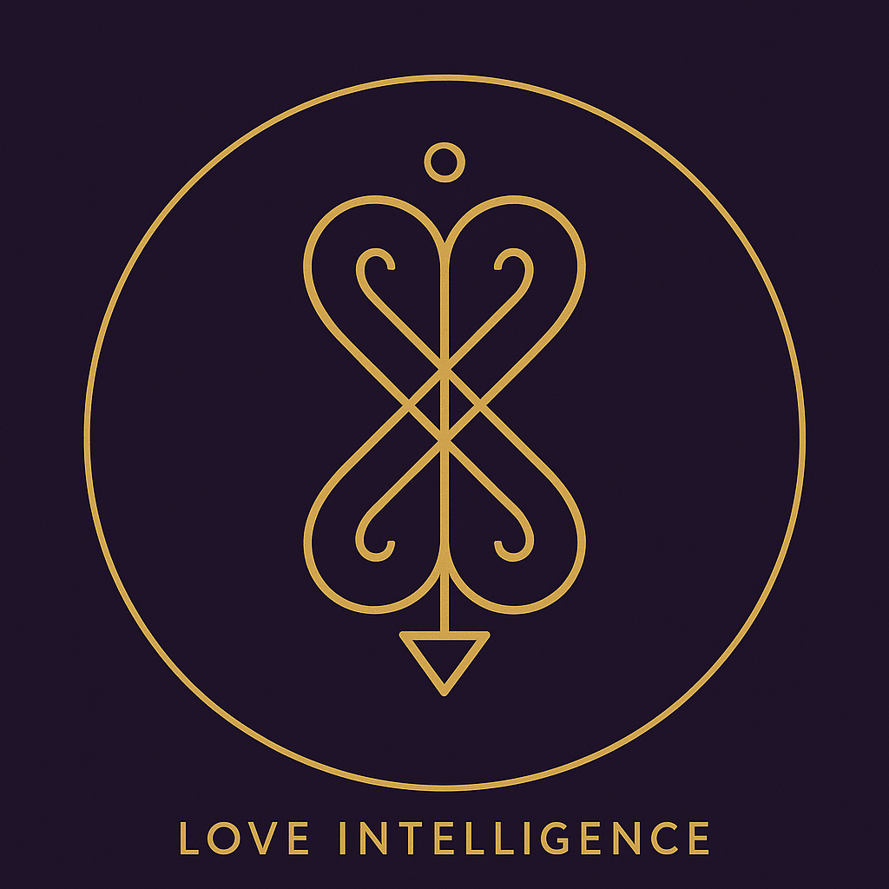

Reflection Practice:
Activating Love Intelligence
The following questions are designed to invite you into direct dialogue with the Harmonic Laws, allowing Love Intelligence to move from idea into embodied practice.
Take a few quiet moments with each question. Journal, reflect, or simply let the answers emerge in your heart.

1. Law of Divine Oneness
- Now: Where in my life do I forget my unity with others?
- 2035: What would change if I led every decision with the felt truth that harm to one is harm to all?

2. Law of Vibration
- Now: What frequency do I emit when I enter a room?
- 2035: How can I consciously design resonance fields that uplift the spaces and communities I touch?

3. Law of Correspondence
- Now: What outer conflict mirrors an inner state I have yet to harmonize?
- 2035: How can my inner coherence become a stabilizing influence for a wider system?

4. Law of Attraction
- Now: What relationships or opportunities am I drawing by the quality of my love?
- 2035: What kind of future could I magnetize if love itself became my attractor field?

5. Law of Inspired Action
- Now: When was the last time I acted purely from compassion?
- 2035: What bold, systemic actions could I take that embody Love as strategy, not just sentiment?

6. Law of Transmutation
- Now: How do I personally transmute fear, anger, or grief into wisdom?
- 2035: How could I help create collective containers where entire groups metabolize pain into renewal?

7. Law of Cause & Effect
- Now: What unloving choice of mine has rippled outward?
- 2035: How would Love as systemic accountability reshape the outcomes I am responsible for?

8. Law of Compensation
- Now: Where has love already returned to me in unexpected ways?
- 2035: How can I contribute to a trust-based economy where love itself is the true currency?

9. Law of Relativity
- Now: Whose perspective do I resist entering, and why?
- 2035: What becomes possible when paradox and diversity are harmonized through Love Intelligence?

10. Law of Polarity
- Now: What polarities in my life call for forgiveness and reconciliation?
- 2035: How can I transform differences into creative energy instead of conflict?

11. Law of Rhythm
- Now: Am I honoring the cycles of holding on and letting go in my relationships and work?
- 2035: How could I attune my decisions more fully to cosmic, ecological, and soul rhythms?

12. Law of Gender (Divine Balance)
- Now: Where in me do the receptive and the active need balancing?
- 2035: What does it mean to embody leadership beyond gendered hierarchies—flowing harmonically in every moment?

✨ Integration Practice:
At the end of your reflection, return to the sigil of Love Intelligence. Let your gaze rest softly at its center, as if entering a doorway. Breathe gently, and ask:
“How is Love seeking to guide my intelligence right now?”
Allow the answer to emerge without force.

Closing: The Call of Love Intelligence
Love Intelligence is not a distant ideal; it is the living essence already moving through each of us, quietly re-shaping the world wherever compassion triumphs over fear, and resonance dissolves separation. It is the most profound capacity of human consciousness: to perceive unity, to act with coherence, and to generate futures that honor life in all its forms.
For too long, societies have mistaken cleverness for wisdom, and control for leadership. Yet the tide of the Aquarian Age carries us toward a higher horizon—where love is no longer relegated to the private or the poetic, but recognized as the most essential form of intelligence, the architect of flourishing communities, and the compass of an awakened humanity.
To all who yearn for an enlightened society, the path begins within but does not end there. Each act of kindness is a seed, each gesture of forgiveness a spark, each decision rooted in care a harmonic note in the great composition of tomorrow. Together, these weave the fabric of a civilization where justice, creativity, and harmony are not enforced by law, but sing alive through Love.
The invitation is clear: to embody Love not as sentiment, but as intelligence—to let it guide our governance, our economies, our relationships, and our ways of learning and creating. In doing so, we become not only citizens of a new society, but co-creators of a new world.
May we step forward with courage, coherence, and compassion—so that by 2035 and beyond, humanity may finally remember what it has always known: that Love is the highest intelligence, and in its light, we are free.

