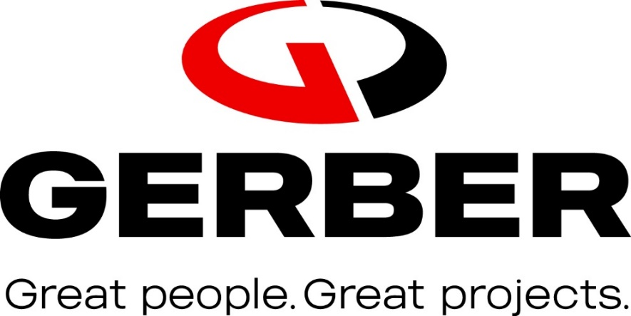

Hazard Communication Program

Gerber Construction

815 East 675 South

Lehi, UT 84043

Jason Woffinden

President

Debi Moore

Health & Safety Manager

Hazard Communication Program Manager
- Introduction

The leadership of Gerber Construction is committed to preventing incidents and ensuring the safety and health of our employees. We will comply with all applicable federal and state health and safety rules. Under this program employees are informed of the contents of the OSHA Hazard Communication Standard 29 CFR 1910.1200, the hazardous properties of chemicals with which they work, safe handling procedures and measures to take to protect themselves from these chemicals. These chemical hazards may be physical or health-related. This written hazard communication program is available at the following location for review by all employees: Gerber Construction Main Office, 815 East 675 South, Lehi, UT 84043.

Identifying Hazardous Chemicals

A chemical inventory is attached to this plan that identifies all hazardous chemicals with a potential for employee exposure at this workplace. Detailed information about the physical, health, and other hazards of each chemical is included in a Safety Data Sheet (SDS); the product identifier for each chemical on the list matches and can be easily cross-referenced with the product identifier on its label and on its Safety Data Sheet.

Identifying Containers of Hazardous Chemicals

The labeling system to be used by Gerber Construction will follow the requirements in the 2012 revision of the OSHA Hazard Communication Standard to be consistent with the United Nations Globally Harmonized System (GHS) of Classification of Labeling of Chemicals. The label on the chemical is intended to convey information about the hazards posed by the chemical through standardized label elements, including symbols, signal words and hazard statements.
All hazardous chemical containers used at this workplace will have:

  - The original manufacturer’s label that includes a product identifier, an appropriate signal word, hazard statement(s), pictogram(s), precautionary statement(s) and the name, address, and telephone number of the chemical manufacturer, importer, or other responsible party, or
  - An alternate label with the appropriate label elements just described above, or

  - Workplace labeling that includes the product identifier and words, pictures, symbols, or combination that provides at least general information regarding the hazards of the chemicals.

The Gerber Construction Health & Safety Manager will ensure that all containers are appropriately labeled. No container will be released for use until this information is verified. Workplace labels must be legible and in English. Information in other languages is available at: Health & Safety Office, Gerber Construction Main Office, 815 East 675 South, Lehi, UT 84043.

Small quantities intended for immediate use may be placed in a container without a detailed label, provided that the individual keeps it in their possession at all times and the product is used up during the work shift or properly disposed of at the end of the work day. However, the container shall be marked with the identity of its contents.

Safety Data Sheets

The manufacturer or importer of a chemical is required by OSHA to develop a Safety Data Sheet (SDS) that contains specific, detailed information about the chemical’s hazard using a specified format. The distributor or supplier of the chemical is required to provide this SDS to the purchaser.
SDS’s are readily available to all Gerber employees at any time during their work shifts. Safety Data Sheets are available in hard copy at the Health & Safety Office, Gerber Construction Main Office, 815 East 675 South, Lehi, UT 84043. SDSs are also provided at all long-term project sites when those employees do not regularly report to the Lehi Main Office. In addition, SDSs will be available online through Gerber’s Tyfoom App in the Documents folder.
The SDSs are updated and managed by the Gerber Construction Health & Safety Manager. If an SDS is not immediately available for a hazardous chemical, employees can obtain the required information by calling the Gerber Construction Health & Safety Manager or by calling CHEMTREC at 1-800-424-9300.

Training

Before they start their jobs or are exposed to new hazardous chemicals, employees must attend a hazard communication training course that covers the following topics:
- An overview of the requirements in OSHA’s Hazard Communication Standard.
- Hazardous chemicals present in their workplace.
- Any operations in their work area where hazardous chemicals are used.
- The location of the written hazard communication plan and where it may be reviewed.
- How to understand and use the information on labels and in Safety Data Sheets.
- Physical and health hazards of the chemicals in their work areas.
- Methods used to detect the presence or release of hazardous chemicals in the work area.
- Steps Gerber Construction has taken to prevent or reduce exposure to these chemicals.
- How employees can protect themselves from exposure to these hazardous chemicals through use of elimination, substitution, engineering controls, administrative controls, and personal protective equipment.
- An explanation of any special labeling present in the workplace.
- Emergency procedures to follow if an employee is exposed to these chemicals.

The Gerber Construction Health & Safety Manager is responsible to ensure that employees receive this training. After attending the training, employees will sign a form verifying that they understand the above topics and how the topics are related to the Gerber Construction Hazard Communication Program.
Prior to introducing a new chemical hazard into any division, group, crew, or project, each employee in that category will be given information and training as outlined above for the new chemical hazard.

Informing Employees who do Special Tasks

Before employees perform special (non-routine) tasks that may expose them to hazardous chemicals, their supervisors will inform them about the chemicals’ hazards. Their supervisors also will inform them about how to control exposure and what to do in an emergency. The employer will evaluate the hazards of these tasks and provide appropriate controls including Personal Protective Equipment and all additional training as required.
Examples of special tasks that may expose employees to hazardous chemicals include the following: cleaning/disinfecting interior surfaces of large above ground water storage tanks.

Informing contractors and other employers about hazardous chemicals present on Gerber work sites

If employees of other employers may be exposed to hazardous chemicals at Gerber’s workplace (for example, employees of a construction subcontractor working on-site), it is the responsibility of the Gerber Construction Health & Safety Manager to provide employers and their employees with the following information:
- The identity of the chemicals, how to review Gerber’s Safety Data Sheets, and an explanation of the container labeling system.
- The control methods in place designed to prevent exposure.

The Gerber Health & Safety Manager will also obtain a Safety Data Sheet for any hazardous chemical another employer brings into the workplace.

8. Program Review and Updates

The Hazard Communication Program will undergo a formal review annually, including Safety Data Sheet currency, labeling systems in use, chemical inventory accuracy, training curriculum design, and training documentation.

Any updates to Safety Data Sheets, container labeling requirements, chemical inventory, etc. will be performed as the new information becomes available.

The annual review and periodic updates are the responsibility of the Gerber Health & Safety Manager.

