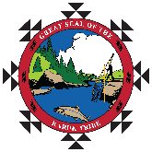
For Immediate Release: June 5, 2026

Karuk Tribal Council Presents $100,000 Check in Support of Fairchild Medical Center Expansion Project

Yreka, CA. With a shared commitment to strengthening healthcare in Siskiyou County, representatives from the Karuk Tribe recently presented a check for $100,000 to Fairchild Medical Center (FMC), marking a major milestone in the FMC Expansion Project. “Fairchild provides essential services to our Tribal Membership and communities,” said Chairman Russell “Buster” Attebery. “We are proud to support their important work through this donation, which reflects our ongoing commitment to the health and well-being of our people and our region.” The donation will directly support FMC’s expansion efforts, which aim to increase access to care, modernize facilities, and enhance services for patients across the region. As healthcare needs continue to grow, projects like this ensure that residents can receive critical care close to home. “This contribution reflects the Karuk Tribe’s deep commitment to the health of our community,” said Jonathon Andrus, FMC President and CEO “Their support helps us move forward with essential improvements that will benefit patients for years to come.” For the Karuk Tribe, the donation represents an investment in people as much as infrastructure. Tribal leadership emphasized the importance of accessible, high-quality healthcare for both tribal members and the broader community. Moments like the one captured in the photo highlight the spirit of collaboration that drives the FMC Expansion Project forward. Together, regional partners are working to build a stronger, healthier future—one that ensures quality care remains within reach for all. The project continues to gain momentum, with community support playing a vital role in bringing the vision to life. Captured in the accompanying photos, tribal leaders and FMC representatives stand together holding the oversized check—symbolizing not only a generous financial contribution but also a powerful partnership rooted in community well-being.
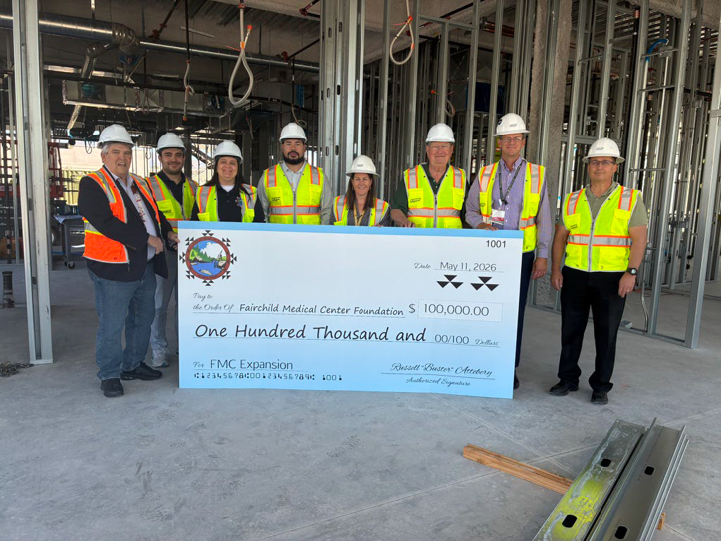Pictured: Russell “Buster” Attebery, Chairman, Tyvin Whittaker, Economic Developer, Jennifer Goodwin, Member-at-Large, Eli Hensher-Aubrey, Karuk Tribe CEO, Claire Anstead, FMC Foundation Executive Director, Larry Mulloy, Past FMC Chairman, Jonathon Andrus, FMC President & CEO, and Tres Churchill, FMC Chairman

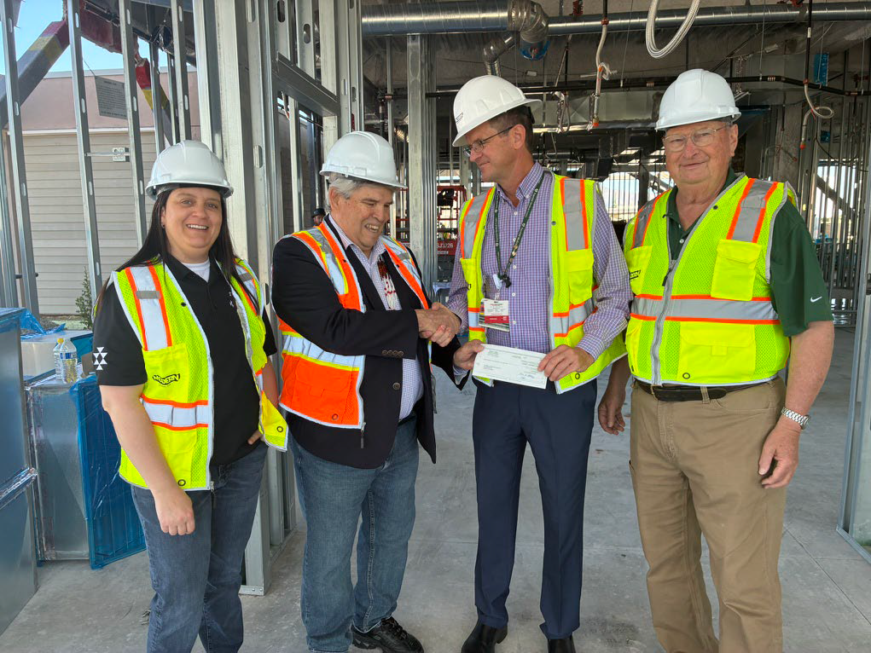
Pictured: Jennifer Goodwin, Member-at-Large, Russell “Buster” Attebery, Chairman, Jonathon Andrus, FMC President & CEO, and Larry Mulloy, FMC Past Chairman

