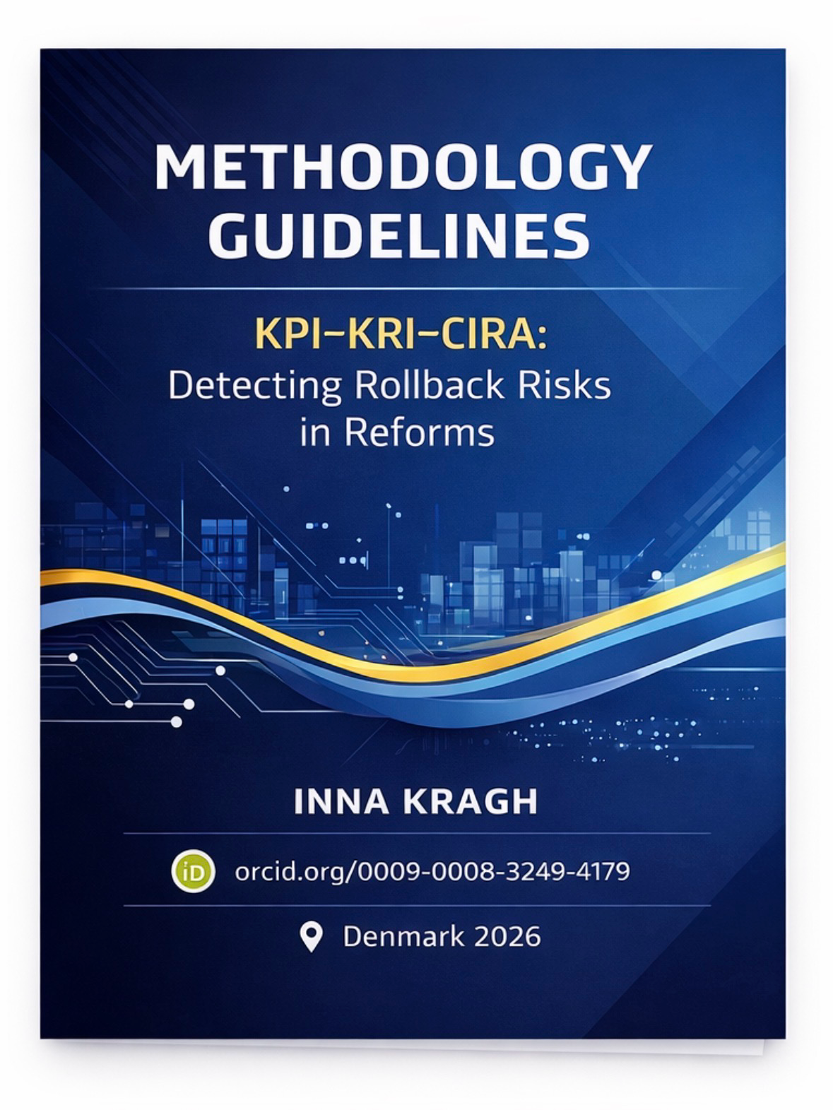

Catalog
Chapter 1: 2
Methodology / Indicators Framework 2
KRAGH KPI ( English translation) 2
Chapter 2: 8
Methodology / Indicators Framework 8
KRAGH KPI — Detailed Indicator Breakdown 8
1.0 — clear criteria + mandatory reasoning 12
1.0 — standards + pilot / live integration 17
CHAPTER 3: 20
Institutional Traceability Matrix and Automatic Rollback Mechanisms in the KRAGH KPI - CIRA System 21
Integrity Trigger: 22
CHAPTER 4: 26
KRAGH KPI — Anti-Corruption Authority 26
1.0 — clear criteria + mandatory reasoning 29
KRAGH KPI for the Judicial System 31
(Master-level, fully self-contained Methodology / Case Study block: Courts) 31
KRAGH KPI — Judicial System 31
KRAGH KRP — 32
Rollback Risk для судової системи 32
General Conclusion / Methodological Reflection 34

Chapter 1:

Methodology / Indicators Framework

KRAGH KPI ( English translation)

1) What is KRAGH KPI
KRACH KPI is a computational methodology for measuring the gap between legal norms and actual execution (normative–operational–computational–audit gap) in institutional systems. The KPI is constructed as an aggregated maturity/compliance index based on indicators, evidence, and a system of weights. The result is a numerically measurable compliance profile and set of failure points, suitable for comparative analysis and for transition to a risk model (KRP / rollback - формули відкату) до CIRA.
KRAGH KPI - KRAGH KRP / rollback + CIRA
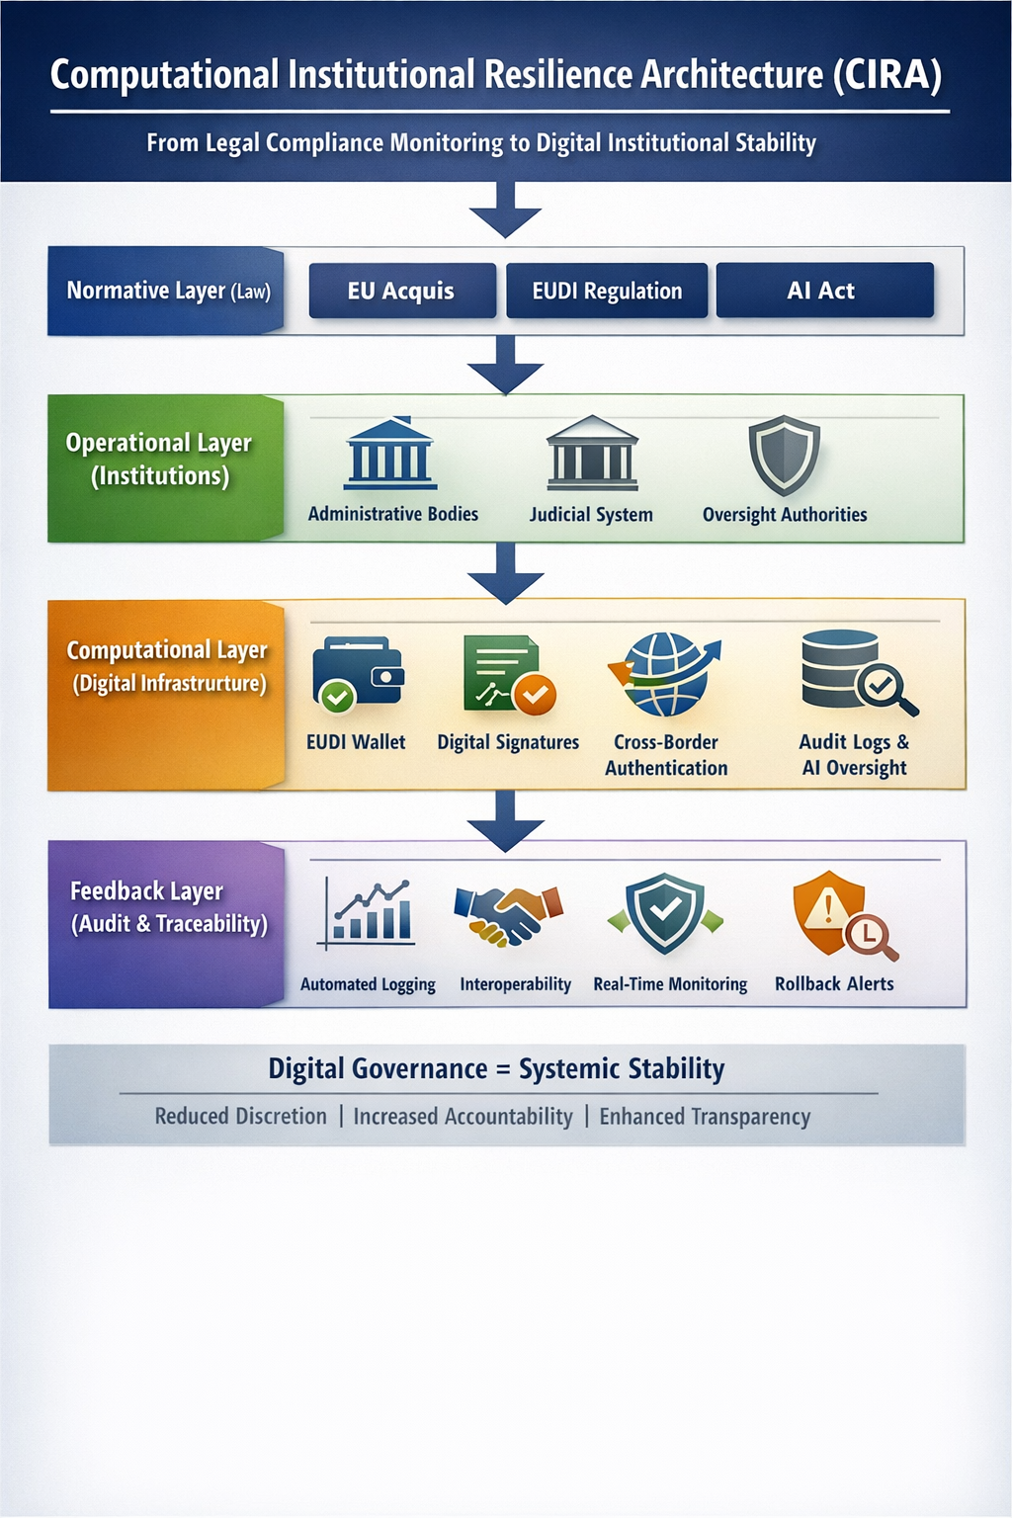

2) Unit of analysis: what exactly is measured
Define the object (u). It must be unambiguously measurable:
an institution (e.g., an anti-corruption authority),
a procedure (e.g., procurement + e-sign),
a digital service (EUDI onboarding),
a reform module (judicial integrity + oversight).

3) Model layers (CIRA-compatible)
The KPI is calculated across four layers (L):
N (Normative) — legal norms, obligations, legal requirements
O (Operational) — processes, institutions, human execution
C (Computational) — digital infrastructure and technical controls
F (Feedback) — audit, traceability, monitoring, rollback

4) Indicators and scales
For each layer (L), a set of indicators (i = 1..m_L) is defined.
Each indicator must include:
- description,
- source of evidence,
- calculation rule.

4.1 Indicator normalization in [0,1]
Each indicator is transformed into a numerical value:
[
x_{u,L,i}\in[0,1]
]
Typical rules:
Binary:
[
x=\begin{cases}
1,& \text{if the condition is fulfilled}\
0,& \text{otherwise}
\end{cases}
]
Ratio:
[
x = \min\left(1,\frac{\text{observed}}{\text{target}}\right)
]
Penalty for delay:
[
x=\exp(-\lambda\cdot d)
]

5) Evidence coefficient
An evidence confidence coefficient is introduced:
[
c_{u,L,i}\in[0,1]
]
Weighted indicator value:
[
\tilde{x}{u,L,i}=c{u,L,i}\cdot x_{u,L,i}
]

6) Weights
Indicator weights:
[
\sum_{i=1}^{m_L} w_{L,i}=1
]
Layer weights:
[
\sum_{L\in{N,O,C,F}}\alpha_L = 1
]
Baseline:
[
\alpha_N=0.20,;
\alpha_O=0.25,;
\alpha_C=0.30,;
\alpha_F=0.25
]

7) KPI calculation
Layer score:
[
S_{u,L}=\sum_{i} w_{L,i}\cdot \tilde{x}_{u,L,i}
]
Overall KPI:
[
KPI_u=\sum_L \alpha_L\cdot S_{u,L}
]

8) Gap logic
[
KPI_u^{(p)}=\left(\sum_L \alpha_L\cdot S_{u,L}^{p}\right)^{1/p}
]
[
G_u=1-KPI_u^{(p)}
]

9) KPI profile
[
(S_{u,N}, S_{u,O}, S_{u,C}, S_{u,F})
]

10) Indicator starter pack
- N (Normative)
- Coverage of obligations
- Procedural safeguards defined
- Clarity / low discretion
O (Operational)
SOP implemented + used
Oversight effectiveness
Remedies / appeals working in practice
C (Computational)
Strong auth / EUDI readiness
Digital signatures adoption
Cross-border interoperability
F (Feedback)
Audit log coverage
Real-time monitoring
Traceability + evidentiary chain
Rollback policy readiness

11) Transition to KRP and CIRA
KPI → maturity and gap
KRP → rollback probability
CIRA → operational resilience architecture

Chapter 2:

Methodology / Indicators Framework

KRAGH KPI — Detailed Indicator Breakdown

General Logic (to keep the reader oriented)
Each indicator is described using the same structure:
- What it measures
- Why it matters (link to rule of law / anti-corruption)
- Evidence (data sources)
- How it is normalized to 0..1
- Typical errors / risks of manipulation
- Mini-example (anti-corruption authority / courts)

LAYER N — Normative

N1) Coverage of obligations
What it measures:
The extent to which legal and regulatory frameworks comprehensively establish the obligations required to ensure the proper functioning of the institution (e.g., independence, powers, procedural transparency).
Why it matters:
A common reform failure occurs when an institution is formally established, but its legal mandate is fragmented or incomplete (missing powers, procedures, or safeguards).
Evidence:
laws governing the relevant authority or court (framework law and amendments),
secondary legislation (regulations, procedural rules),
obligations derived from EU acquis and international standards (used as a “requirements checklist”).
Normalization (example):
A checklist of (k) obligations is constructed (e.g., 20 requirements related to independence and procedures):
[
x=\frac{#\text{fulfilled requirements}}{k}
]
The value is capped within the 0..1 range.
Risks of manipulation:
A provision may be formally included in law but lack any enforcement mechanism (this gap is captured at the Operational and Feedback layers).
Mini-example (anti-corruption authority):
A law guarantees independence, but no clear procedure exists for appointment or dismissal of the leadership → coverage is not 1.0 but, for instance, 0.75.

N2) Procedural safeguards defined
What it measures:
Whether clear procedural safeguards are legally established, including parties’ rights, deadlines, reasoning of decisions, appeal mechanisms, and standards of proof.
Why it matters:
The rule of law is not about “well-written laws” but about due process and protection against arbitrariness.
Evidence:
Procedural codes, internal regulations, procedural guidelines, and judicial practice concerning annulments due to procedural violations.
Normalization:
A set of 10–15 mandatory safeguard elements is defined, and the proportion of clearly regulated elements is calculated:
[
x=\frac{#\text{elements with clear regulation}}{k}
]
Penalties may be applied for the absence of critical elements (e.g., right to appeal or obligation to provide reasoning).
Mini-example (courts):
If there are no formal requirements for decision reasoning or publicity, the indicator score decreases significantly.

N3) Clarity / low discretion
What it measures:
The extent to which legal norms reduce discretionary decision-making by establishing clear criteria (e.g., eligibility rules, conflict-of-interest standards, decision-making benchmarks).
Why it matters:
Corruption frequently emerges in “grey zones” created by vague or undefined criteria.
Evidence:
Legal texts, official interpretative guidelines, existence of closed lists of grounds, and judicial annulments based on findings of arbitrariness.
Normalization (practical approach):
The presence of objective criteria is assessed for key decision types (appointments, disciplinary actions, case allocation, access to data).
Scoring system:

1.0 — clear criteria + mandatory reasoning
0.5 — partially defined criteria
0.0 — “at discretion” with no objective criteria
The final score is averaged across decision categories.
Mini-example (anti-corruption):
Disciplinary decisions taken without predefined criteria indicate a high level of discretion.

LAYER O — Operational

O1) SOP implemented and used
What it measures:
Not merely the existence of procedures, but their actual operational application.
Why it matters:
“Paper reforms” occur when SOPs exist formally, but decisions are taken manually or informally.
Evidence:
internal orders and instructions,
case management logs,
sampled decisions demonstrating compliance with SOP steps,
staff interviews or surveys (used as supplementary evidence with lower confidence).
Normalization:
A sample of (n) cases is selected. For each case, the proportion of mandatory SOP steps actually performed is calculated:
[
x=\frac{1}{n}\sum_{j=1}^{n}\frac{#\text{completed steps in case }j}{#\text{mandatory steps}}
]
Mini-example (anti-corruption authority):
If SOPs require conflict-of-interest checks, but 40% of cases lack any record of such checks → (x \approx 0.6).

O2) Oversight effectiveness
What it measures:
Whether internal and/or external oversight mechanisms function effectively by detecting violations, applying measures, publishing reports, and ensuring implementation of recommendations.
Why it matters:
Without oversight, institutional systems do not self-correct.
Evidence:
Oversight reports, inspection outcomes, number and type of sanctions, implementation rates of recommendations, and public reporting practices.
Normalization (composite example):
(a) — existence of regular inspections (0/1),
(b) — proportion of recommendations implemented (0..1),
(c) — publication of results (0/1).
[
x=0.3a+0.5b+0.2c
]
Mini-example (courts):
A judicial council exists, but its recommendations are not implemented → low indicator score.

O3) Remedies / appeals working in practice
What it measures:
The availability and effectiveness of remedies and appeals, including timelines, accessibility, success rates, and execution of appeal decisions.
Why it matters:
This indicator functions as a core safeguard of the rule of law.
Evidence:
Appeal statistics, appellate decisions, duration of proceedings, and enforcement data.
Normalization:
[
x = 0.5\cdot \text{on-time rate} + 0.5\cdot \text{execution rate}
]
Mini-example (anti-corruption authority):
An appeal is upheld, but the resulting decision is not enforced → execution rate drops → the indicator score decreases.

LAYER C — Computational

C1) Strong authentication / EUDI readiness
What it measures:
The existence of strong identity management and controlled access mechanisms determining who performs actions and on what legal basis.
Why it matters:
Without strong authentication, legally reliable traceability is impossible (any “admin” effectively becomes sovereign).
Evidence:
IAM/SSO systems, MFA, access control policies, authentication logs, EUDI integration plans, pilots, and system architecture.
Normalization:
1.0 — MFA + role-based access + login logging + access policies
0.7 — MFA present, but roles/logs incomplete
0.4 — password-based access with weak controls
0.0 — shared accounts
Mini-example:
An anti-corruption case database without login logging → 0.4.

C2) Digital signatures adoption
What it measures:
The use of electronic signatures in legally significant actions: decisions, acts, requests, and sanctions.
Why it matters:
A digital signature creates a legally binding link between a decision and its author.
Evidence:
E-signature systems, signed document registries, signature procedures, and the share of electronic document workflows.
Normalization:
[
x=\frac{#\text{documents signed electronically}}{#\text{all key documents}}
]
Mini-example (courts):
Decisions are published, but lack digital signatures or metadata → weak evidentiary value.

C3) Cross-border interoperability
What it measures:
The ability to recognize and exchange data, identities, and trust services, particularly relevant for EU members and candidate countries.
Why it matters:
European integration is not about internal formal compliance, but about interoperability within the EU legal and digital space.
Evidence:
Compatibility with eIDAS approaches, interfaces and standards, pilots, APIs, and technical documentation.
Normalization (simplified):

1.0 — standards + pilot / live integration
0.6 — standards or plans exist, no integration
0.3 — conceptual stage without standardization
0.0 — absent
Mini-example:
An EUDI concept exists, but no pilot has been launched → 0.6.

LAYER F — Feedback

F1) Audit log coverage
What it measures:
The proportion of critical events that are actually logged and available for audit.
Why it matters:
“No logs = no state.”
Evidence:
Audit log schemas, storage systems, sample logs, retention policies, and event samples.
Normalization:
[
x=\frac{#\text{critical events with logs}}{#\text{total critical events}}
]
Mini-example:
If 70% of decisions are logged → 0.7.

F2) Real-time monitoring
What it measures:
The existence of real-time monitoring for anomalies (spikes in rejections, mass changes, suspicious actions).
Why it matters:
Without monitoring, rollback always occurs “after the fire.”
Evidence:
Alerts, dashboards, response SOPs, and incident logs.

F3) Traceability and evidentiary chain
What it measures:
The ability to reconstruct “who did what, when, and on what legal basis,” including documents, access rights, and data versions.
Evidence:
Links between decision ID → user ID → legal basis → dataset version → signature → timestamp.
Normalization:
[
x=\frac{#\text{cases with a complete evidentiary chain}}{#\text{cases in the sample}}
]

F4) Rollback policy readiness
What it measures:
The existence of a formalized rollback mechanism to the last legitimate state, both legally and technically.
Evidence:
Rollback policies, trigger criteria, review procedures, state recovery mechanisms, and immutable logs.
Normalization:
1.0 — defined trigger + procedure + technical capability + audit trail
0.7 — procedure exists, technical implementation partial
0.4 — conceptual stage
0.0 — absent
Mini-example:
A decision can be annulled, but the evidentiary chain cannot be proven → maximum score 0.4–0.7.

Closing the chapter (transition to KRP and CIRA)
After calculating:
[
S_{u,N}, S_{u,O}, S_{u,C}, S_{u,F} \rightarrow KPI_u \rightarrow G_u
]
the analysis concludes that:
- the gap identifies structural weaknesses,
- feedback and rollback constitute the critical layer of institutional resilience,
- the next step is the construction of Rollback Risk (KRP) and the CIRA architectural framework.

CHAPTER 3:

Institutional Traceability Matrix and Automatic Rollback Mechanisms in the KRAGH KPI - CIRA System
To bridge the gap between normative design and operational reality, the concept of the "Chain of Institutional Evidence" is introduced. This concept allows for the transformation of abstract Rule of Law principles into verified digital facts.

1. KRAGH Layer Alignment Matrix (Evidence-Based Logic)
This matrix demonstrates the vertical integration of the model: from the legislative norm (N) through the operational step (O) and technical implementation (C) to the irrefutable audit evidence (F).
Legal Requirement (Normative - N) | Procedural Step (Operational - O) | Digital Trace (Computational - C) | Audit Evidence (Feedback - F)
Independence and Impartiality of Case Allocation | Automated assignment of a judge or inspector without the possibility of subjective interference. | System log of the randomization algorithm, recording input parameters and selection metadata. | Queue Hash Code: A cryptographic proof of the sequence's immutability over time.
Guarantee of the Right to Defense (Proper Notification) | Timely and verified notification of parties regarding the date and time of procedural actions. | RFC 3161 Time-stamp: A digital time-stamp of data transmission to the user’s system/app. | E-delivery confirmation: A legally significant delivery receipt from the server signed with a QES.
Immutability and Publicity of Judicial Decisions | Recording the final version of the decision and its signing by an authorized official. | Qualified Electronic Signature (QES) of the judge, applied directly to the document. | Transaction record of the decision registration in a distributed ledger (Immutable Ledger).
Transparency and Accountability of Authority | Verification of the absence of conflict of interest through automated registry queries. | Role-Based Access Control (RBAC), logging of API requests to external databases. | Audit Trail report: A full trajectory of data access requests preceding the decision.

2. Automatic Rollback Trigger Mechanisms
Within the CIRA architecture, the Rollback mechanism (reverting the system to the last legitimate state) is initiated automatically upon the detection of a critical Gap between layers. This ensures system resilience against illegitimate manipulations.

2.1. Algorithmic Anomaly Identification

Integrity Trigger:
Condition: Hash(Current_State) != Hash(Stored_Audit_Record).
Description: If the Hash code of the current case state (e.g., case allocation queue) does not match the cryptographic imprint in the Feedback layer, the system identifies this as unauthorized interference.
Consequence: Automatic blocking of the operation and initiation of a full evidence chain verification.
Authenticity Trigger:
Condition: Execution of an operation in the (O) layer without a valid Qualified Electronic Signature (QES) in the (C) layer.
Description: If a decision is uploaded to the system, but the metadata lacks the judge’s QES or a trusted center’s time-stamp.
Consequence: The decision automatically acquires a "Non-evidentiary" status, rendering it invalid for further execution until the anomaly is corrected.
Traceability Trigger:
Condition: Audit_Log_Coverage < 100% for a critical business process.
Description: Detection of steps in a procedure that are not accompanied by a digital trace (e.g., manual change of case status without registering the reason).
Consequence: The system generates a signal of high Fragility, increasing the KRP risk index and requiring administrative intervention or automatic cancellation of the action.

3. Methodological Conclusion
The integration of this matrix and trigger mechanisms enables the realization of the "Compliance by Design" concept. In this model, the Rule of Law is maintained not only through external oversight but through an internal architectural inability to perform an illegitimate action without leaving a destructive trace.
Mathematical discrepancy between the digital trace (C) and audit evidence (F) becomes an objective impulse for a protective Rollback. This minimizes the "human factor" and guarantees that any institutional outcome is derived from a transparent, traceable, and legally flawless process.

Final Components of the KRAGH Methodology
These components close the cycle from mathematical risk calculation to practical mitigation through the CIRA architecture and legislative changes.

1. Trigger Sensitivity: Response Levels and Thresholds
The system should not cease operation due to every minor technical error. We implement a three-tier trigger sensitivity model where the response depends on the critical impact on the evidentiary chain.
Risk Level | Event (Trigger) | System Action | Impact on KPI/KRP
Critical (L3) | Violation of log integrity, absence of QES on a decision, manipulation of the allocation algorithm. | Instant Rollback: Automatic cancellation of the transaction, access blocking, and alert to the oversight body. | $P_{rollback} \to 1.0$(Irreversible).
Medium (L2) | Violation of deadlines (SOP), absence of e-delivery confirmation despite successful transmission. | Warning and Blocking of Next Step: The system allows data saving but prevents process finalization. | Increase in $G_u$ (Gap) and Fragility.
Low (L1) | Technical synchronization failures, login without MFA from a trusted IP, metadata errors. | Incident Registration: Only a system warning and entry into the audit log without process interruption. | Decrease in Confidence ($c_{u,L,i}$).

2. CIRA Architecture: Data Flows through Model Layers
The CIRA (Computational Institutional Resilience Architecture) ensures data flows such that every step of the operational layer is inextricably linked to digital and audit evidence.
Data Flow Mechanics:
Normative (N): Loading "Smart Rules" (discretion criteria, deadlines, mandates).
Operational (O): Execution of an action by a user (e.g., filing a lawsuit or issuing an order).
Computational (C): The system automatically applies a time-stamp, verifies access rights via EUDI, and validates the QES.
Feedback (F): Generation of the operation’s Hash code and entry into the Immutable Ledger. If data at this stage contradicts the rules from layer (N), a Rollback is triggered.

3. Policy Recommendations: Implementation into Legislation
To legalize the KRAGH-CIRA model, amendments must be made to procedural codes (Civil, Commercial, Criminal) and laws regulating anti-corruption bodies.
Key Proposals:
Principle of "Technological Legitimacy": Establish a norm stating that a procedural action is considered performed only if a corresponding entry exists in the automated logging system with a verified time-stamp.
Legalization of Automatic Rollback (Procedural Rollback): Define the detection of a system data integrity error (Integrity Trigger) as an absolute ground for decision review or the automatic return of the process to the stage preceding the failure.
Status of "Hash Evidence": Grant cryptographic hash codes of audit logs the status of primary evidence when verifying procedural compliance (e.g., when challenging case allocation results).
Mandatory EUDI/Strong Auth: Prohibit the execution of significant legal actions in state registries without using high-level identification tools compatible with EU standards (eIDAS).

Final Formulation for the Dissertation:
"The proposed CIRA architecture, combined with calibrated Trigger Sensitivity thresholds, creates a self-regulating environment. This enables a shift from reactive oversight (ex-post) to the preventive enforcement of the Rule of Law, where any deviation from the normative algorithm initiates a legal and technical Rollback, preventing the legalization of unlawful decisions."

CHAPTER 4:

KRAGH KPI — Anti-Corruption Authority
(Master-level, methodology + examples)

Unit of analysis (u)
u = National Anti-Corruption Authority (NACA)
(no country specification — the method is universally applicable)

Institutional functions:
- prevention of corruption,
- control of asset declarations / conflicts of interest,
- investigation or referral of cases,
- sanctions / recommendations,
- interaction with courts and oversight bodies.

LAYER N — Normative

N1) Coverage of anti-corruption obligations
What it measures:
The extent to which core anti-corruption functions and safeguards are legally established.
Obligations checklist (example):
- Legal mandate of the authority
- Independence from the executive
- Clear investigative powers
- Access to registers / data
- Obligation of inter-agency cooperation
- Sanctioning mechanisms
- Whistleblower protection
- Conflict-of-interest procedures
- Mandatory asset declarations
- Public reporting
Total: k=10k = 10k=10
Formula:
xN1=#fulfilled obligations10x_{N1}=\frac{\#\text{fulfilled obligations}}{10}xN1​=10#fulfilled obligations​
Example:
8 of 10 fulfilled:
xN1=0.8x_{N1}=0.8xN1​=0.8
Evidence:
- law on the authority,
- national anti-corruption strategy,
- related legislation (declarations, whistleblowers).
Typical problem:
Formal powers exist without data-access procedures → formally “present” but operationally unenforceable (captured at O and C layers).

N2) Procedural safeguards defined
What it measures:
The extent to which procedures protect against arbitrariness during:
- inspections,
- information requests,
- decision-making,
- sanctioning.
Mandatory safeguards (example, k=8k=8k=8):
- Clear procedural deadlines
- Right to be heard
- Obligation to provide reasoning
- Evidence recording
- Right to appeal
- Proportionality principle
- Staff conflict-of-interest rules
- Publicity of outcomes (within lawful limits)
Formula:
xN2=#defined safeguards8x_{N2}=\frac{\#\text{defined safeguards}}{8}xN2=8#defined safeguards​
Example:
6 of 8 → xN2=0.75x_{N2}=0.75xN2​=0.75

N3) Clarity / Low discretion
What it measures:
The degree to which decisions are based on objective criteria rather than individual discretion.
Key discretion points:
- case selection,
- depth of investigation,
- choice of sanctions,
- case closure.
Scale:

1.0 — clear criteria + mandatory reasoning
0.5 — partially defined criteria
0.0 — discretionary decisions
Example:
xN3=0.5x_{N3}=0.5xN3​=0.5

Normative Score
SN=0.69S_N=0.69SN​=0.69

LAYER O — Operational

O1) SOP implemented and used
xO1=0.65x_{O1}=0.65xO1​=0.65

O2) Oversight effectiveness
xO2=0.7x_{O2}=0.7xO2​=0.7

O3) Remedies / appeals in practice
xO3=0.55x_{O3}=0.55xO3​=0.55 SO=0.64S_O=0.64SO​=0.64

LAYER C — Computational
SC=0.63S_C=0.63SC​=0.63

LAYER F — Feedback
SF=0.575S_F=0.575SF​=0.575

Overall KRAGH KPI (Anti-corruption)
KPI≈0.63KPI\approx0.63KPI≈0.63
Interpretation:
The anti-corruption authority demonstrates a moderate level of normative and operational maturity; however, limited digital traceability and insufficient rollback readiness significantly reduce institutional resilience.

Next step
The next analytical step is the calculation of KRP (Rollback Risk) for this authority:
derived from Gu=1−KPI(p)G_u=1-KPI^{(p)}Gu=1−KPI(p),
amplified by weak feedback mechanisms,
resulting in a high probability of forced decision rollback.

KRAGH KPI for the Judicial System

(Master-level, fully self-contained Methodology / Case Study block: Courts)

KRAGH KPI — Judicial System
(Rule of Law, judicial integrity, rollback sensitivity)

Unit of analysis (u)
u = Judicial System / Court Instance

Functions:
- dispute resolution,
- protection of rights,
- formation of legal certainty,
- review of legality of decisions of other authorities (including anti-corruption bodies).

Core premise
In courts, rollback is legitimate when exceptional — and destructive when systemic.

KRAGH KRP —

Rollback Risk для судової системи
1.️ Starting position
SN=0.69,SO=0.63,SC=0.60,SF=0.54S_N=0.69,\quad S_O=0.63,\quad S_C=0.60,\quad S_F=0.54SN​=0.69,SO​=0.63,SC​=0.60,SF​=0.54 KPIcourts≈0.61KPI_{courts}\approx0.61KPIcourts​≈0.61 KPIcourts(0.5)≈0.60KPI^{(0.5)}_{courts}\approx0.60KPIcourts(0.5)​≈0.60 Gcourts=1−0.60=0.40G_{courts}=1-0.60=0.40Gcourts​=1−0.60=0.40

2.️Components Rollback Risk
Exposure:
Ecourts=0.95E_{courts}=0.95Ecourts​=0.95
Fragility:
Fr=1−0.60+0.542=0.43F_r=1-\frac{0.60+0.54}{2}=0.43Fr​=1−20.60+0.54​=0.43

3.️ FORMULA KRP
Rcourts=0.40⋅0.95⋅0.43≈0.163R_{courts}=0.40\cdot0.95\cdot0.43\approx0.163Rcourts​=0.40⋅0.95⋅0.43≈0.163 Prollbackcourts=11+e−(6⋅0.163−1)≈0.49P_{rollback}^{courts}=\frac{1}{1+e^{-(6\cdot0.163-1)}}\approx0.49Prollbackcourts​=1+e−(6⋅0.163−1)1​≈0.49

4.️Threshold inevitability порогова неминучість
θcourts=0.35,0.49≥0.35⇒Rollback неминучий\theta_{courts}=0.35,\quad 0.49\ge0.35 \Rightarrow \text{Rollback неминучий}θcourts​=0.35,0.49≥0.35⇒Rollback неминучий
5.️Why judicial rollback is more dangerous
Key phrase:
In judicial systems, rollback does not merely correct an error; it destabilizes legal certainty and undermines the authority of law itself.

6.️Summary in CIRA
KRAGH KPI — where the system is weak
KRAGH KRP — when weakness becomes an inevitable rollback
CIRA — an architecture that turns a crisis rollback into a managed resilience mechanism
The final phrase of the chapter: CIRA transforms rollback from a symptom of institutional failure into a controlled resilience mechanism embedded in legal and digital governance.

General Conclusion / Methodological Reflection
The foundation for the development of this methodological framework and the accompanying methodological guide was laid by the author’s Master’s thesis on Ukraine’s European integration, specifically “Analysis of Cluster 1 — Fundamental Principles” within the EU accession negotiation process.
The research demonstrated that formal alignment of national legislation with the EU acquis does not, in itself, ensure effective institutional capacity, resilience, or predictability of law enforcement. This discrepancy between normative compliance, institutional practice, digital executability, and mechanisms of oversight and rollback revealed a structural gap that existing analytical approaches fail to capture in a systematic and measurable manner. Addressing this gap necessitated the development of an integrated computational methodology.
The proposed KRAGH KPI framework enables a quantitative assessment of normative, operational, computational, and audit-level maturity of key institutions, including anti-corruption authorities and the judicial system. Building upon these measurements, KRAGH KRP (Rollback Risk) models the conditions under which deviations from the rule of law evolve from isolated incidents into structurally inevitable institutional rollbacks.
This analytical progression culminates in CIRA (Computational Institutional Resilience Architecture)—an architectural approach that integrates legal norms, digital infrastructure, auditability, traceability, and controlled rollback mechanisms into a unified institutional resilience framework. Within this model, rollback is no longer treated as a symptom of institutional failure but is redefined as a managed mechanism for preserving legitimacy, legal certainty, and public trust within complex legal and digital governance systems.
Accordingly, the developed methodology extends beyond a descriptive assessment of reforms under Cluster 1 and establishes a transferable analytical instrument suitable for comparative institutional analysis, reform evaluation, digital governance research, and further scholarly inquiry at the doctoral level.

Іnterdisciplinary (International law + AI / governance & political Science)

