Performance policy
Delivery speed
Every DA is responsible for completing their own route within the allocated time. These times vary between 8 hours 30 minutes and 9 hours. All DAs must complete their deliveries within 9 hours of load out time. Our current load out is at 10:30am. Therefore, we expect that all deliveries must be completed by 07:30 pm every day. We do understand that sometimes there are circumstances outside the DAs control. For example, roads blocked due to construction or other unfortunate events. Points will not be awarded in such extenuating circumstances. A rescue occurs when we know that a driver will not be able to complete the route on time and we have to send another DA to help that driver. Rescues disrupt our team, are an additional cost to the company, and are detrimental to the company’s morale. We do not want our delivery associates who finish within the time allowed to have to work harder to cover for associates who cannot finish their routes in time. The following points system will be applied to your performance on a rolling four (4) weeks basis. we reserve the right to modify these points system at any point in time. If any changes are made, you will be notified of such changes 30 days in advance. If you accumulate 9 points at any point in time on a rolling 4 weeks basis, you will be terminated.
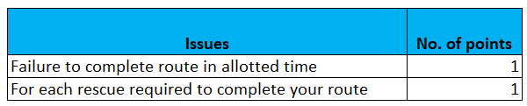

INFRACTIONS
Tier 2 infractions include throwing packages, delivering to the wrong house, being rude to customers, and not following customer delivery instructions. If you get three Tier-2 infractions in any rolling three month period, we will terminate your employment once you have three tier 2 infractions. Tier-2 infractions include but are not limited to throwing packages, mishandling packages and disregarding a customer’s delivery instructions.
Tier-1 infractions are serious offenses. These include urinating in public places, initiating or escalating customer arguments, driving in an unsafe manner etc. If you get any tier 1 infractions, we will terminate your employment.

DA Name: __________________________ Date: __________________

Signature: __________________________

