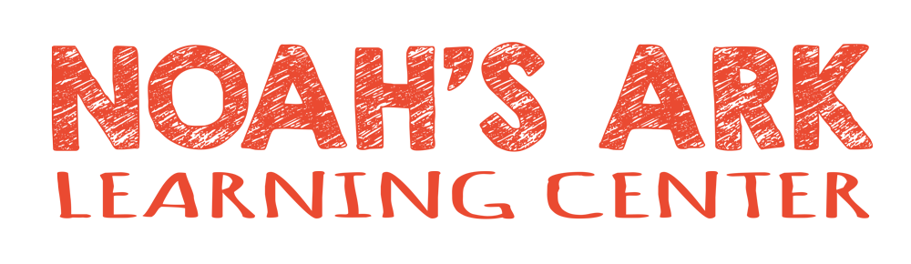

Noah’s Ark Learning Center is a great place to work, offering an encouraging and supportive environment where staff feel valued and appreciated. Employees enjoy paid training opportunities to grow professionally, 10 paid holidays each year, designated planning time to prepare and succeed in the classroom, and regular team-building activities that strengthen relationships. With meals included, competitive pay, and a positive workplace culture, Noah’s Ark is truly a rewarding place to build a career.
Questionnaire: Prospective Employee
Date of Inquiry________________________________(REQUIRED)
Name________________________________(REQUIRED)
Address________________________________(REQUIRED)
Phone Number________________________________(REQUIRED)
Email________________________________(REQUIRED)
D.O.B.___________________
High School Diploma? Yes No
Age Group Desired:_______________________________
Availability:______________________________________
Are you willing to sign a staff covenant? Yes No Have Questions?
Do you have children you would like to enroll at ½ price rate:____________________________
Describe your experience working with children: __________________________________________________________________________________________________________________________________________________________________________________________________________________________________________

