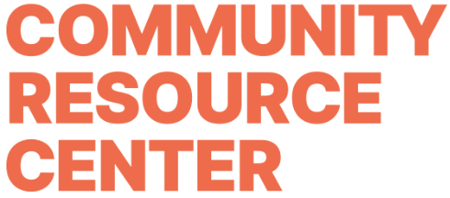

Job Title
Director of Development

Department
Community Relations

Reports To
CEO

Direct Reports
Development Manager

Position Overview
The Community Resource Center is seeking a passionate and results-driven Director of Development to lead its fundraising and donor engagement efforts. Reporting directly to the CEO, this role will play a critical part in expanding CRC’s reach, strengthening donor relationships, and securing the financial resources necessary to sustain and grow the organization’s impact.
This position requires a self-motivated, strategic, and collaborative leader who is committed to advancing equitable access to basic needs. This is an in-office position based in Nashville, Tennessee, with regular engagement in community events and meetings.

Key Responsibilities
Revenue Development
- Develop and execute a comprehensive fundraising strategy aligned with CRC’s mission and organizational goals, with accountability for achieving $1,000,000+ in annual revenue.
- Identify and pursue new funding opportunities to diversify revenue streams.
- Collaborate with contracted grant writers by providing strategy, direction, and organizational insight to support successful grant funding.
- Identify, cultivate, and solicit major gifts ($1,000+) prospects; develop and implement effective stewardship strategies for major donors.
- Take strategic leadership of CRC’s two marquee fundraising events, All In for Hygiene and Dishin’ Up Dignity, ensuring they drive meaningful revenue growth and donor engagement.
- Collaborate with the CEO to develop and manage the fundraising budget, including tracking revenue and expenses.
Community Cultivation
- Cultivate and steward relationships with individual donors, foundations, corporations, and community partners.
- Oversee donor communications, acknowledgments, and recognition processes to ensure a strong and consistent donor experience.
- Represent CRC in the community to increase visibility, build relationships, and expand support.
Supervision and Internal Collaboration
- Directly supervise one development team member, providing coaching, accountability, and support to ensure strong performance
- Work closely with the Office Manager and Director of Marketing to align development operations, communications, and donor experience.
- Partner with program staff to understand funding priorities and effectively communicate impact to donors and funders.
- Collaborate with the Board of Directors to actively engage them in fundraising efforts and provide regular updates on progress and opportunities.
- Oversee donor database management, ensuring accurate records, gift processing, and reporting.

Qualifications
- Bachelor’s degree in a relevant field; advanced degree preferred or equivalent work experience.
- Minimum of 3 years of successful nonprofit fundraising experience, including major gift solicitation and event management
- Proven track record of developing and executing fundraising strategies that achieve annual team revenue goals of $750,000 or more.
- Strong interpersonal, communication, and presentation skills
- Ability to work collaboratively with diverse stakeholders, including board members, staff, volunteers, and donors.
- Excellent organizational and project management skills with strong attention to detail
- Proficiency in donor management systems and Microsoft Office Suite
- Demonstrated passion for CRC’s mission and empathy for individuals and families in need.
- Supervisory experience

Work Environment
Office based position.

Compensation and Benefits
- $75k-$80k based on experience.
- Health insurance stipend.
- Paid vacation and sick days.
- Career growth opportunities
- Professional Development

Application Instructions
Send a cover letter, resume, and two professional references to hello@crcmidtn.org. Applications without the requested information will not be considered. Qualified candidates will be contacted for an interview. No calls, please.

