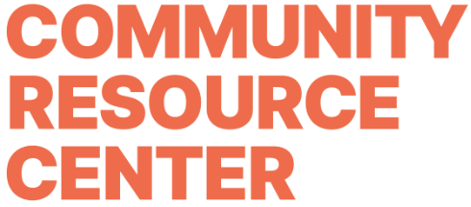

Job Title
Development Manager

Department
Community Relations

Reports To
Director of Development

Direct Reports
n/a

Position Overview
The Community Resource Center is seeking an enthusiastic, detail-oriented Development Manager to help advance our mission through exceptional event execution and donor stewardship. This position will play a key role in CRC’s development strategy by managing our signature fundraising events—Dishin’ Up Dignity and All in for Hygiene—as well as overseeing a portfolio of individual and corporate donors. The ideal candidate is passionate about community impact, thrives in fast-paced environments, and brings a strong blend of organizational, communication, and relationship-building skills.

Key Responsibilities
Event Management
- Plan, execute, and evaluate all aspects of CRC’s fundraising events, including Dishin’ Up
- Dignity, All in for Hygiene, and other donor-facing gatherings.
- Manage event timelines, budgets, vendor relationships, volunteers, and logistics to ensure high-quality, mission-driven experiences.
- Collaborate with the Marketing Director to create promotional strategies and materials for events.
- Coordinate with internal teams and external partners to ensure successful fundraising outcomes and brand alignment.
- Solicit and manage in-kind donations, sponsorships, and event-related fundraising opportunities, as well as event host committees.
- Maintain detailed records and evaluations of events for continuous improvement.

Donor Relations
- Manage a portfolio of individual and corporate donors, building and deepening relationships through regular communication and personalized engagement.
- Support the cultivation, solicitation, and stewardship of gifts in partnership with the Director of Development and CEO.
- Track donor interactions, event participation, and giving history in CRM/database.
- Coordinate donor acknowledgments, recognition opportunities, and stewardship touchpoints.
- Assist in the development of donor communications, including appeals, newsletters, and impact reports.
General Development Support
- Assist in the implementation of the overall development strategy, including annual giving campaigns and donor acquisition plans.
- Work cross-functionally with programs and marketing teams to ensure alignment between fundraising and organizational impact.
- Attend and staff CRC events as a representative of the development team.
- Perform other duties as assigned by the CEO or Director of Development.

Qualifications
- Bachelor’s degree in a relevant field; advanced degree preferred or equivalent work experience.
- Minimum of 1 year of successful nonprofit fundraising experience, including major gift solicitation and event management
- Proven track record of developing and executing fundraising strategies that achieve annual team revenue goals of $750,000 or more.
- Strong interpersonal, communication, and presentation skills
- Ability to work collaboratively with diverse stakeholders, including board members, staff, volunteers, and donors.
- Excellent organizational and project management skills with strong attention to detail
- Proficiency in donor management systems and Microsoft Office Suite
- Demonstrated passion for CRC’s mission and empathy for individuals and families in need.

Work Environment
Office based position.

Compensation and Benefits
- $45k-$55k based on experience.
- Health insurance stipend.
- Paid vacation and sick days.
- Career growth opportunities
- Professional Development

Application Instructions
Send a cover letter, resume, and two professional references to hello@crcmidtn.org. Applications without the requested information will not be considered. Qualified candidates will be contacted for an interview. No calls, please.

