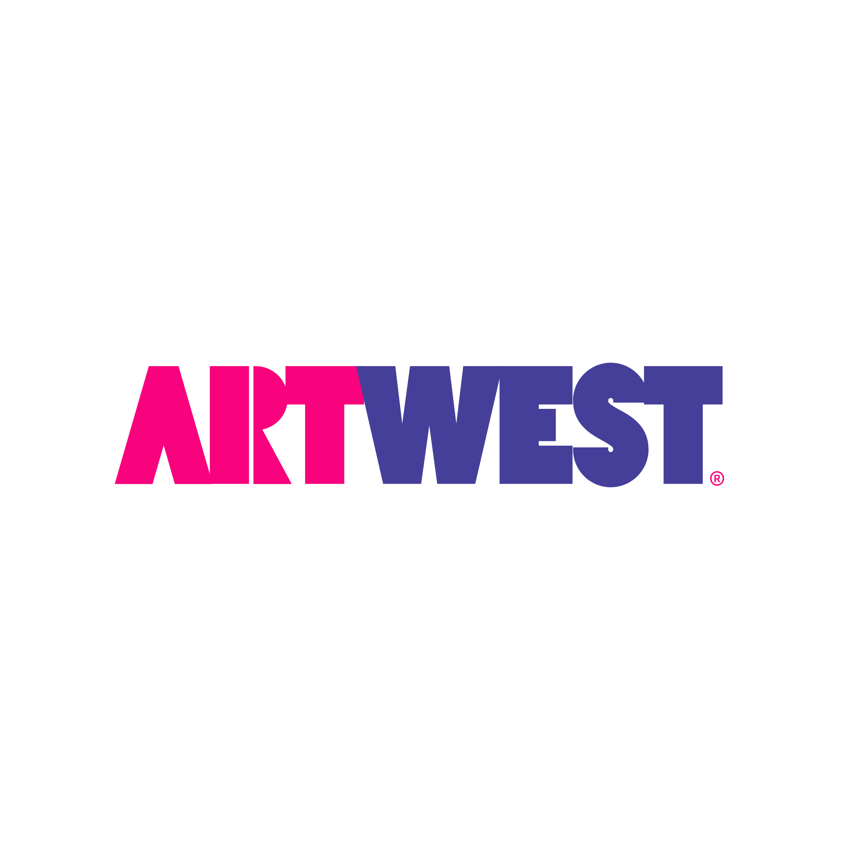
Additional Community Fees

- Application Fee: $45 per applicant above 18 years old

- Administration Fee: $200 non-refundable

- Pet Screening: REQUIRED
  - $25 per pet
  - Free screening for residents with no pets
  - Free screening for residents with ESA pets

- Security Deposit: Refundable
  - $500 (OAC) or
  - $1000- $2250 (conditionally approved) and/or
  - JETTY - Non-refundable surety bond

- Pet Fees/Deposit/Monthly Rent:
  - Pet Deposit: $200 refundable
  - Pet Fee: $300
  - Pet Rent: $45/month per pet

- Community Fees: $185 REQUIRED
Includes:
  - Water, Sewer, and Trash
  - Pest Control
  - Fastel Internet (1Gig)
  - Wise Home smart features

- Electric: REQUIRED
Account set up by resident with Rocky Mountain Power
- Renters Insurance: REQUIRED
$12 Liability Wavier (or your own – proof of insurance must be provided to remove liability).

