

3i Construction Management
Subcontractor Process for Creating Submittals in Procore
Purpose. This procedure explains how a subcontractor creates and submits its own submittal in the 3i project in Procore.
Important 3i Rule. Creating a record in Procore does not replace the subcontractor’s responsibility to review the submittal for contract compliance.
Do not order, fabricate, deliver, or install materials until the submittal has received the required written approval.

1. Access and Permission Requirements
- The subcontractor must have an active Procore account and access to the correct 3i project.
- The subcontractor must have permission to create submittals. If the “+ Create” button is not visible, contact the 3i Project Manager or Project Engineer.
- The subcontractor must use its own named Procore account. Shared logins are not permitted.
- The subcontractor must confirm the 3i Project Manager or Project Engineer who will manage submittals before creating the first item.

Step 1 - Select the Correct Project
Log in to Procore and select the 3i project for which the submittal applies. Confirm the project name before creating the record.
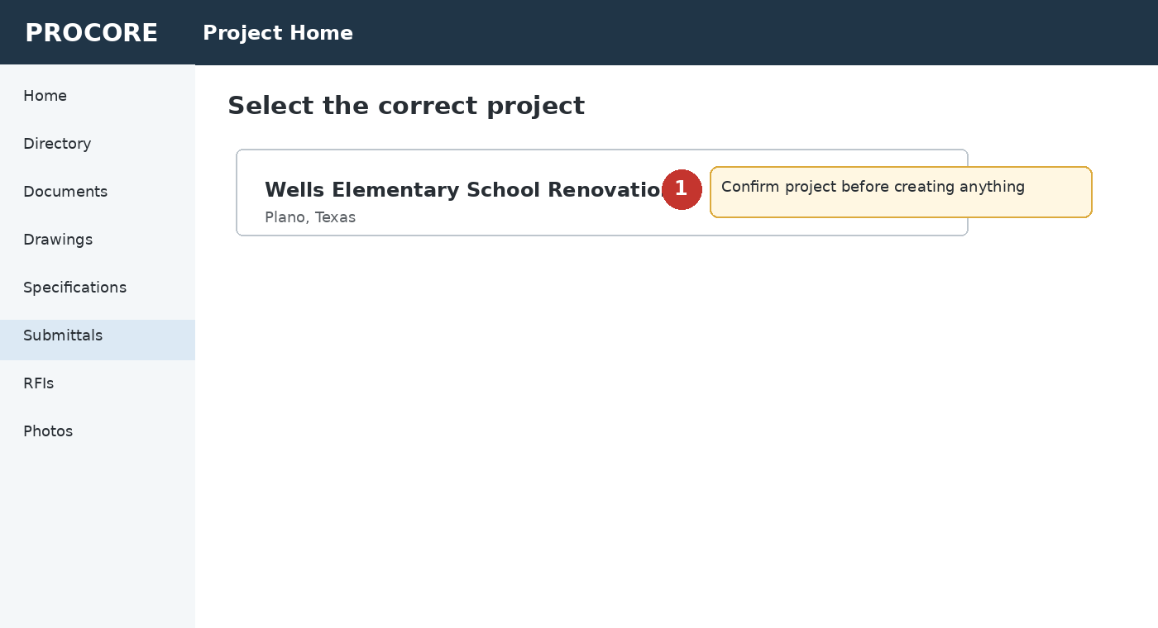
Figure 1. Illustrative Procore screen for select the correct project.
- Never create a submittal in a different project and assume 3i can move it later.

Step 2 - Open the Submittals Tool
From the project menu, select Submittals. The Submittals log will display existing items and their current status.
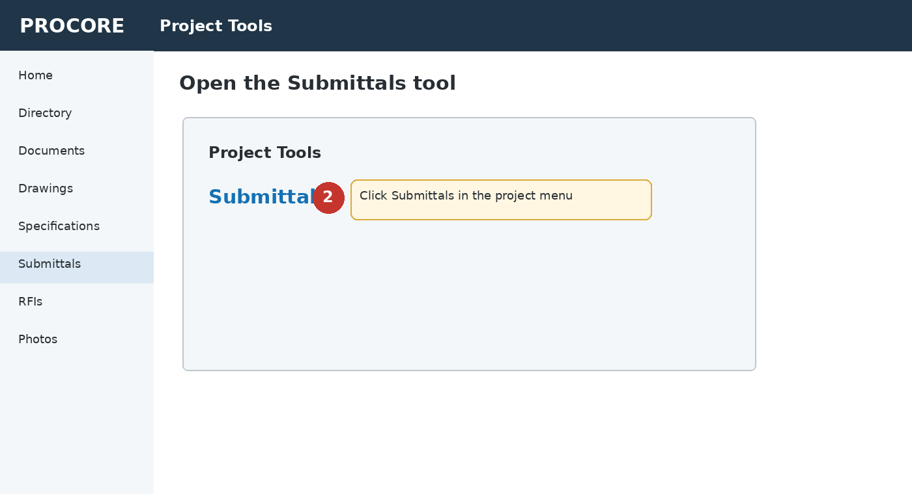
Figure 2. Illustrative Procore screen for open the submittals tool.

Step 3 - Create a New Submittal
Select + Create and then select Submittal. Do not create a Submittal Package unless 3i specifically instructs you to do so.
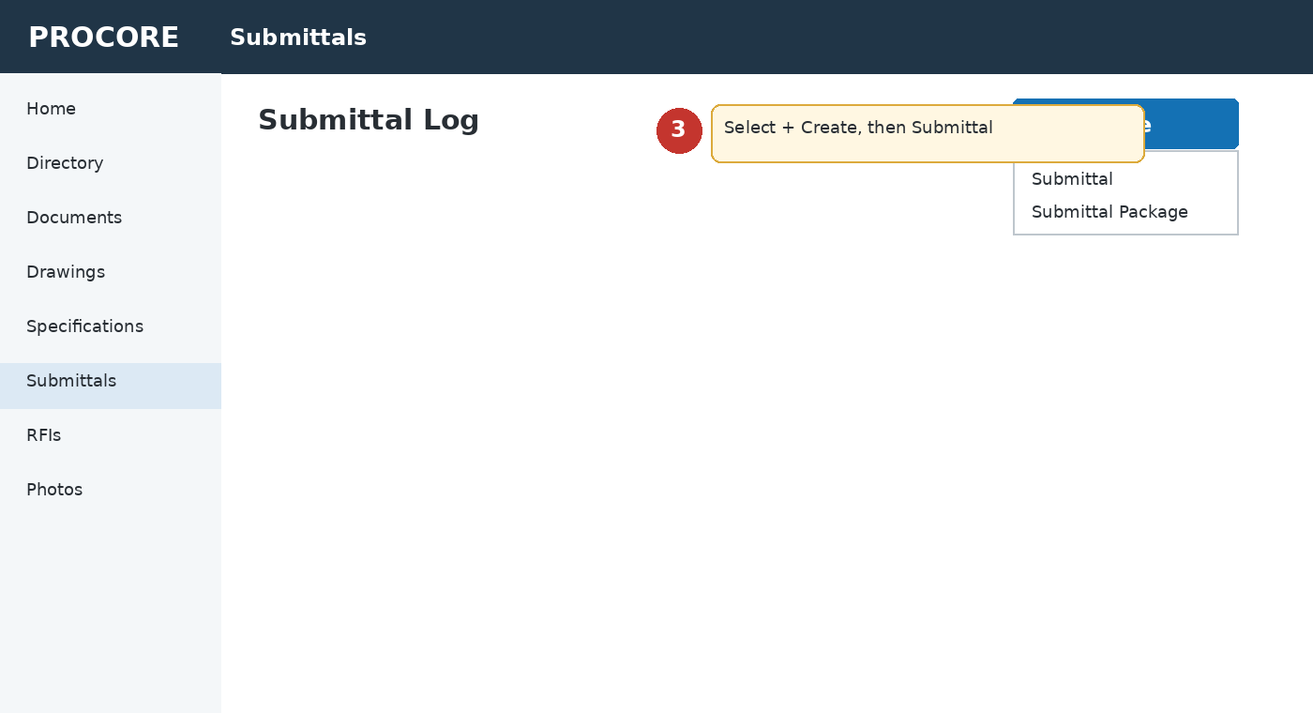
Figure 3. Illustrative Procore screen for create a new submittal.

Step 4 - Complete General Information
Enter complete and accurate identifying information. Use the project specifications and drawings, not supplier terminology alone.
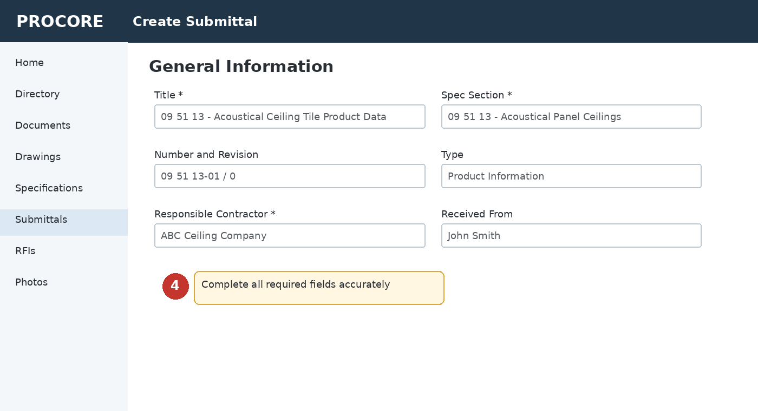
Figure 4. Illustrative Procore screen for complete general information.
- Title: Use the specification section and a clear description of the exact item.
- Spec Section: Select the applicable specification section.
- Number and Revision: Use the numbering assigned by 3i, or follow the project naming convention. The initial submission is normally Revision 0.
- Type: Select Product Information, Shop Drawing, Sample, Product Manual, or the most applicable type.
- Responsible Contractor: Select your subcontracting company.
- Received From: Select the person within your company who prepared or submitted the package.

Step 5 - Enter Dates, Lead Time, and 3i Manager
Complete the scheduling and responsibility fields using actual procurement information. These dates allow 3i to determine whether the submittal supports the construction schedule.
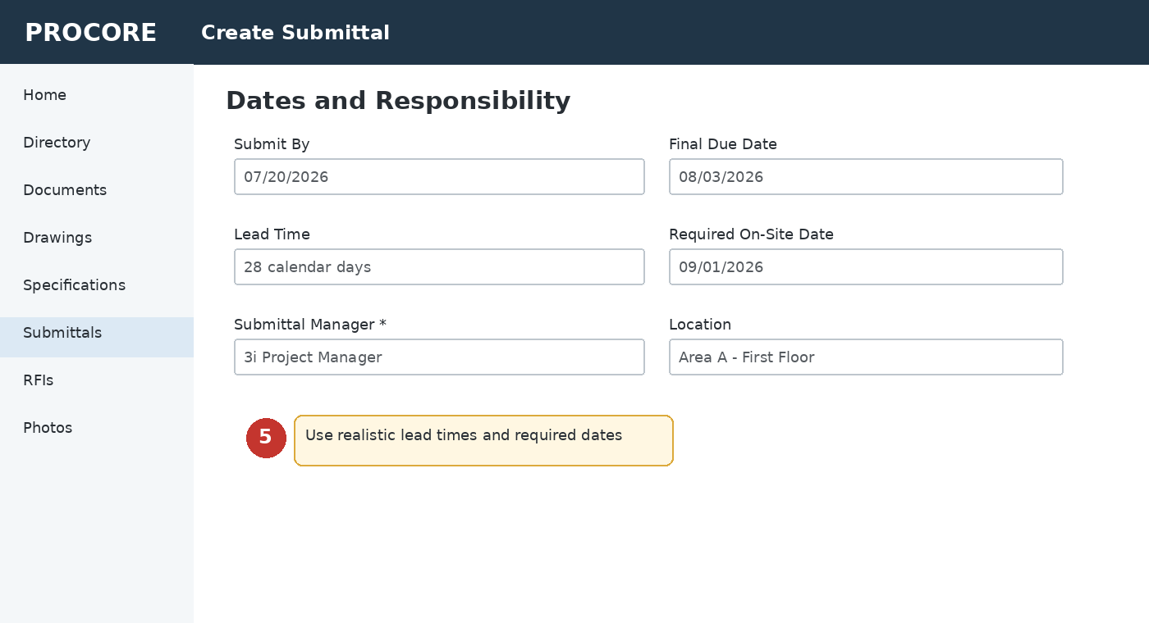
Figure 5. Illustrative Procore screen for enter dates, lead time, and 3i manager.
- Submit By: Date your complete package is being provided or is required.
- Final Due Date: Use the date directed by 3i. Do not create an unrealistic approval date.
- Lead Time: Enter the current calendar-day lead time confirmed by the supplier.
- Required On-Site Date: Enter the date the approved material must be available at the project.
- Submittal Manager: Select the 3i Project Manager or Project Engineer identified for the project.
- Location: Identify the building, floor, room, area, or phase when applicable.

Step 6 - Add the Description and Attachments
Describe what is included and attach the complete submittal package. The attachment must be reviewed by the subcontractor before uploading.
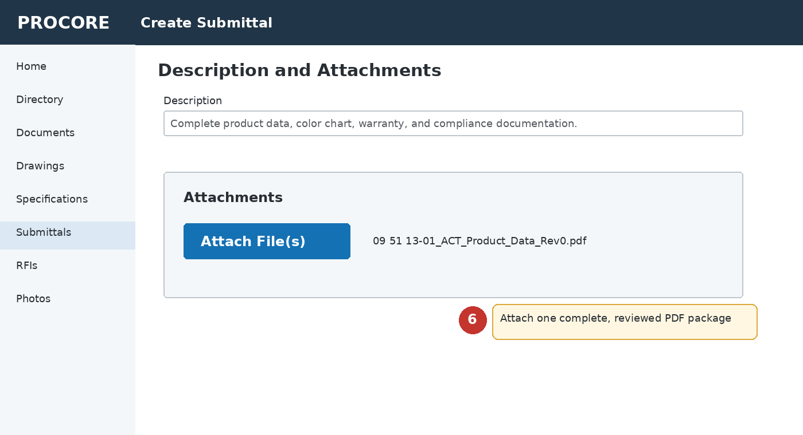
Figure 6. Illustrative Procore screen for add the description and attachments.
- Combine related documents into one organized, searchable PDF whenever practical.
- Include product data, shop drawings, color charts, samples, certifications, test reports, warranties, and installation data required by the specifications.
- Clearly highlight the exact manufacturer, model, size, color, finish, accessory, and option being submitted.
- Cross out or remove unrelated products and options.
- Clearly identify every deviation or substitution from the contract documents.
- Use a file name such as: Project - Spec Section - Description - Subcontractor - Revision.

Step 7 - Confirm the Workflow
Add or verify the required workflow participants only as directed by 3i. The subcontractor should normally be identified as the Submitter, and the designated 3i representative should be the next reviewer or Submittal Manager.
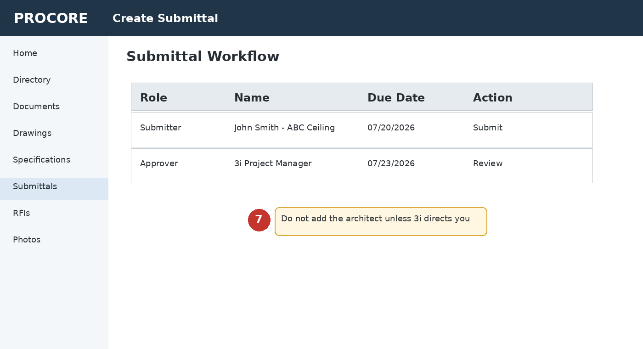
Figure 7. Illustrative Procore screen for confirm the workflow.
- Do not add the architect, engineer, owner, or consultant unless 3i provides written direction.
- Do not bypass 3i by transmitting the submittal directly to the design team.
- If you cannot select the correct 3i person, save the draft and contact the Project Manager or Project Engineer.

Step 8 - Perform Final Review and Submit
Review the entire record before selecting Create, Create and Send Emails, or the comparable action shown in the project. Confirm that 3i receives the notification.
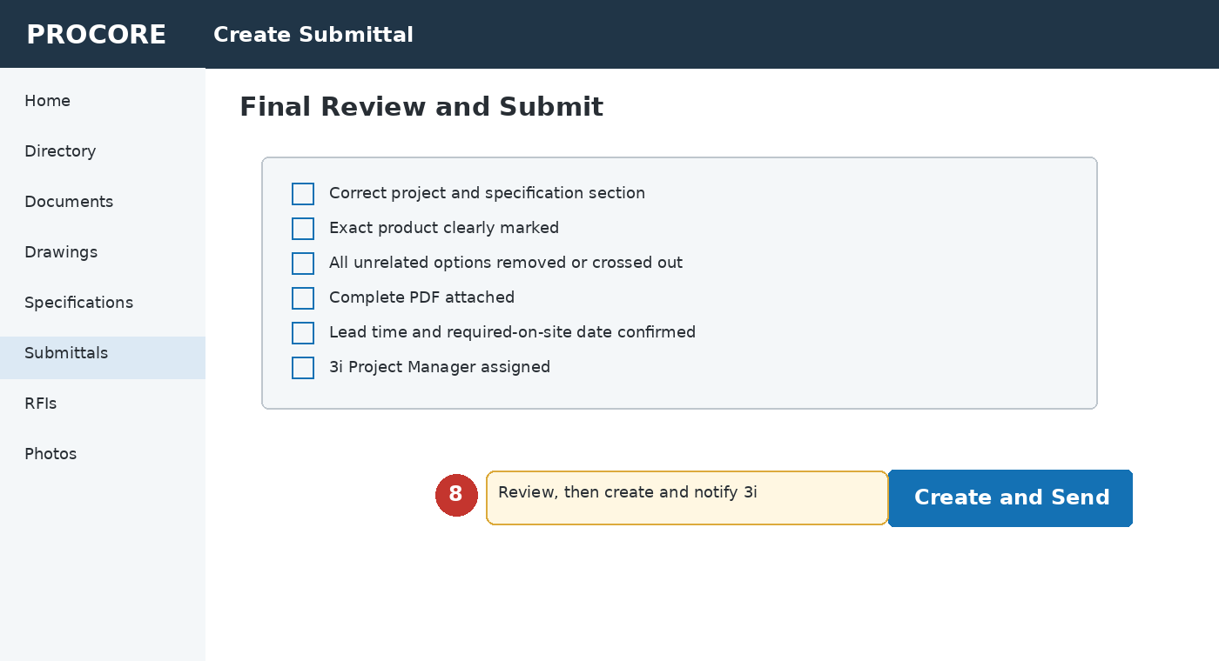
Figure 8. Illustrative Procore screen for perform final review and submit.
- After submission, verify that the item appears in the Submittals log.
- Retain the Procore email or record confirming submission.
- Monitor Procore for comments, status changes, and required resubmittals.

2. Required Quality Check Before Submission
☐ Correct project identified
☐ Correct specification section identified
☐ Correct drawing and detail references included
☐ Exact manufacturer and product clearly marked
☐ Unrelated products and options removed or crossed out
☐ Required sizes, model numbers, colors, finishes, and accessories identified
☐ Installation location identified
☐ Product complies with drawings and specifications
☐ Field conditions and adjacent trades coordinated
☐ Lead time and required-on-site date confirmed
☐ Warranty, test reports, certifications, shop drawings, engineering, and samples included when required
☐ Every deviation or proposed substitution clearly identified
☐ Package reviewed and approved internally by the subcontractor
☐ PDF is complete, legible, searchable, and properly named
☐ Submission is early enough to permit 3i and design-team review and any resubmittal

3. After Submission
- Check Procore regularly. The subcontractor is responsible for monitoring its open submittals and responding by the stated due date.
- If the item is returned Revise and Resubmit or Rejected, address every review comment, cloud or highlight all changes, update the revision number, and upload the complete revised package.
- Do not replace an approved manufacturer, product, model, finish, or accessory without creating and obtaining approval of a revised submittal.
- Provide the final approved submittal and all review comments to field supervisors, installers, suppliers, and fabricators before work begins.
- Confirm delivered and installed materials match the final approved submittal.

4. Items That Will Be Returned Without Review
- Wrong project or specification section
- Incomplete package or missing required documents
- Generic catalog with no product selection marked
- Unidentified substitution or deviation
- Illegible or improperly named files
- Missing subcontractor review
- No lead time or required-on-site date when applicable
- Direct workflow to the architect or owner without 3i authorization
- Multiple unrelated products combined in a manner that prevents clear review

5. Assistance
Questions about Procore access, numbering, workflow, required attachments or the correct 3i Submittal Manager must be resolved with the 3i Project Manager or Project Engineer before submission. Do not guess or create duplicate records.

