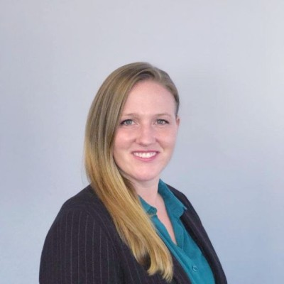
Jane Long
VP of People & HR Solutions
Jane is dedicated to fostering cohesive organizational strategies that drive sustained success. She seeks to integrate people programs seamlessly with operational goals, paving the way for stability, leading to long-term growth, excellence, and exits.
With over 20 years of hands-on experience in people operations and organizational development, Jane has honed a diverse skill set across various industries. From guiding HR initiatives in burgeoning biotech startups to steering the human capital strategies of multistate manufacturing organizations, she excels in crafting scalable people programs that fuel engagement, bolster retention, and propel organizational objectives forward across periods of distress, stability, and growth.
She is passionate about leveraging technology and innovation to streamline processes and enhance organizational effectiveness. Her proven track record of operational excellence is underscored by her successful execution of organizational restructuring initiatives, resulting in substantial cost reductions and operational efficiencies for countless clients.
Jane holds a Bachelor’s degree in Business Management with a concentration in Human Resources.

