Medical and Nursing Policy | Subject: Pain Management
Approved By:

Effective: | Revised: 12/6/2024

POLICY
It is the policy of this facility to provide adequate management of pain, in accordance to State and Federal regulatory requirements and professional standards of practice, to ensure that residents attain or maintain their highest practicable physical, mental, and psychosocial well-being.

REGULATORY REQUIREMENT
§483.25(k) Pain Management.
The facility must ensure that pain management is provided to residents who require such services, consistent with professional standards of practice, the comprehensive person-centered care plan, and the residents’ goals and preferences.

DEFINITIONS
TERM | DEFINITION
Acute Pain | pain that is usually sudden in onset and time-limited with a duration of less than 1 month and often is caused by injury, trauma, or medical treatments such as surgery.
Subacute Pain | pain that has been present for 1–3 months.
Chronic Pain | pain that typically lasts greater than 3 months and can be the result of an underlying medical disease or condition, injury, medical treatment, inflammation, or unknown cause.
Breakthrough Pain | an abrupt, brief flare-up of pain that occurs despite well-controlled background pain.
Incidental Pain | breakthrough pain is associated with a specific activity, such as walking, turning, lifting, coughing, and deep breathing.
Adverse Consequence | an unpleasant symptom or event that is due to or associated with a medication, such as impairment or decline in a resident’s mental or physical condition or functional or psychosocial status. It may include various types of adverse drug reactions and interactions (e.g., medication-medication, medication-food, and medication-disease).
Opioid Use Disorder | a problematic pattern of opioid use leading to clinically significant impairment or distress. Additional criteria used to assess and diagnose OUD can be found in the Diagnostic and Statistical Manual of Mental Disorders, Fifth Edition (DSM-5).

PROCEDURES
- Each resident will be evaluated for pain upon admission/re-admission, each shift, and with any change in condition or status (e.g., after a fall) to identify risk factors that could result in pain.
- Facility staff will utilize evidence-based practice tools (e.g., numeric pain scale, Wong Baker, and Pain Assessment in Advanced Dementia (PAINAD)) to be used for assessment of pain, with both cognitively intact as well as cognitively impaired residents, as applicable.
- The primary medical doctor (PMD) will be notified for those residents who trigger for pain and orders will be obtained for appropriate pain management.
  - When starting opioid therapy for acute, subacute, or chronic pain, clinicians may consider prescribing immediate-release opioids instead of extended-release and long-acting.
    - Short-Acting Opioid (SAO): has a quick onset of action and short duration of analgesic activity. Often used for acute or subacute outpatient opioid therapy and include codeine, hydrocodone, oxycodone, oxymorphone, and morphine.
    - Long-Acting Opioid (LAO): has a potentially longer onset of action and a longer duration of analgesic activity. Includes controlled or extended-release formulations of hydromorphone, morphine sulfate, oxycodone, oxymorphone, and tramadol, as well as any dose of fentanyl patch and buprenorphine patch.
- The interdisciplinary team (IDT) will investigate non-pharmacological interventions that may be beneficial in assisting with pain relief for individual residents. When indicated, the IDT will offer specific non-pharmacological interventions for a particular resident. The measures(s) will be documented in the medical record and evaluated in the Comprehensive Care Plan including the residents response. These include but are not limited to:
- Cognitive/Behavioral interventions (e.g., relaxation techniques, reminiscing, diversions, activities, music therapy, offering spiritual support and comfort, as well as teaching the resident coping techniques and education about pain).
- Physical /Occupational Therapy
- Moist heat/cold packs
- Altering the environment for comfort (such as adjusting room temperature, tightening and smoothing linens, using pressure redistributing mattress and positioning, comfortable seating, and assistive devices)
- Exercises to address stiffness and prevent contractures as well as restorative nursing programs to maintain joint mobility
- Residents and representatives will be questioned re: interventions that assisted w/ pain relief in past and when applicable these interventions will be incorporated in the plan of care (POC).
- Residents will be referred to pain management consultant (physiatrist) as needed.
- During Care Plan review, and as needed, the resident’s pain levels will be reviewed in conjunction with the use of PRN or programmed pain medication and non-pharmacological measures. When indicated, the PMD will be notified and requested to revise pain management program.
- Prior to administering pain medication, the nurse will document the level of pain and document this on the EMAR. The nurse will re-assess the resident’s pain 30-60 minutes later and document the resident’s response to pain medication on the EMAR.
- Administration of pain medication will follow the rights of medication administration (right patient, right medication, right dose, right route, right time, right documentation).
- For residents with an intrathecal pain pump, the medical record will indicate the model and date of implantation of device, medication and dosage, date cartridge was last refilled, and when the device is due to be changed.
- All Nursing Staff will be in-serviced on Pain Management and on non-verbal expressions and behaviors that could indicate pain in residents living with dementia or unable to verbalize their pain.
- Pain assessments may be done when residents display unpredictable behaviors to rule out a behavior problem versus the need for pain management.
- Licensed staff will be educated regarding the types of pain. When feasible, the PMD will document the type of pain (e.g. acute, subacute, chronic, breakthrough, incidental) requiring medication.
- The IDT will review any residents experiencing pain via:
        - Review of nursing admission assessment to identify risk factors.
        - Notation on the Electronic 24hr report.
        - Feedback from Rehabilitation staff members.
        - Feedback from all Departments
        - Feedback from resident/representatives
- Residents and representatives will be educated regarding the pain management plan as needed.

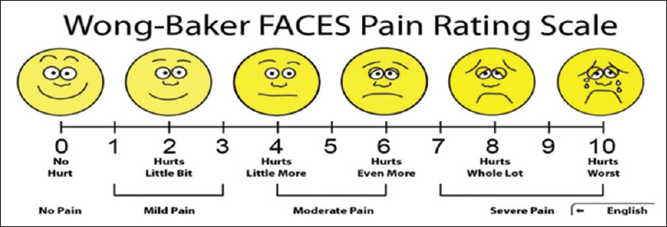

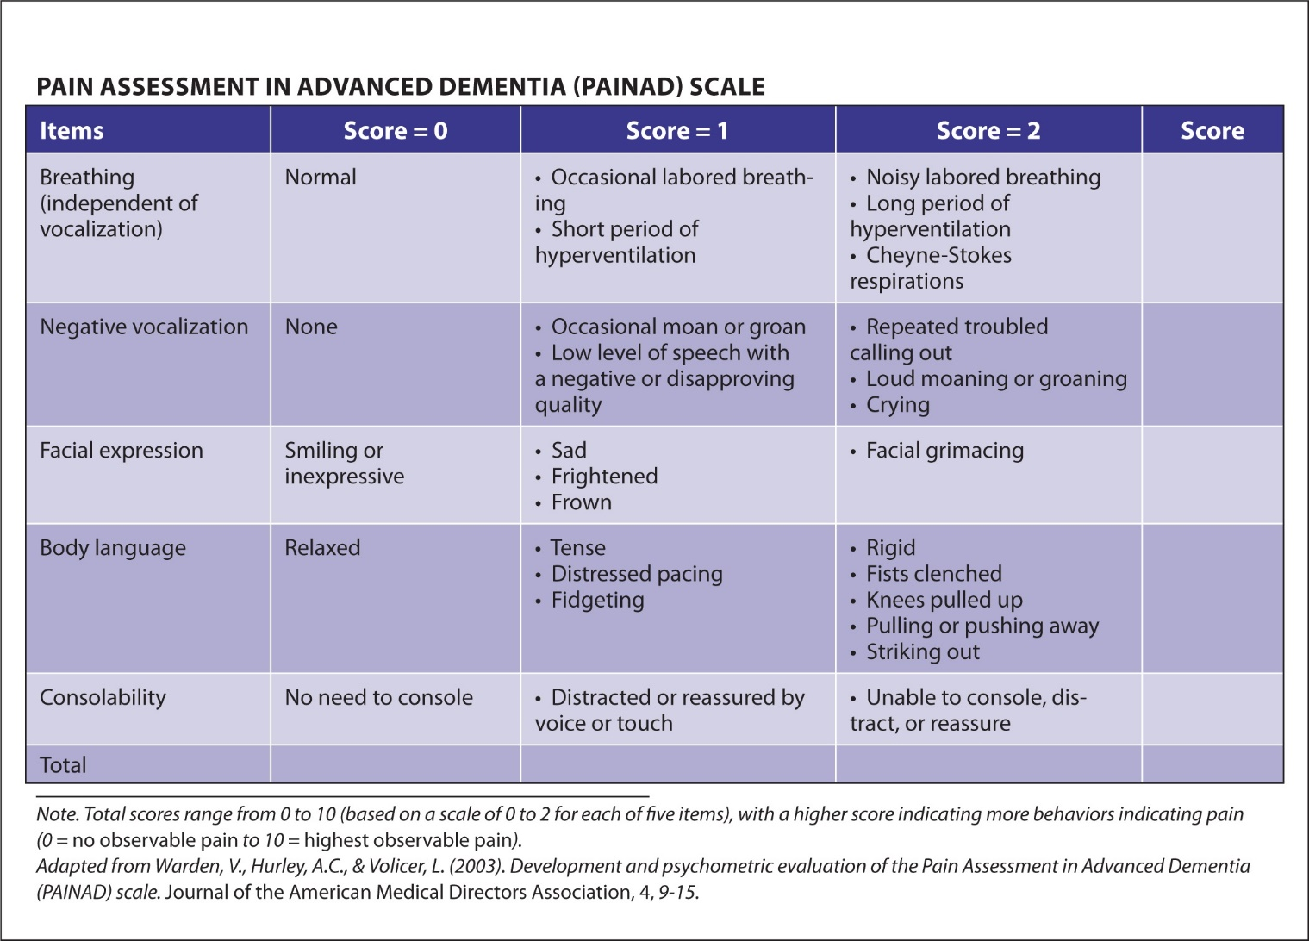

References
CDC (5/8/2024). Opioid Therapy and Different Types of Pain | Overdose Prevention | CDC
Terrie, Y.C. (2023). Identifying and Assessing Breakthrough Pain. US Pharm. 2023;48(3):HS2-HS6. Identifying and Addressing Breakthrough Pain

CDC (5/2/2024). Nonopioid Therapies for Pain Management | Overdose Prevention | CDC

NIH (7/22/2024). Pain | National Institute of Neurological Disorders and Stroke.

Argoff, C.E. & Silvershein, D.I. (2009). A Comparison of Long- and Short-Acting Opioids for the Treatment of Chronic Noncancer Pain: Tailoring Therapy to Meet Patient Needs - Mayo Clinic Proceedings

CDC (11/4/2022). CDC Clinical Practice Guideline for Prescribing Opioids for Pain — United States, 2022 | MMWR

