Using the PDSA Cycle
Plan: After identifying the problem, make a plan/objective to allow for improvement. Identify the root cause and plan the system changes. Plan how the results will be measured. Make a prediction about the results.
Do: Carry out the plan. Share it with all the staff. Have formal and informal in service. Gather data to see if there have been improvements. Collect and record the data.
Study: Analyze the data. Compare it to what was predicted. Summarize what was learned.
Act: What are new changes to be made? What areas need re-focusing? What will be the next area of improvement?

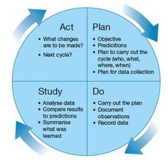

Performance Improvement Project
PERFORMANCE IMPROVEMENT PROJECT
PIP Title:
PIP Leader: |  |  |  |  | Date  Initiated:
Team Members:
PLAN (Approach)
What opportunity for improvement (OFI) have you identified?
Identify the Root Cause:
State your goal / desired result:
DO (Deployment)
What will you implement based on the Root Cause? |  |  |  | Who will implement the action? |  | What is the status of the action?
1
2
3
4
STUDY (Learning)
What did you learn?
What is your goal?
Did you achieve the desired outcome?
What will you do differently to meet the goal?
ACT (Integration)
How is your approach integrated with what you want to accomplish?

DATA COLLECTION AND REVIEW | Current  Month: | Previous  Month 1: | Previous Month 2: | Trending
PROCESS REVIEW: Are systems in place to _______________ (fill in with what you’re reviewing)
Review/Management:
□ Yes □ No □ To be determined
□ Yes □ No □ To be determined
□ Yes □ No □ To be determined

Summary:

