Infection Prevention and Control Policy | Subject: Respiratory Therapy Equipment
Approved By:
Effective: 4/18/2025 | Revised:

POLICY
To guide prevention of infection associated with respiratory therapy tasks and equipment, including nebulizers, BiPAP (bilevel positive airway pressure) and CPAP (continuous positive airway pressure), among residents and staff.

BACKGROUND
Nebulizers, oxygen concentrators, ventilators, continuous positive airway pressure (CPAP), bilevel positive airway pressure (BiPAP), and nasal cannulas are all medical devices and respiratory supplies commonly used by residents receiving care in skilled nursing facilities. These devices can contribute to the resident developing a respiratory infection by serving as a reservoir and supporting the growth of microorganisms and by directly infecting residents when this equipment becomes contaminated.

DEFINITIONS
TERM | MEANING
Cleaning | activity that removes organic and inorganic materials or dirt that is on the device surfaces with the main purpose of removing conditions that would enable the growth of microorganisms. Cleaning also allows the disinfectant to come into contact with items to kill microorganisms.
Disinfection | activity that consists of eliminating many of the pathogenic microorganisms that live on the device’s surfaces. It should be performed just after a cleaning activity to guarantee that all other organic material has been removed.
Sterilization | the process that eliminates all living microorganisms including spores from surfaces. It should be performed just after cleaning and disinfection activities to guarantee that organic material and most pathogenic microorganisms have been removed.

PROCEDURE

General Guidelines
- Licensed nurses and/or respiratory therapists who have received training will administer medications and monitor residents receiving supplemental oxygen and nebulizer treatments.
- All medications, including supplemental oxygen, will have a doctor’s order to indicate the name and dosage of the medication and the route and frequency for administration.
- Pre and post medication administration, the licensed nurse or respiratory therapist will assess the resident’s pulse, respiratory rate and oxygen saturation and record same in the electronic medical record (EMR).
- The licensed nurse or respiratory therapist will inform the resident’s physician of any vital signs that are not within normal ranges and of any wheezing or shortness of breath during and post medication administration.
- The licensed nurse or respiratory therapist will document accordingly in the resident’s EMR.
- Oxygen delivery tubings will be changed and dated weekly (or per manufacturer’s recommendation) and as needed. Documentation will be reflected on the treatment administration record (TAR).
- Nebulize set will be changed and dated weekly and as needed. Documentation will be reflected on the TAR.
- Respiratory therapy equipment will be cleaned and disinfected between each resident use.
- The facility may collaborate with the medical supply company for any rented respiratory equipment for servicing and maintenance of equipment.

Maintaining Nebulizer Devices
- After the completion of each medication treatment:  - Rinse nebulizer medication chamber with sterile water and towel dry with clean paper towel  - Once opened, sterile water is good for 24 hours. Date bottle upon opening.  - Place in labeled (resident’s name and room/bed #) zip lock bag  - Clean external compressor with a damp cloth or disposable wipe soaked in detergent and clean water once weekly on (insert specific day) and as needed.  - Disinfect after with a device compatible disinfectant (per MIFU) | 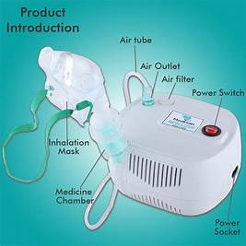
Maintaining Oxygen Concentrators
Clean external oxygen concentrator from top to bottom with a damp cloth or disposable wipe soaked in detergent and clean water once weekly on (insert specific day) and as needed.  - Disinfect after with a device compatible disinfectant (per MIFU)  Clean oxygen bubble humidifier bottle daily  - Empty the water from the humidifier  - Rinse the bottle under running water  - Refill with distilled water (do not use tap or bottled water)  - Replace bottle per manufacturer recommendation or as needed  Clean air filter with soapy water once weekly on (insert specific day)  - Ensure filter is completely dry before replacing  Inspect the bacterial filter weekly (insert specific day)  - Do not wash in water  - Change monthly or per manufacturer’s instructions. | 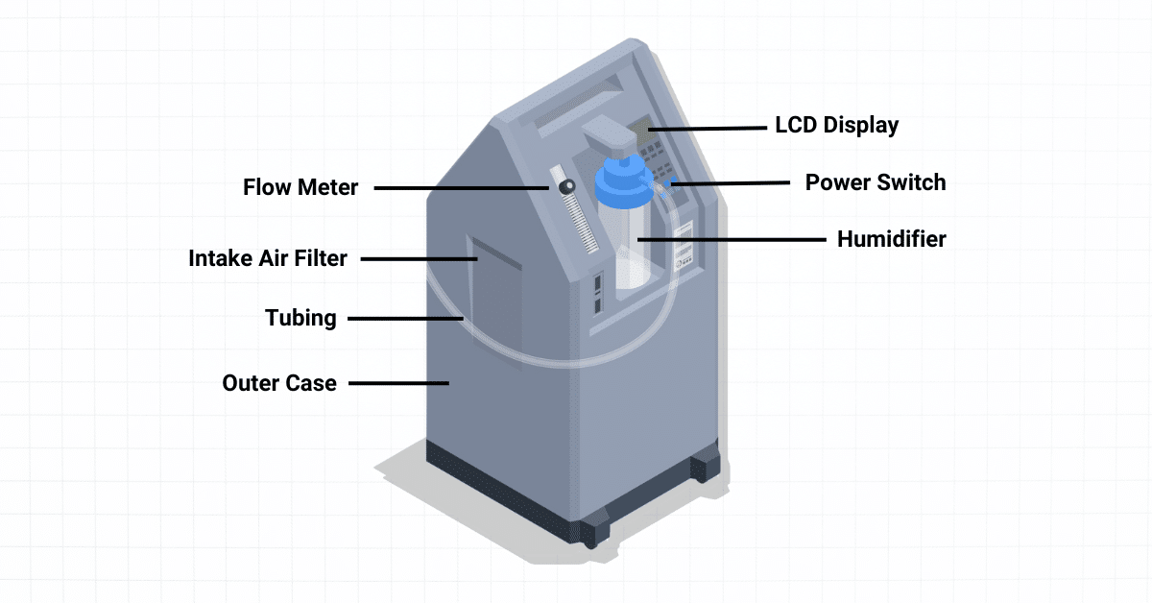

Maintaining BiPAP/CPAP

- Clean exterior of device from top to bottom with a damp cloth or disposable wipe soaked in detergent and clean water once weekly on (insert specific day) and as needed.  - Disinfect after with a device compatible disinfectant (per MIFU)  - Clean bubble humidifier chamber daily  - Empty the water from the humidifier  - Rinse the chamber under running water  - Refill with distilled water (do not use tap or bottled water)  - Replace bottle per manufacturer recommendation or as needed  - Check inlet filter, surface, interface, and chamber per manufacturer’s recommendation  - Replace air filter monthly (insert specific date)  - Replace more often if there are any holes or blockages by dirt, dust, or other organic matter  - Change circuits and humidifier chambers monthly and PRN  - Change interfaces every 3 months and PRN  - Replace hose, mask, and headgear per manufacturer’s recommendations. | 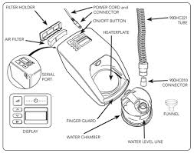

Critical, Semi Critical and Non-Critical Respiratory Equipment
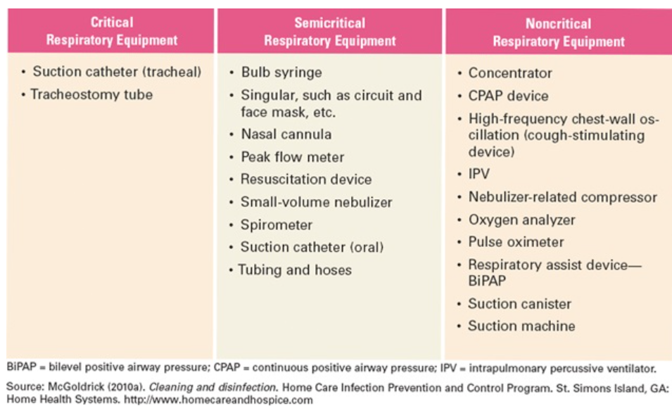

References

World Health Organization (no date). care-cleaning-disinfection-and-sterilization.pdf

McGoldrick, Mary MS, RN, CRNI. Preventing Infections in Patients Using Respiratory Therapy Equipment in the Home. Home Healthcare Nurse: The Journal for the Home Care and Hospice Professional 28(4):p 212-220, April 2010. | DOI: 10.1097/NHH.0b013e3181d6be3e Home Healthcare Now

