Lesson Plan
TITLE | F881 Antibiotic Stewardship
TARGET AUDIENCE | Nursing and Medical Staff
METHOD | Direct Lecture/Handout/Discussion
EFFECTIVENESS CRITERIA | Participation in discussion
TIME | 30 mins
INSTRUCTOR(S)

Learning Objectives
- Define antibiotic and explain its purpose in treating infections
- Understand the regulatory requirements at F881 Antibiotic Stewardship
- Describe the concept of antibiotic stewardship and its importance in healthcare
- Demonstrate ways healthcare providers at all levels can support antibiotic stewardship at all levels

Lesson Content
What is an antibiotic and what does antibiotic stewardship mean?
Antibiotics are a class of medicine designed to kill bacteria.
Penicillin was the first antibiotic discovered. Since then, over 100 have been developed to prevent and treat infections, all of which are vital in treating a wide range of infections.
Antibiotic stewardship means using antibiotics carefully and only when they are truly needed, so they stay effective against infections. It focuses on using the right medicine, at the right dose, for the right duration, and at the right time to protect the individual and public health

Regulatory Requirements of F881 Antibiotic Stewardship
§483.80(a) The facility must establish an infection prevention and control program (IPCP) that must include, at a minimum, the following elements:
§483.80(a)(3) An antibiotic stewardship program that includes antibiotic use protocols and a system to monitor antibiotic use.
When (and When Not) to use antibiotics
Use when bacteria cause an infection to prevent more severe illnesses like sepsis.
Most common infections in nursing homes include urinary tract infections (most common), followed by respiratory and skin infections.
Antibiotics are not effective against viruses such as cold, flu, or Covid-19.
Evaluate symptoms to identify the underlying cause before giving antibiotics.

Side Effects of Antibiotics
Antibiotic use can lead to unintended harm by causing side effects. Some of the most common side effects include gastrointestinal issues such as nausea, vomiting, abdominal cramping, C. difficile and diarrhea; yeast infections such as oral thrush and vaginal itching or discharge, and allergic reactions such as rash or hives, swelling of the face or lips, and trouble breathing.

Why is Antibiotic Stewardship Necessary?
To counter antibiotic resistance.
Antibiotic resistance:
- can occur when antibiotics are overused or improperly administered
- surviving bacteria adapt and grow into stronger, more resistant strains
- reduces the effectiveness of standard antibiotic treatments
- makes infections harder to treat
- increases the risks of severe illnesses and can even lead to death

Role of frontline caregivers (CNAs)
- Report any changes in resident conditions to unit nurse.
- Recognize signs and symptoms associated with an infection – e.g., redness, swelling, pain, pus, fever, chills, complaints of burning on urination, new cough or shortness of breath, diarrhea, etc.
- Model safe practices – hand hygiene, appropriate use of PPE, safe linen handling, etc.

Nurses: Know before you call
- Signs and symptoms (complete Loeb or McGeer criteria form)
- When symptoms were first observed
- Current medication list
- Allergy information
- Recent antibiotic usage

Physicians
- Order Microbiologic test
- Order Radiologic tests
- Review diagnostic results; tailor antibiotics to subsequent microbiology and radiology results
- Order antibiotic for the shortest duration possible; shorten duration when possible
- Document indications for use
- Reassess response 2-3 days after initiation of therapy; change from broad to narrow spectrum when possible
- Convert from IV to oral when possible

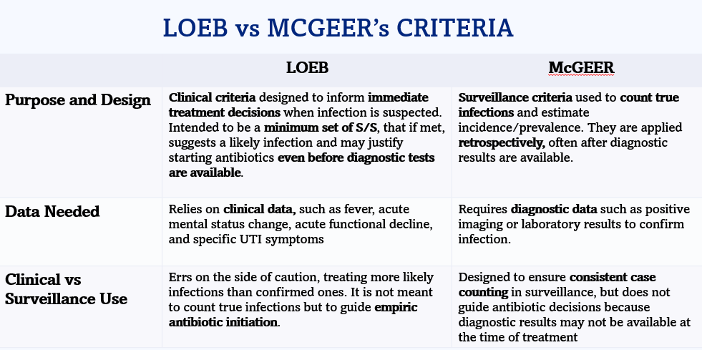

Loeb’s Criteria
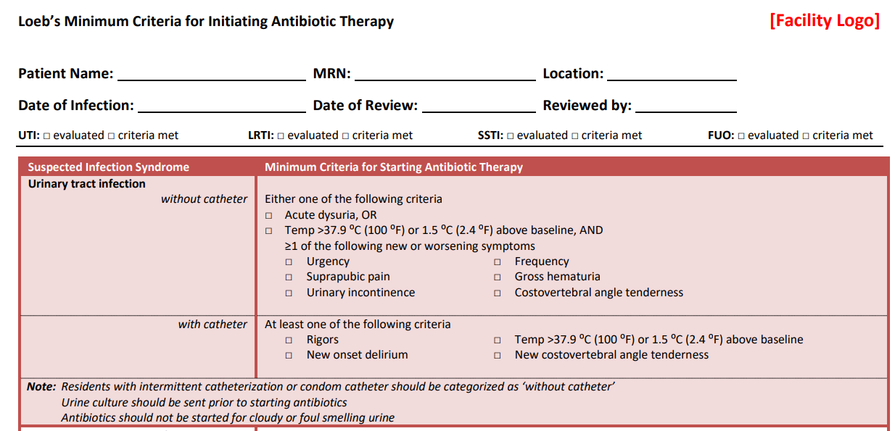

McGeer’s Criteria
