Press release Paris, October 14, 2026
Nexia S&A appoints three new partners
Nexia S&A announces the appointment of Victor Lelong, Nicolas Olivier and Laurent Ravoux as partners, effective September 1, 2026. Two appointments in Audit and one in Transaction Services strengthen the firm's support for listed groups, mid-sized companies, family-owned groups and LBO-backed companies. The group now has 65 partners.
These three appointments are part of Nexia S&A's growth trajectory: the firm has doubled in size in just a few years and now brings together nearly 680 professionals. They strengthen two core businesses of the group, statutory audit and transaction advisory, and reflect a demanding view of partnership: recognized technical expertise, practical knowledge of clients' challenges and a genuine contribution to collective development.
Victor Lelong has built his career within the group, which he joined in 2015. Nicolas Olivier has developed the Transaction Services practice alongside the partners since joining in 2021. Laurent Ravoux, who comes from an international firm, joined Nexia S&A in October 2025. All three share a track record of investing, beyond their engagements, in projects that are key to the group.
“These appointments fully illustrate the qualities we expect from our partners: recognized expertise, a thorough understanding of our clients' challenges and a strong commitment to the collective. The complementarity of their backgrounds, in Audit as in Transaction Services, strengthens our ability to support our clients across every dimension of their financial challenges.” Olivier Juramie, Chairman of Nexia S&A.
Three complementary backgrounds
Victor Lelong - Audit
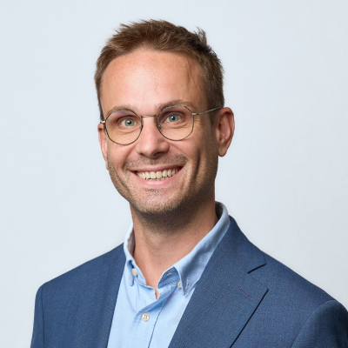
A graduate of IESEG, statutory auditor and chartered accountant, Victor Lelong joined Nexia S&A in 2015 and has accompanied every stage of the firm's growth over the past eleven years. He works mainly in statutory audit for clients of varying sizes and sectors, including listed groups, family-owned groups and LBO-backed companies. He has also taken part in Transaction Services and advisory engagements.
Alongside his engagements, he has been involved in several internal projects that are decisive for the group: business development, structuring of production tools and human resources. As an Audit partner, he now manages and develops a portfolio of statutory audit mandates and continues the group's business development initiatives.

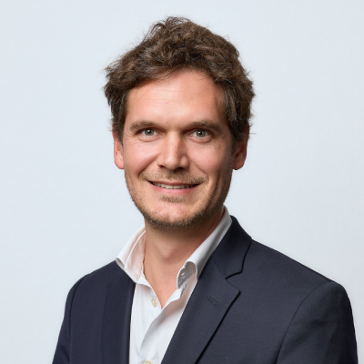
Nicolas Olivier - Transaction Services
A graduate of Audencia Business School and a chartered accountant (expert-comptable mémorialiste), Nicolas Olivier began his career in statutory audit at a major French firm, before joining a mid-sized player specializing in transactions. He joined Nexia S&A in 2021 in the Financial Advisory – Transaction Services practice.
Since then, he has led buy-side financial due diligence, vendor due diligence (VDD) and financial advisory engagements for companies across a range of sectors. He has also played a decisive role in the practice's business development, through targeted initiatives and by running a network of qualified contacts, and contributes to several internal projects, particularly in human resources. As a Transaction Services partner, he oversees all engagements of this service line in every dimension, including business development.
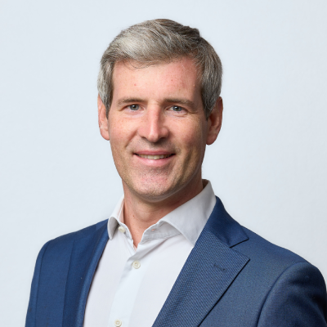
Laurent Ravoux - Audit
A graduate of SKEMA Business School, statutory auditor and chartered accountant, Laurent Ravoux joined Nexia S&A in October 2025 as a Senior Manager, after sixteen years in audit at an international firm. He has extensive experience in the statutory audit of groups of various sizes, notably mid-sized companies in the agri-food and retail sectors, as well as in the audit of consolidated financial statements under French GAAP and IFRS, and in internal control.
From the day he arrived, he became involved in the group's business development work. His appointment illustrates Nexia S&A's determination to attract experienced profiles and to entrust them quickly with responsibilities. As a partner, he is in charge of group mandates and contributes to the development of the Audit practice.
About Nexia S&A
Nexia S&A is a leading player in audit, accounting and advisory in France. The firm brings together nearly 680 professionals, including 65 partners, serving 5,000 clients - mid-sized companies, SMEs and family-owned groups - in France and internationally. As a guarantor of financial information and a strategic partner to its clients, Nexia S&A combines proven technical rigor with strong human values. A member of the Nexia network, present in nearly 120 countries, it supports its clients across the five continents.

Contacts

Olivier Juramie
Chairman
Tel.: +33 (0)6 03 67 57 59
Email: o.juramie@nexia-sa.fr
Jaimie Mayet
Marketing Director
Tel: +33 (0)6 27 19 22 96
Email: j.mayet@nexia-sa.fr

