MS Viking Lady
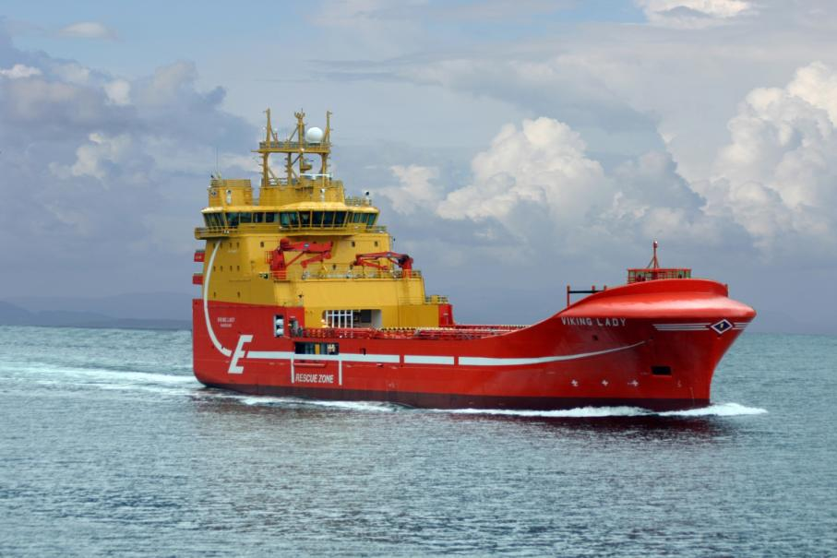
MS Viking Lady – 92m Platform Supply Vessel/LNG. Delivered in April 2009 by West Contractors AS, Ølensvåg, Norway as yard no. 30 to Eidesvik, Norway. The design is by Vik & Sandvik AS, Fitjar, Norway.

Principal particulars
Length o.a.: 92 m
Length p.p: 84 m
Breadth mid: 21,00 m
Depth to main deck: 9,60 m
Gross tonnage: 6125 GT
Speed: 15,5 knots
Class: DNV +1A1, supply vessel, SF, E0, DP AUTR, Gas fuelled, LFL*, Oil Rec, Clean Design, COMF-(V3), NAUT-OSV(A), Ice C. FiFi-1, dk (+) and HL(p)
MS Viking Lady

Dieselelectric Propulsion system
Main Motors: 4 x Wärtsilä 6R32DF 2010kW
Main Generators: 4 x Alconza NIR 6391 A-10LW 1950kW
Propeller system: 2 x Rolls Royce AZP 100FP
Electric motor: 2 x Alconza QD 560 M2-6W 2300kW

Sidethrusters: 2 x Rolls Royce TT2200 DPN FP 1200kW

Azimuth thruster: 1 x Rolls Royce ULE 1201 FP, 880 kW
Emergency diesel generator: Volvo Penta D9-MG-RC 160 kW

Electronical equipment
Radar 10 cm: Furuno FCR-2837S
Radar 3 cm: Furuno FCR-2837
ECDIS: Telchart Tecdis T2137
Autopilot: Simrad AP-9
Gyrocompass: Simrad GC-80
Speed log: Furuno DS-800
Dyn Pos System: Kongsberg K-Pos 2
Radar Transponder Jotron, Tron SART
Echo Sounder: Furuno FE 700
Sat Phone/fax Telenor V-Sat 4996
PA System: Zenitel type ACM
AIS: Furuno FA-150
GPS: Furuno GP-150
VDR: Furuno VR-5016
Sound reception sys.: Sento VSS-111
VHF: Sailor RT2048
Radio plant: Furuno GMDSS A3
MF/HF: FS-1570
VHF/DSC: FM-8800S
Inmarsatt C
Weather faximile: Furuno Fax-208A
VHF direction finder: TD-L 1550 A
Navtex receiver: NX700B
VHF Motorola GM360

Ship systems
Separators: Alfa Laval
Bulk Compressors: 2 x Atlas Copco TMS 200
Oily water separator: Ocean Clean EB 2,5
Vent./AC-arrangement: Aeron AS
Watermist plant: Marioff
Main alarm system: Wärtsilä Norway
Mob boat: Mako 655
Liferafts: 4 x Viking 25 DK
Bulk storage system Randaberg Sveiseindustrier AS
Ballastmonitoring: Wärtsilä Norway
Searchlights: Norselight 2000 W
Fire alarm: Eltek
Steering Gears: Rolls-Royce
Switchboard: 690, 440, 230V - Wärtsilä

Capacities
Fuel oil: 1000 m3
Fresh water: 993 m3
Methanol: 167 m3
Water Ballast: 3518 m3
Dry bulk: 318 m3
Accommodation: 25 men
Deck area: 945 m2
Deck load: 3450 tonnes

Deck equipment
Deck Crane: TTS 1 x GPK-80, 1 x GPK 260
Tugger winch: Karmøy Winch
Anchor windlass: Karmøy Winch

