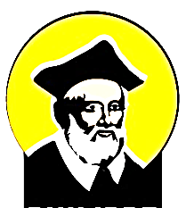

The Oratory of Saint Philip Neri London
Catholic Enquiry Group

Contact Form

(BLOCK CAPITALS PLEASE)

Name:

Contact Details (email):

Please mark one of the below:

( ) Not Baptised

( ) Baptised in a non-Catholic church
please write denomination here:

( ) Baptised Catholic, but not yet Confirmed

Protecting your privacy
Your personal details will be held securely on file and computer, treated as confidential, and used only to contact you as required for the purposes of this Enquiry Group.
If you decide to become a Catholic or to be Confirmed, after this takes place a written record will be kept in the Oratory Parish Register. You can read our full privacy policy at https://www.bromptonoratory.co.uk/privacy-and-cookies.

Signature:

Date:

