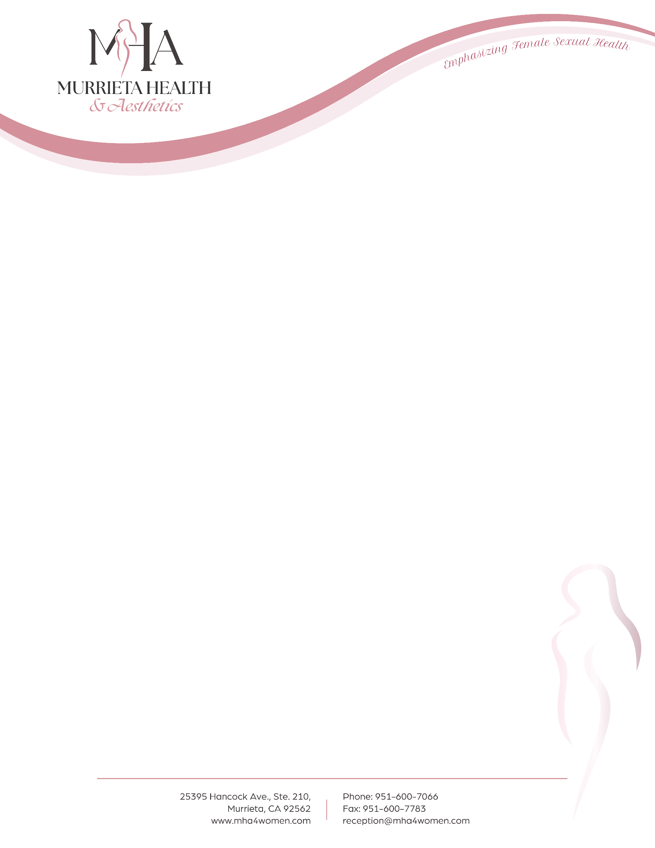

BLADDER DIET: THINGS TO TRY

ACCEPTABLE FOODS AND SUPPLEMENTS:
- Vitamin A (750-1200 mg daily)
- Magnesium (300 mg daily)
- Zinc (50 mg daily)
- Vitamin D (2000 iu daily)
- Whole wheat grains and unleavened breads
- Oatmeal
- Pumpkin and pumpkin seeds
- It is okay to eat the following fruits:
  - Berries of all types (blueberries, blackberries and raspberries, etc.)
  - Bananas
  - Watermelon
  - Pears
  - Papaya
  - Apricots
  - Cranberries and cranberry juice
- It is okay to eat any meats not on the “AVOID” list below. These include:
  - Eggs
  - Fish and seafood of all types
  - Lamb
  - Pork
  - Poultry
  - Most beef

OTHER RECOMMENDATIONS:
- Lose weight (5-10lbs makes a big difference)
- Walk 30 minutes a day
- Drink water when thirsty, but restrict fluids near bedtime
- Time your voids by urinating every 2-4 hours to keep your bladder from being too full
- If you are a smoker, stopping helps

BLADDER DIET: THINGS TO AVOID

FOODS AND SUPPLEMENTS TO AVOID:
- B Vitamin supplements
- Foods and supplements containing Vitamin C and ascorbic acid
  - This includes oranges, orange juice, grapefruits, lemons, and limes
- All fruits not on the “ACCEPTABLE” food list
- Avoid the following drinks:
  - Alcohol of any kind
  - Caffeinated beverages of any kind (coffee, tea, soda, etc.)
  - Carbonated beverages of any kind, including carbonated water
- Avoid the following meats:
  - Chicken livers
  - Corned beef
  - Pickled herring
  - Cured meats, such as salami and pepperoni, etc.
  - Canned or processed tuna
  - Canned or processed crabmeat
  - Bacon
  - Lunchmeats
  - Hot dogs
- Avoid the following dairy products:
  - Yogurt
  - All cheeses
  - Mayonnaise
  - Sour Cream
- Any foods containing sugar (chocolate, desserts, juices, sodas, etc.)
- Avoid all sugar substitutes (Stevia, sucralose, NutraSweet, saccharin, etc.)
- Vinegar
- Soy products (soy sauce, tofu, veggie patties, etc.)
- Spicy foods of any kind
- Tomatoes, tomato juice and tomato-based sauces
- Onions
- Avocados
- Nuts of any kind
- Fava beans
- Lima beans
- White bread and any bread containing brewer’s yeast or yeast extract

