Use Cases
- Welfare cabins (20’ & 40’)
- EV charging hubs (AC & DC)
- Remote compounds & construction sites
- Hybrid setups with HVO, hydrogen, or DNO grid
- Integration with iTrailer® mobile BESS
- Temporary site power & rapid deployment <1 day

Key Features
- 550W high-efficiency solar panels
- Fully integrated with iTrailer® 200kWh BESS & DC fast charge
- MPPT / Tigo optimisation with 5G & Starlink connectivity
- Precast bases or screw piles — minimal groundworks required.
- Rapid deployment, relocatable, and scalable
- ESG-aligned, BREEAM compatible, zero diesel burn.
- Proven in field — not just a concept.

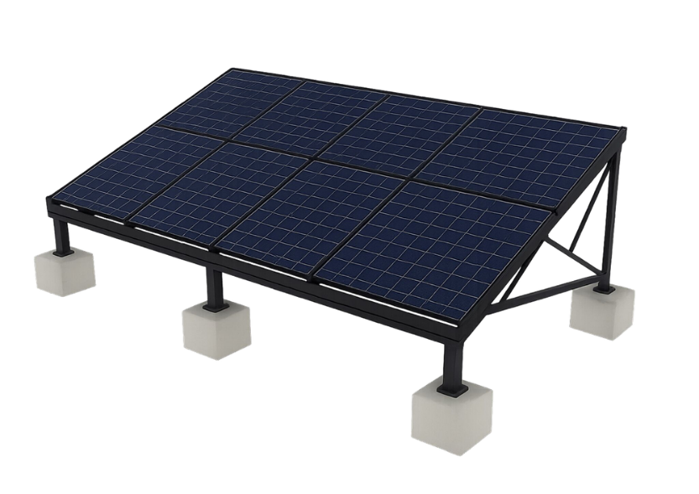
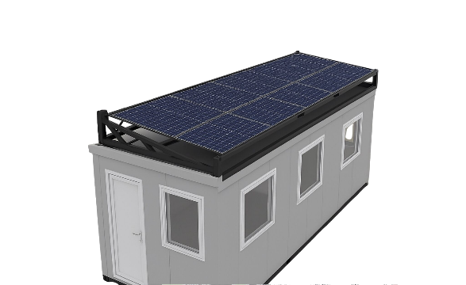
Remote Compounds
- Independent power with satellite connectivity
Emergency Response
- Rapid-deploy renewable microgrid.

Technical Specifications
- Panel size: 550W monocrystalline modules
- Capacity: Scalable from 10kW+ arrays
- 200kWh via iTrailer® integration
- Connectivity: MPPT, Tigo, 5G-ready, Starlink-enabled
- Rooftop or ground-mounted (precast base/screw pile)
- Compatible with hybrid power sources (HVO gensets, hydrogen fuel cells, grid-tie)

Commercial Benefits
- Eliminate diesel burn on welfare & compound setups.
- Unlock ESG credits and BREEAM compliance.
- Save £500–£1,200/week vs diesel gensets.
- Avoid temporary grid connection costs (£20k–£80k)
- Redeployable between sites — no stranded capex
- Enables permanent-performance power in temporary locations.

Case Studies
Construction Site
- Hybrid solar + storage for cabins & plant
Events & Festivals
- Silent, clean power supply for crew & charging
EV Charging Hub
- Renewable charging with zero-noise footprint

