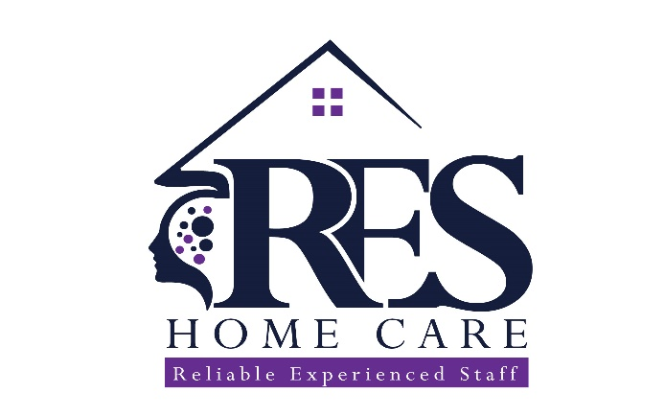

RES Home Care

Notice of Privacy Practices

Clients Name: ________________________________________
(PRINT)

RES Home Care

ACKNOWLEDGEMENT OF RECEIPT

I have received a copy of RES Home Care’s Notice of Privacy Practices.

__________________________________________
Signature of Consumer or Personal Representative

__________________________________________
Print Name of Consumer or Personal Representative

__________________________________________
Date

__________________________________________
Description of Personal Representative’s Authority
RES Home Care
NOTICE OF PRIVACY PRACTICES
Amended and Effective Notice Date: February 1, 2026

THIS NOTICE DESCRIBES HOW MEDICAL INFORMATION ABOUT YOU MAY BE USED AND DISCLOSED AND HOW YOU CAN GET ACCESS TO THIS INFORMATION. PLEASE REVIEW IT CAREFULLY.
RES Home Care is required by law to maintain the privacy and security of your Protected Health Information (PHI), to provide you with this Notice of Privacy Practices, and to follow the terms of this Notice currently in effect.
This Notice applies to all PHI maintained by RES Home Care, including information created or received before the effective date of this Notice.

CONTACT INFORMATION
HIPAA Compliance Officer
RES Home Care
1461 Lakeland Ave., Suite 12
Bohemia, NY 11716
Phone: 631-732-4794 x115
RES Home Care, we understand that your medical information about you and your health is personal. Our agency is committed to protecting your medical information. We are required by federal and state laws to maintain the privacy of your Protected Health Information (PHI) and to give you this notice explaining our privacy practices with regard to that information. This notice explains your rights and our legal obligations regarding the privacy of your PHI.
RES Home Care includes its staff providing services, employees, trainees, students, volunteers, and business associates) along with other agencies that jointly perform treatment, payment activities and/or health care operations within RES Home Care. You may obtain additional copies of this Notice by writing to RES Home Care at 1461 Lakeland Ave. Suite 12 Bohemia, NY 11716 or logging on to our website at www.reshomecareli.com.
Protected Health Information is information that individually identifies you. It may be used and disclosed by your physician, our staff, another health care provider, your health plan, your employer, or a healthcare clearing house that relates to (1) your past, present, or future physical conditions, (2) the provision of health care to you, or (3) the past, present, or future payment for your health care.
When RES Home Care uses or discloses PHI it is required to abide by this Notice (or amended Notice in effect at the time of the use or disclosure of PHI).
WHO WILL FOLLOW THIS NOTICE?
RES Home Care provide health care to Consumers jointly with physicians and other health care professionals and organizations. The privacy practices described in this notice will be followed by:
- Any health care professional who treats you as Consumer RES Home Care’s facilities.
- All employees, medical staff, trainees, students or volunteers at any of RES Home Care’s locations.
- All employees, medical staff, trainees, students or volunteers in the practice offices and other health care practitioners employed by RES Home Care (“Faculty Practice Offices”), or other facilities that are part of an organized health care arrangement performing treatment, payment or health care operations RES Home Care.
- Any business associates of RES Home Care (as defined in this Notice).

USES AND DISCLOSURES OF PHI
We may use and disclose PHI without your authorization for treatment, payment, and health care operations, including care coordination, quality improvement, and administrative activities.
We may also disclose PHI as required or permitted by law, including for public health activities, health oversight, law enforcement, judicial proceedings, abuse or neglect reporting, serious threats to health or safety, workers’ compensation, and other lawful purposes.
Redisclosure of Protected Health Information
Protected Health Information (PHI) disclosed by RES Home Care may be redisclosed by the recipient and may no longer be protected by federal privacy laws if the disclosure is not otherwise required or permitted by HIPAA.
However, certain types of PHI, including information related to substance use disorder treatment, psychotherapy notes, and other specially protected information, may be subject to additional federal or state confidentiality protections that limit or prohibit redisclosure.
BUSINESS ASSOCIATES
We may share PHI with business associates who perform services on our behalf. All business associates are required to safeguard PHI and comply with HIPAA.

MARKETING AND SALE OF PHI
RES Home Care does not sell your PHI. We will not use or disclose your PHI for marketing purposes involving financial remuneration without your written authorization. You may opt out of fundraising communications at any time.
SPECIAL PROTECTIONS
Psychotherapy notes, HIV-related information, and substance use disorder treatment records receive additional protections and will only be disclosed with your authorization or as permitted by law.
Substance Use Disorder (SUD) Treatment Records
Records related to the diagnosis, treatment, or referral for treatment of a substance use disorder are protected by federal law (42 CFR Part 2) and receive additional privacy protections beyond those provided by HIPAA.
RES Home Care will not use or disclose substance use disorder treatment records without your specific written authorization, except as permitted or required by law.
Permitted disclosures without your authorization may include disclosures:
- For medical emergencies;
- For research, audit, or program evaluation activities, as allowed by law;
- To public health authorities or other government agencies when required by law; or
- As otherwise permitted under 42 CFR Part 2.
Any disclosure made under these limited circumstances will be limited to the minimum necessary information required by law.
You have the right to revoke your authorization for disclosure of substance use disorder records at any time, except to the extent that action has already been taken in reliance on your authorization.
Reproductive Health Care Information
Protected Health Information (PHI) related to lawful reproductive health care receives additional protection under federal law.
RES Home Care will not use or disclose your PHI to:
- Investigate or impose criminal, civil, or administrative liability on any person for the lawful provision, receipt, or facilitation of reproductive health care; or
- Identify any person for the purpose of initiating such investigations or proceedings.
These protections apply when reproductive health care is lawfully provided, including care that is lawful in the state where it is provided.
RES Home Care may only use or disclose reproductive health care information for these purposes when required by law and only after receiving a valid, signed attestation that the request is not for a prohibited purpose, as required by federal regulations.
Nothing in this Notice prevents RES Home Care from using or disclosing PHI for:
- Treatment, payment, or health care operations, as permitted by law;
- Public health activities required by law; or
- Other uses or disclosures expressly permitted under HIPAA.

YOUR RIGHTS
You have the right to:
- Access and receive copies of your PHI, including electronic copies
- Direct PHI to a third party
- Receive access within 30 days as required by law
- Request amendments
- Request restrictions, including restrictions for services paid out-of-pocket
- Request confidential communication
- Receive an accounting of disclosures
- Be notified of a breach of unsecured PHI
Electronic copies will be provided without per-page fees. Fees, if any, will be reasonable and cost-based.

ELECTRONIC PHI AND SAFEGUARDS
We maintain PHI in electronic systems and use reasonable administrative, technical, and physical safeguards to protect it. No system is completely secure. You will be notified if a breach of unsecured PHI occurs as required by law.

CHANGES TO THIS NOTICE
We reserve the right to change this Notice and make the revised Notice effective for all PHI we maintain. The most current Notice will be posted in our office and on our website.
COMPLAINTS
You may file a complaint with RES Home Care or with the U.S. Department of Health and Human Services if you believe your privacy rights have been violated. You will not be retaliated against for filing a complaint.
U.S. Department of Health and Human Services
Office for Civil Rights
200 Independence Avenue, S.W.
Washington, DC 20201
Phone: 877-696-6775
Website: www.hhs.gov/ocr

You have the right to receive a paper copy of this Notice at any time.

