Customer Advocate Program Marketing Plan Outline
Background
This plan was developed by Point of Reference to help companies establish a formal customer advocate program. It is based on our experience working with clients with programs at various stages of evolution, but particularly those that came to us with little more than a desire to bring order to their chaotic customer reference practices. Many sections in the outline align to the 11 elements of our Customer Reference Program Maturity Model, thus the reference to Program Vision, Managing Upward, etc., to provide context within the model.
How to Use It
The outline is organized into 4 phases: I) Secure Program Approval, II) Launch Preparation and User Adoption Plan, III) Launch and User Adoption, and IV) Program Sustainability. We’ve done our best to document everything we’ve run across in our client experiences and organize everything first in a linear checklist format (this document). To reflect the timeline of events involved we also produced a simple Gantt chart format document where tasks may occur concurrently and synergistically with others. This view or format of the outline is contained in the corresponding Excel workbook. Note that the 11 elements of the Maturity Model appear in the first column of the workbook to provide a framework that ensures a comprehensive approach―a method to the madness. We hope these tools make your program planning less arduous, and help you avoid common pitfalls that occur when important activities are overlooked.
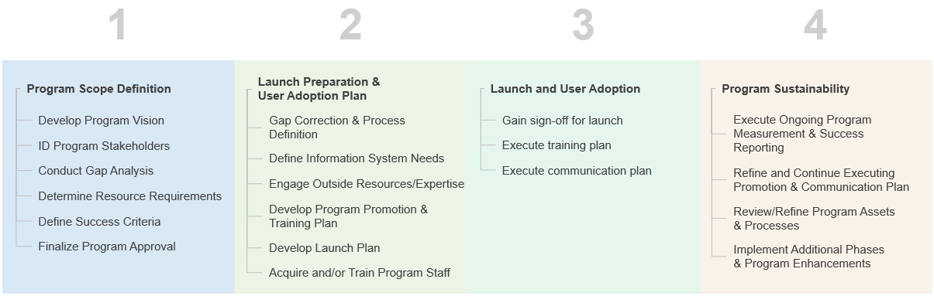

Program Scope Definition

Develop Program Vision (Program Vision)

Define program overview and objectives

Identify current pain and develop problem statement

Develop future state vision

Define success criteria

Develop program scope with prioritized phases if required (e.g., teams to be supported, advisory board, community, customer content, etc.)

Determine business impact and develop business goals

ID Program Stakeholders: Sponsors, Influencers, Users, and Champions

Identify Sponsors (Managing Upward)

What are your company’s top growth goals?

What are executives’ challenges in achieving those goals?

How can advocates “move the needle” toward those goals?

How are executives best accessed?

What does program success look like to them and how will you prove it?

What does program failure look like to them and how do you prevent it?

Who are the executive approvers and who are the influencers?

Determine executive sponsor(s) and form steering committee

Define executives’ role in change management

Identify Influencers (Horizontal Integration, Field Relationships)

Who are they?

What are their challenges?

What’s in it for them?

How are they best reached?

What does program success look like to them and how will you prove it?

What does program failure look like to them and how do you prevent it?

Identify Users & Champions (Horizontal Integration, Field Relationship)

Who are they?

What are their challenges?

What’s in it for them?

How are they best reached?

What does program success look like to them and how will you prove it?

What does program failure look like to them and how do you prevent it?

Solicit user feedback

Form a customer marketing program advisory board (sales, marketing, CS)

Conduct Gap Analysis (Customer Advocate Relationships, Content Strategy, Systems)

Take inventory of current program assets (customer advocates, content, systems)

Evaluate inventory in the context of top company growth goals

Match against needs gathered from stakeholders

Determine Resource Requirements
(Staff Composition, Organization & Perspective, Content Strategy, Outside Expertise)

Determine resource requirements to support program scope (people, systems, services and other program costs)

Determine additional resource needs

Develop budget requirements

Identify internal organizations and other support needed to make program successful (e.g., IT, Corporate Communications, etc.)

Define Success Criteria (Managing Upward, Horizontal Integration, Field Relationship)

Review user feedback

Validate pain points

Validate future state vision

Validate initial success criteria

Refine and finalize metrics by audience

Detail change management plan to individual users

Finalize Program Approval (Managing Upward)

Review program vision, approach and budget requirements with executive sponsor(s), change management plan and steering committee

Gain program approval

Launch Preparation and User Adoption Plan

Gap Correction and Process Definition (Content Strategy, Customer Relationships)

Develop prioritized approach to address content gaps

Develop prioritized approach to address customer gaps (recruiting plan)

Develop process flows, outputs, measurements and determine impacted functional areas (i.e., sales, PR, social, RFP)

Validate gap correction priorities and processes with focus group and influencers/champions in other groups

Develop plan to coordinate efforts between internal teams (events, PR, digital, etc.)

Develop ongoing plan to manage content (e.g., retire, update, archive)

Develop ongoing plan to maintain, cultivate customer relationships

Define Information System Needs (Information Systems)

Determine search and data requirements

Identify system needs to support requirements

Analyze state of current data

Develop data cleansing plan, as needed

Develop data exchange/synchronization plan, if required

Engage Outside Resources/Expertise (Outside Expertise)

Identify types and number of outside resources required based on gap analysis

Develop vendor requirements based on resource needs and requirements (people, systems, content, services)

Research potential vendors

Select vendor(s) based on requirements (check references :-))

Gain approval for vendor(s) selection from steering committee and executive sponsor(s)

Develop and implement plan(s) with selected vendor(s)

Develop Program Promotion and Training Plan (Program Promotion)

Executives (Managing Upward)

Determine frequency and communication channel(s)

Develop plan for executive assistance with promotion of the program

Determine use of champions to build/reinforce executive support

Identify training needs/vehicles (e.g., tools, dashboards, reports)

Build rewards program for end-users, secure budget

Execute pre-launch executive communication plan

Sales (Field Relationship)

Determine phases, frequency, and communication channel(s)

Establish focus group (a.k.a., program advisory board)

Design sales tool kit

Identify training requirements and training vehicles

Determine use of peer champions as part of plan

Identify adoption techniques such as incentives, contests, peer-to-peer training, viral communications, etc.

Execute pre-launch sales promotion and training plan

Other Identified Organizations (Horizontal Integration)

Determine phases, frequency, and communication channels

Identify training requirements and training vehicles

Establish focus group(s)

Determine use of peer champions as part of plan

Identify adoption techniques such as incentives, contests, peer-to-peer training, viral communication, etc.

Execute pre-launch other organization promotion and training plan

Customers (Customer Reference Relationships)

Determine frequency and communication channels (e.g., newsletters, customer communities, Slack channels, etc.)

Identify participation techniques/customer benefits (e.g., roadmap participation, executive access, rewards, etc.)

Design Program Branding (Program Promotion)

Develop branding (i.e., name, look & feel)

Incorporate branding elements into promotional plan

Determine promotional premiums

Develop Launch Plan

Develop milestones and timelines (including soft launch if appropriate)

Document checkpoint and sign-off process

Confirm launch plan with steering committee and executive sponsor(s)

Acquire and/or Train Program Staff (Staff Composition, Organization & Perspective)

Hire and orient new program members

Training both internal and external resources

Train on processes (e.g., effective reference use) and systems

Launch and User Adoption

Gain sign-off for launch

Execute training plan

Execute communication plan

Program Sustainability

Execute Ongoing Program Measurement and Success Reporting (Program Metrics)

Evaluate and refine success criteria

Evaluate and identify metric changes

Refine and Continue Executing Promotion and Communication Plan (Program Promotion)

Add new communications vehicles as identified (e.g., events, meetings, Slack channels, etc.)

Reach additional internal groups, spread awareness

Extend program awareness/reach internally

Review rewards program and refine as needed

Review/Refine Program Assets and Processes (Content Strategy, Customer Relationships, Systems)

Perform ongoing content and customer gap analysis

Execute plan for ongoing customer relationship building and cultivation

Update systems in use to support needs of users

Update trainings of all users as processes/systems evolve

Evaluate process requirements

Implement Additional Phases and Program Enhancements

Execute additional program phases

Execute feedback process

Identify and gain approval for program enhancements

Implement program enhancements

