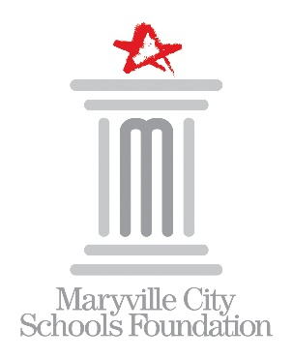

MARYVILLE CITY SCHOOLS FOUNDATION

2026-2027 Board of Directors Nomination Form

Mission: to support the ongoing enrichment of educational programs for all students in Maryville City Schools

Deadline: April 7, 2025

Thank you for your interest in nominating an individual for consideration for election to the Maryville City Schools Foundation Board of Directors. MCSF is a 501(c)(3) organization governed by its Board of Directors. Members of the Board are elected to serve a term of four (4) years. Your nomination will be considered for any Board seats becoming vacant in the 2026-2027 fiscal year.

Nominator Name: Click or tap here to enter text.

Phone: Click or tap here to enter text.
Email: Click or tap here to enter text.

NOMINEE INFORMATION:
Name: Click or tap here to enter text.

Address: Click or tap here to enter text.
City: Click or tap here to enter text. State: Click or tap here to enter text. Zip Code: Click or tap here to enter text.
Work: Click or tap here to enter text. Mobile: Click or tap here to enter text.
Email: Click or tap here to enter text.
Occupation/Employer: Click or tap here to enter text.
MHS Alumnus: ☐Yes ☐No Year: Click or tap here to enter text.
Check all schools where Nominee will have children attending during the 2026-2027 academic year.
☐FHE ☐JSE ☐SHE ☐CGIS ☐MRIS ☐MJHS ☐MHS ☐MVS
Skills: (check all that apply)
☐ Communications/PR ☐ Legal
☐ Estate Planning/Planned Giving ☐ Marketing
☐ Event Planning ☐ Organizational Development
☐ Financial Management ☐ Organizational Governance
☐ Fundraising ☐ Strategic Planning
☐ Human Resource/Personnel ☐ Web Design

Additional community involvement:
Click or tap here to enter text.

Please give a brief statement of support explaining why you think this person would make a great addition to our board.
Click or tap here to enter text.

Submit nomination form to:

Mary Beth Martin
520 S Washington St
Maryville, TN 37804
865-982-7121
mary.martin@maryville-schools.org

