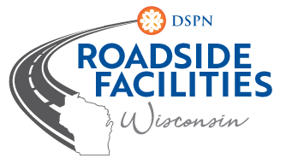
Roadside Facilities
Invoicing Training
Wednesday, July 28, 2021
9:00 a.m. – 12:00 p.m.

Seminar Hosted on Zoom

Check Your e-mail From ZOOM for the Link to Register
You Must Register to Receive the Link to the webinar

- Welcome! (Susan McCann) (9:00 a.m. – 9:05 a.m.)
- FY22 AWP Invoicing Changes Overview (Susan McCann and Pat Karlen) (9:05 a.m. – 9:15 a.m.)
- FY22 RAM Invoicing Form – Review (Susan McCann / attendee participation) (9:15 a.m. – 10:00 a.m.)
- FY22 RAM Invoicing – Submitting monthly invoices (Susan McCann) (10:00 a.m.-10:10 a.m.)
- Q & A (Susan McCann & Pat Karlen) (10:10 a.m. – 10:30 a.m.)

10 Minute Break (10:30 a.m. – 10:40 a.m.)

- FY22 SWEFM Invoicing Form – Review (Susan McCann / attendee participation) (10:40 a.m. – 11:00 a.m.)
- FY22 SWEFM Invoicing – Submitting monthly invoices (Susan McCann) (11:00 a.m. – 11:10 a.m.)
- Q & A (Susan McCann and Pat Karlen) (11:10 a.m. – 11:30 a.m.)

Handouts:
- Invoicing sections of RAM program manual (Chapter 11) and SWEFM program manual (Section 7)
- NEW RAM Invoicing Workbook
- SWEFM Invoicing Workbook

