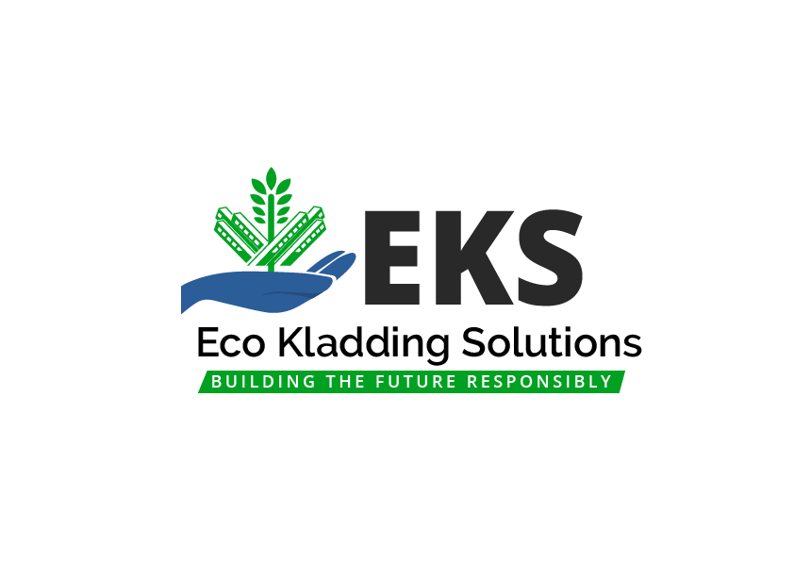
EKS Panel Finishes — ACM & Steel-Core Panels
Exterior and interior finish capabilities. The examples shown are a small sample of the available palette.
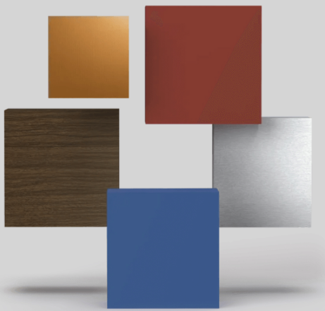 | 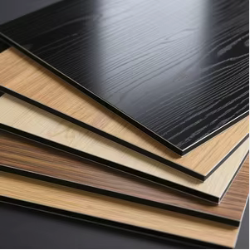
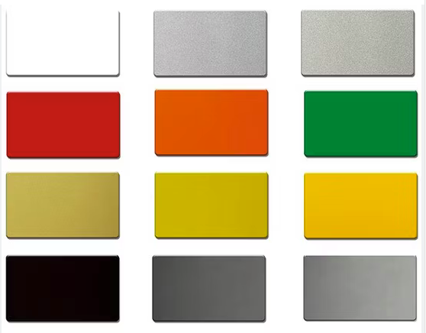 | 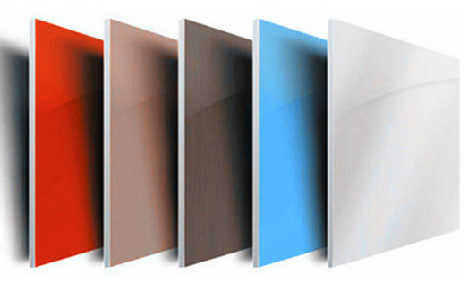

Finish Families
• Solid & Matte • Metallic & Mica • Brushed/Anodic look • High-Gloss • Textured/Embossed • Woodgrain & Stone/Concrete visuals • Anti-graffiti clear coats • Custom RAL/PANTONE matches.

Processes We Support
• Architectural coil coating (PVDF/FEVE) • Powder coat • Film lamination & sublimation (wood/stone) • Digital print with protective clear • Baked-enamel touch-up program.

Performance & Compliance
• UV stability and colorfastness for façade duty • Abrasion & impact resistance • Salt-spray and humidity durability • Fire performance up to Class A* • Warranty programs available. *Final ratings depend on complete assembly, substrate, and local code approvals.

Panel Compatibility & Options
• ACM: 3 mm / 4 mm / 6mm architecture-grade.
• Steel-Core Sandwich Panels: 0.45–0.76 mm faces, multiple cores; interior and exterior skins.
• Sheen levels: matte 10–20, satin 30–50, gloss 70+.
• Emboss patterns: smooth, stucco/pebble, woodgrain.
• Edge finishing, bends, and formed profiles supported.

Color Matching & Sampling
Rapid draw-downs and production-grade samples available on request. For brand programs, we lock down master standards and manage batch-to-batch delta-E control.
Eco Kladding Solutions — 416 899 6060 • rob.c@ekssolutions.ca • ekscanada.com

