

Does Underwater Research Interest You?
Presenting
Acoustic System Development and Experimental Platform
A Universal Platform for Under-Water Research
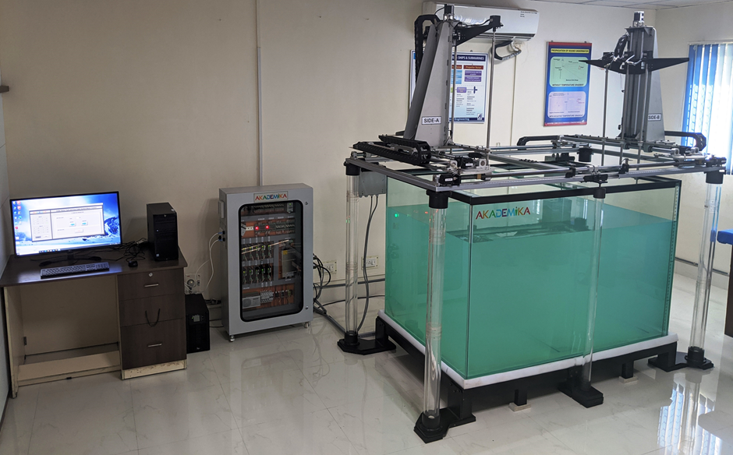
Akademika has designed an Electromechanical Platform for the Professor and Students to carry out Under-water Research activity at the comfort of Laboratory environment.
Be it Under-water communication or testing of various transducers/ sensors our Acoustic System Development and Experimental Platform is a perfect platform for you to carry out your research activities.

SYSTEM OVERVIEW

AKADEMIKA’s Acoustic System Development and Experimental Platform is an Electro-mechanical system having automated 12 AXIS of motion support and 4 degree of freedom along with water tank to carry out underwater experimentation/research in the lab environment.
ASDEP consists of a Mechanical Gantry made up of aluminum extrusion profiles. This frame structure supports transport system and transducer guide rail. Structure is placed over 15mm soft glass water tank of size 6’ x 4’ x 4’ with separate support over the ground.
This System has provision to hold over all six external sensors / transducers and the holding coupler is custom designed based on the users Sensor dimensions. All the external sensors has motion in X, Y and Z direction as a group and each one rotating about its own Axis by 360 Deg..
This System is provided with a Control Panel which is an electrical interface between the Gantry and the Motion Control Software using Lab View.
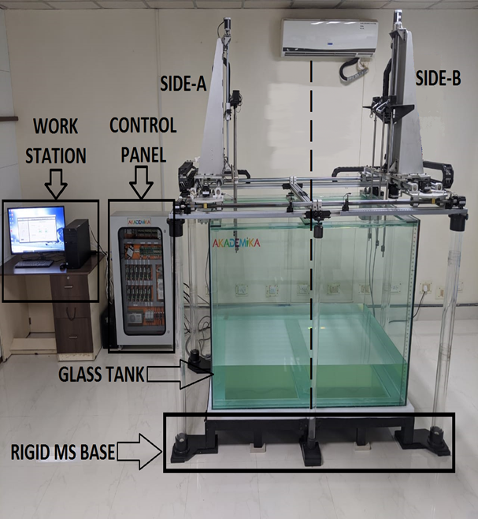
TECHNICAL SPECIFICATIONS
Glass Water Tank with Rigid MS Base
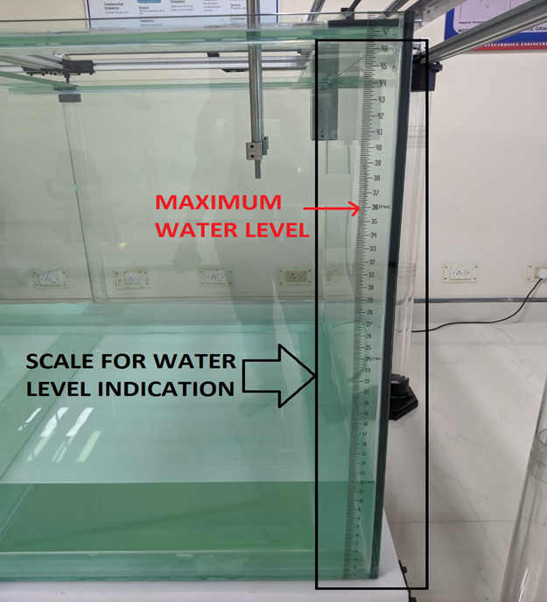
Water tank is made up of soft glass with wall thickness of 15mm and Dimension of 6’ x 4’ x 4’. It will be open from the top. It is designed to withstand maximum of 2,000 Kg weight of water. Scale is provided on the Water Tank for level indication. Maximum recommended water Level for this Tank is 3 Feet. To control water temperature, heater rod installation provision is made.
A rigid lightweight metal platform is provided to hold water filled glass tank of size 6’ x 4’ x 4’. A cushion is provided at the top of the platform to avoid direct contact of metal and glass bottom. Cushion also serves absorber for the mechanical vibrations.
Anti-Vibrations pads are used beneath the legs of the Rigid MS Base.
Mechanical Gantry:
Frame: Extruded Aluminium
Lead Screw Mechanism for Linear Motion, Pitch: 2mm
X- AXIS MOTION : Maximum Traverse 610 mm
Y- AXIS MOTION : Maximum Traverse is 430 mm and Minimum Traverse is 280 mm
Z- AXIS MOTION : Maximum Traverse 650 mm
Rotational AXIS : Maximum Angular movement of 360 Deg.
Holders for external Sensor : Deldrin
Holding Capacity: 1 Kg
Holder Length: 2.5’ with Telescopic Adjustment max up to 1.5’ which allows
maximum span of 4’

SIDE – A and SIDE – B of the Mechanical Gantry has 6 Stepper Motors each for X – Y – Z MOTIONS as shown in the below figure
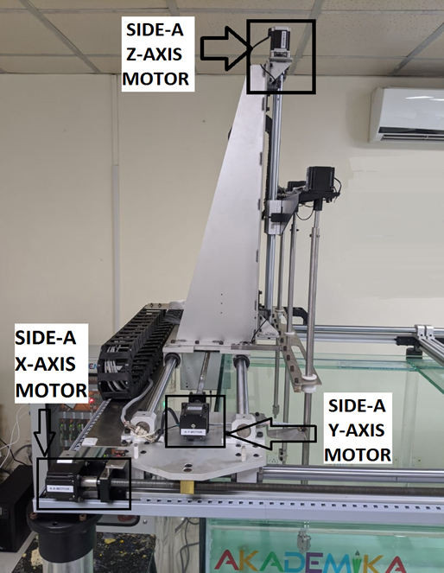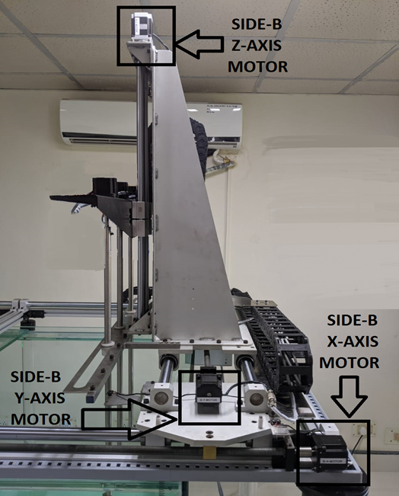
6 Motors support Rotational Motion SIDE-A (R1, R2, R3) and SIDE-B (R4, R5, R6) as shown in the below Figure
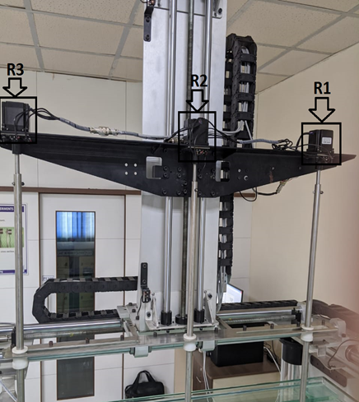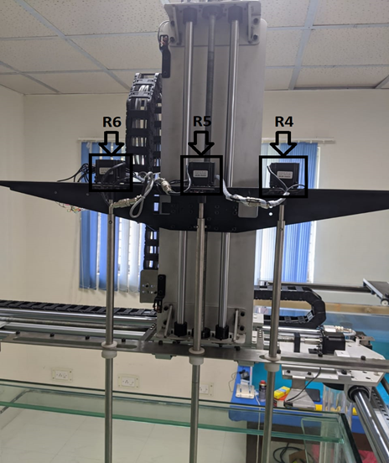
X-Y-Z Motions are achieved using Lead Screw mechanism having pitch of 2mm.
For X and Y AXIS the System uses a 20 Kg Stepper Motor and for Z and Rotational AXIS the system used a 10 Kg Stepper Motor.
Electrical Control Panel:
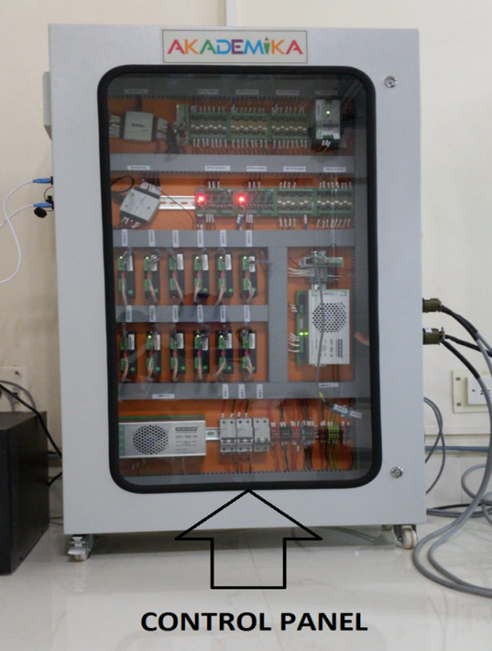
- 2 No of National Instruments 24 Digital I/O Cards
- 2 No Programming Logic Controller ( PLC )
- 7 No of Opto Isolator Cards
- 12 No of Stepper Motor Drives
- 1 No of SMPS-1 – 24V DC , 2.5 A
- 1 No of SMPS-2 – 24V DC , 20 A
- 1 No of SMPS-3- 36V DC , 16 A
- 3 No of MCB

Advanced Motion Control Software- Optional Upgrade
A Motion Control Software exe based on LabVIEW is provided along with the System as a Test / Demo program to Test the Motion of all Axis.
An Advanced Motion Control Software can also be custom designed as an Optional upgrade based on a specific application

Deliverables
- 6’X4’X4’ Water Tank mounted on a Rigid MS Base – 1 No
- Mechanical Gantry with 12 AXIS of Motion - 1 Set
- Control Panel – 1 No
- Akademika Motion Control Software (Test/Demo Version) – 1 No
- 2W Heaters – 1No
- ½ HP Water Pump – 1 No
- Inlet pipe – 12 feet
- Outlet pine – 100 feet
- Set of Manuals – 1 No

Esteemed Customers Using our Platform
- INS- Valsura ( Ministry of Defence )
- Indian Naval Academy ( Ministry of Defence)

