Video Transcript

Metropolis – Pay Operations including Cashier Troubleshooting
This document supports the Metropolis – Pay Operations including Cashier Troubleshooting training video and includes a word for word account of each screen captured and its supporting text.
Venue staff may find this document useful to reference if they want to review the content of the training video.
It is recommended that the training video be watched as it does include videos of various activities that cannot be viewed in this document.

SLIDE | IMAGE | VIDEO SCRIPT
1 |  | Welcome to the Metropolis Training Video.
2 | 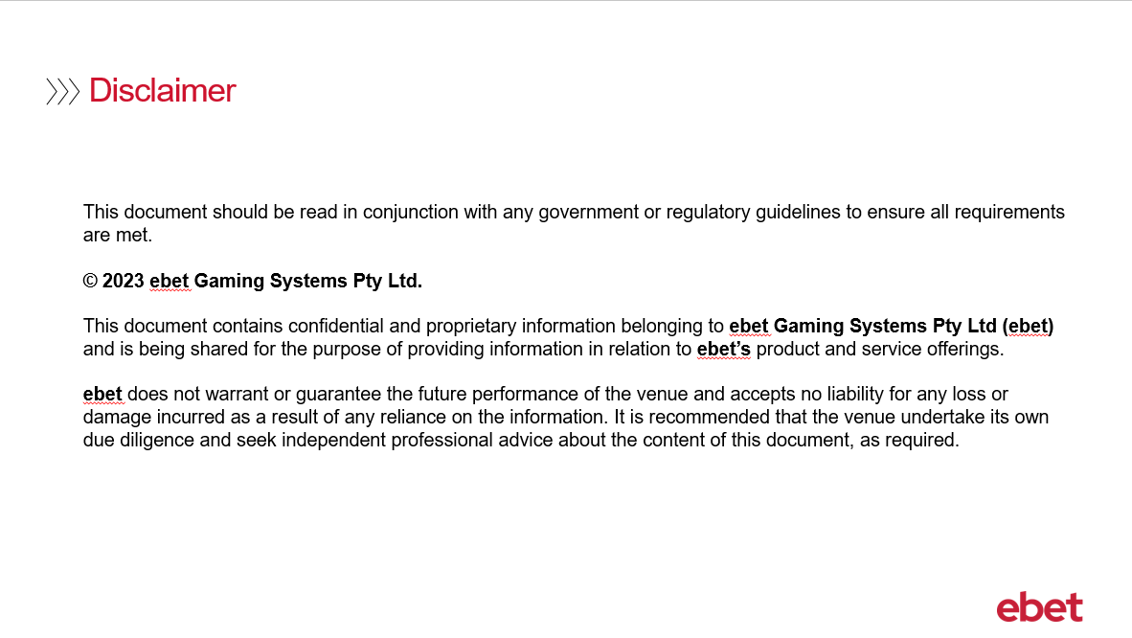 | No script available for this slide.
3 | 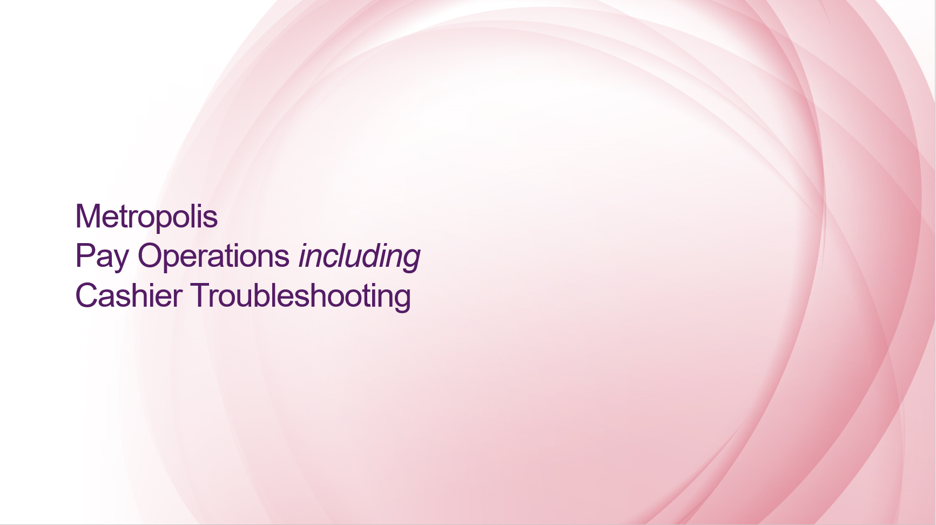 | The following training is specifically geared to cashiers and supervisors. It is expected that supervisors have investigated issues experienced by the cashier so that they can continue to process the ticket payout.
4 | 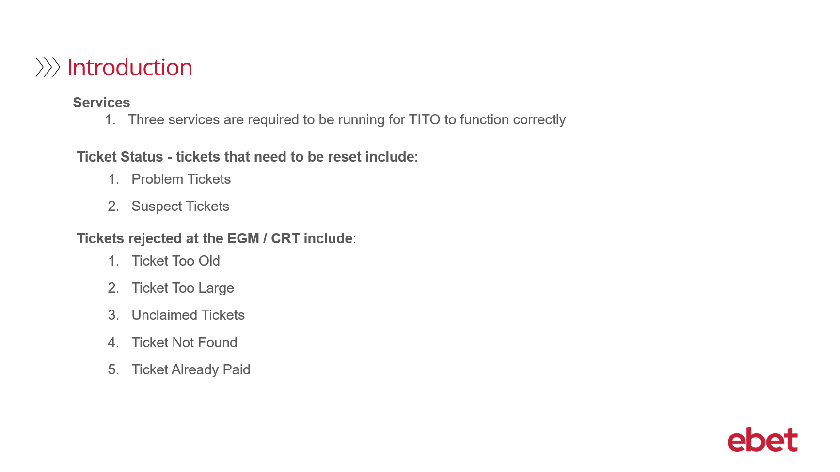 | This is an overview highlighting the topics that will be covered in the following 8 slides  Services  - If the services aren’t running TITO won’t work  Problem Tickets  - Problem tickets won’t be accepted in the EGM or the CRT  - Note however that there are different status number’s which will flag what the problem is and what subsequent action is required  Ticket Rejects  - Tickets that are flagged as a reject won’t be accepted at the EGM or the CRT
5 | 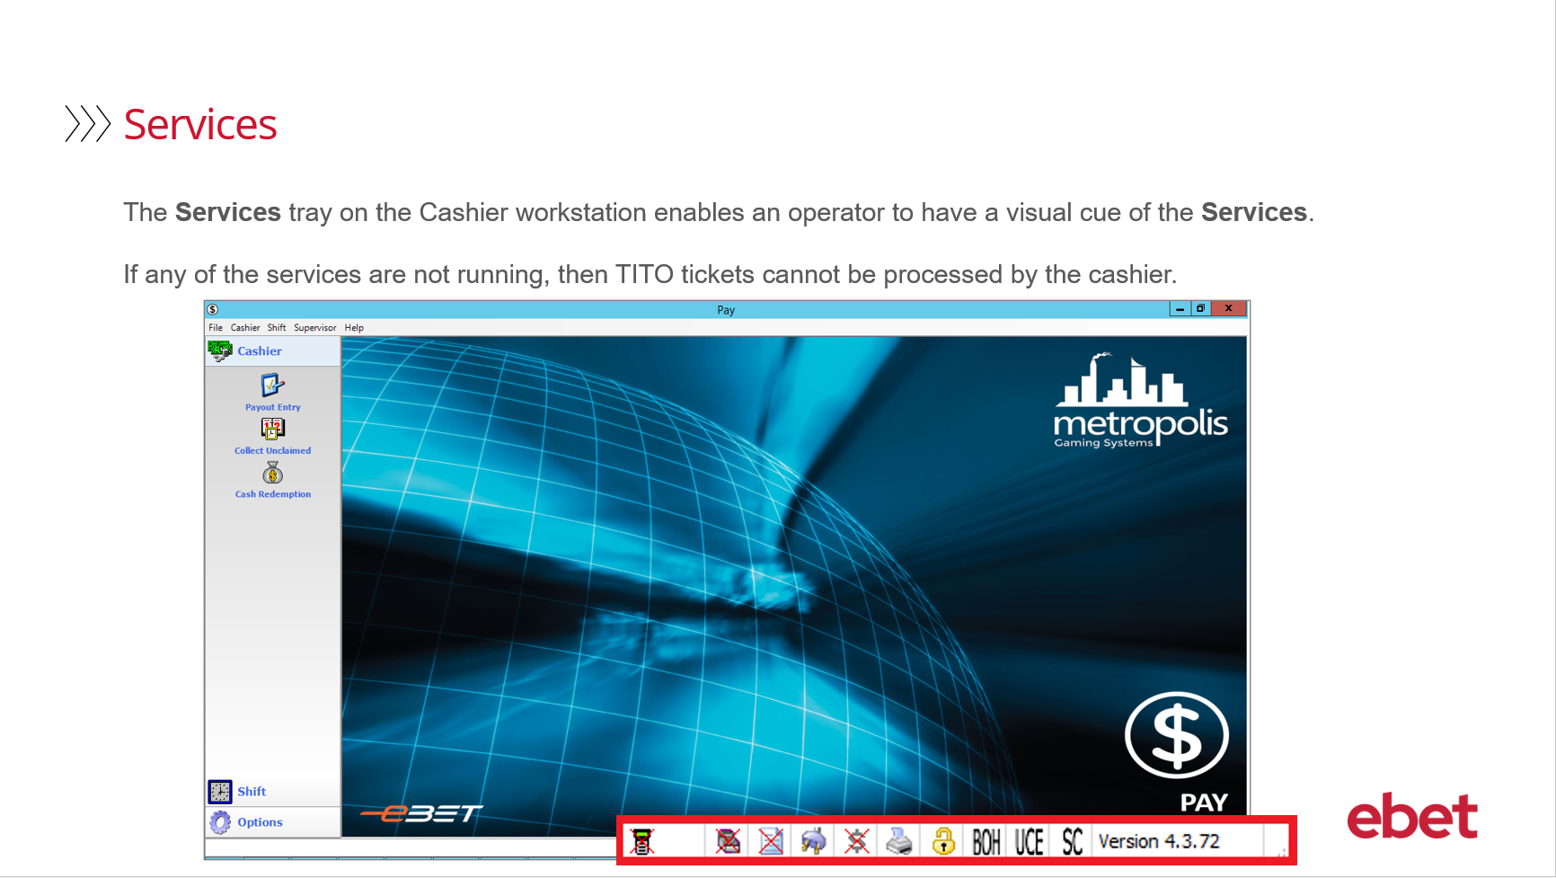 | At the cashier when using the Pay application, the Services tray is located on the bottom right-hand corner. This provides the operator with a visual cue of the Services and their current status.
6 | 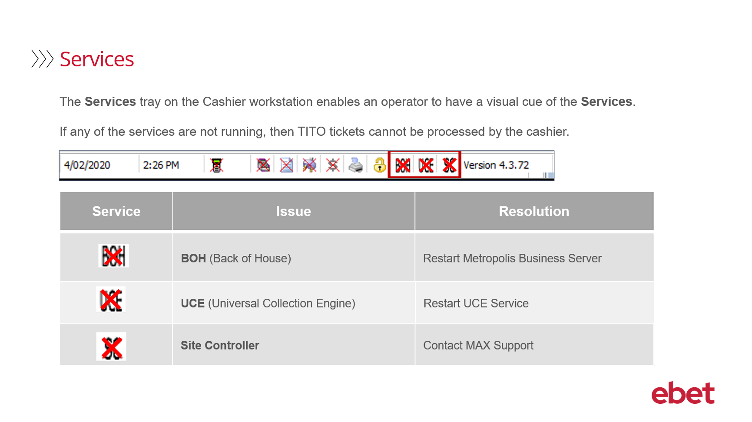 | If any of the Services are not running, then a RED cross will appear through the Service. This means that the TITO system is offline, and tickets cannot be issued or collected at any redemption point including the cashier.  To resolve the issue with the Services, they are separated into 3 categories:  - The first is BOH - which stands for back of house – if the connection is lost - the FIX is to restart the Metropolis Business Server. This is located in the Services icon on the Server.  - The second is UCE - which stands for Universal Collection Engine – if the connection is lost – the FIX is to restart the UCE Service. This is also located in the Services icon on the Server. If you need assistance to restart either of these Services, please contact ebet Support.  - and then the third is SC – which stands for Site Controller. This is Intralot hardware. If the connection is lost – contact ebet Support.  We also advise that all TITO related issues must be reported to ebet Support and if Intralot assistance is required - ebet Support will contact them direct.
7 | 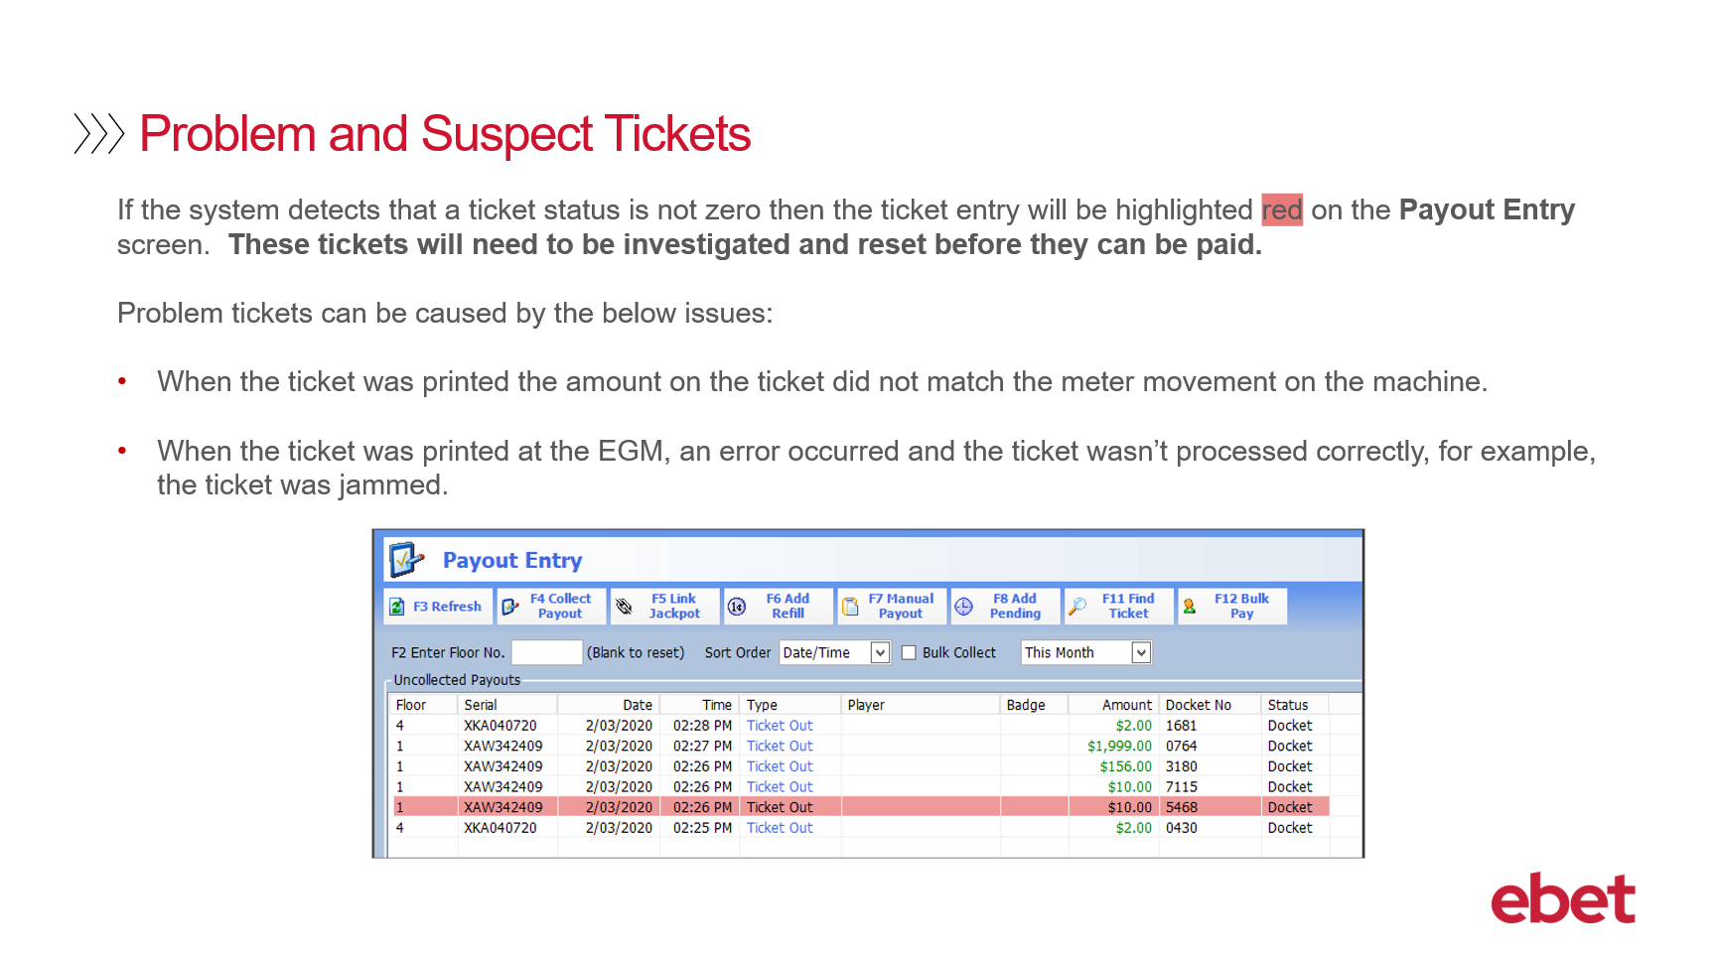 | - When a ticket is processed - if the ticket is successful then in the Metropolis database it will have a status code of zero  - If there is an issue with the transaction and the status code is not zero - then in the Pay application, it will be flagged as a problem or suspect ticket and highlighted in red. Managing TITO tickets in Pay will be covered in more detail in the Introduction to TITO Training.  When there is a problem or suspect ticket, a venue will need to decide if they will be:  - Proactive – and investigate a Problem Ticket that is highlighted OR  - be Reactive – and wait for the ticket to be presented to the cashier and then a Supervisor will be required to investigate.  - It is important to note that problem and suspect tickets will not be accepted in EGM or CRTs.  Some examples of problems tickets could be:  - When a ticket was printed - the amount on the ticket did not match the meter movement on the machine OR  - When a ticket was printed at the EGM - an error occurred during the transaction and the ticket was not processed correctly - for example, the ticket was jammed in the machine.  When the problem or suspect ticket is scanned at the cashier the Ticket Problem box will open
8 | 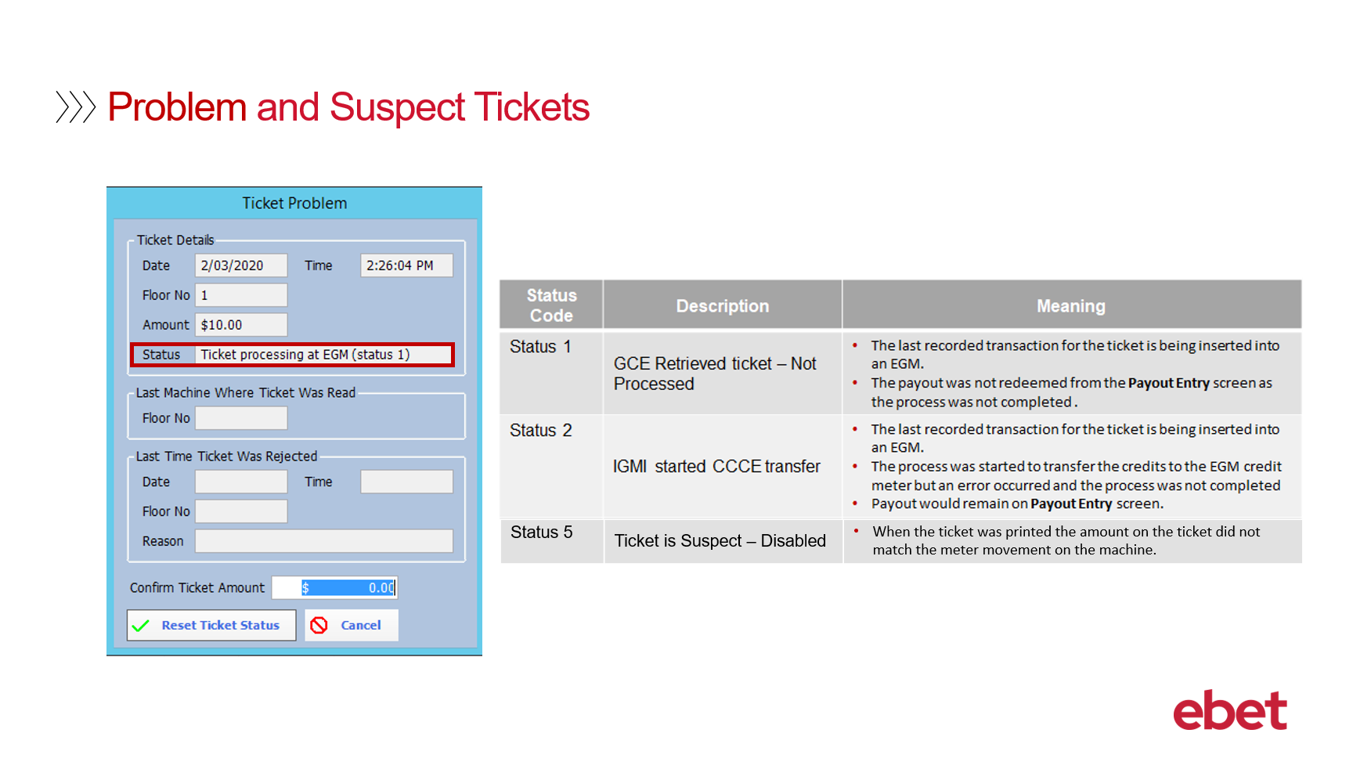 | This screen will provide you with the status code and its applicable error for you to action accordingly.  Status 1 refers to the GCE Retrieved ticket – Not Processed which means that the ticket was inserted into the EGM and the payout was then not redeemed from the Payout Entry screen. The transaction was therefore not completed.  Status 2 refers to the IGMI started CCCE transfer which means that the ticket was inserted into the EGM – the credit transfer to the meter commenced but an error occurred leaving the credit on the ticket and the payout remained on the Payout Entry screen. The transaction was therefore not completed.  and finally, Status 5 refers to Ticket is Suspect – Disabled which means when the ticket was printed from the EGM it did not match the meter movement on the machine.  Once the ticket is investigated the cashier can then proceed
9 | 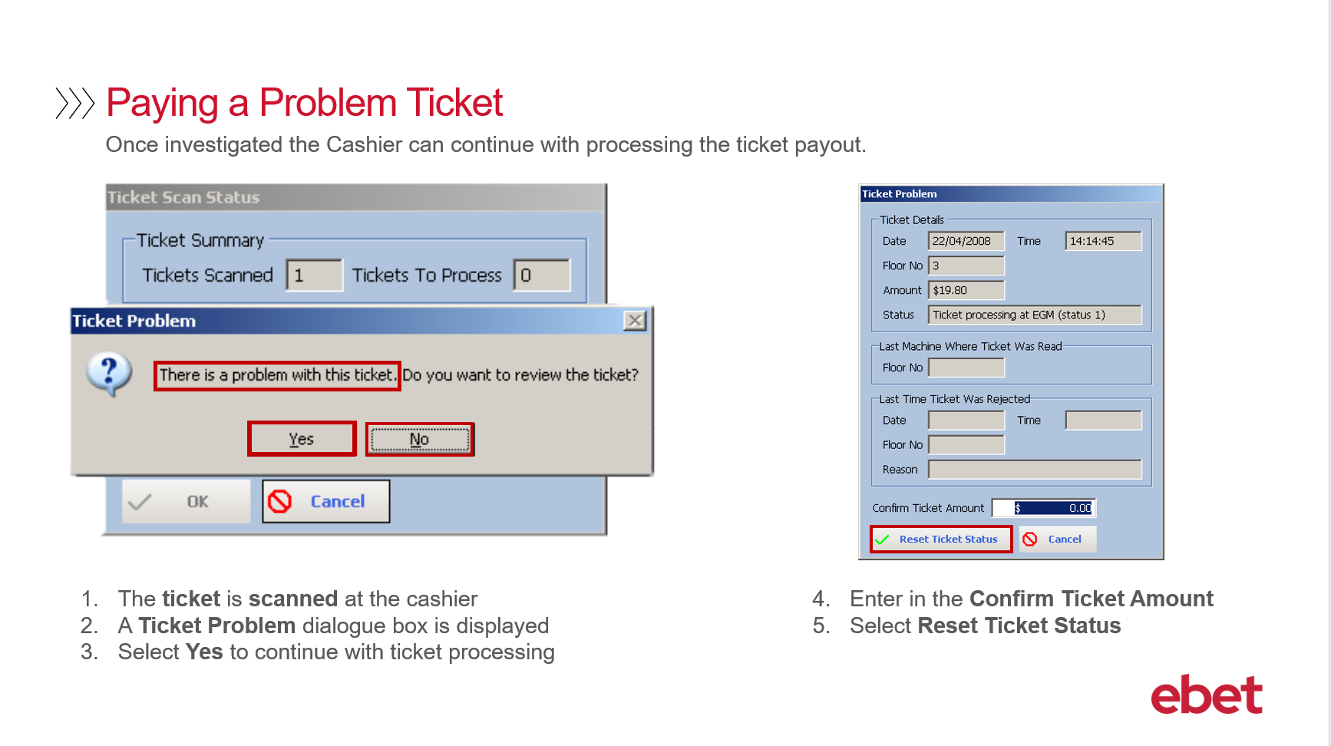 | The following demonstrates how to process and pay out a Problem Ticket.  - The ticket is scanned at the cashier  - And then the Ticket Problem dialogue box will display  The suggested practice would be for the supervisor OR manager to generate an Audit Report to confirm that the payout is valid before resetting and paying credits  Selecting:  - Yes, will open the Ticket Problem dialogue box which will allow you to Reset the Ticket Status and pay the credits  - Or if No is selected the dialogue box will close and allow you to cancel the transaction until further investigation has occurred  - Let’s select YES and then select the Reset Ticket Status box
10 | 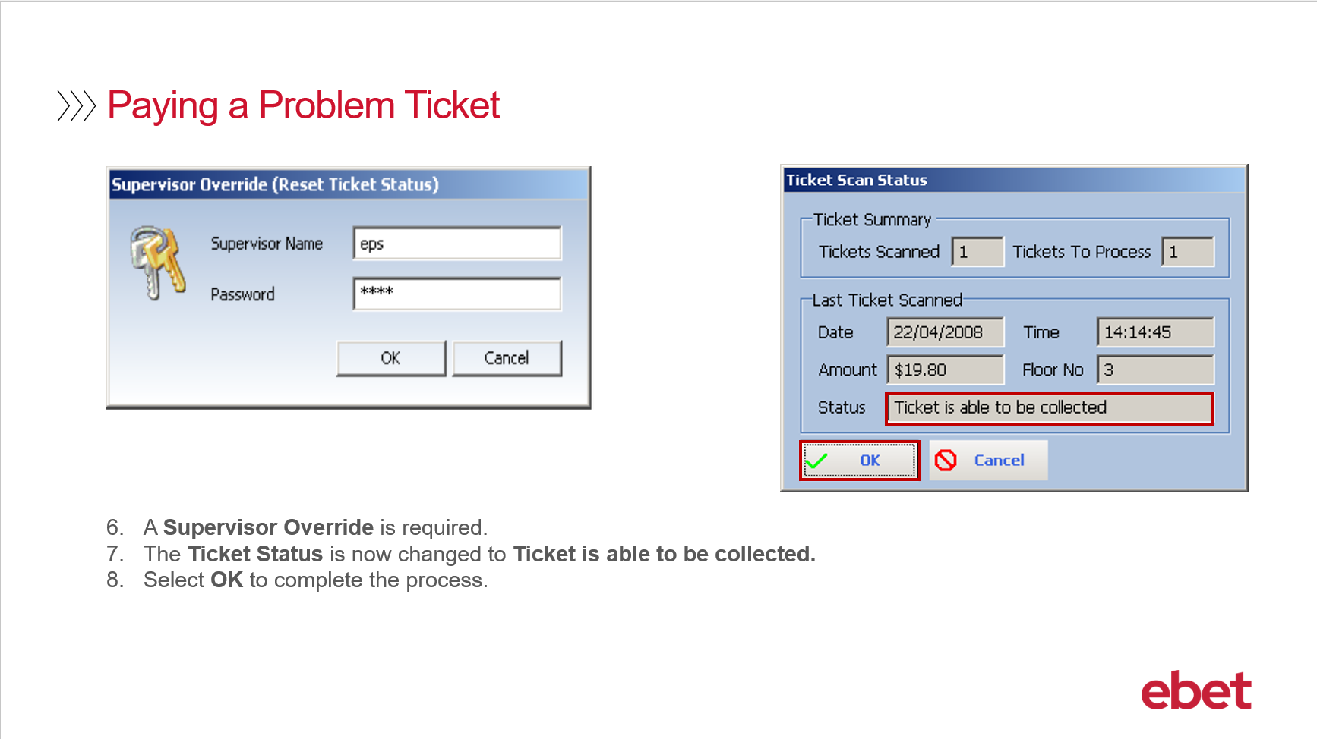 | - A Supervisor Override will be required  - The Status of the ticket will be changed to “Ticket is able to be collected”  - Select OK and process as normal
11 | 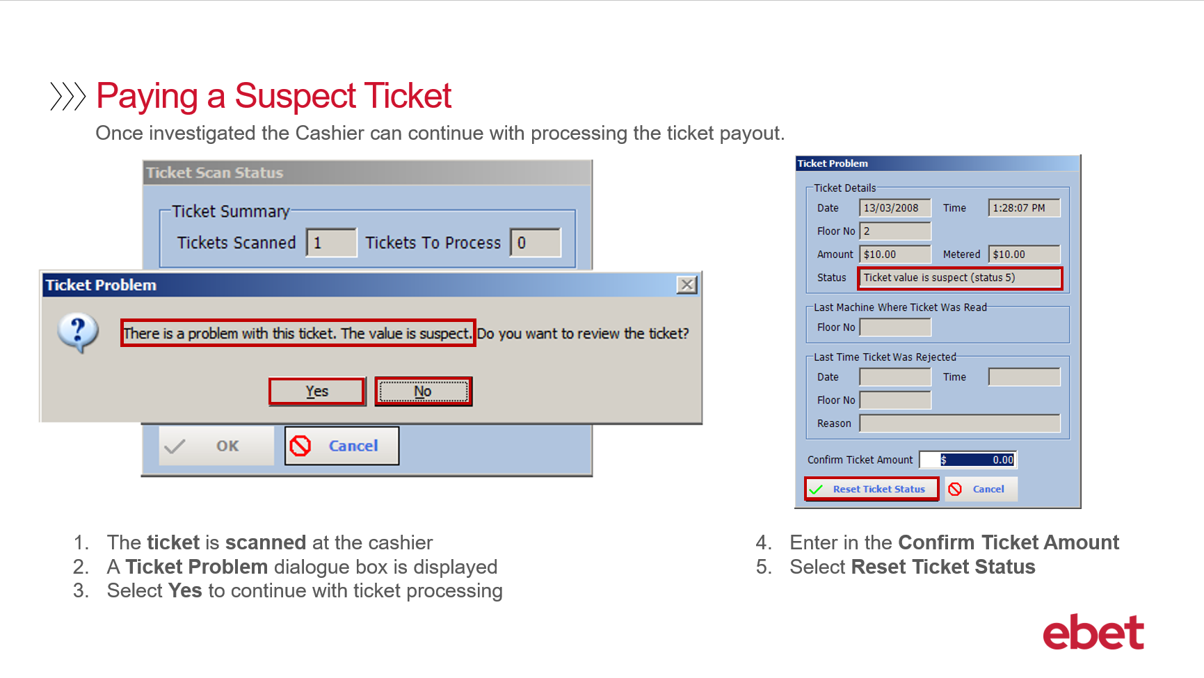 | Paying out a Suspect Ticket is the same procedure as paying out a Problem Ticket.  - The ticket is scanned at the cashier  - And then the Ticket Problem dialogue box will display  The suggested practice would be for the supervisor OR manager to generate an Audit Report to confirm that the payout is valid before resetting and paying credits. Selecting:  - Yes, will open the Ticket Problem dialogue box which will allow you to Reset the Ticket Status and pay the credits  - Or if No is selected the dialogue box will close and allow you to cancel the transaction until further investigation has occurred  - Let’s select YES and then select the Reset Ticket Status box
12 | 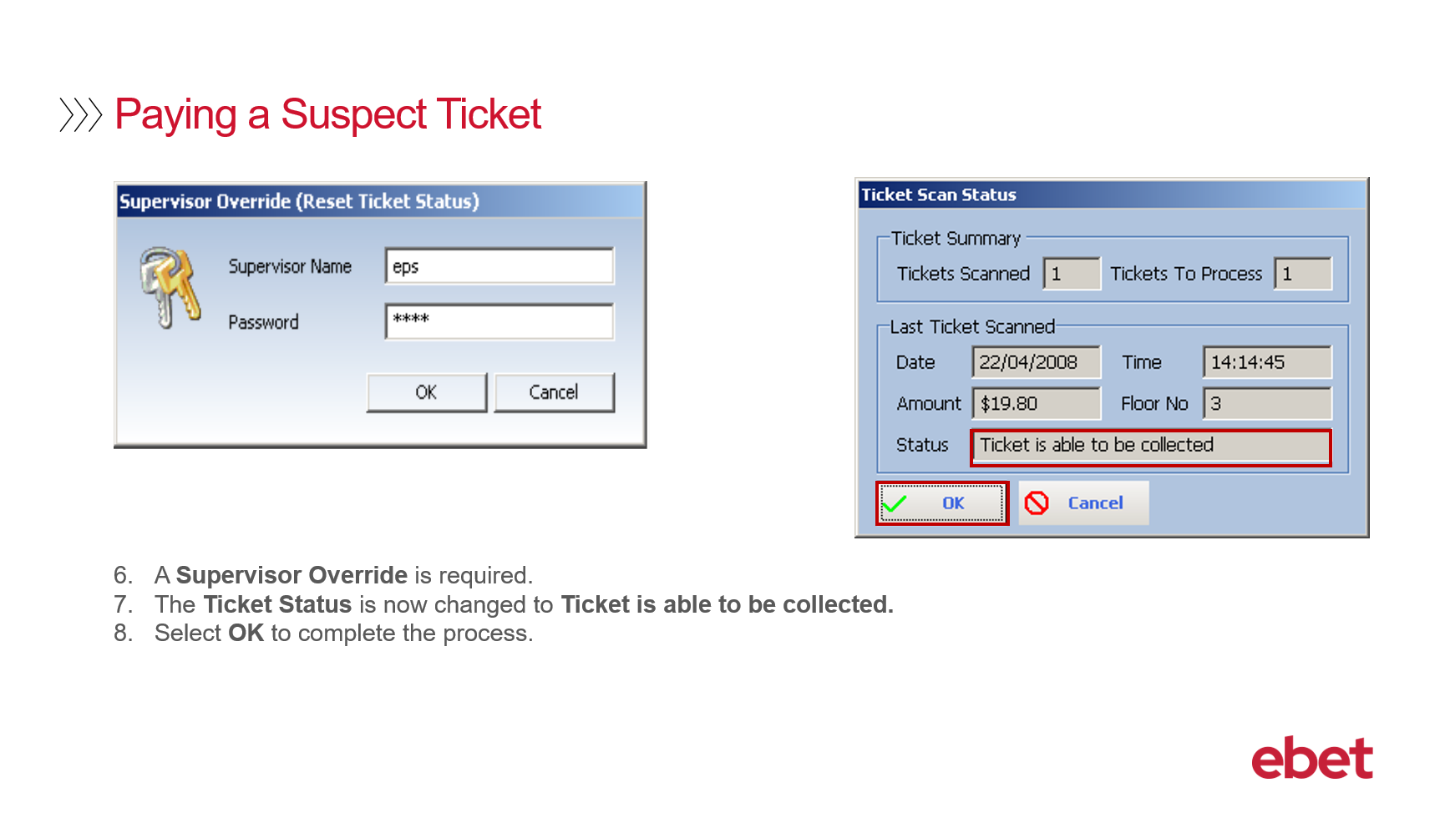 | - A Supervisor Override will be required  - The Status of the ticket will be changed to “Ticket is able to be collected”  - Select OK and process as normal
13 | 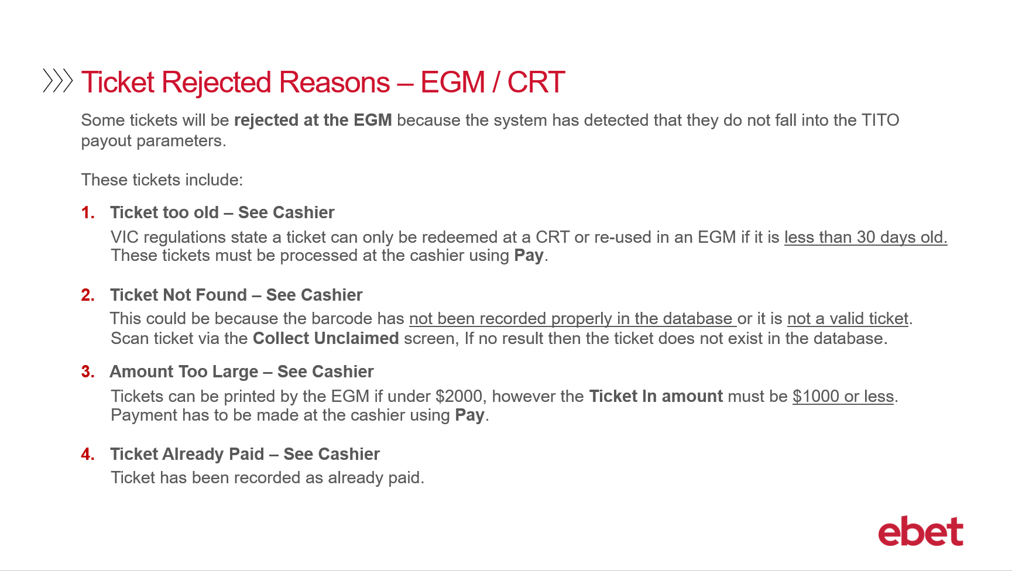 | When a patron inserts their TITO ticket into the EGM or the CRT, the Metropolis system might detect an issue with the ticket. As a result - the patron will experience one of the following Ticket Rejected messages which will appear on the screen of the EGM or CRT. These messages will act as a prompt for the patron to seek assistance.  - Ticket too old – See Cashier  In Victoria the regulation states, that a TITO ticket can only be redeemed at a CRT or re-inserted into an EGM if it is less than 30 days old. Tickets that have passed the 30 days must be processed at the cashier using the Metropolis > Pay application.  As mentioned in the Introduction to TITO video, this time frame can be customised - so if you would like it to be set for a lesser time period – for example 5 days – then please advise the ebet Team at the time of your TITO implementation or alternatively you can contact ebet Support for assistance at any time.  - Ticket Not Found – See Cashier  This occurs when both systems - Intralot and Metropolis - do not recognise the barcode on the TITO ticket. This can occur if the barcode has not been recorded properly in the databases - or it is not a valid ticket. To investigate this error, the ticket can be scanned at the cashier workstation using the Pay application. If there is no result, then the ticket did not exist in the database and may be fraudulent or from another venue.  - Amount Too Large – See Cashier  Similar to a book pay or cancel credit - a TTTO ticket MUST be under $2000 to be printed from an EGM. However, the Ticket in Amount must not exceed $999.95. If the ticket is over $1000.00 then the ticket will be required to be processed at the cashier workstation using the Pay application.  - Ticket Already Paid – See Cashier  The ticket barcode has been recognised by the system as being already paid and there is a collection record that already exists for the ticket.
14 | 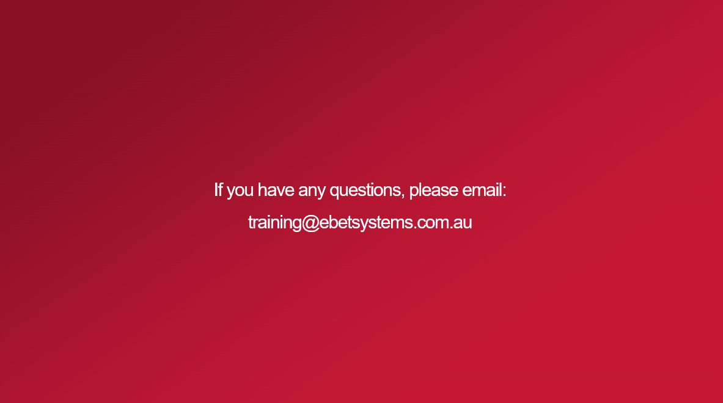 | This brings you to the end of the Metropolis Pay Operations including Cashier Troubleshooting Training video.  If you have any questions regarding the content of this training course - please email - training@ebetsystems.com.au.

