Video Transcript

Metropolis including TITO
This document supports the Metropolis including TITO training video and includes a word for word account of each screen captured and its supporting text.
Venue staff may find this document useful to reference if they want to review the content of the training video.
It is recommended that the training video be watched as it does include videos of various activities that cannot be viewed in this document.

SLIDE | IMAGE | VIDEO SCRIPT
1 |  | Welcome to the Metropolis Training Video.
2 | 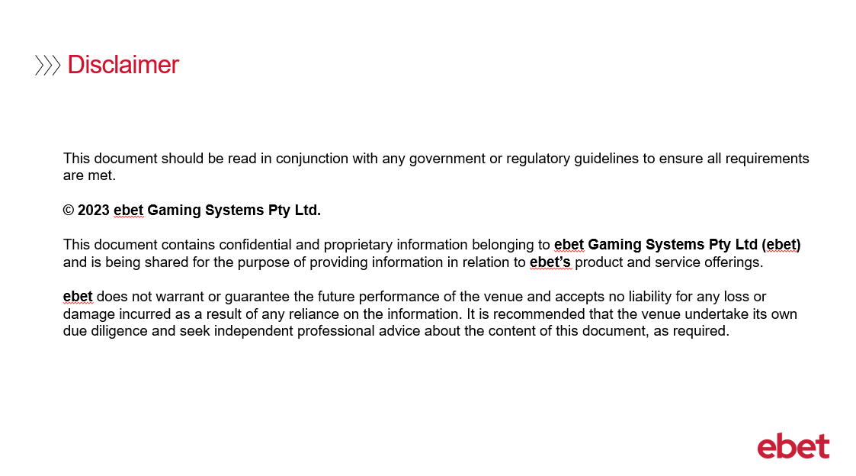 | No script available for this slide.
3 |  | With the introduction of Ticket in Ticket Out into your venue this session will focus on TITO functionality covering the various Metropolis applications that will be used.
4 | 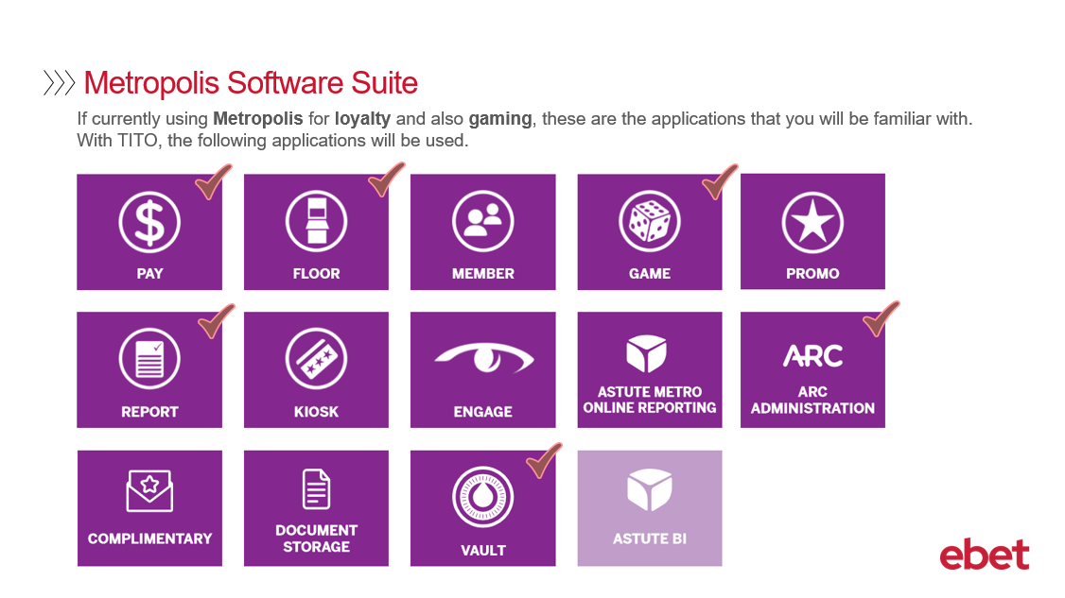 | If you are a venue currently using the full Metropolis software suite for loyalty and also gaming, you will be familiar with its applications.  With the introduction of TITO functionality, the applications that will be used for TITO include:  - Pay  - Floor  - Game  - Report  - Arc Administration  - and finally Vault
5 | 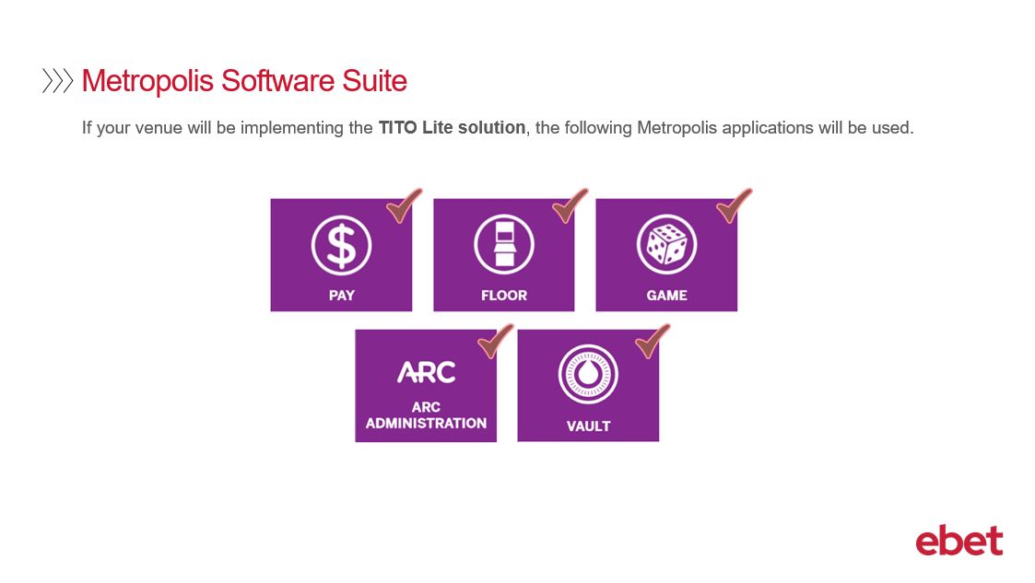 | Alternatively, if your venue will be implementing the Metropolis TITO Lite solution - the applications that will be used include:  - Pay  - Floor  - Game  - ARC Administration  - and Vault  So, let’s take a closer look at each of these applications to get a better understanding of how the TITO functionality is used by each of them.
6 | 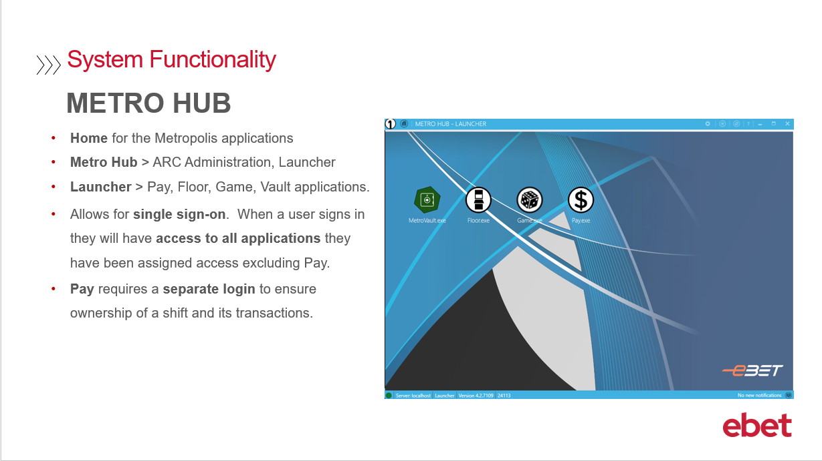 | To begin with when accessing Metropolis - the Metro HUB will open.  The HUB is the home of the Metropolis applications with direct access to ARC Administration.  As well as ARC there is also the Launcher icon. When this is selected a further menu will open where Pay, Floor, Game and Vault applications can be accessed.  The HUB has been designed to allow for single sign-on. This means - that when a user signs in, they will have open access to all the applications that they have been assigned access in ARC Administration. This stops the need to sign into each application.  Pay however - is the only application that still requires a separate login as this ensures ownership of the cashier shift and the transactions for that cashier.
7 | 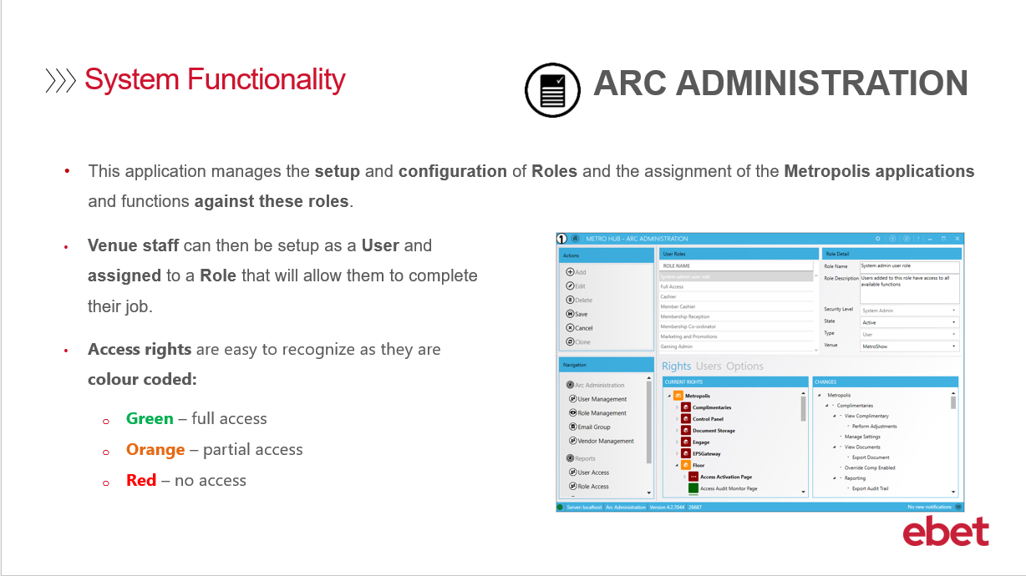 | The first application to cover is ARC Administration. This is used to:  - Setup and configure the venues Roles - for example Cashier, Supervisor or Management - and the assignment of access to the various Metropolis applications.  - In addition - it is also where you can setup staff as Users - so they can then be attached to the Role that is relevant to their job. This will ensure that they only have access to the areas of the software that is applicable to them.  - Something to consider - is that users can be setup individually - or you may want to setup a generic login.  Access rights are easy to recognise as they are colour coded. Green is for full access - and has no restrictions, Orange is partial access - so some functions are available - and Red is no access at all - so staff are restricted and unable to access the function.  This is also the place to assign Supervisor Rights - which will allow selected staff to have a higher level of access to specific areas in the system compared to general staff.
8 | 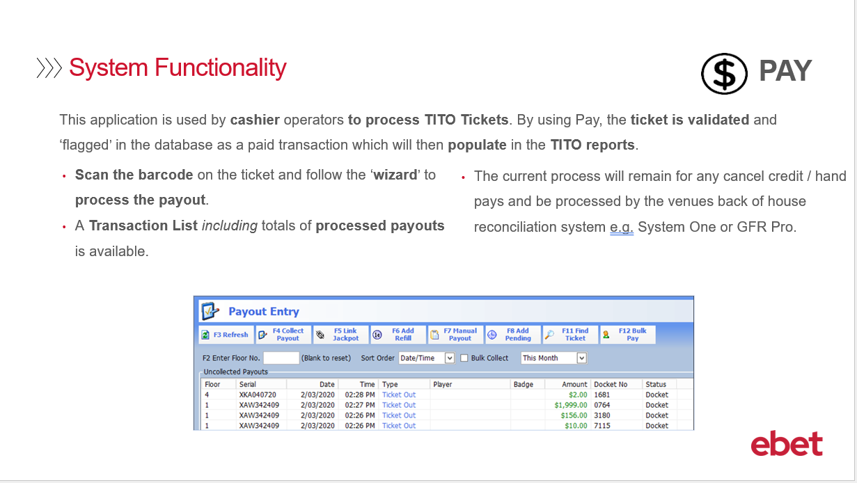 | Moving onto the Pay application.  This is where the cashier operator will be able to process a TITO ticket. As part of this process - the ticket will be validated and ‘flagged’ in the Metropolis database as a paid transaction and will populate values in the Metropolis TITO reports.  Let me explain the process in more detail:  - When a patron is at the EGM and presses the collect button a ticket with a barcode will print – this will also add a TITO ticket payout into the Payout Entry screen  - The patron will then approach the cashier and present their TITO ticket for payment  - At this time, the cashier will scan the ticket and the Payout Wizard will automatically launch prompting the cashier to follow the wizard by confirming the details of the payout and then proceed to process the transaction.  Once the transaction is completed the payout is removed from the Payout Entry screen and it is added to the Transaction List where it is now included in a total of processed payouts for that shift.  Your current process for managing cancel credits and hand pays will remain the same and will still be processed by your back of house reconciliation system.
9 | 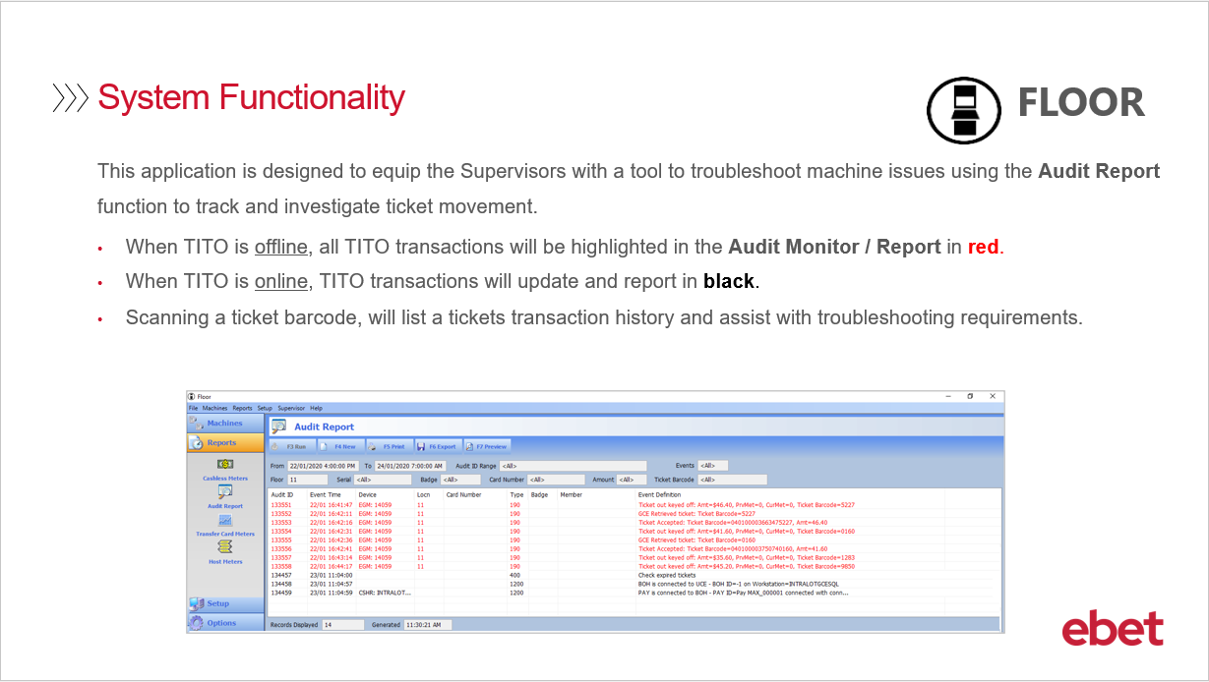 | Now onto the Floor application:  Floor is designed to help your Supervisors troubleshoot machine issues by using the Audit Report function which will allow them to track and investigate ticket movements.  From the Reports menu select the Audit Report where you can generate a custom audit search to trace machine event logs – as well as track ticket movement through the machines – which is basically the journey of the ticket.  Further information about using the Audit Report is covered in more detail in the TITO Troubleshooting Training Video.  When looking at the Audit Report – it is easy to identify when TITO is offline as the TITO transactions will be in red.  In reverse – when TITO is online the transactions will update and report in black.  Finally, when using the Audit Report tool, you can scan the barcode on the ticket to list its transaction history, this is useful when investigating the ticket and its activity.  Let’s now take a look at the Game application.
10 | 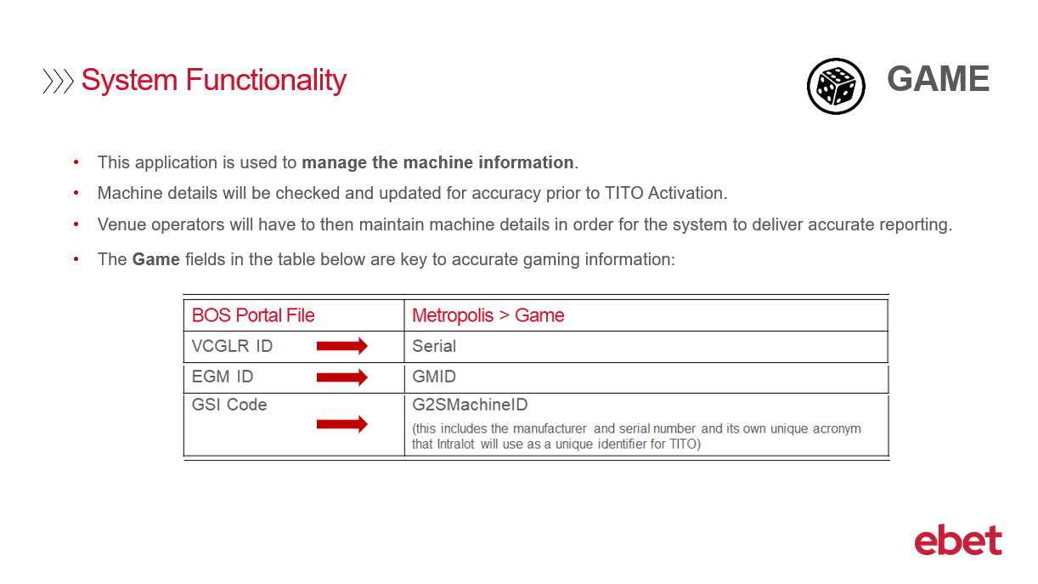 | Game is the application that is used to manage all machine information.  As part of your TITO implementation your machine details will be checked and confirmed by the ebet Team prior to your TITO go-live. Having this machine information accurate in Game is necessary to ensure that TITO functions correctly and populates your reports accurately.  In order for the system to continue to deliver accurate reporting, it is the venue’s responsibility to maintain machine details during future machine moves or installs at the venue.  To assist with interpreting the different terminology between the BOS Portal file and Metropolis Game - this table highlights key information that will need to be populated:  - In the BOS Portal file – the VCGLR ID field is known in Metropolis Game as Serial  - The EGM ID is known as GMID and the  - GSI Code is G2SMachineID  The G2SMachineID – is a unique acronym of the machines serial number and Intralot coding. This field will self-populate when the technician activates the Pathway on the EGM by inserting a tech card and entering in the IP address.  Although this field does not need to be maintained by your venue, we advise at the time of machines changes for you to check that the G2SMachinesID field is not blank or that the information provided is accurate.  If the G2SMachineID field has failed to populate correctly during the deployment, you can locate this information by downloading the BOS Portal Machine Listing. Once you have the correct information you can then edit the relevant fields in Game.  Game will also record the end of day meters and ticket clearance figures which will allow venue operators to have access to daily reports to assist with clearance and banking figures.  Let’s now take a look at a Machines detail screen
11 | 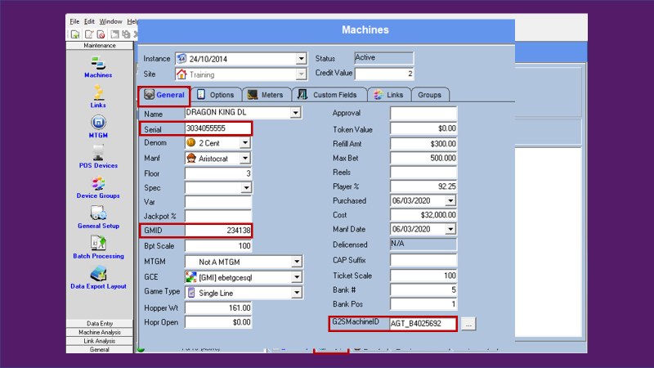 | In Game and under the Maintenance menu, select Machines, Setup and finally the General tab  The important fields that need to be populated are Serial, GMID and G2SMachineID.  You can complete other fields however this will depend on your venue needs.
12 | 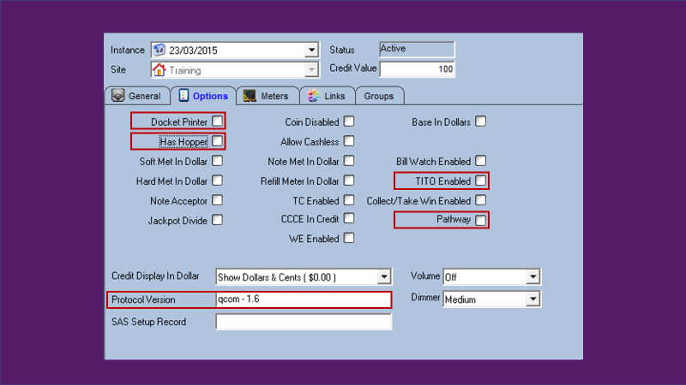 | In addition to the General tab - when selecting Options, the following areas will need to be updated to ensure TITO functions correctly.  - Docket Printer - for TITO enabled EGM’s - this must be ticked  - Has Hopper – for TITO enabled EGM’s – this needs to be unticked to ensure that a cashier does not try to process a refill in Pay – note that a TITO enabled machine will no longer require a hopper  - TITO Enabled – for TITO enabled EGM’s - this must be ticked  - Pathway – for ebet venues that use the Pathway to display advertising at the EGM - this option must be ticked  - Protocol Version - for venues using the Vault application - this field must also be populated as it will ensure that the jackpot contributions are calculated correctly in the Daily Management Report. Currently - all new EGM’s to the venue will be using the qcom protocol. If you know the exact version - for example qcom 1.6 – enter this in - otherwise if you do not know the version - simply type in qcom.  This information should be available on your Annexure or alternatively you can engage the appropriate manufacturer for the protocol details
13 | 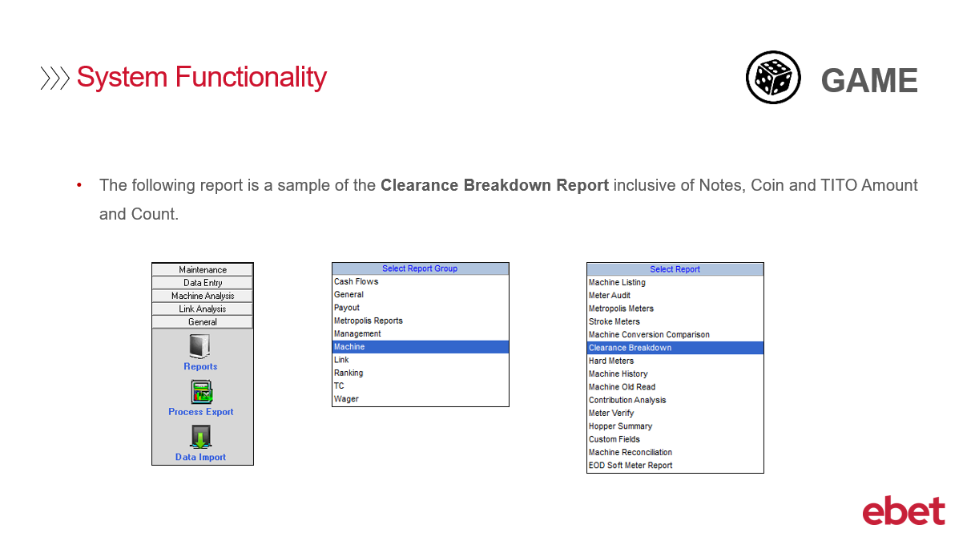 | In Game located in the General tab and from the Reports option you will find the Clearance Breakdown Report. This report is used to provide a breakdown of the notes, coins and tickets accepted by each EGM. The Clearance Breakdown Report includes the following.
14 | 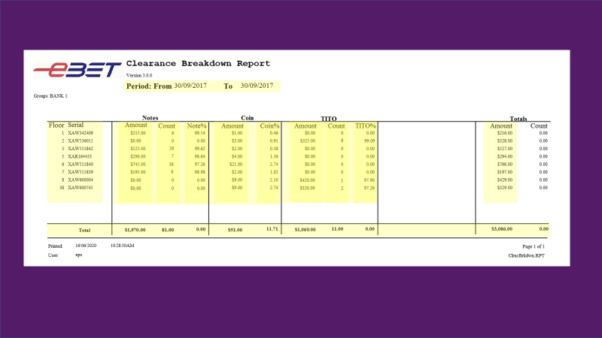 | - The Period that the report was generated for  - The Floor and its Serial number  - The breakdown of how many Notes, Coin, and TITO tickets that the Metropolis system has recorded as being inserted into each machine.  For each of these clearances the report will display the  - total $ amount accepted,  - The total Count received - you will however see that the coin clearance column doesn’t have a count – as this value would be the same as the Amount column  - and the Amount value cleared as a percentage.  There is also a total amount for each individual machine as well as each clearance.
15 | 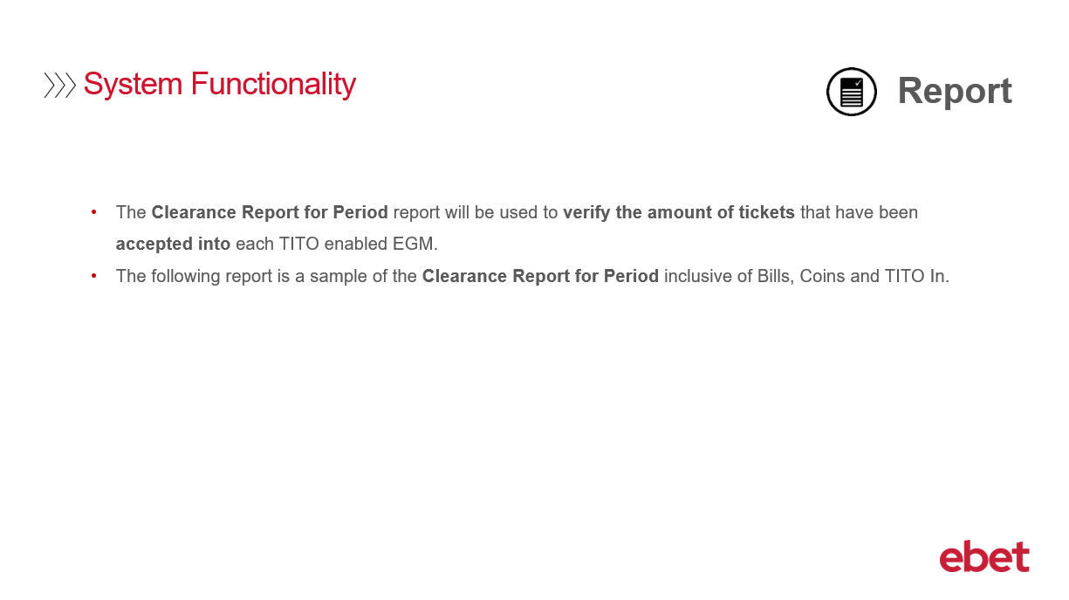 | Venues that are using the full Metropolis suite will have access to the Report application and will be able to generate Clearance Report for Period reports, which are updated with every 15minute meter poll.  The Clearance Report will be used to verify not only the amount of Notes and Coins that have been inserted, but also any tickets that have been accepted into each TITO enabled machine.  The following report is a sample of the Clearance Report for Period inclusive of Bills, Coins and TITO In.
16 | 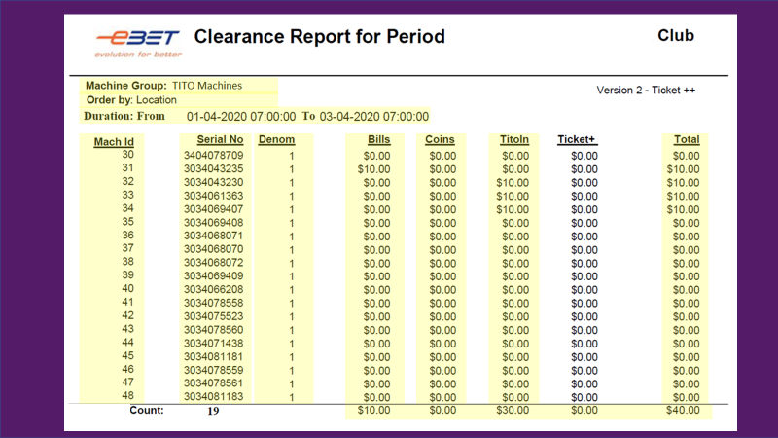 | The Clearance Report for Period includes:  - The Machine Group that you have generated the report for  - The option you have selected to sort the report by which can be either Location or Serial No  - The trading dates selected for the report  - The machine location, the serial number, and its denomination  - The dollar value of any Bills, Coins or Tickets that have been inserted into the machine  - The overall total for each individual machine  - As well as totals for the Bills, Coins and Tickets.
17 | 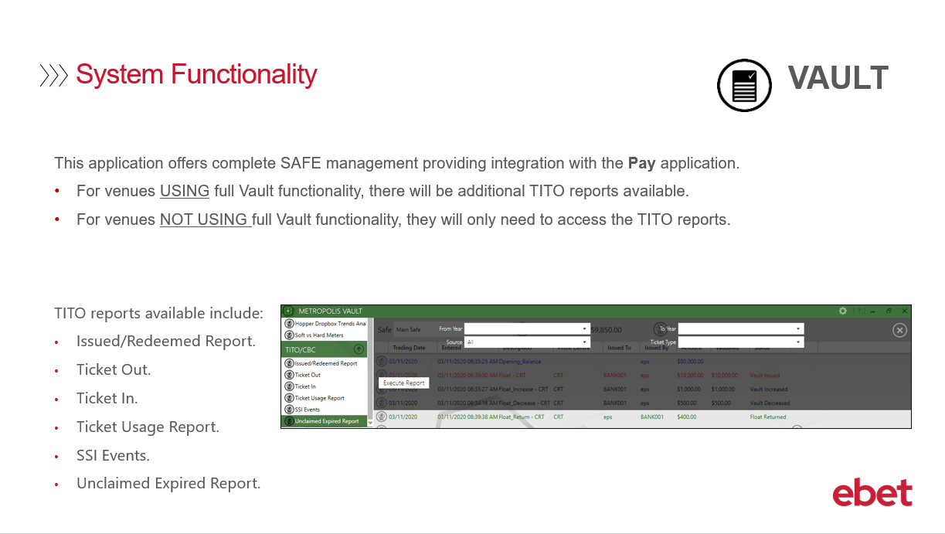 | The Metropolis Vault application offers a complete SAFE management system, providing integration with the Pay application.  - For venues using full Vault functionality there will be an additional 6 TITO reports available.  - For venues not using full Vault functionality you will only need to access these 6 reports for TITO.  The TITO reports now available include:  - Issued / Redeemed Report  - Ticket Out  - Ticket In  - Ticket Usage Report  - SSI Events  - and Unclaimed Expired Report
18 | 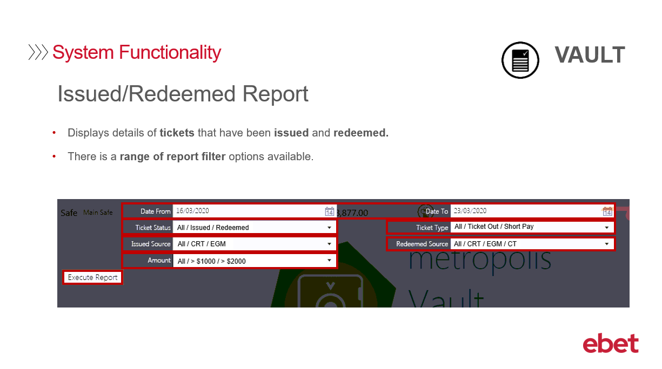 | In Vault the first TITO report available that we will look at is the Issued / Redeemed Report.  This report displays details of tickets that have been:  - Issued – meaning the ticket has been issued, printed, and NOT yet redeemed at a cashier, EGM or CRT – so this ticket is still identified as active  - Redeemed – meaning they have been reinserted into an EGM, presented to a cashier, or collected at the CRT  There is a range of report filter options available when generating this report  - Firstly, the date range - for which you would like to generate the report  - Next the Ticket Status - where you can select to view either All transactions, Issued transactions or transactions that have been redeemed.  - the Issued Source – this the location where the ticket redeemed was printed so either from an EGM or the CRT or both.  - the Ticket amount – which allows you to display all transactions or just those greater than either $1000 or $2000  - the Ticket Type - where you can select All transactions or only to display Ticket out or Short Pay transactions.  - And finally – the Redeemed Source – which is where the ticket was claimed at – either All locations or the CRT, any EGM’s, or Cashier Terminals.  Let’s now Execute the Report …
19 | 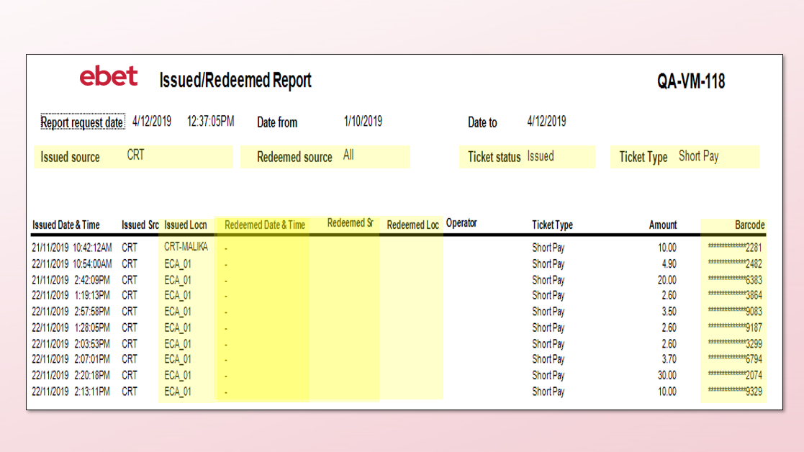 | This report has been generated using the following options,  - The Issued source is for the CRT  - The Redeemed source is for All locations  - The Ticket status is for Issued which means tickets that have not yet been claimed  - And finally - the Ticket Type is for Short Pay.  Key information to note on this report includes:  - The Issued Location – so if your venue has more than one CRT on the floor this report will list them with their individual device name as recorded in the Game application.  - The Barcode – Due to government legislation, the full barcode will not be displayed until the ticket has been flagged in the system as being redeemed. This report sample has only been generated to display tickets that have not yet been redeemed, so we will only see the last four digits displayed.  - You will also note that the Redeemed Date & Time, Source and Location fields are also blank, which indicates that the ticket has not yet been claimed.
20 | 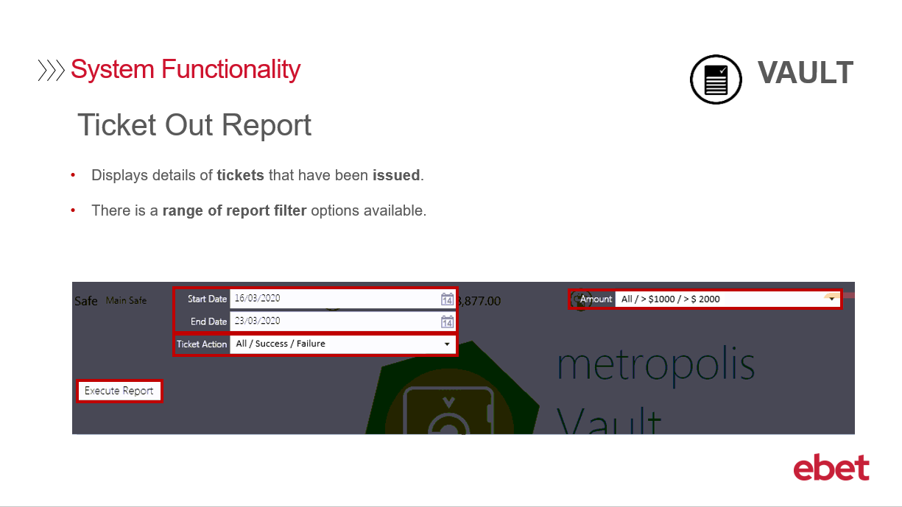 | Next, we will have a look at the Ticket Out Report.  This report will display the details of any tickets that have been issued – or printed from an EGM or CRT.  There is a range of report filter options available when generating this report  - Firstly, the date range for which you would like to generate the report  - Next the Ticket Action – that is if the Ticket Out transaction was a success or Failure  - And finally, the ticket Amount – which allows you to display all transactions or just those greater than either $1000 or $2000  Let’s now Execute the Report …
21 | 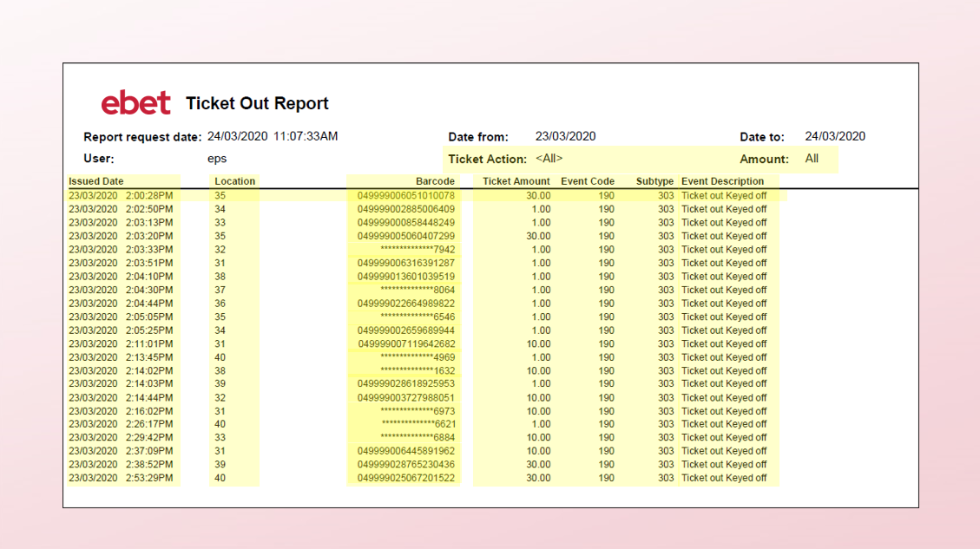 | This report displays details that have been generated using no filter options, so we see all transactions for all amounts.  The report displays:  - The individual tickets and their Issued Date and Time  - The Location it was printed at  - The ticket Barcode – we can see here that some transactions have the full 18 digit barcode displayed – which indicates that the ticket has been claimed – and other transactions which only display the last four digits, as they have yet to be claimed.  - The value of the ticket  - A database Event code and Subtype number  - And lastly - the Event Description - stating if the Ticket Out was a success or failure. If a success the description will report Ticket out Keyed off and if a failure it will report one of the various Event Codes and its Description which will highlight the reason for the failure.
22 | 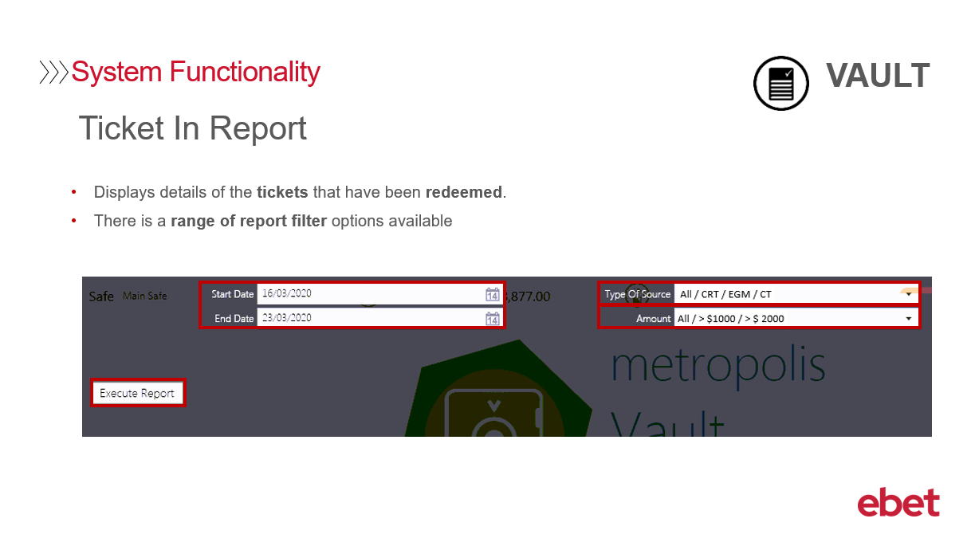 | Where the Ticket Out Report looked at where tickets were issued, the Ticket In Report will display details of any tickets that have been redeemed – and where the redemption occurred.  There is a range of report filter options available when generating this report  - Firstly, the date range for which you would like to generate the report  - Next the Type of Source – so where the ticket was redeemed  - And finally, the ticket Amount – which allows you to display all transactions or just those greater than either $1000 or $2000  Let’s now Execute the Report …
23 | 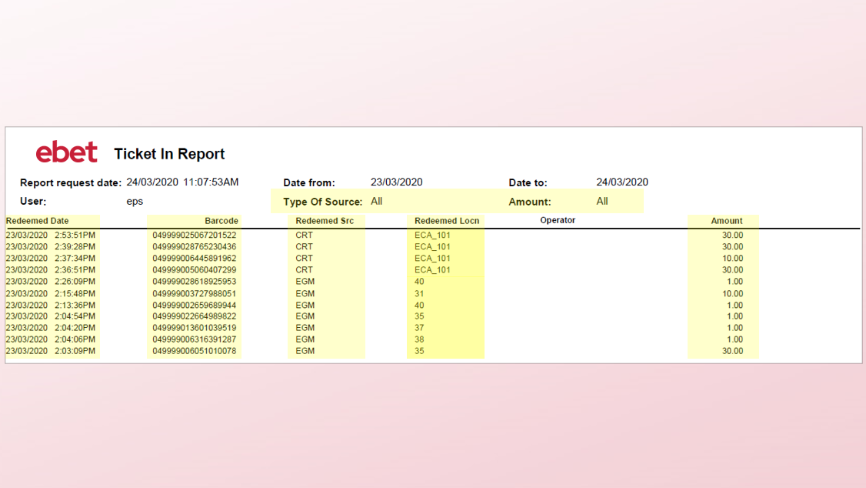 | This report displays details that have been generated using no filter options, so we see all transactions for all amounts.  The Ticket In Report displays:  - Each individual tickets Redeemed Date and Time  - As the ticket has been flagged as redeemed, we see the full 18-digit barcode number,  - The Redeemed Source so where the ticket was redeemed from the CRT, EGM, or cashier  - The Redeemed Location name – in this example we can see the first 4 tickets were accepted into CRT 1 and the rest were inserted into several different EGMs  - And lastly, we have the value of the TITO ticket.
24 | 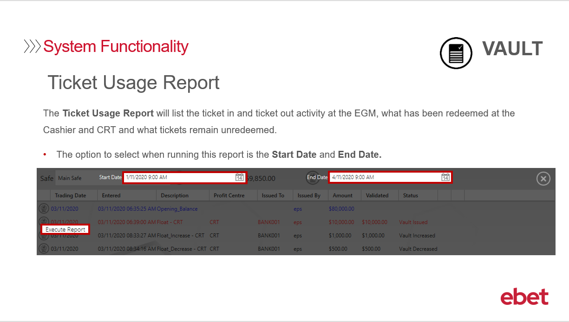 | Next, we have the Ticket Usage Report, which will list the ticket in and ticket out activity at the EGM, what has been redeemed at the Cashier and CRT and what tickets remain unredeemed.  If you choose to run this report the only option available is the Start Date and End Date.  Let’s now Execute the Report …
25 | 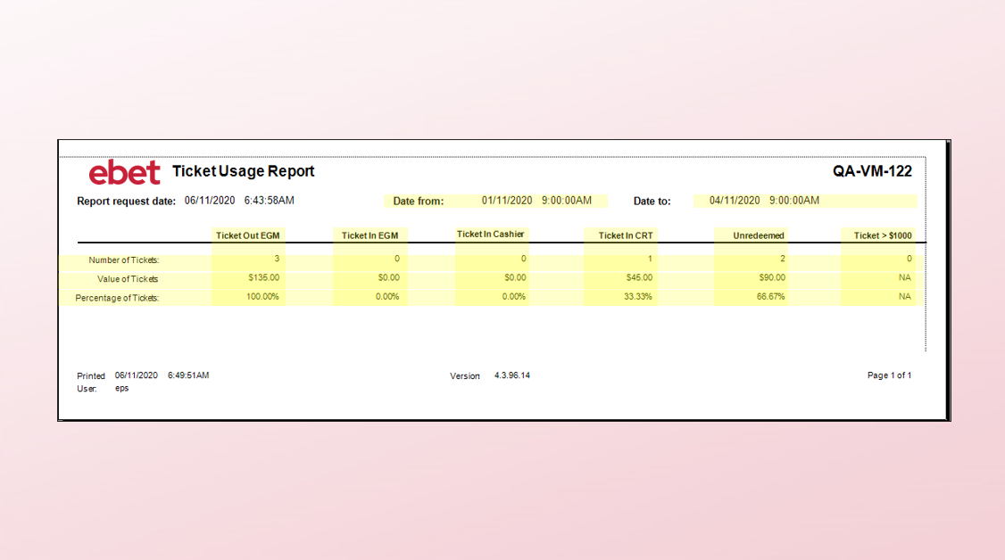 | This report displays details that have been generated using a date selection only.  The Ticket Usage Report displays:  The Number, Value and Percentage of Tickets for:  - Ticket Out at the EGM  - Ticket In at the EGM  - Ticket In at the Cashier  - Ticket in at the CRT  - Any Unredeemed Tickets and finally  - Any tickets greater than $1000
26 | 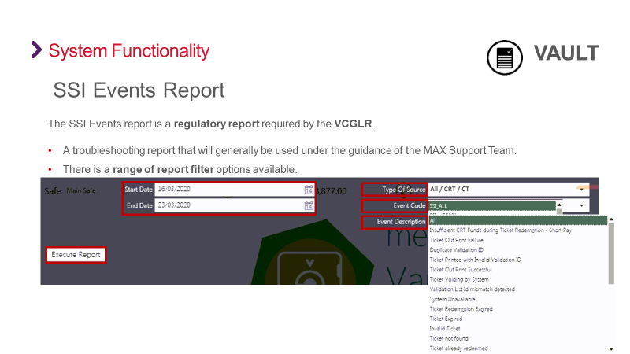 | Next, we have the SSI Events Report, which is a regulatory report required by the Victorian Commission for Gambling and Liquor Regulation. Or more commonly known as the VCGLR.  SSI stand for Simple System Interface and will generally be used for troubleshooting purposes under the guidance of the ebet Support team.  If you choose to run this report, there are a range of report filter options available  - Firstly, the date range for which you would like to generate the report  - Next is the Type of Source – where you can select either CRT, Cashier Terminal, or both  - And then the Event Code – and multiple Event Descriptions - which includes but not limited to Ticket Expired, Ticket Not found and Large amount.  Let’s now Execute the Report …
27 | 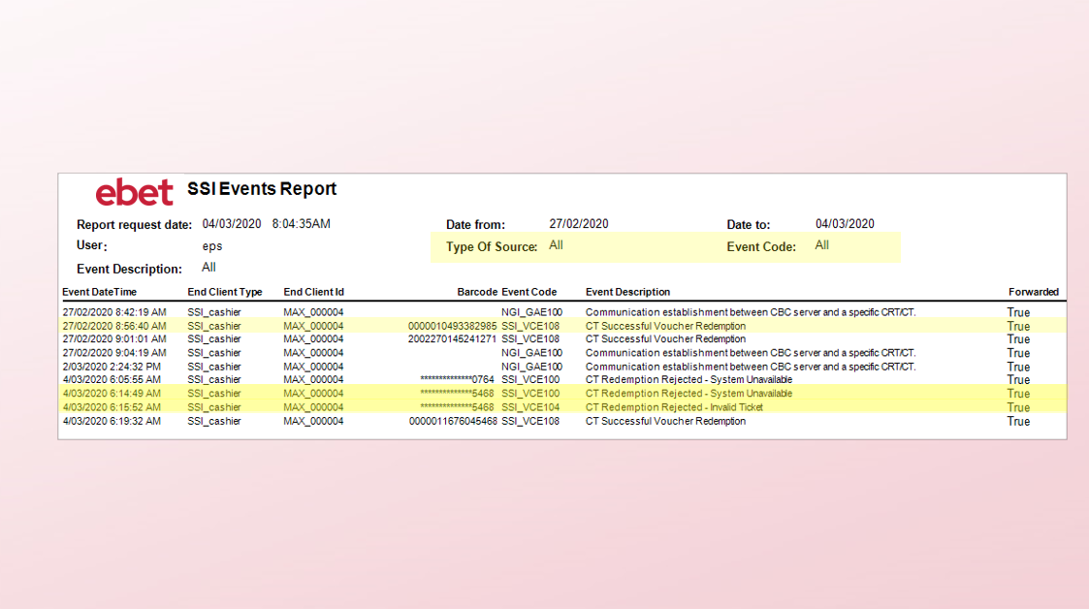 | This report displays details that have been generated using no filter options.  This SSI Events Report sample displays:  - The transactions with the full barcode which represents tickets that have been successfully redeemed at the Cashier Terminal.  - Next, looking at the transactions with the barcode ending in ****5468 – the first one shows that the system was unavailable so the transaction could not be completed, and then the second transaction shows that it was tried again and was rejected as the system could not validate the ticket.
28 | 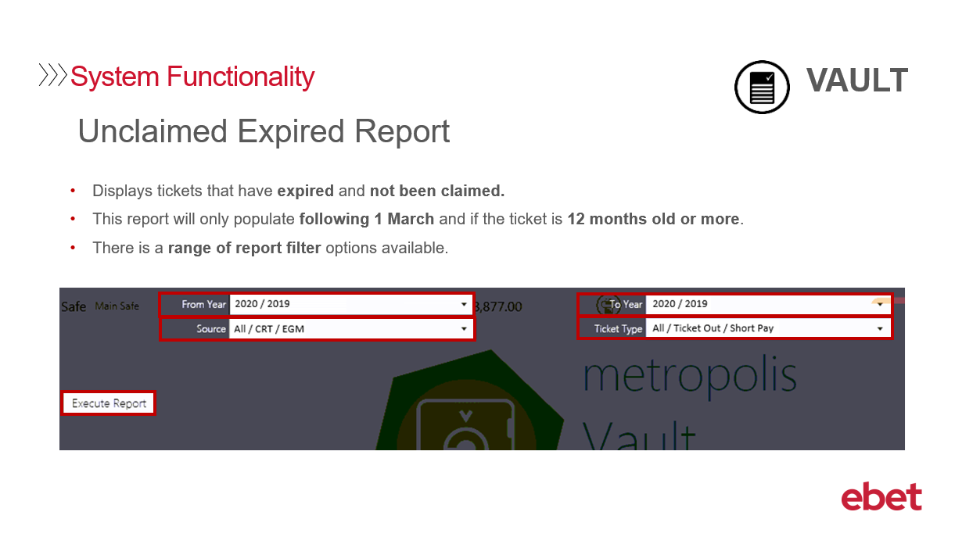 | Our last Vault TITO report is the Unclaimed Expired Report, which will display any ticket's that have expired and not been claimed.  There is a scheduled task that runs on the first of March each year that checks if any UNCLAIMED tickets are 12 months old or more and flags them as EXPIRED.  Information on this report will not populate until at least 12months after going live with TITO.  So for a venue that goes live with TITO in June – the task will first run the following year in March, but generating the report will not return any data, - this is because 12 months has not passed and the system would not have flagged any tickets as being unclaimed – when the task is run the following year, and if there are any unclaimed tickets, the report will then populate with these transactions.  There is a range of report filter options available when generating this report  - Firstly, the year selection for which you would like to generate the report  - Next the Source – so where the ticket was issued  - And finally, the Ticket Type – which allows you to display ALL tickets, Ticket Out tickets only or Short Pay tickets  Let’s now Execute the Report …
29 | 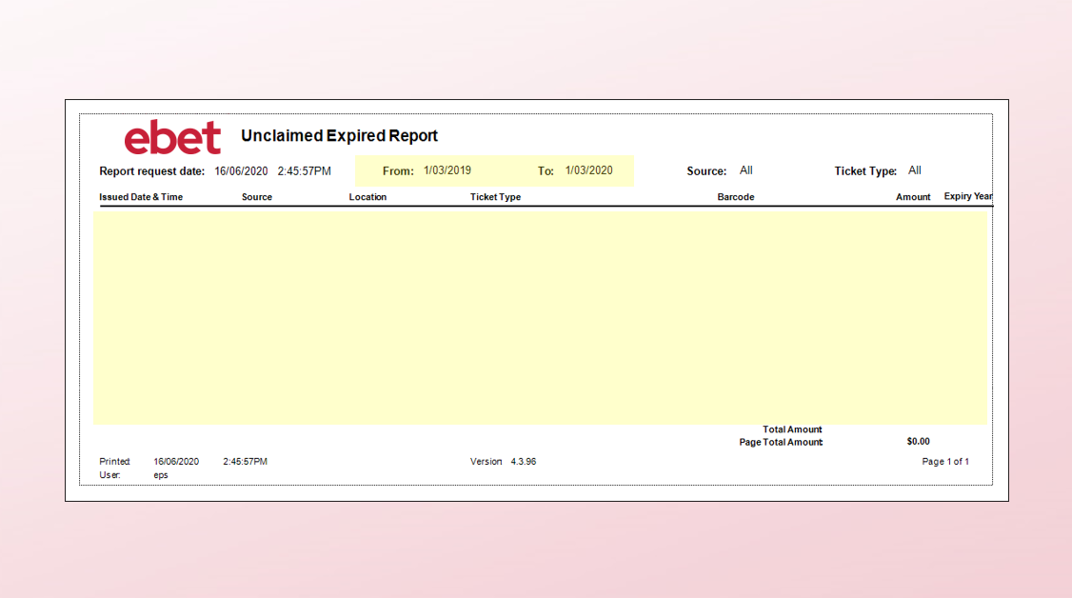 | - The report sample we see here was generated for the 12-month period for March 2019 to March 2020.  - As there are no unclaimed Expired tickets the report will return no transactions.
30 | 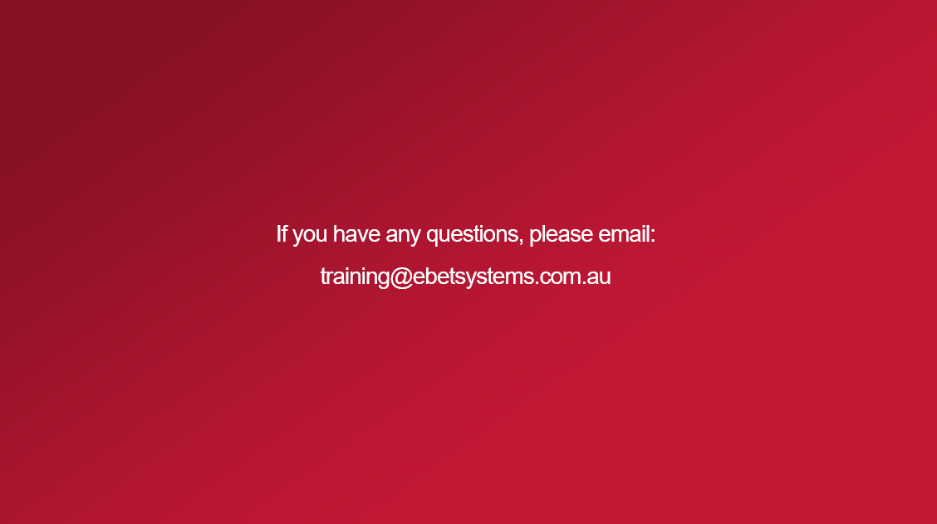 | This brings you to the end of the Metropolis including TITO training video.  If you have any questions regarding the content of this training course - please email - training@ebetsystems.com.au.

