Video Transcript

Metropolis – An Introduction to TITO
This document supports the Metropolis – TITO at the Cashier training video and includes a word for word account of each screen captured and its supporting text.
Venue staff may find this document useful to reference if they want to review the content of the training video.
It is recommended that the training video be watched as it does include videos of various activities that cannot be viewed in this document.

SLIDE | IMAGE | VIDEO SCRIPT
1 |  | Welcome to the Metropolis Training Video.
2 | 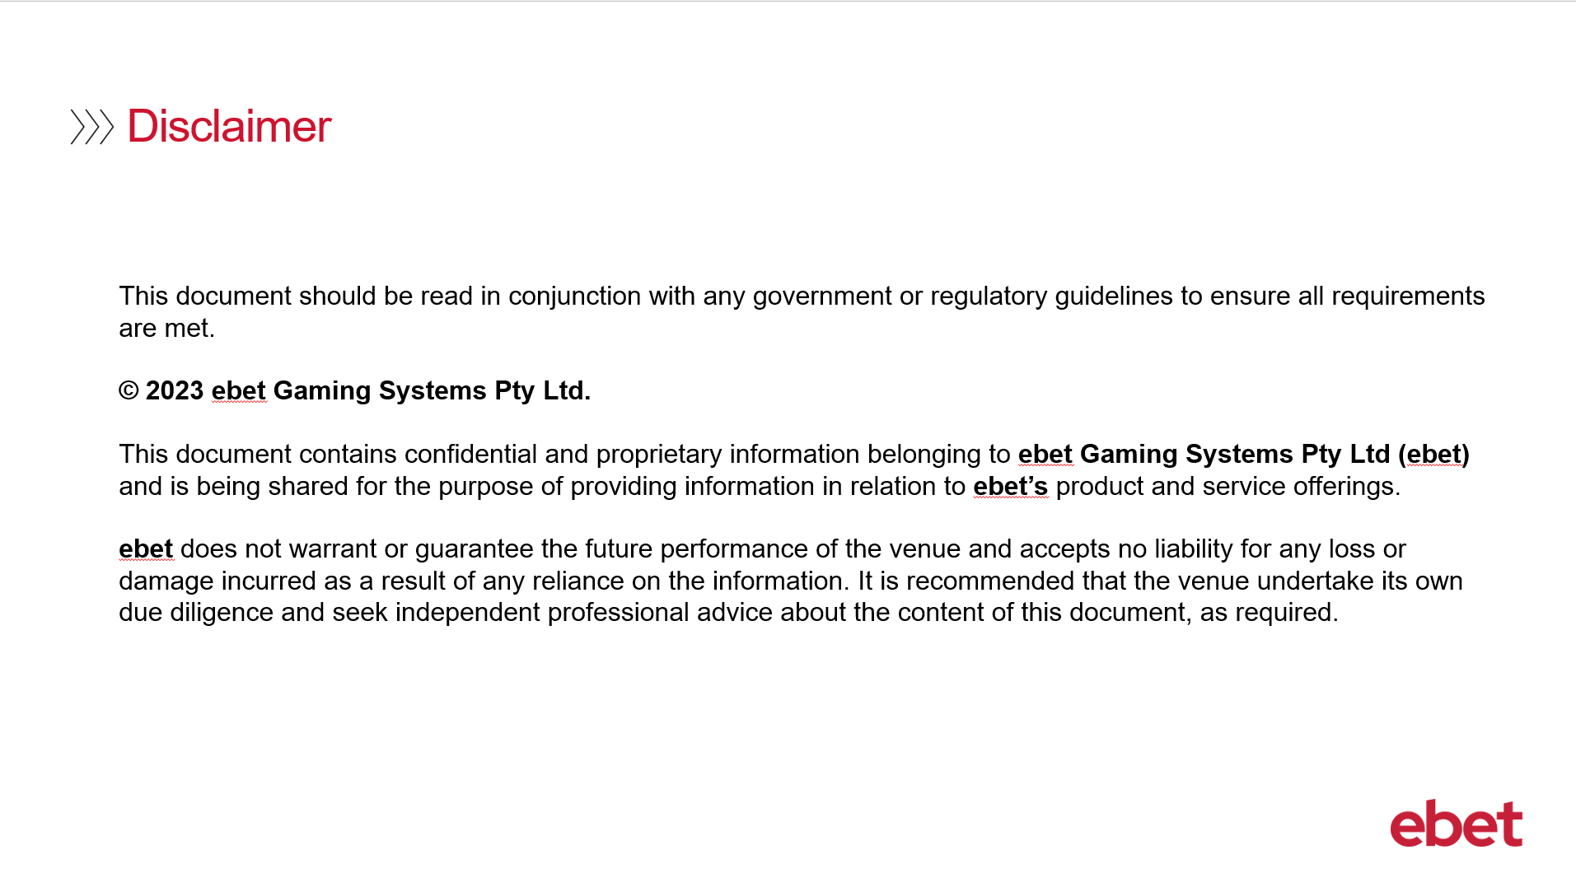 | No script available for this slide.
3 |  | With the introduction of Ticket in Ticket Out into your venue this session will focus on:  - What is TITO and its benefits?  - As well as the journey of the ticket from the EGM to the time of redemption
4 | 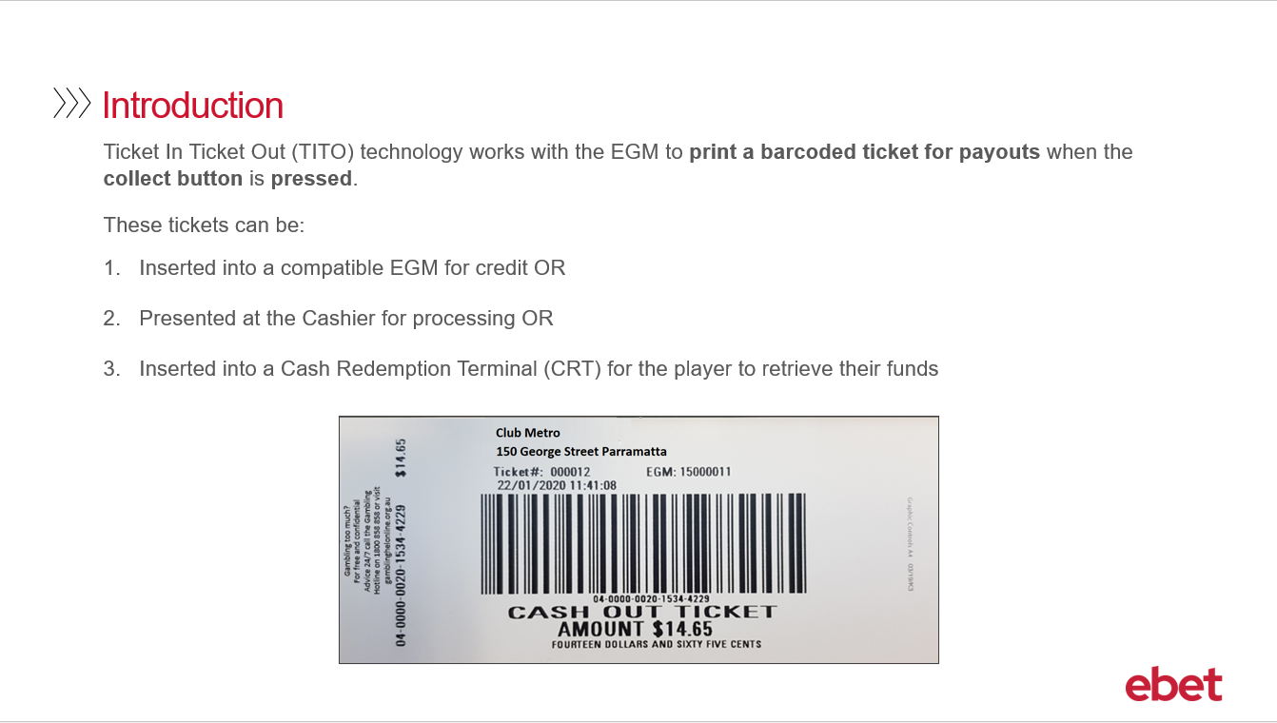 | Ticket In Ticket Out or TITO technology works with the EGM - so when the patron is ready to cash out their remaining credit, they will press the collect button. The EGM will then print a ticket with a barcode to the amount of the credits.  TITO replaces the need for a hopper, or a book pay.  When the ticket is printed, the patron can then: ​  - Insert the ticket into the note acceptor of another TITO enabled machine and the credits will be added to the credit meter of that machine​  - or - they can present their ticket to the cashier and redeem cash ​  - or finally - they can insert the ticket in at the Cash Redemption Terminal and redeem cash
5a | 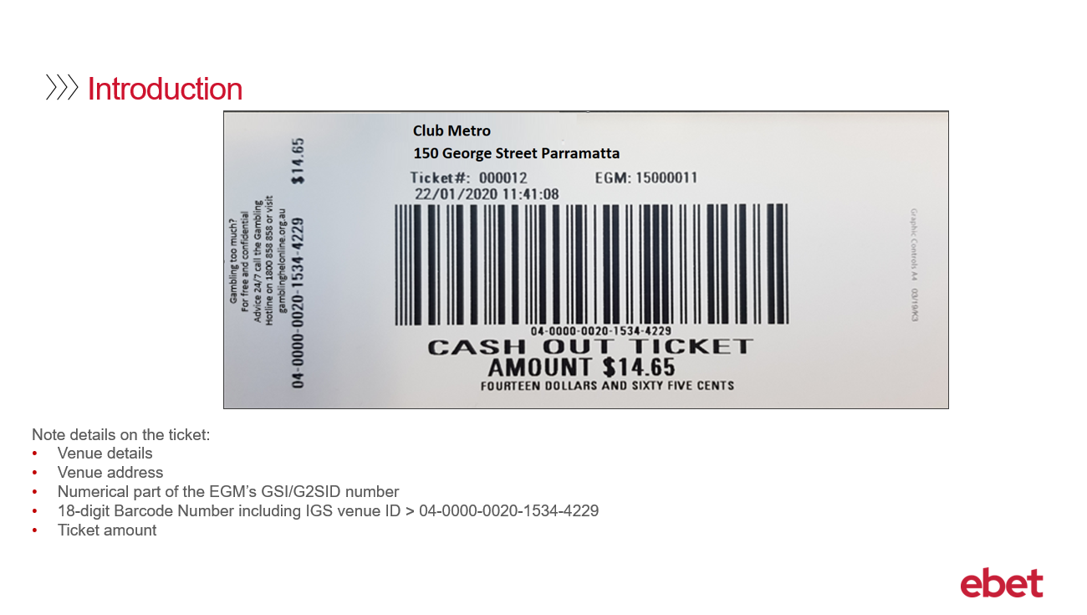 | This is a sample of a TITO ticket that has been printed from an EGM.  Some details to note on the ticket are  - Your venue name  - Your venue address  - The numerical part of the EGM’s Intralot GSI number - which in Metropolis Game is referred to as the G2SID number  - The date and time the ticket was printed  - The Ticket Barcode  - The Barcode number – this is a unique 18-digit number that is printed below the barcode image. Included in this number is your IGS Venue ID number. You will find that all tickets printed from your venue will have the same four digits in this field. This number is useful to identify that this ticket was printed at your venue and not another.  - and lastly - the value of the ticket.
5b | 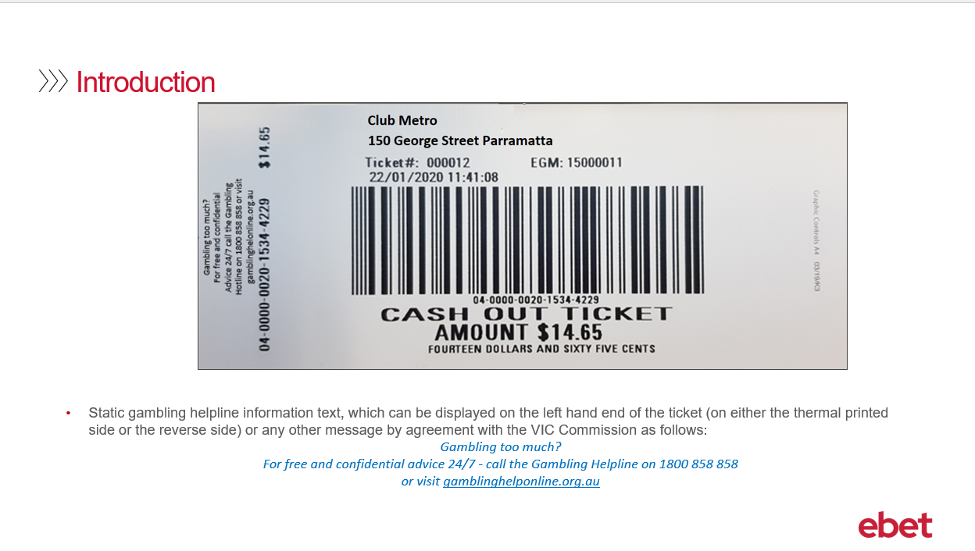 | The static gambling helpline information text is also printed, which can be displayed on the left hand end of the ticket (on either the thermal printed side or the reverse side) or any other message by agreement with the VIC Commission as follows:  Gambling too much? For free and confidential advice 24 hours a day 7 days a week - call the Gambling Helpline on 1800 858 858 or visit gamblinghelponline.org.au
6 | 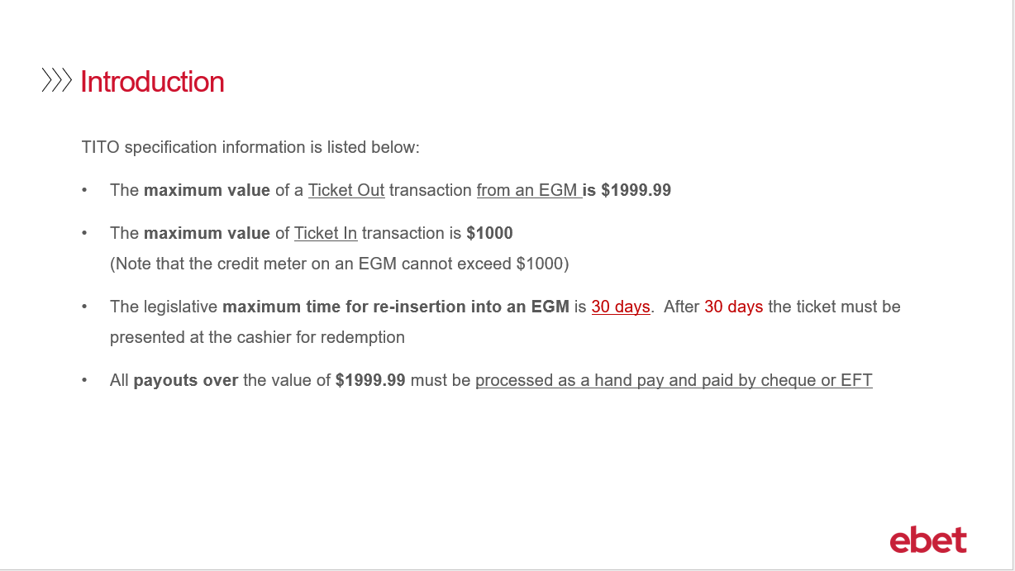 | The following is key information that refers to how TITO will function within your venue.  - The maximum value of a ticket that prints OUT from an EGM is $1999.99. All payouts over the value of $2000 will be treated as a book pay and must be paid by Cheque or EFT.  - The maximum value of a ticket that can be INSERTED into an EGM is $1000 this is because the credit in meter for an EGM can only go to the total value of $999.95. If a patron is currently playing a machine that has credits on it, the patron will only be able to insert a TITO ticket that will not exceed the total credit on the EGM of $1000.00 - for example – if EGM 1 has $200 on the credit meter, then they will only be able to insert a ticket with a value of no more than $799.  - As per legislation, a TITO ticket removed from an EGM can remain active for re-insertion into an EGM or CRT for up to 30 days. After 30 days the ticket must be presented to the cashier for redemption. This time frame can be customised - so if you would like it to be set for a lesser time period – for example 5 days – then please advise the ebet Team at the time of your TITO implementation or alternatively you can contact ebet Support for assistance at any time.
7 | 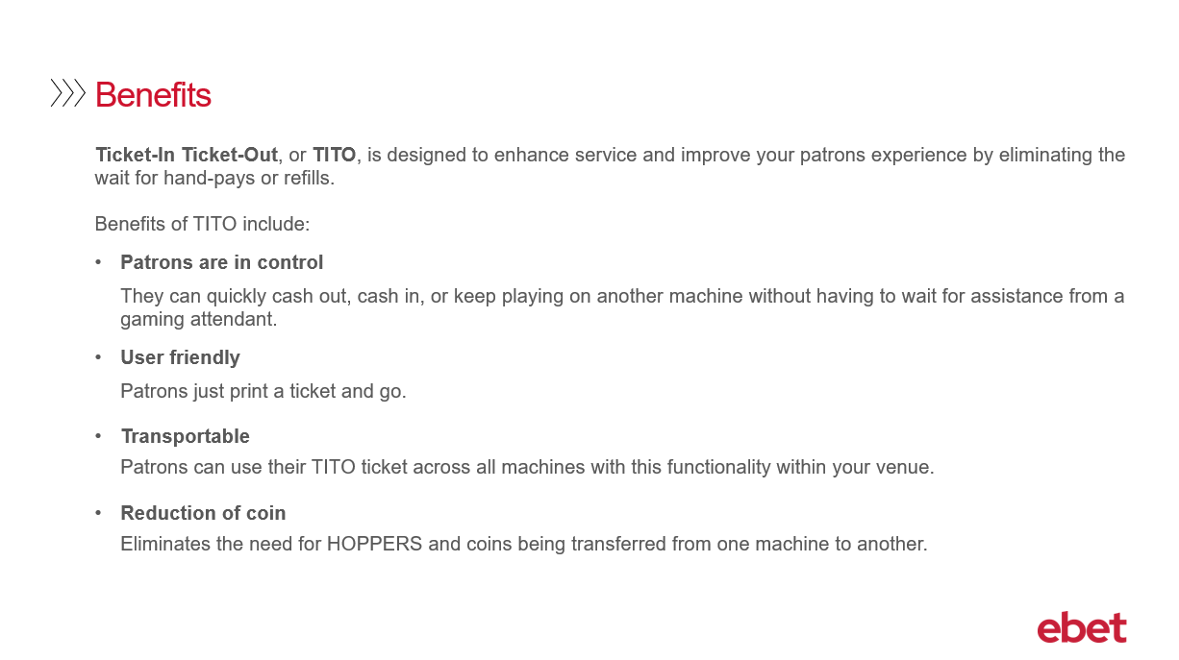 | There are many benefits with introducing TITO functionality into your venue. TITO is designed to enhance and improve your customer experience.  - With TITO the patron is in control. At their convenience they can quickly and easily cash out, cash in, or move to another TITO enabled machine where they can continue to play. No longer do they need to page for a gaming attendant and then have to wait for a hand pay or a refill.  - TITO is user friendly. The patron simply has to press the collect button for a ticket to print before they are on their way.  - TITO Tickets are transportable. The patron can use their TITO ticket across any TITO enabled machines within your venue.  - and finally - with the introduction of TITO - it will now eliminate the need for hoppers to be refilled and coins being transferred from one machine to another.
8 | 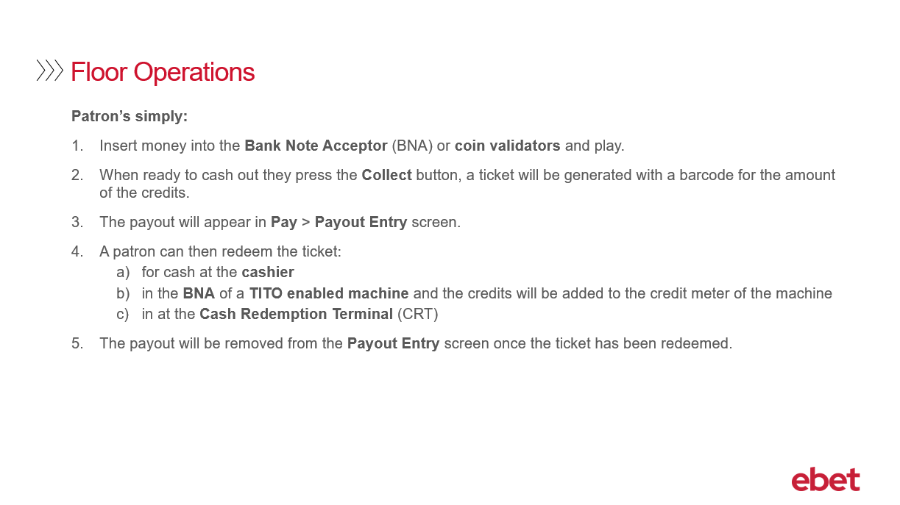 | What the customer will experience on the floor is the following process  - They simply insert their money into either the Bank Note Acceptor or the coin validator and then begin to play.  - When they have finished playing, they press the Collect button, and a ticket will be printed with a barcode for the amount of the credits.  - At the Cashier’s workstation and when using the Metropolis Pay application the payout transaction will appear.  - The patron can then redeem the ticket  - For cash at the cashier  - In the Bank Note Acceptor of a TITO enabled machine and the credits will be added to the credit meter of the machine  - or in the Cashier Redemption Terminal  - Once the ticket has been flagged as being redeemed at any of these locations - the transaction will be removed from the Payout Entry screen.  However - it is IMPORTANT TO NOTE:  - The majority of EGM’s will accept the ticket all 4 ways – for best practice we recommend to have the ‘barcode up’. This way the ticket will always be accepted.
9 | 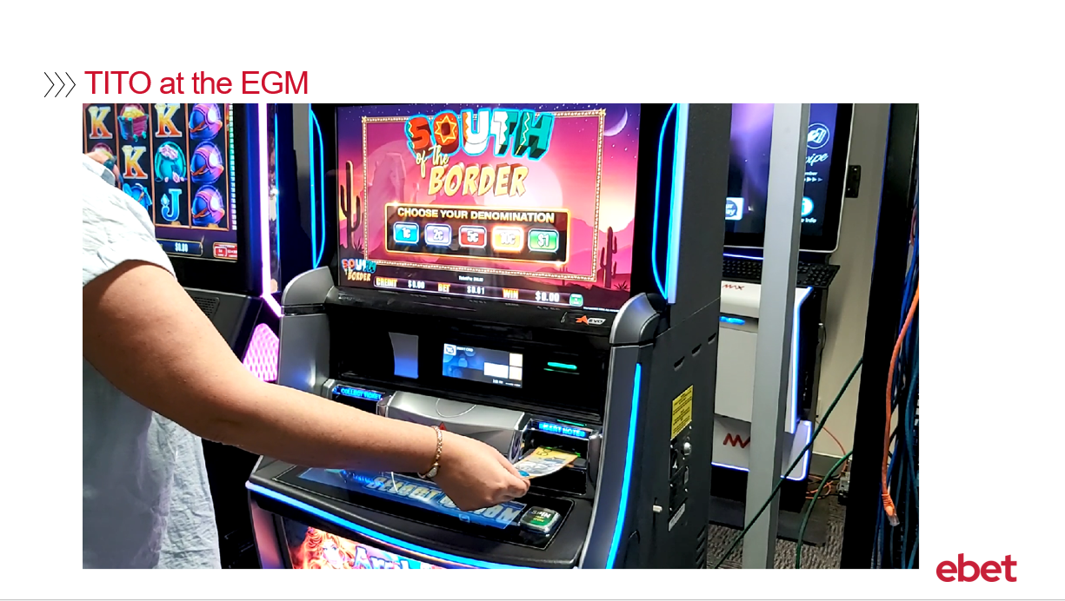 | This video demonstrates TITO at the EGM.
10 | 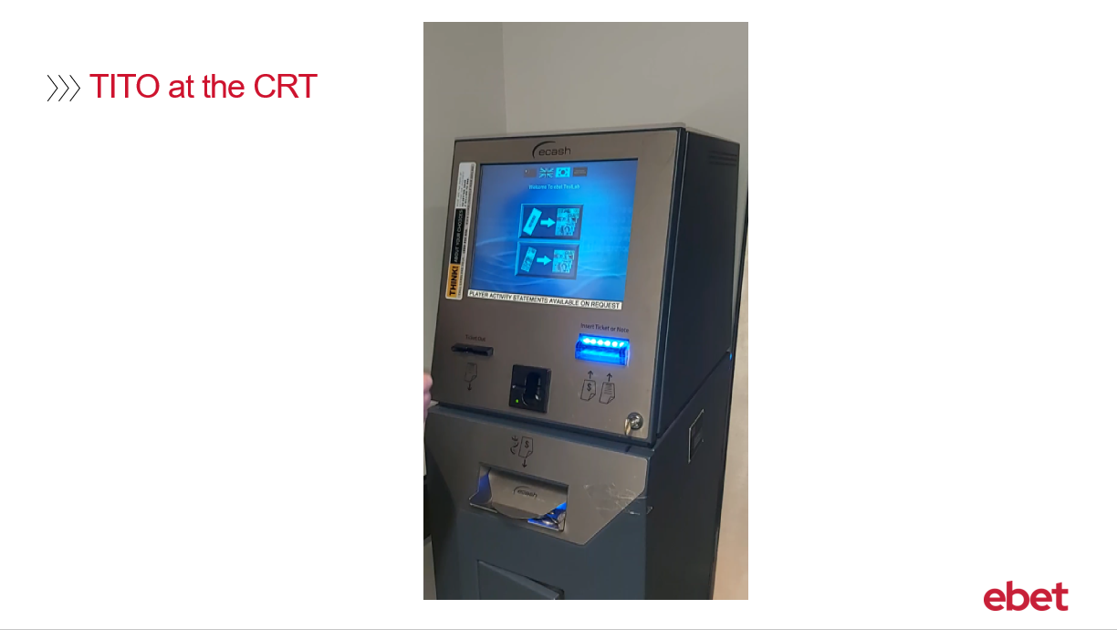 | This video demonstrates TITO at the CRT.
11 | 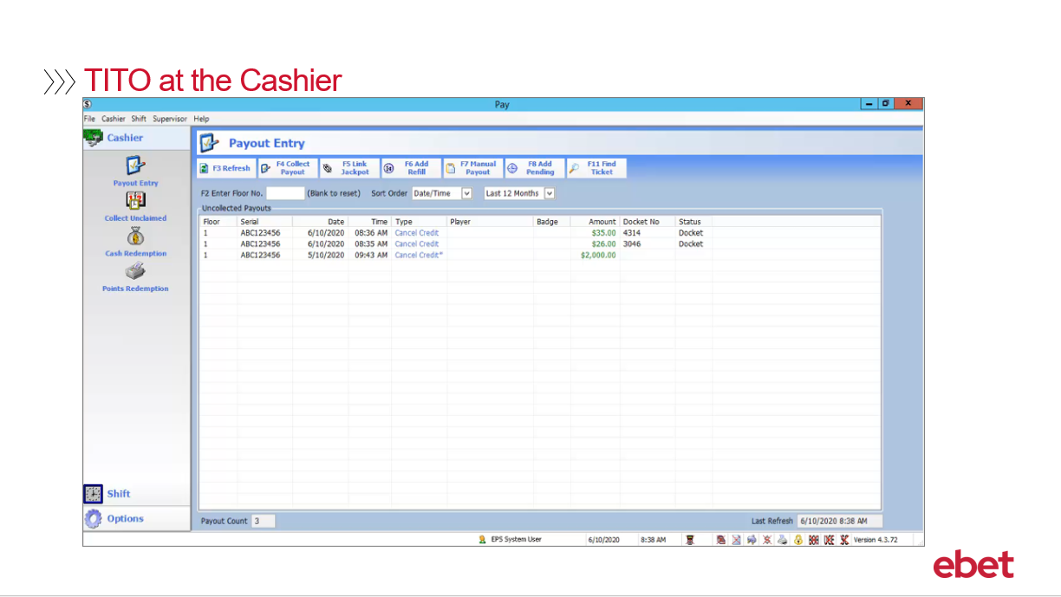 | Refer to the Video 1 – Metropolis – An Introduction to TITO – TITO at the Cashier – Supporting Document. This document provides a detailed account of each screen and the supporting text as detailed below.  The following will demonstrate what the cashier will experience when using the Pay application to process a TITO ticket.  - The patron will present their TITO ticket to the cashier  - From the Payout Entry screen, scan the TITO ticket  - Check the payout details and press OK  - The cashier will have the option to verify the amount prior to taking the funds out of the cashier till. By default – the dollar amount will be set to auto populate – however if required – this can be customised and can be changed to be a manual process. Once the value is entered or checked select OK.  - When the ticket has been paid, the ticket will be removed from the Payout Entry screen leaving only unpaid tickets.  - Moving to the Shift menu –  - Shift Totals  - and then Payout Totals - Ticket Out will now include the ticket that was paid by the Cashier and the relevant Cash Totals will also be updated.  - In the Float Reconciliation tab  - the float values will also be updated. This information can be reviewed and printed as part of the end of shift procedures.  - In addition to the Shift Totals and under Transactions  - and then the Payouts tab, the cashier will be able to view details of ALL payouts that have been processed as part of their shift. This screen is also able to be printed for reconciliation requirements.  For safe practice, we recommend that the barcode scanner be positioned to face the patron which will allow them to scan their ticket. Once the ticket is scanned, the patron can then place the ticket in a tray located next to the scanner for the venue to process later during reconciliation and reduce the need for additional manual handling.
12 | 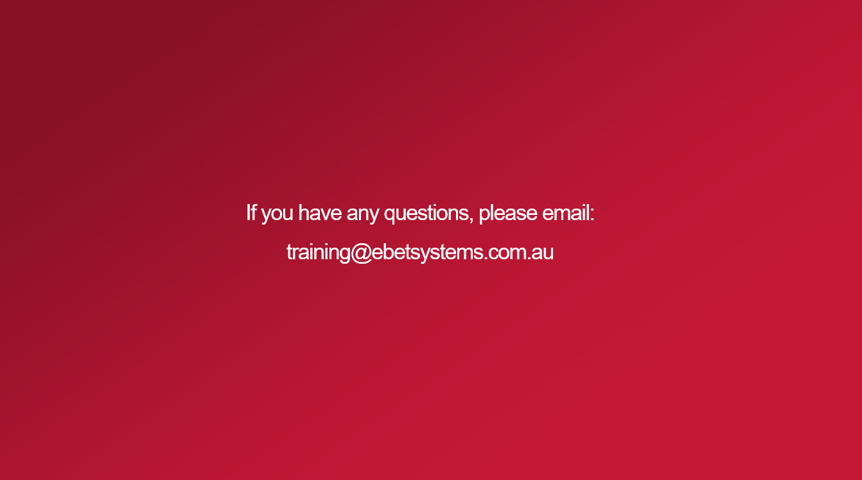 | This brings you to the end of the Metropolis – An Introduction to TITO training video.  If you have any questions regarding the content of this training course - please email - training@ebetsystems.com.au.

