Video Transcript

Metropolis – TITO Troubleshooting including EGM and CRT
This document supports the Metropolis – TITO Troubleshooting including EGM and CRT training video and includes a word for word account of each screen captured and its supporting text.
Venue staff may find this document useful to reference if they want to review the content of the training video.
It is recommended that the training video be watched as it does include videos of various activities that cannot be viewed in this document.

SLIDE | IMAGE | VIDEO SCRIPT
1 |  | Welcome to the Metropolis Training Video.
2 | 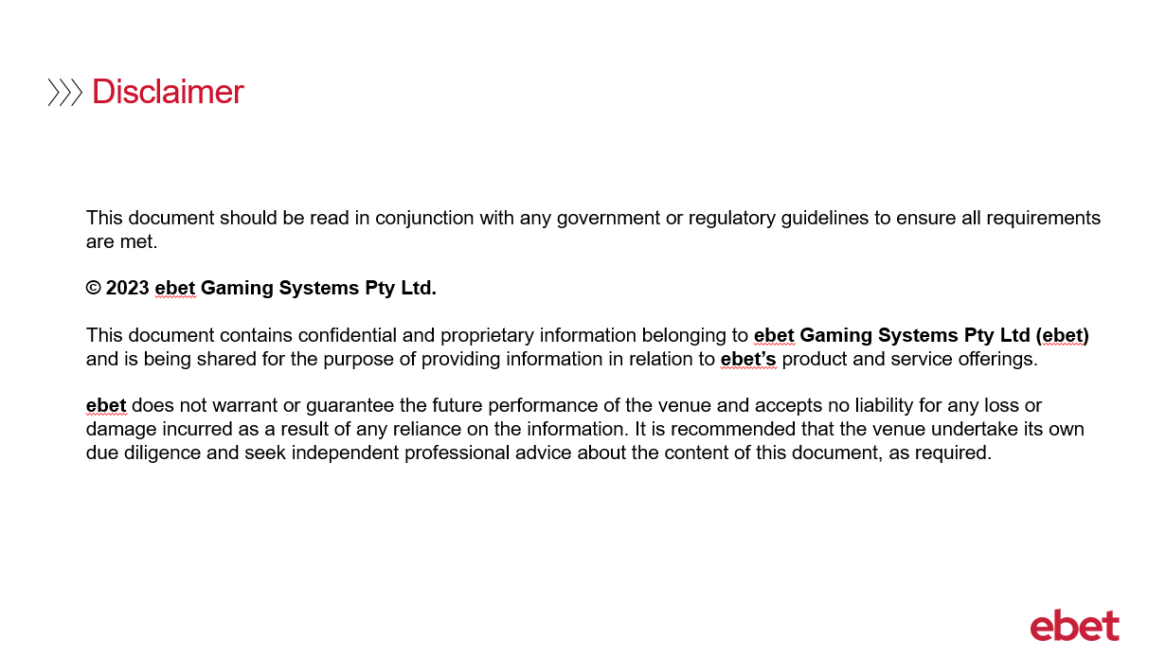 | No script available for this slide.
3 |  | The following training is specifically geared towards supervisors and provides a detailed guide on how a venue can investigate a ticket that has flagged as either a suspect or problem ticket.  For this training video we will be covering the material provided in your TITO Floor Operations & Troubleshooting Guide and recommend you have this document available to reference whilst watching this video.  Some of the troubleshooting features that will be demonstrated in this training video may have been discussed in previous TITO videos, however this section will provide a more detailed look at the TITO issues that may occur and will guide you on how to effectively troubleshoot and resolve the issue.  Please note that when referencing the Guide, the first sections refer to information that is covered in the Introduction to TITO and Metropolis Pay Operations including Cashier Troubleshooting training videos.
4 |  | Let’s start off by looking at TITO Troubleshooting at the EGM.  Please now reference the guide and navigate to the Troubleshooting at the EGM section.
5 |  | No script available for this slide.
6 | 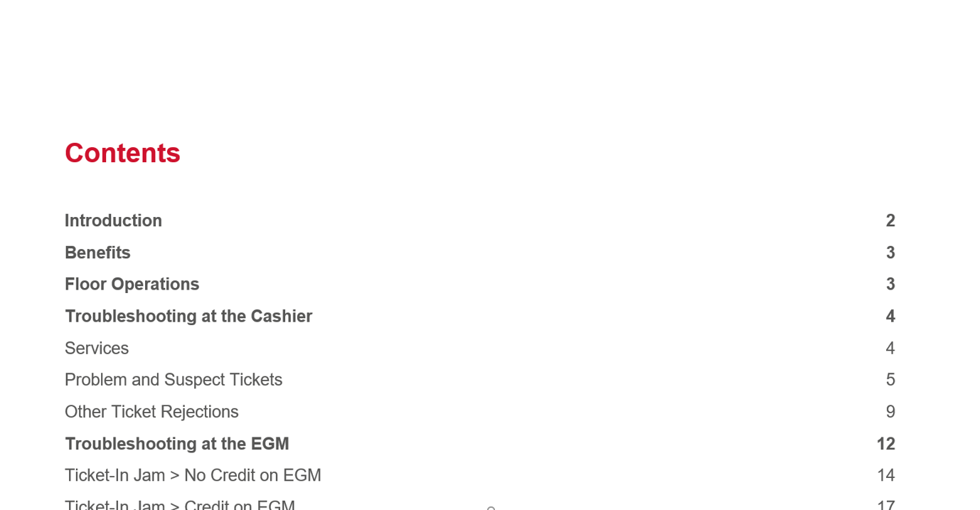 | No script available for this slide.
7 | 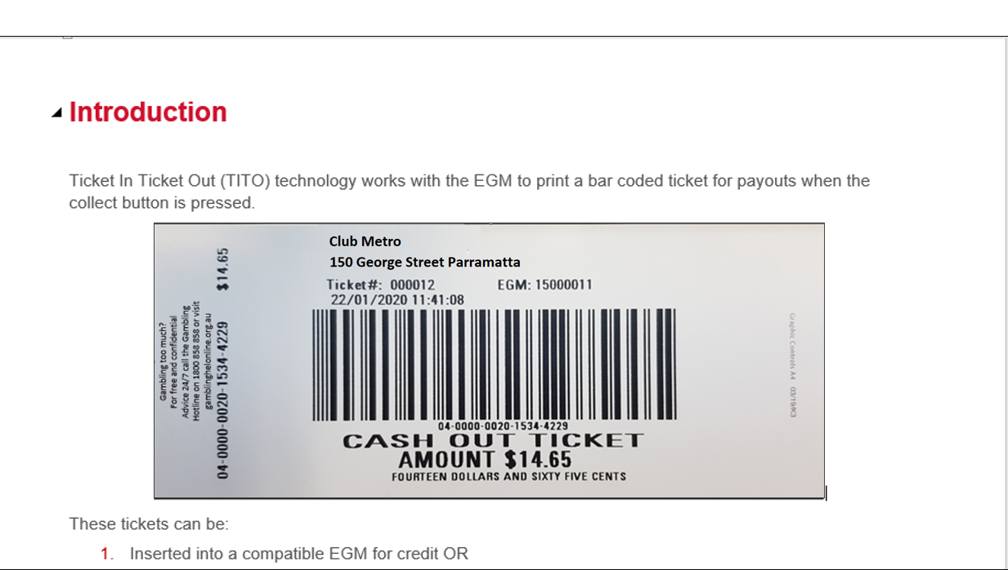 | No script available for this slide.
8 | 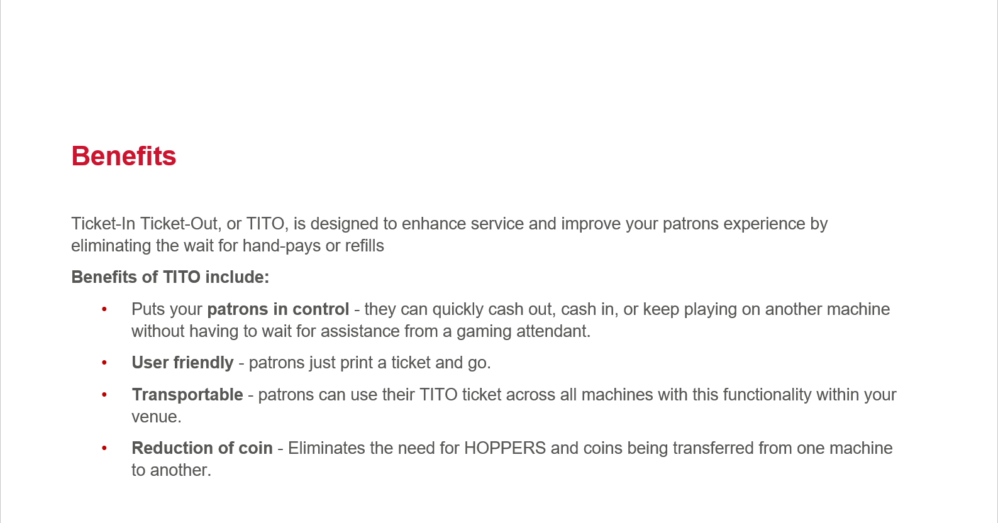 | No script available for this slide.
9 | 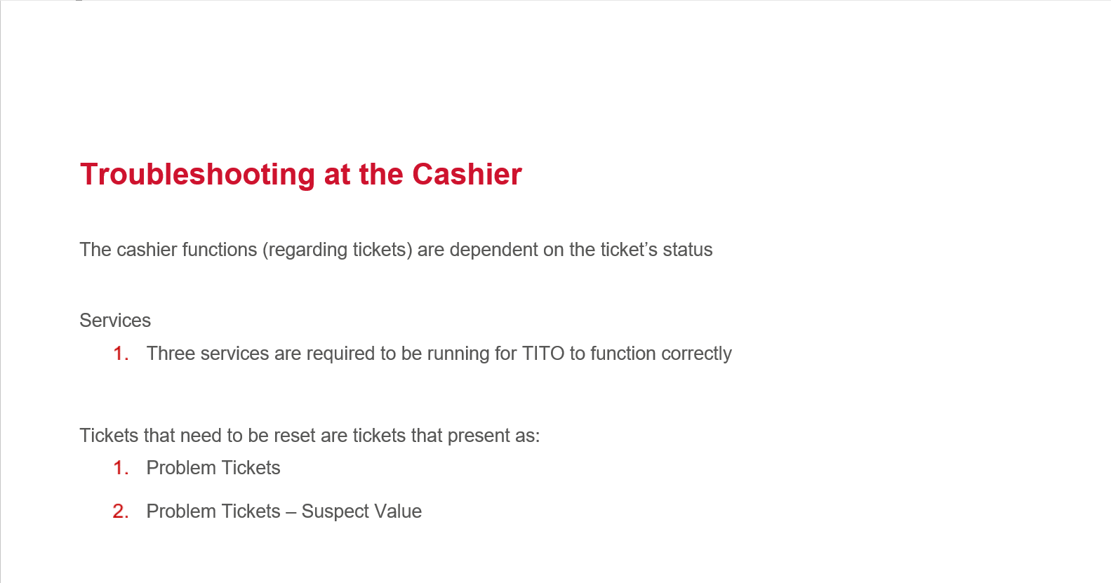 | No script available for this slide.
10 | 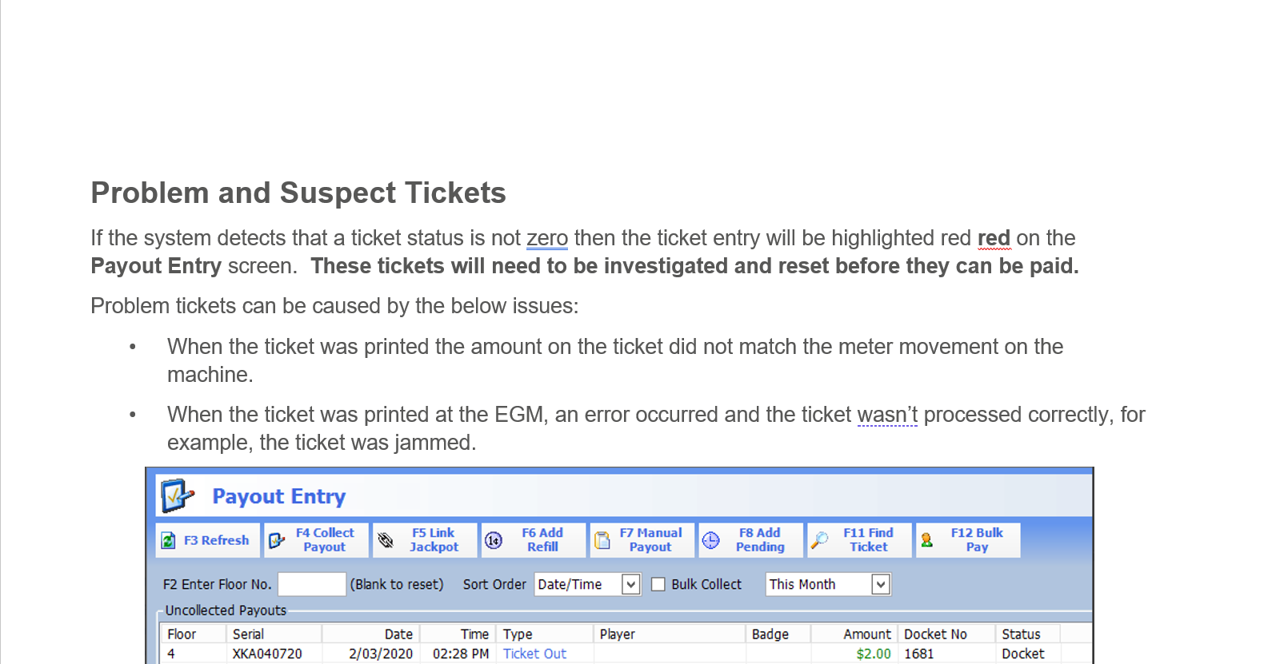 | No script available for this slide.
11 | 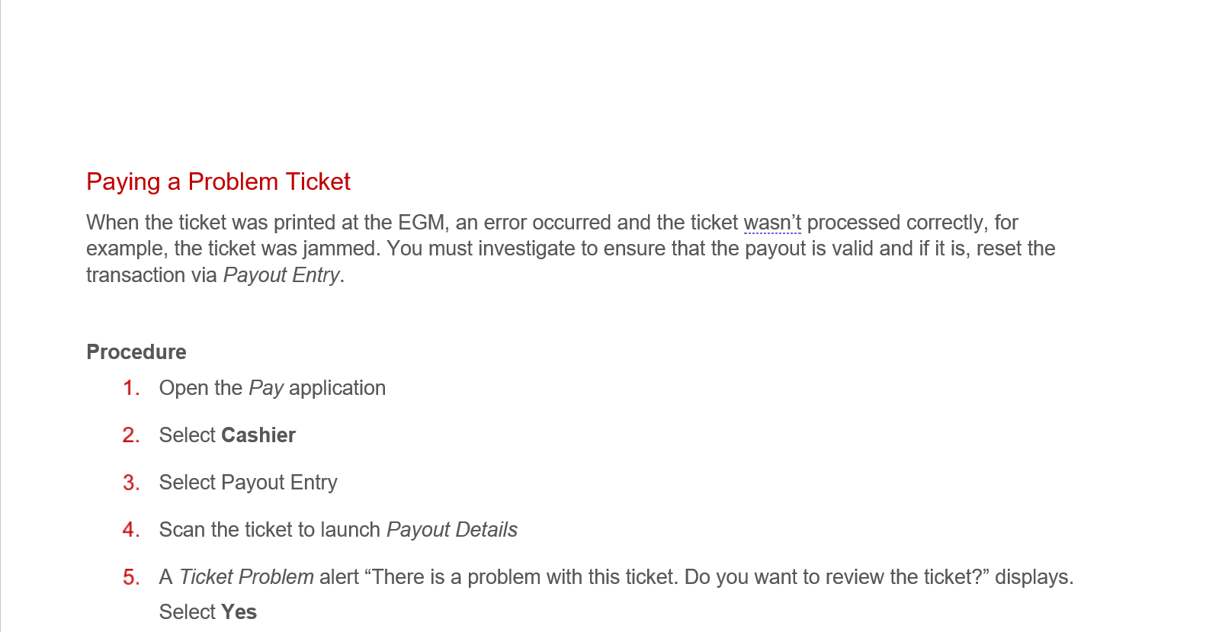 | No script available for this slide.
12 | 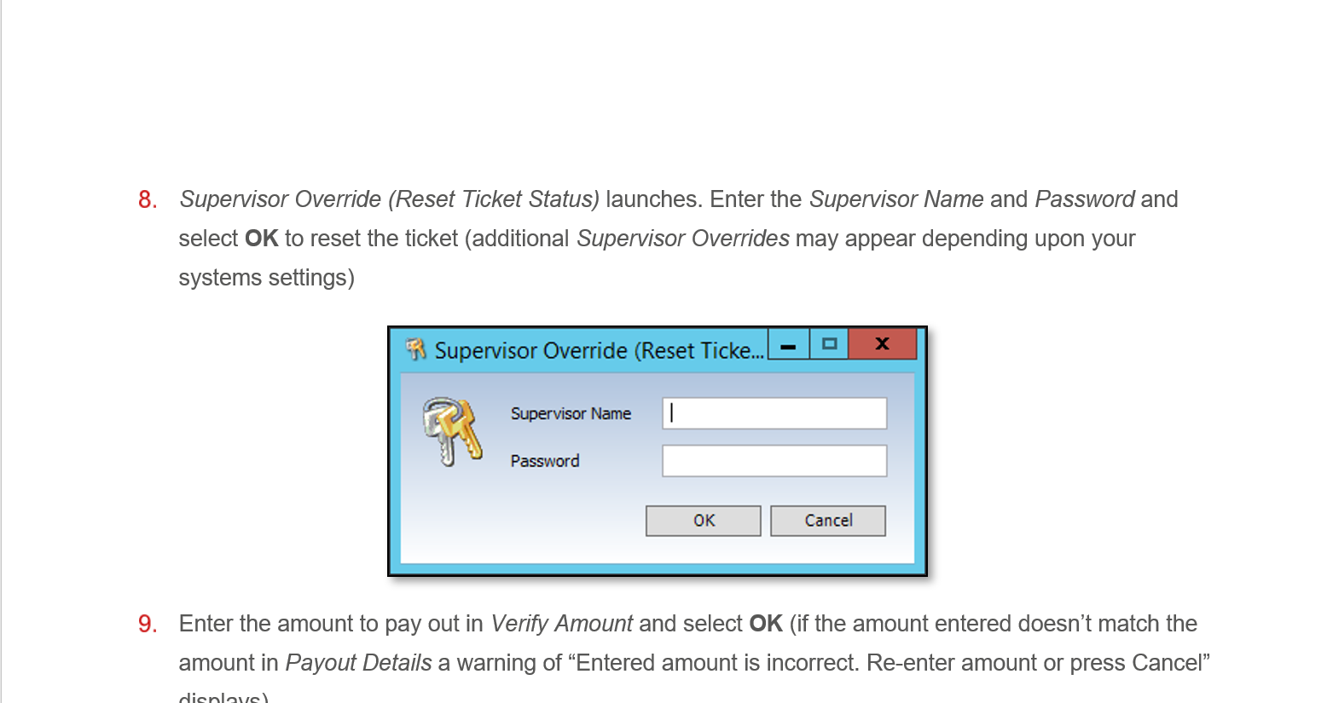 | No script available for this slide.
13 | 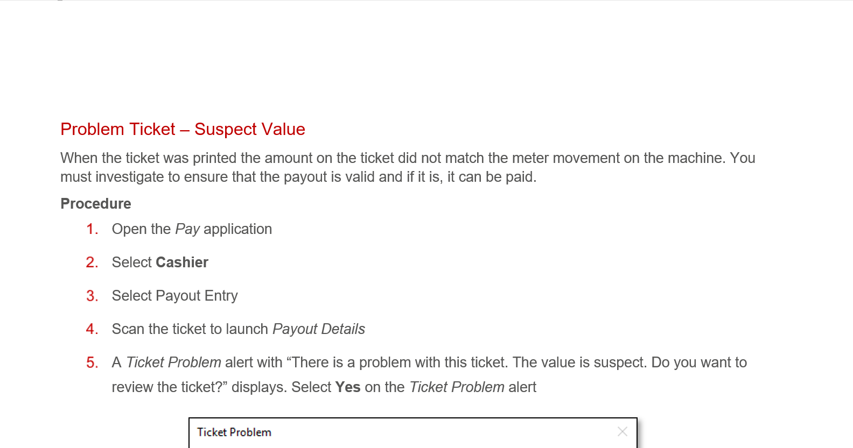 | No script available for this slide.
14 | 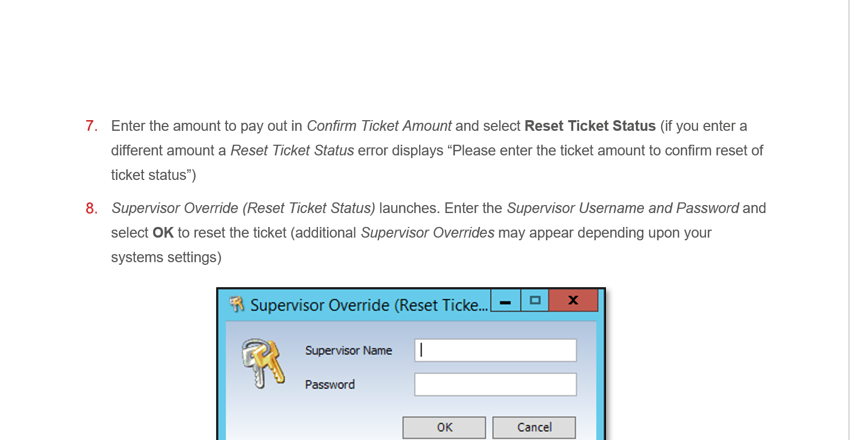 | No script available for this slide.
15 | 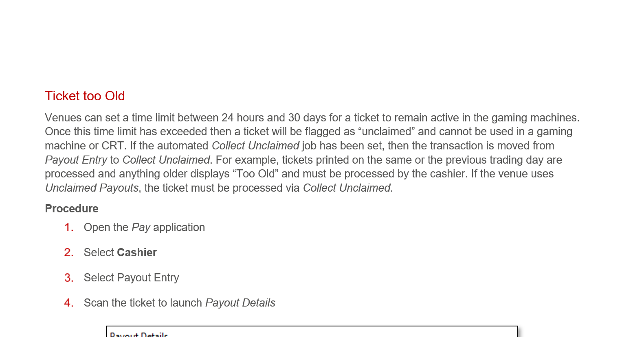 | No script available for this slide.
16 | 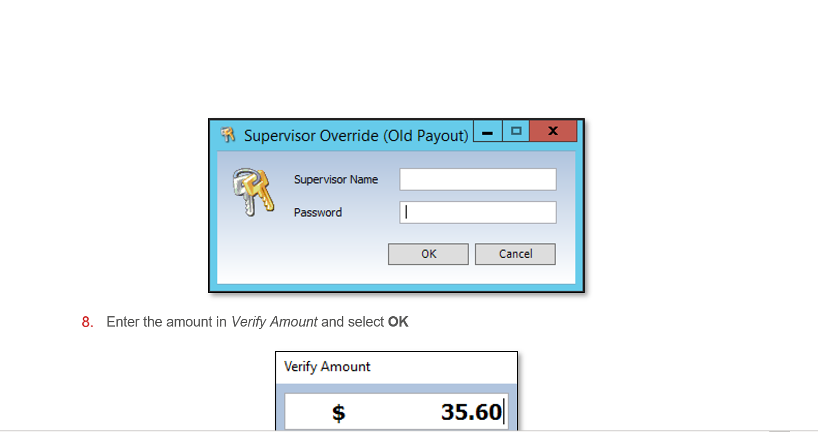 | No script available for this slide.
17 | 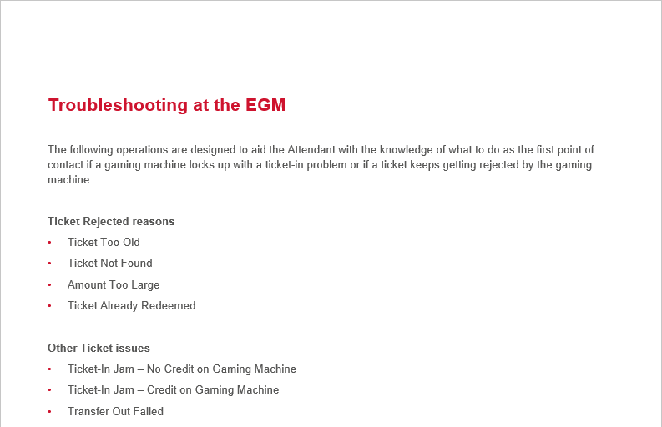 | No script available for this slide.  Non-scripted text:  Refer to the TITO Floor Operations & Troubleshooting Guide and navigate to the Troubleshooting at the EGM section.
18 | 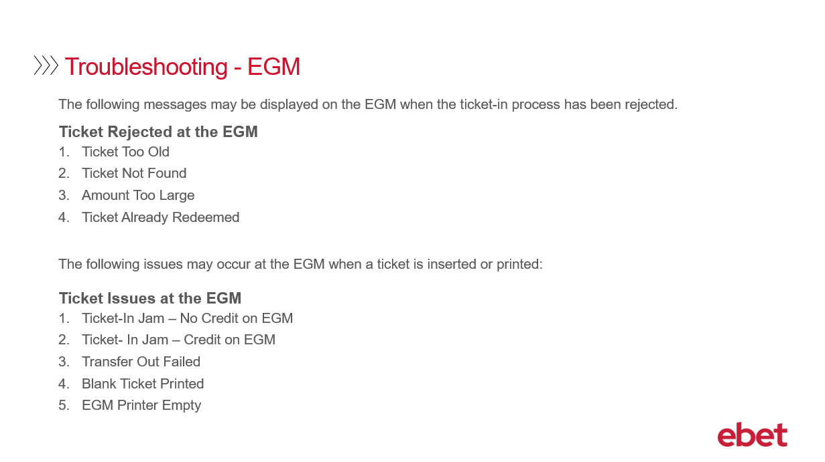 | When a patron inserts their TITO ticket into the EGM, the Metropolis system might detect an issue with the ticket. As a result - the patron will experience one of the following Ticket Rejected messages which will appear on the screen of the EGM. These messages will act as a prompt for the patron to seek assistance.  The various Ticket Rejected messages at the EGM includes:  - Ticket Too Old  - Ticket Not Found  - Amount Too Large - and lastly  - Ticket Already Paid  In addition, a patron may also experience Ticket Issues at the EGM when a ticket is inserted or printed. As a result - the patron will experience one of the following messages which will appear on the screen of the EGM. These messages will act as a prompt for the patron to seek assistance.  The various Ticket Issues messages at the EGM includes:  - Ticket-In Jam – No Credit on EGM  - Ticket-In Jam – Credit on EGM  - Transfer Out Failed  - Blank Ticket Printed and lastly  - EGM Printer Empty  So, let’s firstly take a closer look at the 4 different Ticket Rejected at the EGM messages and how to effectively troubleshoot each of them.
19 | 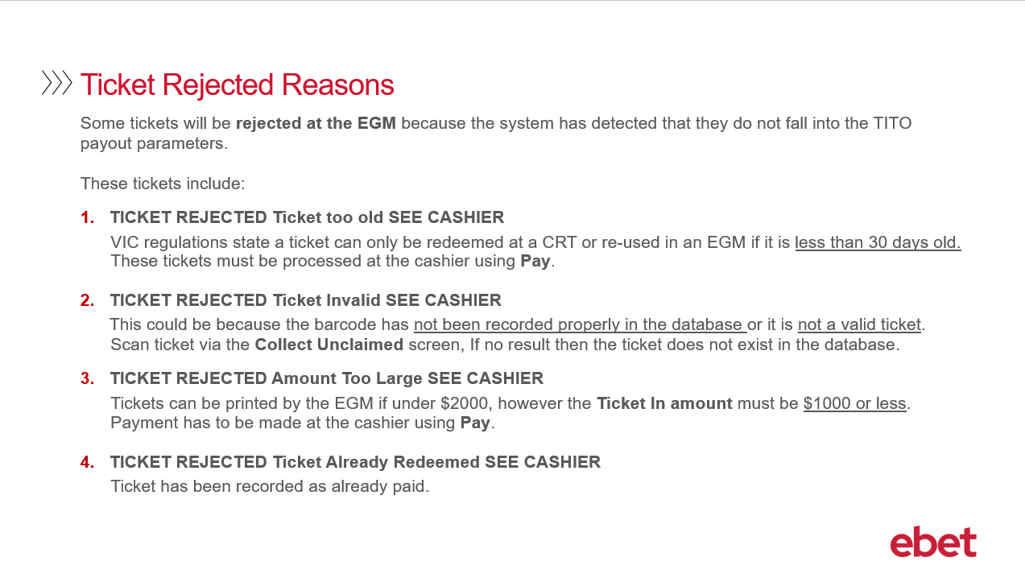 | The actual message that is displayed at the EGM when the system has detected that the ticket does not fall into the TITO payout parameters includes the following.  1. TICKET REJECTED Ticket too old SEE CASHIER  In Victoria the regulation states, that a TITO ticket can only be redeemed at a CRT or re-inserted into an EGM if it is less than 30 days old. Tickets that have passed the 30 days must be processed at the cashier using the Metropolis > Pay application.  As mentioned in the Introduction to TITO video, this time frame can be customised - so if you would like it to be set for a lesser time period – for example 5 days – then please advise the ebet Team at the time of your TITO implementation or alternatively you can contact ebet Support for assistance at any time.  2. TICKET REJECTED Ticket Invalid SEE CASHIER  This occurs when both systems - Intralot and Metropolis - do not recognise the barcode on the TITO ticket. This can occur if the barcode has not been recorded properly in the databases - or it is not a valid ticket. To investigate this error, the ticket can be scanned at the cashier workstation using the Pay application. If there is no result, then the ticket did not exist in the database and may be fraudulent or from another venue.  3. TICKET REJECTED Amount Too Large SEE CASHIER  Similar to a book pay or cancel credit - a TTTO ticket MUST be under $2000 to be printed from an EGM. However, the Ticket in Amount must not exceed $999.95. If the ticket is over $1000.00 then the ticket will be required to be processed at the cashier workstation using the Pay application.  4. TICKET REJECTED Ticket Already Redeemed SEE CASHIER  The ticket barcode has been recognised by the system as being already paid and there is a collection record that already exists for this ticket.
20 | 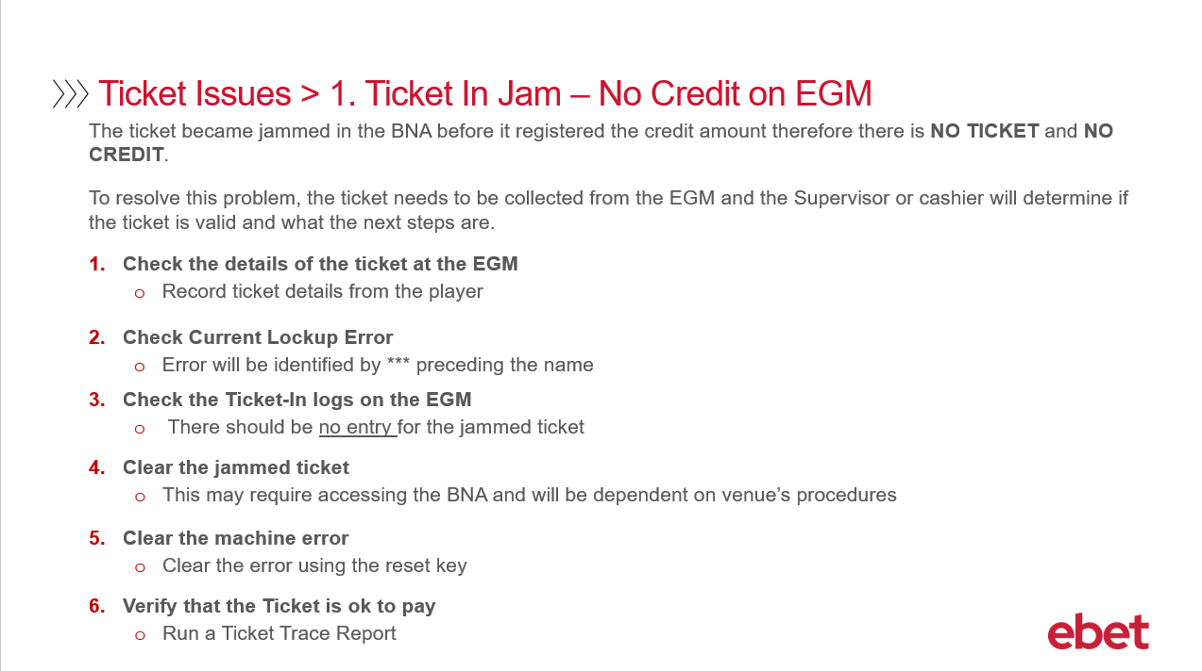 | Let’s now take a look at the 5 different Ticket Issues that may be experienced.  The first ticket issue is Ticket in Jam – No Credit on EGM  This issue occurs when the ticket has become jammed in the Bank Note Acceptor before it has registered the credit amount. The EGM has not recognised or recorded the TITO ticket inserted, leaving the patron with No ticket and No credits on the meter.  To resolve this issue, the ticket will need to be investigated by a Supervisor or Cashier to determine if the ticket is valid or not.  The process to troubleshoot and resolve Ticket In Jam – No Credit on EGM - is as follows:  - Check the details of the ticket at the EGM. You will need to engage the patron and record the details of the TITO ticket, these details may include, the EGM, the time, the amount and anything else that the customer experienced.  - Check Current Lockup Error message on the EGM. This is done by accessing the Audit Screen on the EGM - navigate to the lock error menu and locate the error which will be identified by 3 Asterix *** preceding the name  - Check the Ticket-In logs on the EGM. As you are still in the Audit Screen - check the Ticket In logs. You will have to navigate to the Ticket In menu. NOTE: that the location of this menu will vary based on the EGM model. When you are at the correct menu check for the last entries – there should be no entry for the jammed ticket.  - Clear the jammed ticket. This is done by accessing the Bank Note Acceptor to clear the jam. This will be dependent on your venues procedures on who is permitted to perform this duty.  - Clear the machine error. Once the ticket has been removed, clear the error using the reset key.  - And finally – 6 – Verify that the Ticket is ok to pay. You will need to verify that the ticket is valid. To do this you will be required to run a Ticket Trace Report to confirm that the ticket is valid. Once the ticket is verified it can be paid at the cashier workstation using the Pay application.  It is recommended that this problem ticket NOT be reinserted into an EGM or CRT, as it is likely to jam again.  So, let’s now see how a Ticket Trace Report is run using the Floor application.
21 | 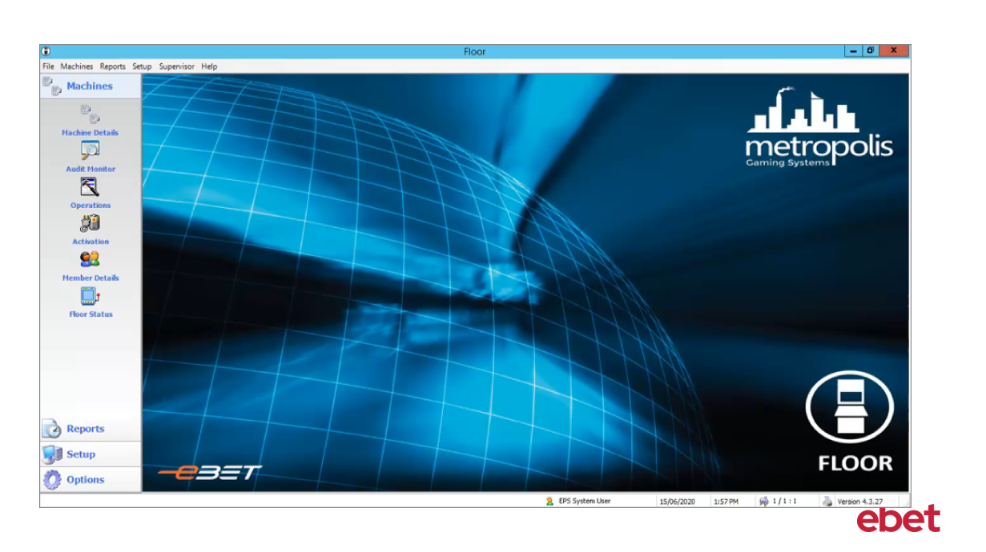 | Non-scripted text:  This video demonstrates TITO Ticket Transactions that are Under Investigation.  Refer to the Video 4 –Ticket Trace Report – Video Transcript. This document provides a detailed account of the video and supporting text.
22 | 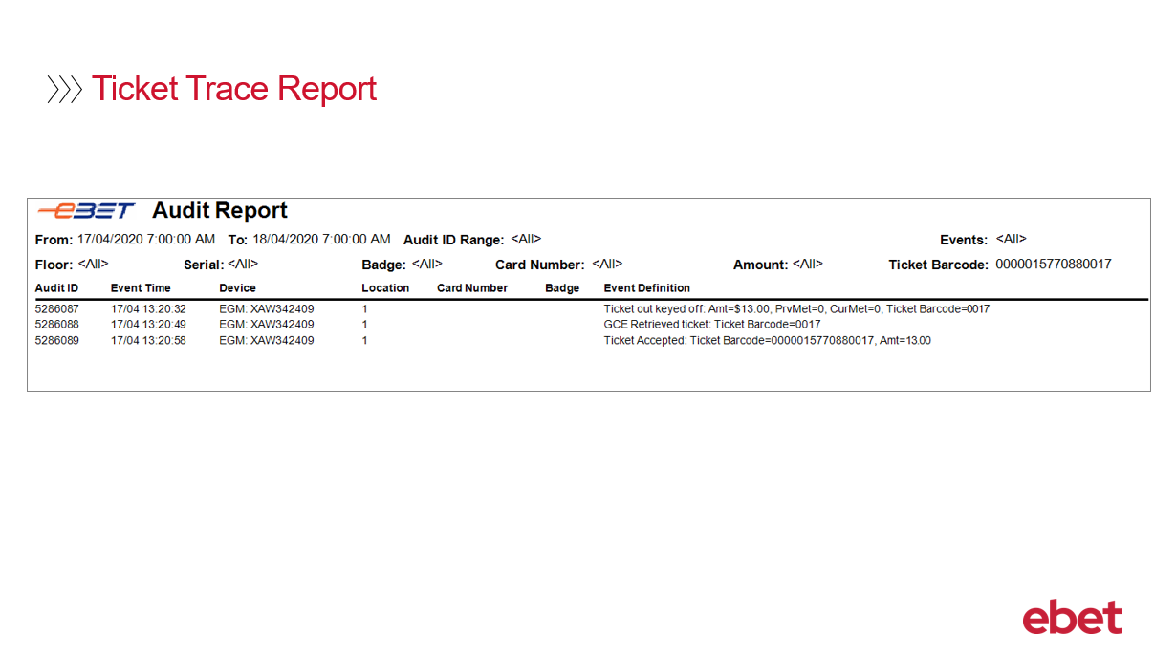 | The Ticket Trace Report will display the following information which will assist in your investigation.  - The date and time range the report was generated.  - The Ticket Barcode number that was scanned.  Looking at this report sample we note the following:  The first transaction, for EGM 1 reports Ticket out keyed off. This means that the ticket was printed successfully, the amount of the ticket was $13, and then the ticket barcode. You will note, that as the ticket has not yet been claimed, the report only shows the last four digits of the barcode.  The next line reports GCE retrieved ticket, which shows the system accepting the transaction.  And finally, the last line reports 26 seconds are the ticket was inserted into EGM 1 - that the ticket was accepted successfully.  When a ticket has been redeemed by being inserted into an EGM, CRT or paid at the Cashier workstation, the report will then display the full barcode number followed by the value of the paid ticket.
23 | 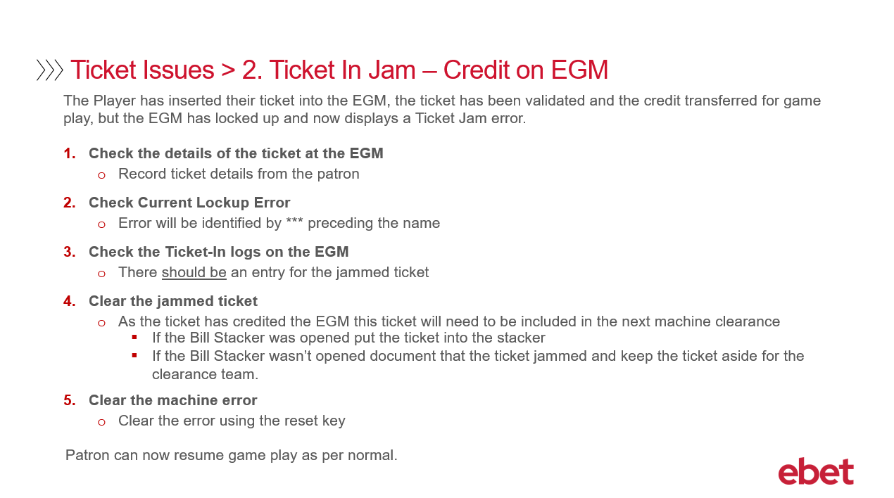 | The 2nd Ticket Issue that may be experienced is Ticket in Jam – Credit on EGM.  This issue occurs when the ticket has registered the credit amount but has become jammed in the Bank Note Acceptor causing the ticket to be validated and credit transferred, but unable to be played as the EGM is now in a lockup state and is displaying a Ticket Jam error on the EGM screen.  To resolve this issue, the ticket jam will need to be cleared from the EGM before play can resume.  The process to troubleshoot and resolve Ticket In Jam – Credit on EGM is as follows:  - Check the details of the ticket at the EGM. You will need to engage the patron and record the details of the TITO ticket, these details may include, the EGM, the time, the amount, and anything else that the customer experienced.  - Check Current Lockup Error message on the EGM. This is done by accessing the Audit Screen on the EGM - navigate to the lock error menu and locate the error which will be identified by 3 Asterix *** preceding the name  - Check the Ticket-In logs on the EGM. As you are still in the Audit Screen - check the Ticket In logs. You will have to navigate to the Ticket In menu. NOTE: that the location of this menu will vary based on the EGM model. When you are at the correct menu check for the last entries – there should be an entry for the jammed ticket.  - Clear the jammed ticket. This is done by accessing the Bank Note Acceptor to clear the jam. This will be dependent on your venues procedures on who is permitted to perform this duty.  - and finally - 5 - Clear the machine error. Once the ticket has been removed, clear the error using the reset key.  At this point the patron can then resume game play.  It is recommended that the ticket that was removed from the EGM, if it cannot be placed in the stacker, then it should be stored in a safe location and ready for the clearance to process.
24 | 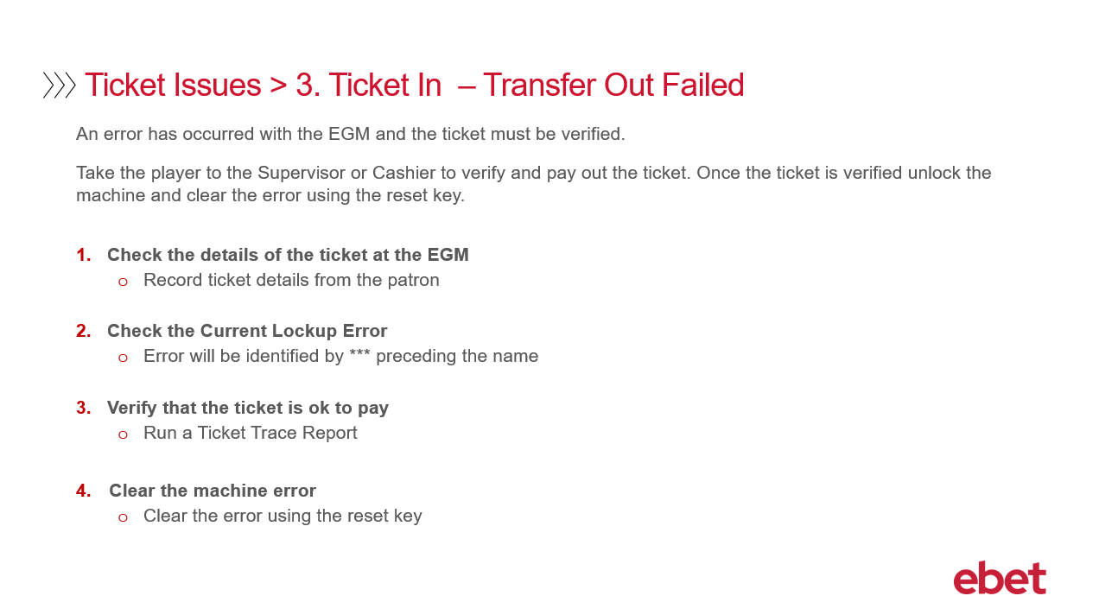 | The 3rd Ticket Issue that may be experienced is Ticket in – Transfer Out Failed  This issue occurs when the EGM has an error and will require the ticket to be verified.  To resolve this issue, the ticket will need to be investigated by a Supervisor or Cashier to determine if the ticket is valid or not.  The process to troubleshoot and resolve Ticket In – Transfer Out Failed - is as follows:  - Check the details of the ticket at the EGM. You will need to engage the patron and record the details of the TITO ticket, these details may include, the EGM, the time, the amount, and anything else that the customer experienced.  - Check Current Lockup Error message on the EGM. This is done by accessing the Audit Screen on the EGM - navigate to the lock error menu and locate the error which will be identified by 3 Asterix *** preceding the name  - Verify that the Ticket is ok to pay. You will need to verify that the ticket is valid. To do this you will be required to run a Ticket Trace Report to confirm that the ticket is valid. Once the ticket is verified it can be paid at the cashier workstation using the Pay application  - and finally - 4 – Clear the machine error. Once the ticket has been removed, clear the error using the reset key.
25 | 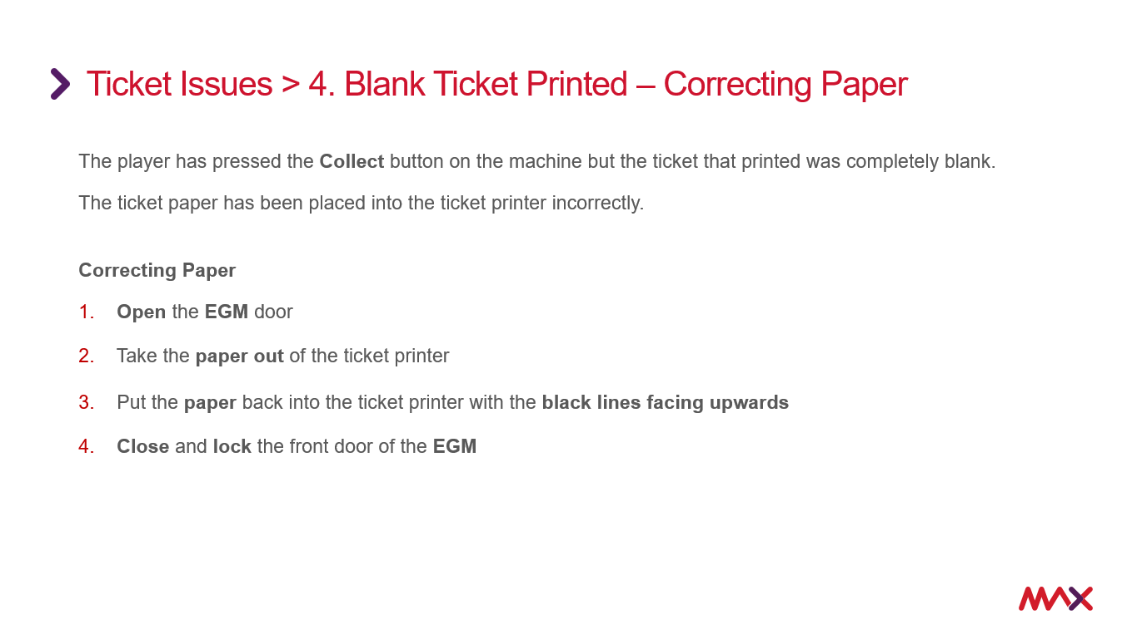 | The 4th Ticket Issue that may be experienced is Blank Ticket Printed – Correcting Paper  This issue occurs when the patron has pressed the collect button on the EGM and the ticket that is printed is completely blank. This normally occurs when the ticket paper in the printer has been placed upside down.  To resolve this issue, firstly the ticket paper will need to be corrected.  The process to resolve a Blank Ticket Printed by Correcting the Paper - is as follows:  - Open the EGM door  - Take the paper out of the ticket printer  - Put the paper back into the ticket printer with the black lines facing upwards  - and 4. Close and lock the front door of the EGM  If the paper was facing the correct direction, then there may be an issue with your printer and an incident will need to be raised with your service provider for repair or replacement.  As the EGM cannot reprint the ticket, the patron will be required to go to the cashier workstation to have their ticket details verified before been paid.
26 | 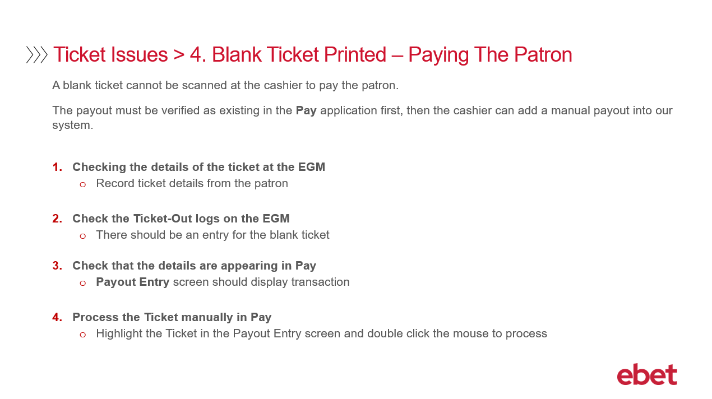 | At the Cashier workstation, as a blank ticket cannot be scanned and therefore not paid out, further investigation will be required, before the cashier can payout the ticket.​  ​  To verify the amount that needs to be paid, the cashier, will use the Pay application, and then via the Payout Entry screen locate the ticket. When the payout is identified the cashier can then add a manual payout into the system. This will need to be done as a ticket must be scanned to be processed as a blank ticket has no visible barcode to scan.​  ​  The process to resolve a Blank Ticket Printed – Paying the Patron – is :​  ​  - Check the details of the ticket at the EGM. You will need to engage the patron and record the details of the TITO ticket, these details may include, the EGM, the time, the amount and anything else that the customer experienced.​  - ​  - Check the Ticket Out logs on the EGM – In the Audit screen, navigate to the Ticket Out menu. NOTE, the location of this menu will vary based on the EGM model. When you are at the correct menu check for the last entries – there should be an entry for the blank ticket.​  ​  - Check the details are appearing in Pay. Check the Payout Entry screen as this should match the information in the Ticket Out logs at the EGM.​  ​  and lastly 4. Process the Ticket manually in Pay​  - Highlight the ticket in the Payout Entry screen and double click the mouse to process
27 | 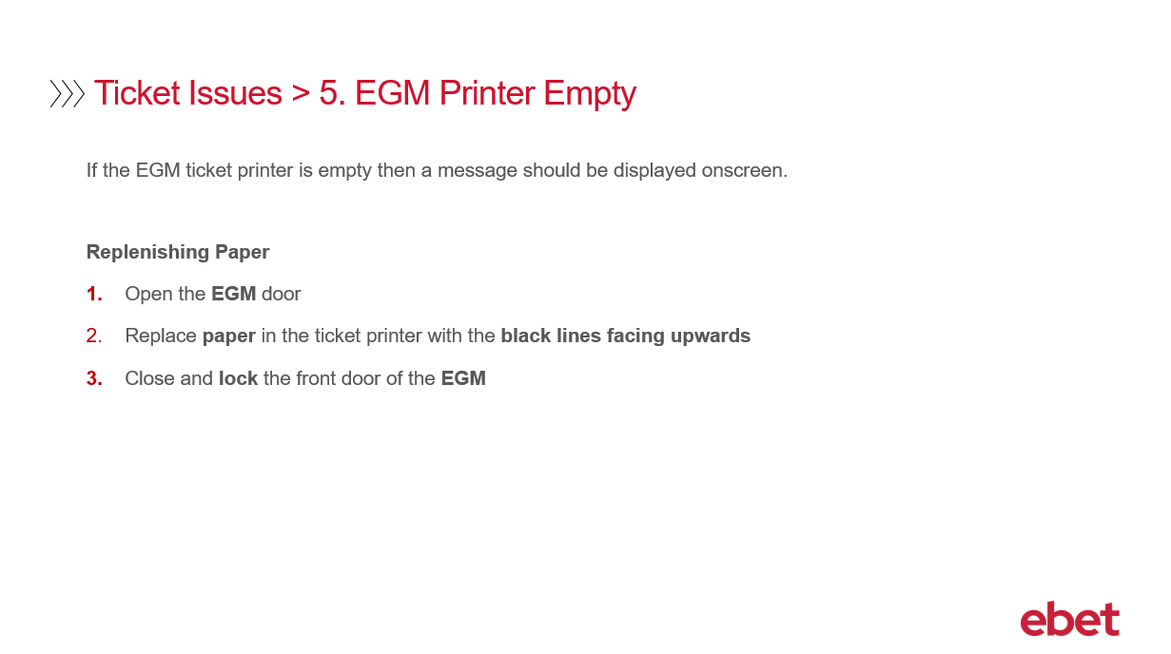 | The 5th Ticket Issue that may be experienced is EGM Printer Empty.  This issue occurs when there is no paper in the ticket printer stacker. To resolve this issue, simply add more paper.  To replenish the paper:  - Open the EGM door.  - Add paper to the ticket printer stacker with the black lines facing upwards.  - and then close and lock the front door of the EGM.
28 |  | Let’s now look at TITO Troubleshooting at the CRT.
29 | 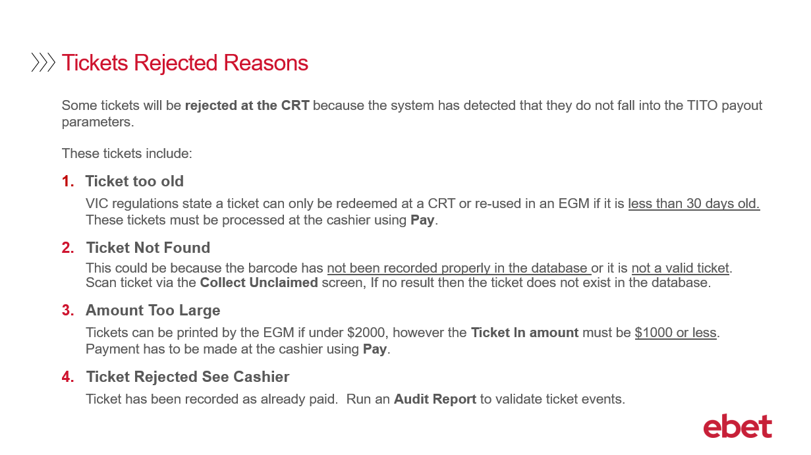 | In a TITO environment, same as the EGM, the CRT will also reject tickets if the system detects that they do not fall into the TITO payout parameters.  Ticket Rejection at the CRT includes:  1. Ticket too old  2. Ticket Not Found  3. Amount Too Large  4. Ticket Rejected – See Cashier
30 | 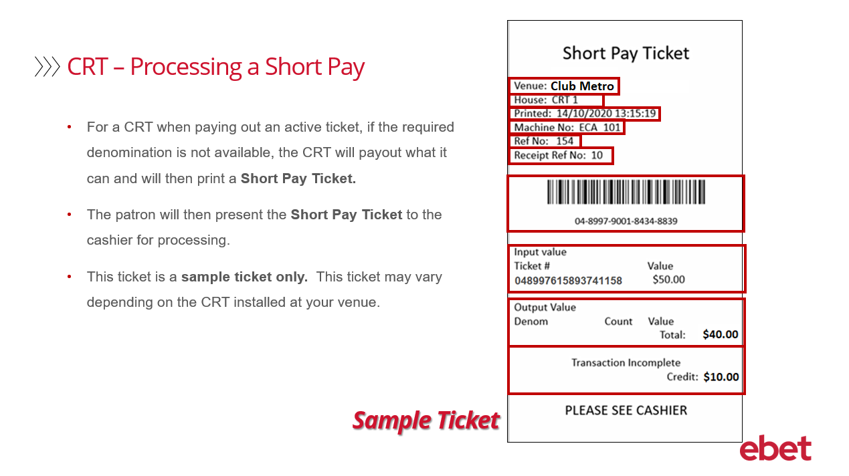 | For a CRT, when paying out an active ticket, if the required denomination is not available, the CRT will pay what it can and will then print a Short Pay Ticket. The patron will then present this ticket to the cashier for processing.  Some details to note on the ticket are  - Your venue name  - The CRT House number  - The date and time the ticket was printed  - The Machine No. which is the CRT Device ID number  - The Ref No. – which refers to the CRT Transaction number  - The Receipt Ref No. – which is the CRT Receipt number  - The Barcode and barcode number – which is generated for this Short Pay ticket  - The Input Value – which represents the original amount of the ticket that was inserted into the CRT,  - The Barcode Number – which is the number that went into the CRT  - The Output Value – which represents the value of what the CRT dispensed  - and lastly the Transaction Incomplete – which represents the amount that the CRT could not be pay out and will be the Short Pay Ticket printed  The ticket shown is a sample only. The Short Pay Ticket that is printed at your venue may vary in appearance as the ticket format is dependent on the CRT installed.
31 | 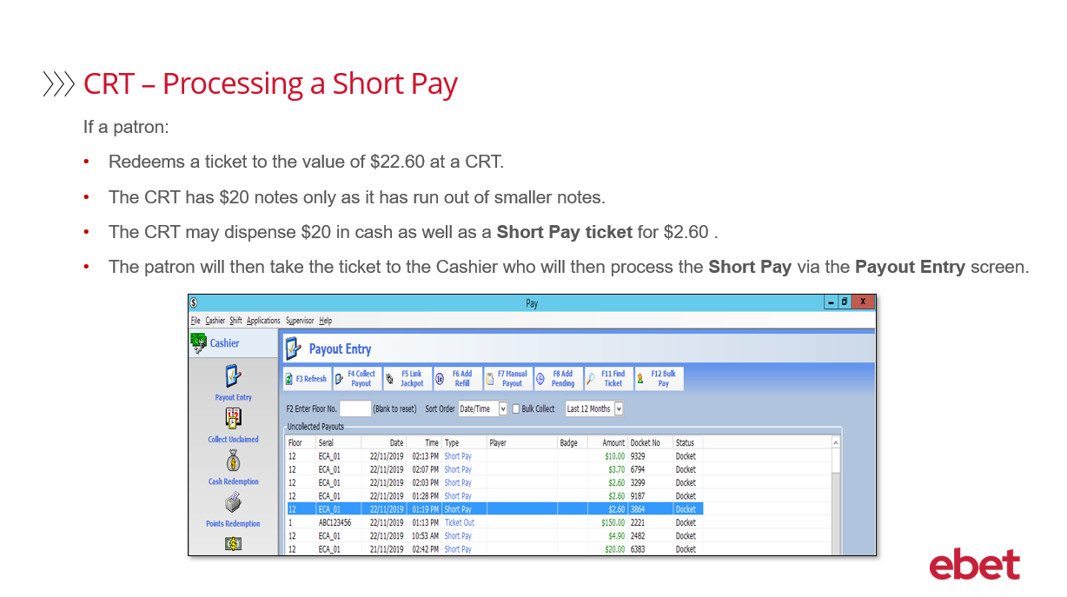 | For example  If a patron:  - Inserts a ticket into the CRT to the value of $22.60  - And the CRT has only $20 notes and no coin  - Then the CRT will dispense $20 in cash as well as a Short Pay ticket for $2.60  - The patron will then take the ticket to the Cashier who will then process the Short Pay ticket via the Payout Entry screen  - The transaction is then complete
32 | 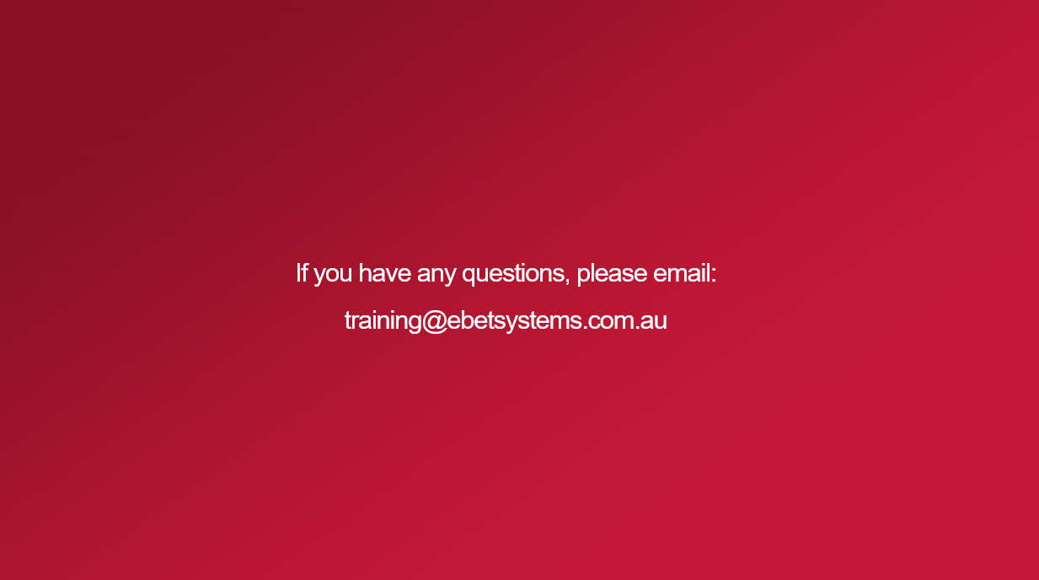 | This brings you to the end of the TITO Troubleshooting including EGM and CRT Training video.  If you have any questions regarding the content of this training course - please email - training@ebetsystems.com.au.

