Video Transcript

Metropolis – TITO Reconciliation
This document supports the TITO Reconciliation training video and includes a word for word account of each screen captured and its supporting text.
Venue staff may find this document useful to reference if they want to review the content of the training video.
It is recommended that the training video be watched as it does include videos of various activities that cannot be viewed in this document.

SLIDE | SLIDE IMAGE | VIDEO SCRIPT
1 |  | Welcome to the Metropolis Training Video.
2 | 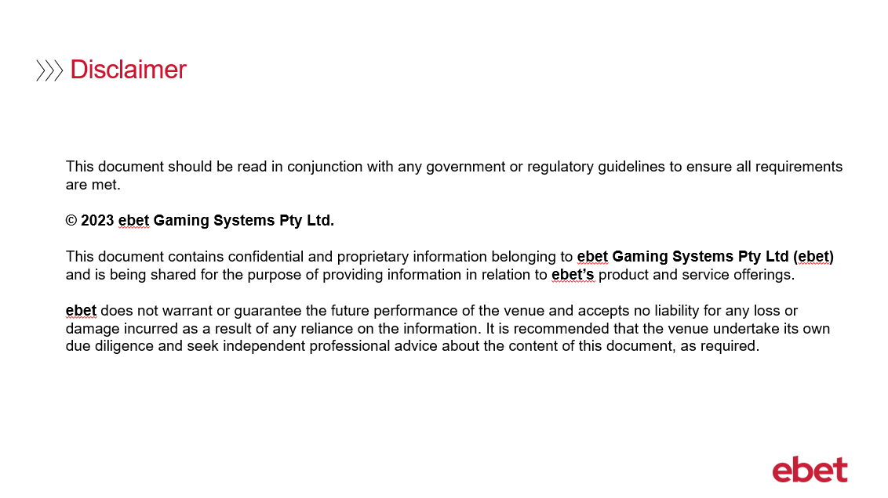 | No script available for this slide.
3 |  | This training will mainly focus on venues using the Metropolis Vault application and how their back of house reconciliation will now change with the introduction of TITO functionality.  For venues that use a third-party provider such as System 1 or GFR Pro for their back of house reconciliation, please consult them for guidance on managing these requirements.
4 | .  | So, let’s start by focusing on venues using the Metropolis Vault application and how to manage their reconciliation requirements.
5 | 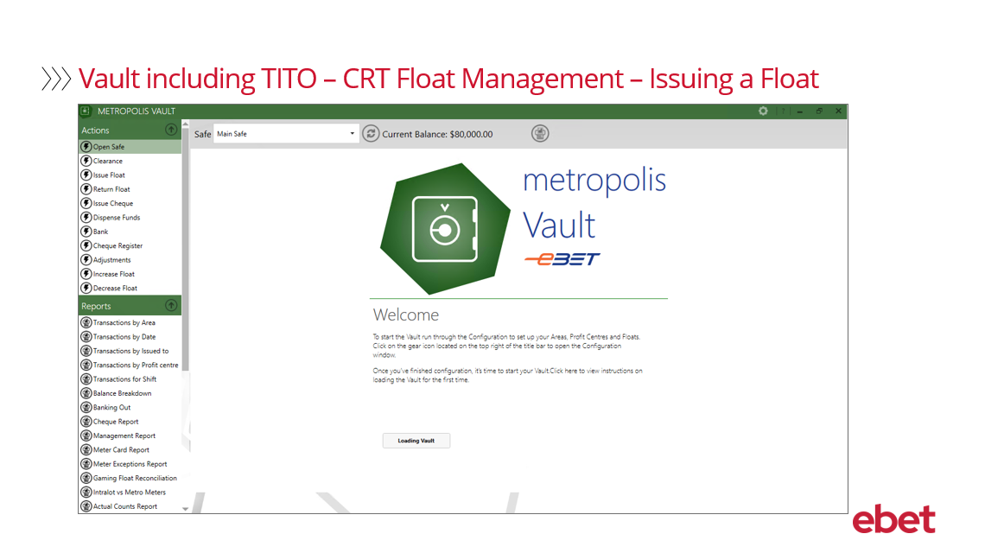 | Refer to CRT Float Management – Vault – Issue Float – Supporting Document
6 | 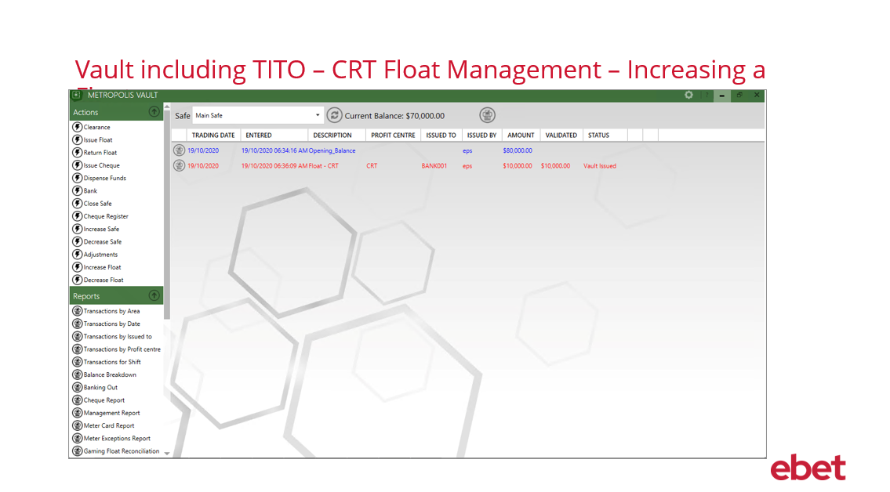 | Refer to CRT Float Management – Vault – Increasing a Float – Supporting Document
7 | 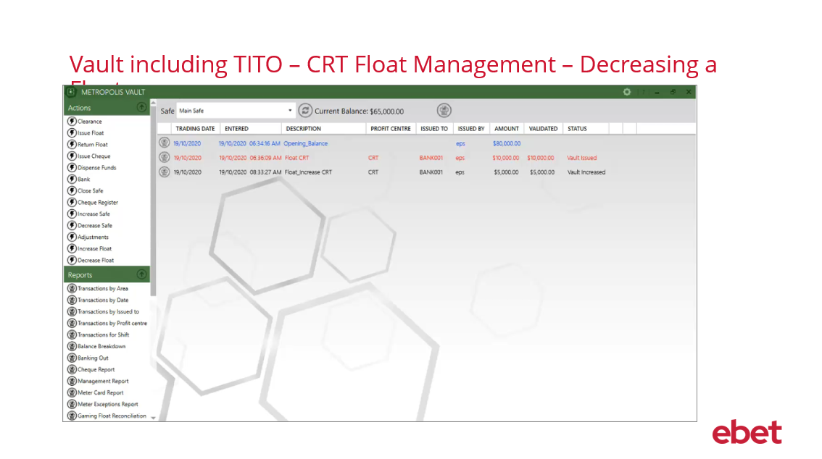 | Refer to CRT Float Management – Vault – Decreasing a Float – Supporting Document
8 | 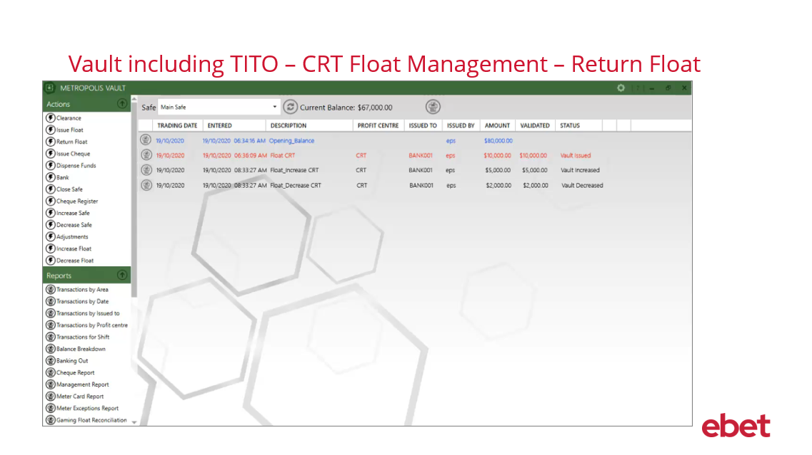 | Refer to CRT Float Management – Vault – Return Float – Supporting Document
9 | 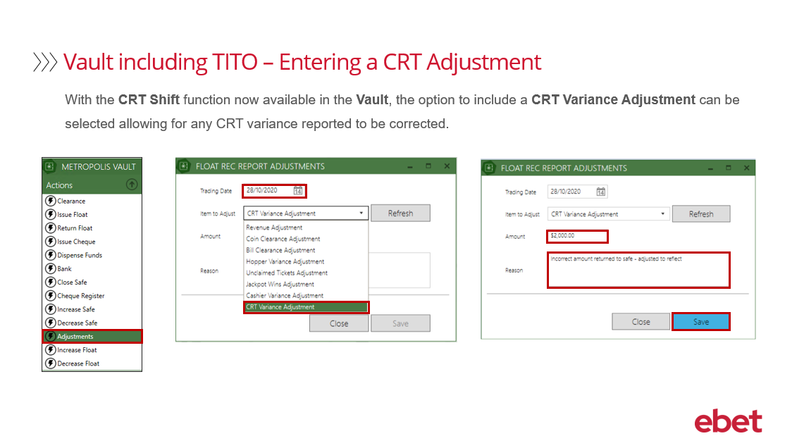 | With the CRT Shift function now available in the Vault, the option to include a CRT Variance Adjustment can be selected allowing for any CRT variance reported to be corrected.  - From the Actions menu  - Select Adjustments  - Select the Trading Date the CRT adjustment is required for  - From the Item to Adjust drop down list – select CRT Variance Adjustment  - Enter the Amount to be adjusted – it is important to note that depending on the variance reported you will need to consider whether the value to be entered will need to be either a negative or positive value  - Enter the Reason for the adjustment  - And then select Save  This adjustment will now be recorded in the following reports:  - The Gaming Float Reconciliation Report or GFR Report  - The Management Report including Daily, Weekly or Monthly  - The Adjustments Report – and the  - Gaming Float Adjustment Report
10 | 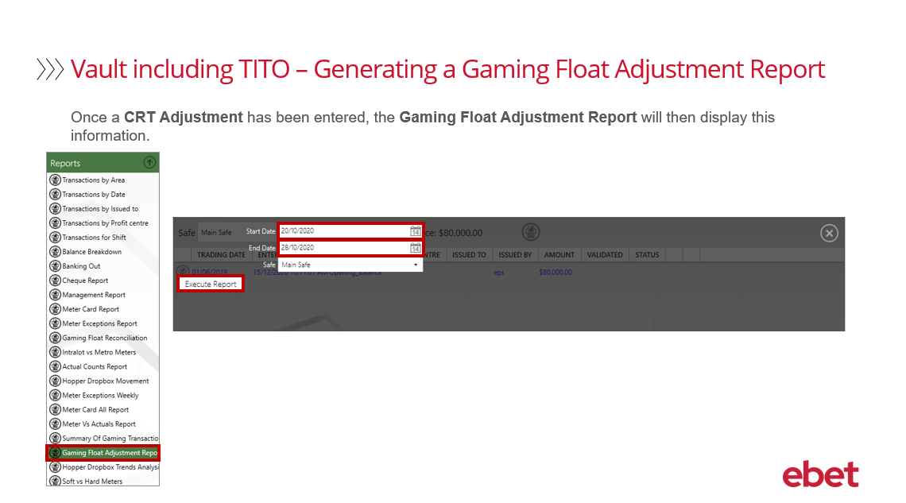 | Once a CRT Adjustment has been entered, the Gaming Float Adjustment Report will display this information.  To generate the report:  - From the Reports menu select Gaming Float Adjustment Report  - Select the Start and End date the CRT Adjustment was entered  - Then select Execute Report
11 | 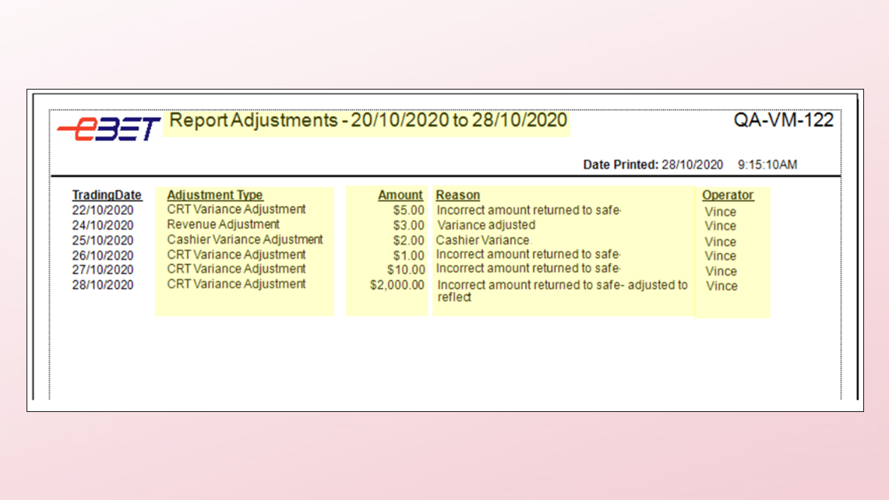 | The Report Adjustments will display the following information:  - The Trading Date Range the report was generated  - The Adjustment Type – this field will report on all gaming float adjustments entered  - The Amount that the adjustment was for  - The Reason for the adjustment that was entered at the time of the adjustment been made  - And finally, the Operator who was logged into Vault at the time the adjustment was made
12 | 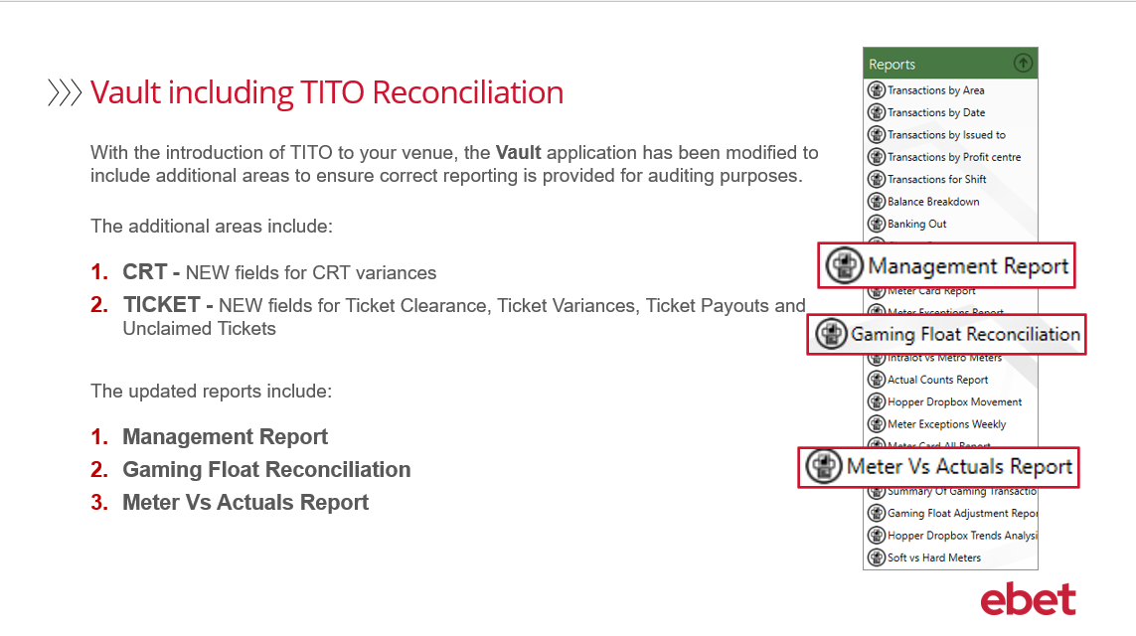 | With the introduction of TITO into your venue, the Vault application has been modified to include additional areas of reporting to ensure correct data is recorded and provided for auditing purposes.  The two new TITO functions that are now available in your reconciliation reports include:  - CRT – new fields are now available for CRT variances - and  - TICKETS – new fields are now available for ticket clearance, ticket variance, ticket payouts and unclaimed tickets  The reports that have been updated to include the CRT and ticket information includes:  - The Management Report  - The Gaming Float Reconciliation Report  - And finally, the Meter Vs Actuals Report  Let’s now take a look at each of these reports in more detail.
13 | 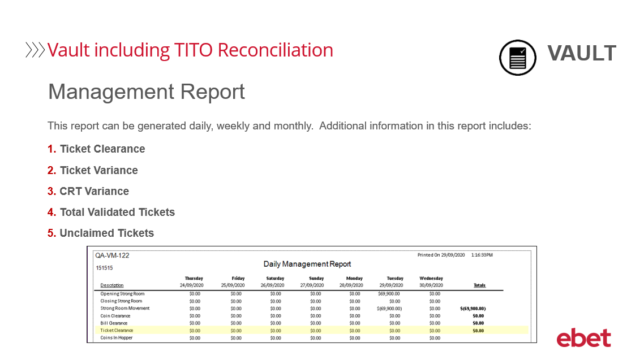 | The first report that we will review is the Management Report.  The additional information that is now available in this report includes:  - Ticket Clearance  - Ticket Variance  - CRT Variance  - Total Validated Tickets  - and Unclaimed Tickets
14 | 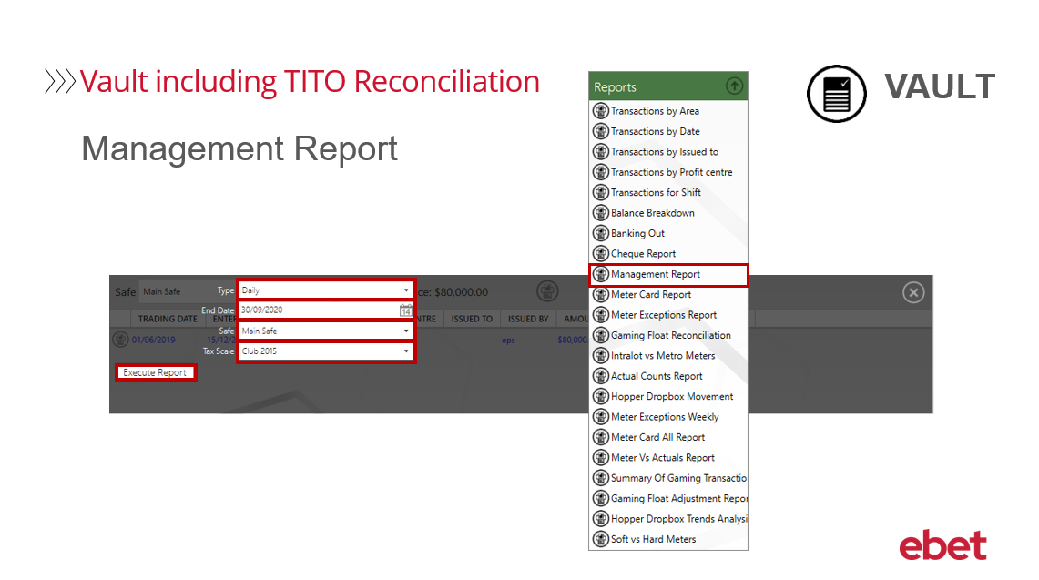 | To generate the report:  - From the Reports menu select Management Report  - There is a range of report filter options available when generating this report  - Firstly, the Type – this is where you can choose Daily Weekly or Monthly  - Next is the End Date that you want to run the report for  - Then there is Safe - which will generally default to Main Safe  - And finally, the Tax Scale  Let’s now Execute the Report.
15 | 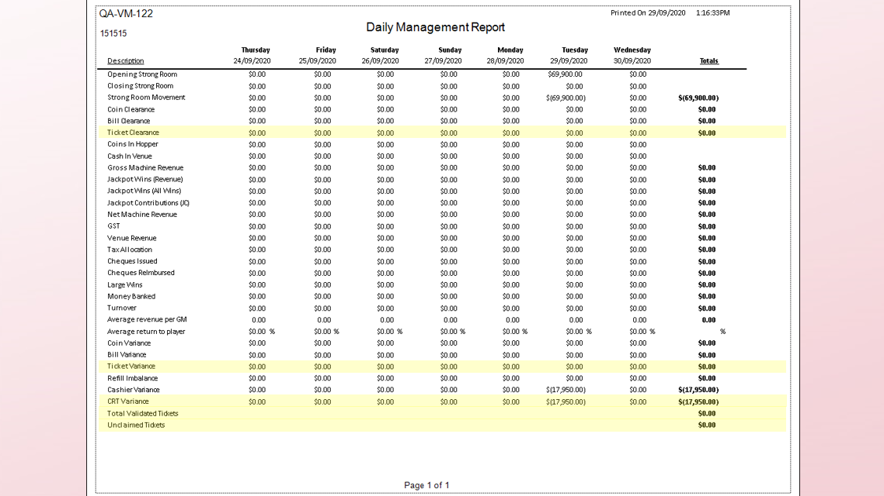 | The new information in this report includes:  - Ticket Clearance – this provides the total value of tickets cleared from each EGM  - Ticket Variance – this provides the variance between the Actual vs Metered Ticket Clearance  - CRT Variance – this provides any shift Variance in Pay for the CRT  - Total Validated Tickets – this includes BOTH Cancel Credits and Tickets Paid Out – and lastly …  - Unclaimed Tickets – this includes BOTH Cancel Credits and Tickets Unclaimed
16 | 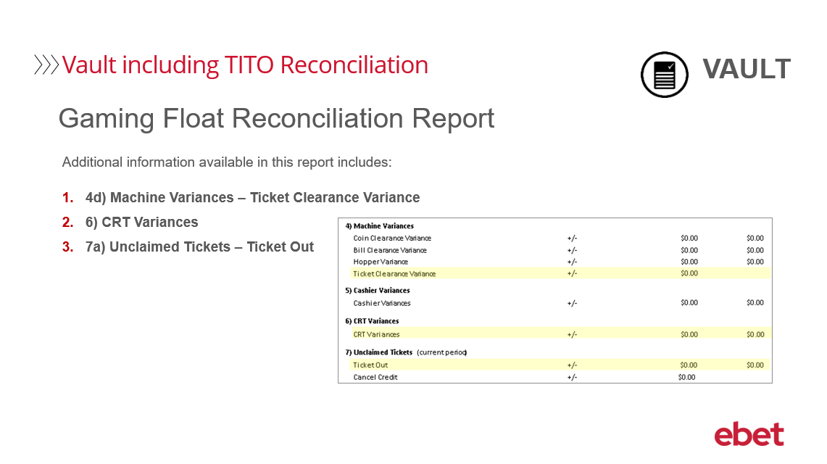 | The second report that we will review is the Gaming Float Reconciliation Report  The additional information that is now available in this report includes:  - Under the Machine Variances section – the Ticket Clearance Variance  - The CRT Variances is now a new section  - And finally, The Unclaimed Tickets which will now include Ticket Out
17 | 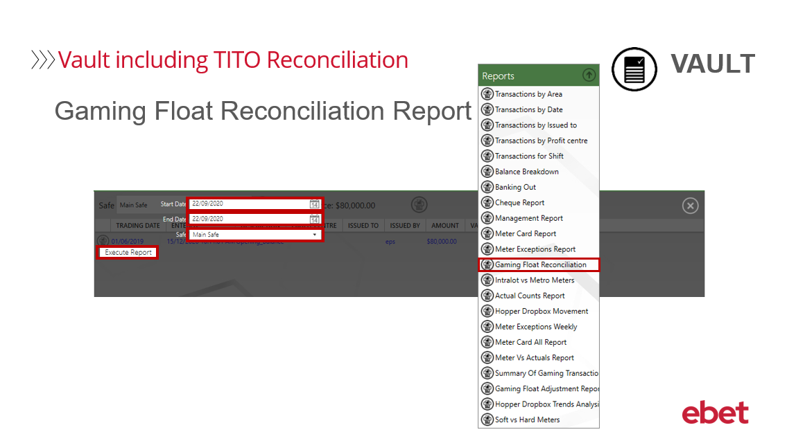 | To generate the report:  - From the Reports menu select Gaming Float Reconciliation Report  - There is a range of report filter options available when generating this report  - Firstly, the Start Date and End Date that you want to run the report for  - And then the Safe which will generally default to Main Safe  Let’s now Execute the Report.
18 | 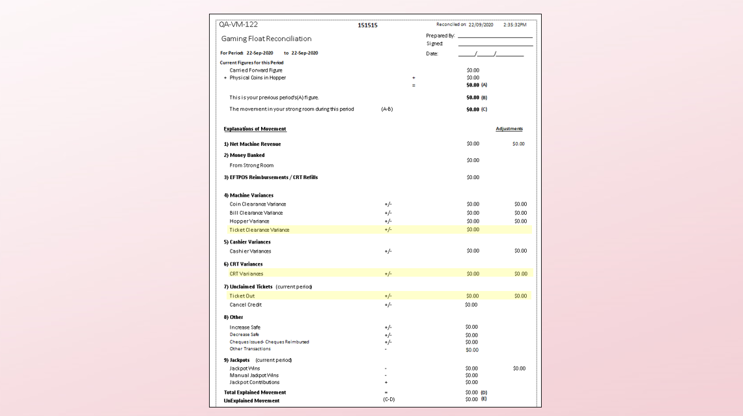 | The Ticket Clearance Variance will report any variance made between the Actual and Metered Ticket Clearance using data from the Game application. If your clearances are set to Auto Populate this field will be zero unless an adjustment has been made via the Fast Payout Entry in the Game application.  The CRT Variances provides any (A – B) variances on the Pay Float Reconciliation when the cashier shift was closed.  The Unclaimed Tickets – Ticket Out will compare TITO tickets that have been printed at the gaming machine to actual TITO tickets that have been redeemed  Values in this field could be either a ticket printed from the EGM today but not yet collected – or a ticket printed on a previous day that has been collected today  Remember that a TITO ticket is flagged in the system as redeemed once it has been accepted in the CRT, EGM or at the cashier.
19 | 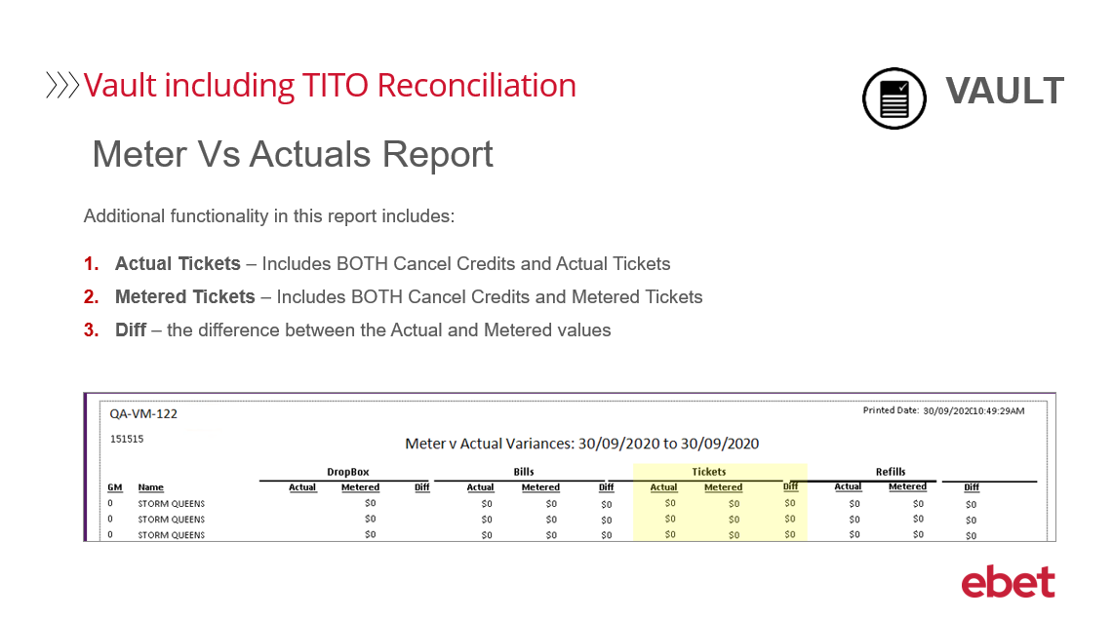 | The third report that we will review is the Meter Vs Actuals Report  The new information in this report includes:  - The Actual TITO Tickets  - The Metered TITO Tickets  - And the Difference between the two
20 | 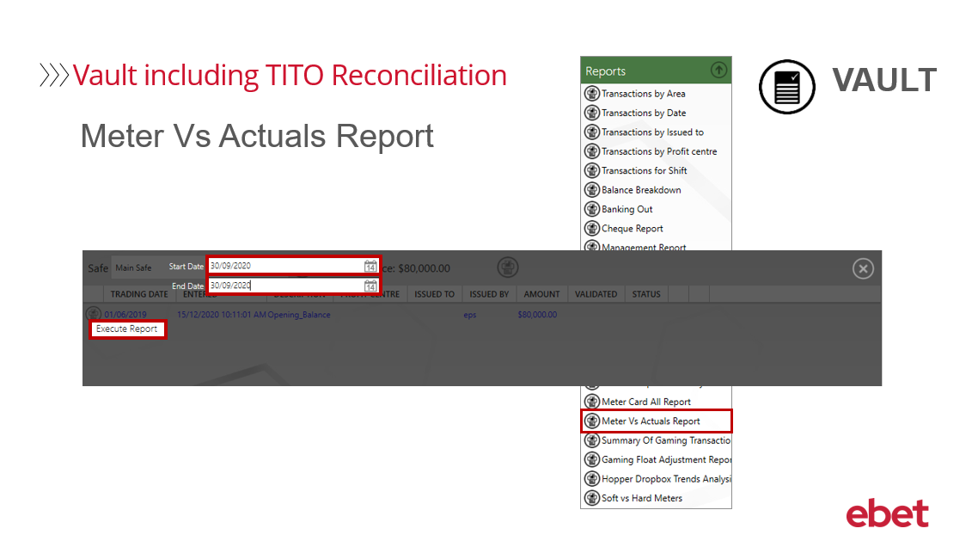 | To generate the report:  - From the Reports menu select Meter Vs Actuals Report  - When generating this report, you simply need to select the Start Date and End Date that you want to run the report for  Let’s now Execute the Report.
21 | 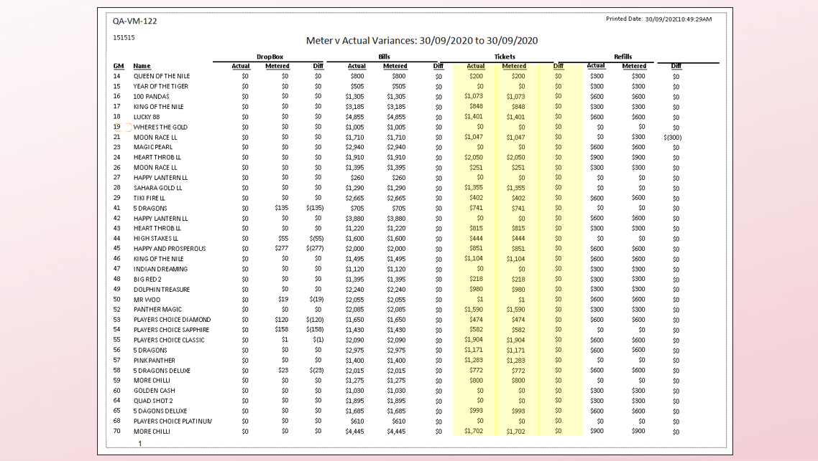 | The new information in this report includes:  - Actual – which includes BOTH Cancel Credits and TITO Tickets  - Metered – which also includes BOTH Cancel Credits and TITO Tickets  - And the Difference is between the Actual and Metered values
22 |  | This brings you to the end of the Metropolis – TITO Reconciliation Training video.  If you have any questions regarding the content of this training course - please email - training@ebetsystems.com.au.

