WhatsApp Guidelines
Class WhatsApp groups are a very useful and efficient way for parents and carers to communicate to the whole class and share information relevant to the school and the community.
The messages in the class WhatsApp groups come from parents and carers in their personal capacity and are managed by parents. The school and the Friends of Belham are not responsible for any WhatsApp parent/carer groups. Unfortunately, sometimes message threads can get out of hand and as well as people getting upset, others can become misinformed.
To help parents and carers to manage and navigate these groups, we are sharing guidelines on appropriate behaviour.
The following online activity is considered inappropriate:
- Abusive or personal comments about staff, pupils, parents/carers, or any member of the school community.
- Sharing of emails, photos of or messages from members of the school community without their permission.
- Displays of anger including swearing or using offensive language.
- Bringing the school or Friends of Belham into disrepute.
- Posting aggressive, defamatory, or libellous comments.
- Using the group as a political platform for airing opinions on current affairs.
- Using the group to discuss issues about individual children.
- Threatening behaviour, such as verbally intimidating individuals, or using bad language.
The group should treat all members of the school community with respect and ensure cultural sensitivity – setting a good example with speech and behaviour.
Raising Concerns
If you are concerned about inappropriate comments on a class WhatsApp group, in confidence, please contact your year group rep, the Friends of Belham on friendsofbelham@gmail.com or a senior leader within the school who will do their best to help:
Ally Sprakes - Headteacher ecohen18.210@lgflmail.org
Richard Wilson - Deputy Headteacher rwilson115.210@lgflmail.org

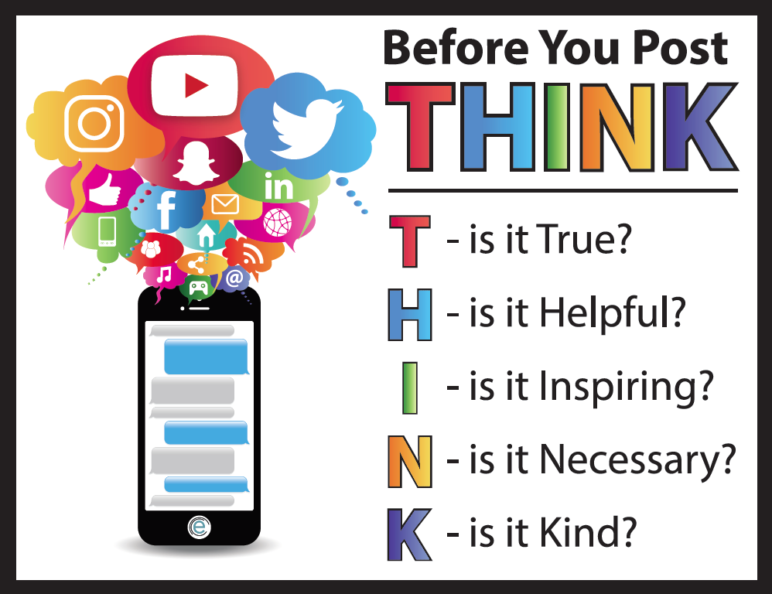

Some great rules to follow:
- Am I posting in anger?
- Who might be able to read this?
- Could someone misinterpret what I am saying?
- Should I wait and post this tomorrow?
- Could someone be upset by my comment?
- Is there a better way to respond to this situation?

