NEWS

LINDAL publishes new Sustainability Report 2024
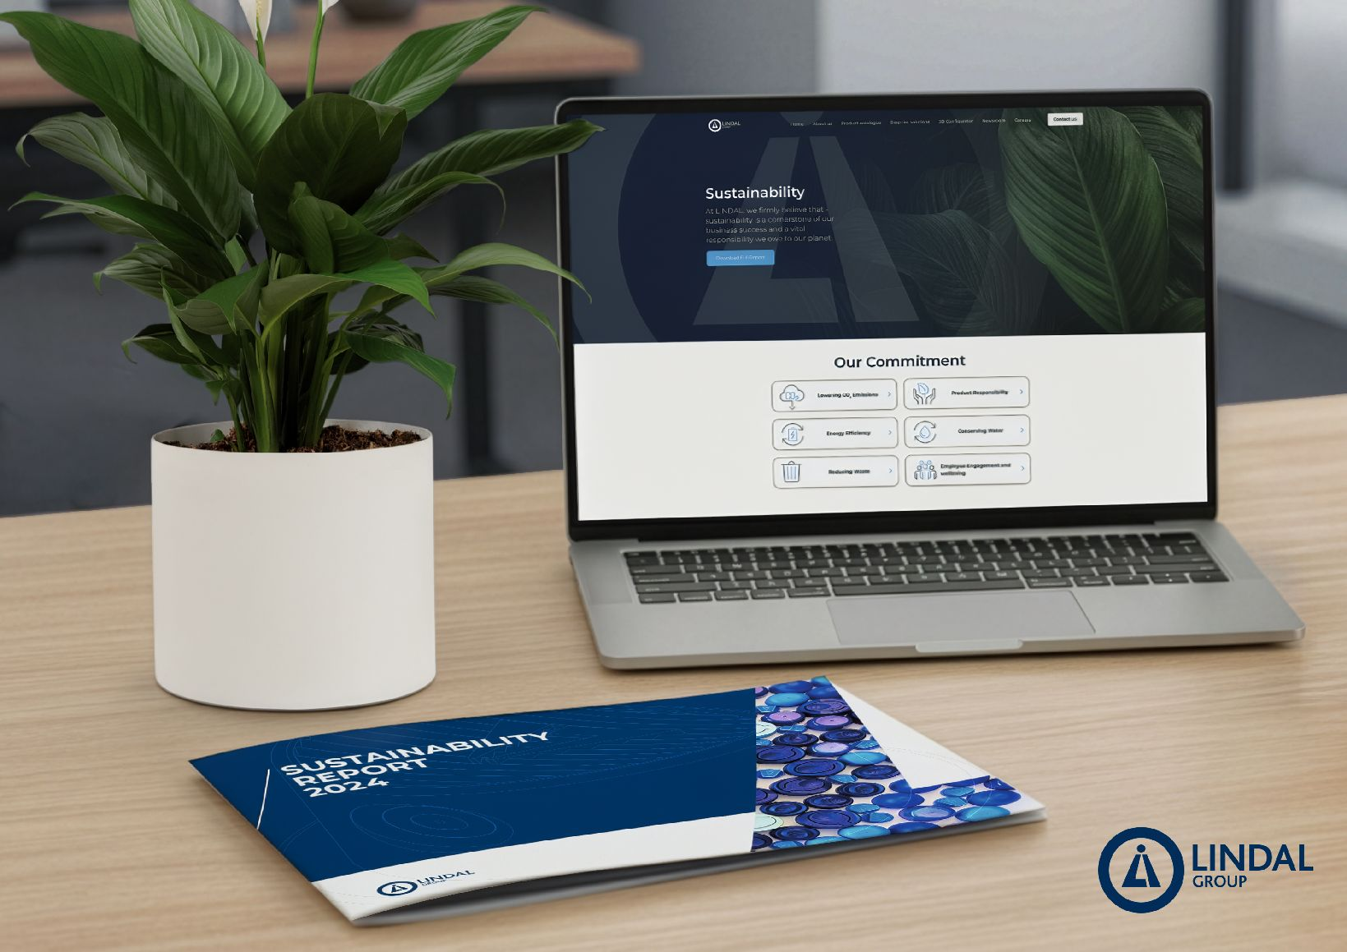

LINDAL Group announces significant progress in sustainability and ESG performance across 2023–2024

The LINDAL Group, a global leader in aerosol dispensing solutions, has published its Sustainability Report 2024 and launched a new webpage to highlight its continuous progress and ongoing objectives.

Over the past two years, LINDAL has strengthened its sustainability governance framework, increased transparency, and achieved measurable progress toward its Sustainability Roadmap 2025. The company’s alignment with the consolidated GRI Standards 2024 represents a significant milestone in the development of its reporting structure.
These accomplishments underscore LINDAL’s commitment to continuous improvement, operational excellence, and long-term value creation for customers, employees, and stakeholders worldwide.

Continuous Improvement in EcoVadis Ratings

LINDAL recorded strong year-on-year improvements in its EcoVadis sustainability rating, rising from 38 to 56/100 in 2023, and further to 60/100 in 2024, placing the Group in the 62nd percentile of rated companies. These results highlight the company’s strengthened practices across environment, labour & human rights, ethics, and sustainable procurement.

Advances in Product Sustainability & Innovation

LINDAL continued to accelerate the development of sustainable dispensing technologies:

- Expansion of fully plastic recyclable aerosol valves and actuators with PCR material supporting improved recyclability.
- Development of Valve technology suitable for compressed air formulation without compromising consumer experience.
- Continuous reduction in virgin plastic and metal usage through eco-design, lightweighting, and digital optimisation tools.

These initiatives reinforce LINDAL’s commitment to offering low-impact, future-ready packaging solutions that meet evolving customer and regulatory expectations.

Enhanced Safety & People Development

In 2024, LINDAL recorded a significant improvement in its Total Recordable Incident Rate (TRIR), supported by Safety Day initiatives, global safety induction programmes, and strengthened incident reporting. Today, 80% of LINDAL’s manufacturing sites are certified under ISO 45001, marking steady progress from 2023.

Strengthened Environmental Management

LINDAL remains firmly committed to its 2025 targets, Scope 1 and 2 emissions already reduced by 49% since 2020. Throughout 2024, the company expanded data coverage, reinforced environmental KPIs, and advanced efforts to improve visibility into Scope 3 emissions. Two of our sites are already certified under ISO 14001 with a further roll out to more sites planned.

Reinforced Governance, Ethics & Cybersecurity

The Group implemented major upgrades to its cybersecurity framework, including:

- Multi-Factor Authentication (MFA)
- Enhanced Identity and Access Management
- 24/7 external security monitoring
- Cyberattack simulations and global employee training

These initiatives strengthen organisational resilience and reinforce LINDAL’s commitment to responsible business conduct.

Sustained Financial and Operational Growth

LINDAL is supporting further investment in sustainable product development, operational efficiencies, and global capabilities.

François-Xavier Gilbert, CEO of LINDAL Group, commented: “Our progress over the past two years reflects the collective commitment of our teams worldwide. Sustainability is embedded in our strategy, our innovation efforts, and our day-to-day operations. We remain committed to working collaboratively with our partners and stakeholders as we continue our journey toward a more sustainable future.”

For more information or to download LINDAL’s Sustainability Reports, please visit: www.lindalgroup.com/sustainability

