

Your partner for everything relating to industry rubber seals and products
Since 1906, GLOBUS Gummiwerke GmbH – headquartered in Ahrensbök, Schleswig-Holstein – has been your experienced contact in the aerosol, automotive and industrial sectors for:
- Flat seals
- Short tube lengths
- Material development
- Customised order production
- Extrusion, vulcanisation, cutting & grinding
As a well-known manufacturer, we produce our seals using an extrusion process. This makes us much more flexible in terms of dimensional design and tolerances, as we are not tied to fixed moulds. We use our own large inventory of tools. We also have a large selection of approved mixtures for different areas of use. The basis for how we act and work as a long-standing series supplier in the automotive sector is, of course, certification under IATF 16949.
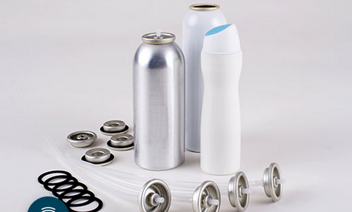
12 AEROSOL EUROPE VOL. 33, NO. 6-2025
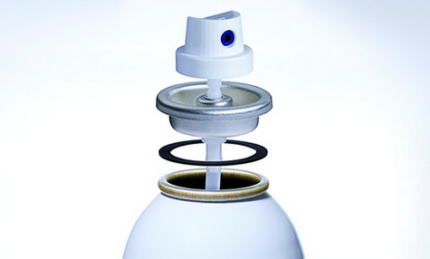
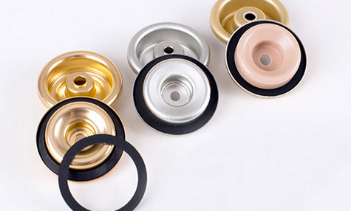

Leakproof
Spray cans and pump atomizers – everyone knows about them, everyone uses them. They are used billions of times around the world and have become an integral part of our day-to-day lives. GLOBUS supplies the right seal for every one in three (!) aerosol can in the world. Our market leadership is based on more than 110 years of experience in rubber processing and continuous improvement.
VOL. 33, NO. 6-2025 AEROSOL EUROPE 13
This makes GLOBUS your strategic partner for aerosol sealing solutions. As an example, our seals are used in the fields of beauty, personal care, home care, food, technical applications, paint and pharmaceuticals.
Our ultra-modern production facilities in Germany guarantee the highest quality standards. We produce our aerosol seals in a production process which has been specially adapted through many years of experience.
The parameters are checked in-line in every work step to ensure the best level of quality. We particularly value waste avoidance and energy efficiency.
Our team of process engineers and material specialists can take on customer requirements and develop a tailor-made solution, even for unusual applications. Thanks to our specialists, we are able to meet increasingly stringent market compliance requirements. Our seals are suitable for all common types of propellants and can materials.
Our sales team is constantly in close contact with our customers and is able to meet new requirements and needs at short notice.
Rely on us and our expertise!

14 AEROSOL EUROPE VOL. 33, NO. 6-2025

