Company Portrait

Shenzhen Huate Packing Shanghai
Shanghai Huate Packing, established in 2001, is a leading manufacturer of tinplate packing solution providers. Located in Shanghai Pudong, China, Shanghai Huate Packing has partnered with many large brands to launch products that are well-established in today’s marketplace.
The facilities were enhanced with the acquisition of advanced equipment while products were improved with continuously research and development. The major equipment were imported from Europe and Japan, which guarantee high-efficiency and steady production capacity, the company operates 3 fully automatic production lines for aerosol packing, the annual production capacity is more than 210 million; 3 fully automated production lines for milk powder, annual output is more than 50 million, and chemical can capacity is more than 50 million per year, also we have grocery can, annual output reaches up to 50 million per year.
Shanghai Huate Packing focuses on developing high-end products and continue to break new grounds in improvements, innovation at the same time we keep close attention to provide better services to our partners.
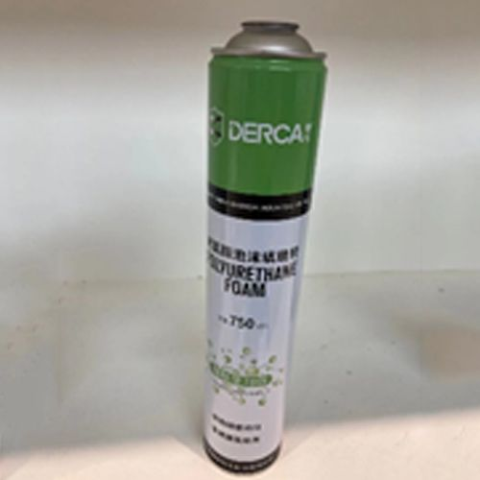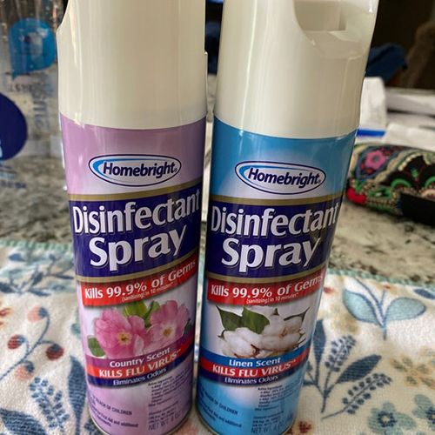 AEROSOL AUTOMOTIVE AEROSOL HOUSEHOLD

Easy to Use Aerosol Spray Can
An aerosol spray can or Refillable Aerosol Spray Can is a common way to apply a wide variety of products, from paints to hairsprays to insect repellents. Other than being one of the Aerosol Can Manufacturers, we also provide our Milk Powder Can to our customers.

How Aerosol Spray Cans Work
Aerosol spray can and Refillable Aerosol Spray Can contain a mixture of a product and a propellant. The propellant is usually a gas, such as compressed air or a hydrocarbon, that helps to push the product out of the can and through the nozzle. When you press down on the nozzle, the propellant is released and pushes the product out in a fine mist.
10 AEROSOL EUROPE VOL. 33, NO. 6-2025
One of the advantages of using an aerosol spray can is that it allows you to apply the product evenly and with minimal effort. The mist by the propellant helps to distribute the product evenly over a surface. This can be especially useful for applying paints or other coatings, as it helps to avoid drips and streaks.
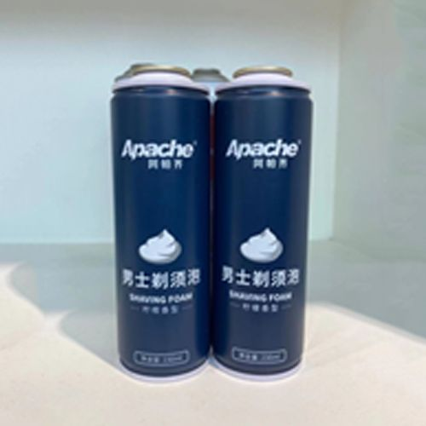 AEROSOL PERSONAL CARE
Considerations for Using Aerosol Spray Cans
While aerosol spray cans are convenient and easy to use, there are a few things to consider that we can guide you as one of the top Aerosol Can Manufacturers:
- VOCs (Volatile Organic Compounds): Many products that come in aerosol spray cans, such as paints and cleaners, contain VOCs. These compounds can be harmful to the environment and to your health if you inhale them. Make sure to use these products in a well-ventilated area and follow the safety instructions on the label.
- Overuse: It is easy to accidentally use too much product when using an aerosol spray can, especially if you are not paying attention. This can lead to waste and can also make the product less effective. Make sure to follow the instructions on the label and use the product sparingly.
- Recycling: Aerosol spray cans can be recycled, but it’s important to make sure that they are empty before you recycle them. If they can still contain the product, it can be dangerous to transport and can cause problems during the recycling process.

VOL. 33, NO. 6-2025 AEROSOL EUROPE 11

