NEWS



Aerosol Valves from MAJESTY

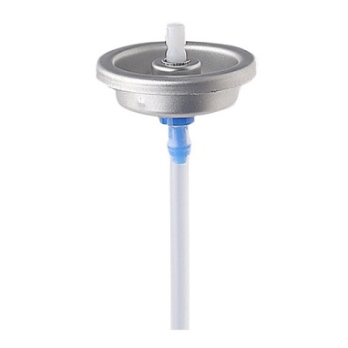

1" S-type Continuous Valves MS

Aerosol valve, Moisturizing waters, Sunscreen spray, Pharmaceutical aerosols, Air freshener, Insecticides

Personal care/Pharmaceutical/Food/Home care/Technical
- Tinplate or Aluminium mounting cap
- A variety of orifices of stem and housing are available
- Mature production technology, high cost-performance ratio, large output and strong applicability
___________________________________________________________________________

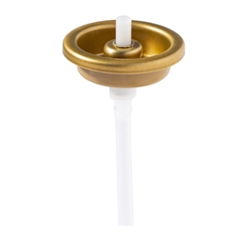

1" L-type Continuous Valves ML

Aerosol valve, Moisturizing waters, Sunscreen spray, Pharmaceutical aerosols, Air freshener, Parts cleaner, Spray paint

Personal care/Pharmaceutical/Food/Home care/Technical
- Tinplate or Aluminium mounting cap
- A variety of orifices of stem and housing are available
- Adopt German advanced production technology, large output and strong applicability
__________________________________________________________________________________
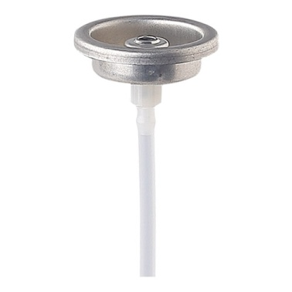

Continuous Female Valves MC

Aerosol valve, High viscosity material, Spray paints, Adhesive

Technical
- Tinplate or Aluminium mounting cap
- A variety of orifices of stem and housing are available
- Effectively solve the stem and actuator congestion problem
- Light press feels, easy to use
_______________________________________________________________________________

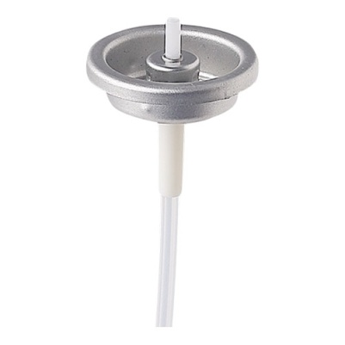

Metered Dose Valves MM

1" Aerosol valve, Meter, Mouth freshener, Air freshener, Pharmaceutical aerosols, Insecticides

Personal care/Pharmaceutical/Home care/Technical
- Tinplate or Aluminium mounting cap
- Dosage: 75mcl, 90mcl, 100mcl, 120mcl
- More accurate quantitative and more scientific
___________________________________________________________________________

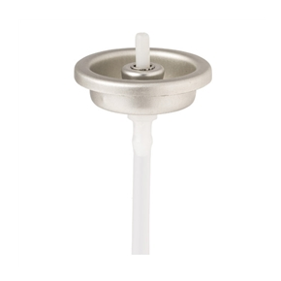

Continuous Valves for Powder MG

Aerosol valve, Powder based formula, Antiperspirant, Talcum powder, Hair color, Nail polish, Oil remover, Mite remover

Personal care/Technical
- Tinplate or Aluminium mounting cap
- A variety of orifices of stem and housing are available
- Small diameter straight stem is not easy to accumulate powder, it can effectively reduce the stem congestion issue, it is delicate and more practical
___________________________________________________________________________
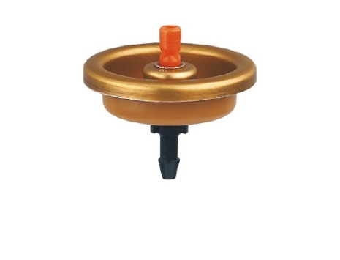
Continuous Valves for upside down use ML or MS

Aerosol valve, Positioning foam, Mousse, Marking paint

Personal care/Technical
- Tin plate or Aluminium mounting cap
- Inverted use
_______________________________________________________________________________
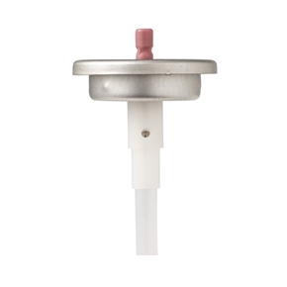

Continuous Valves for 360° use (One Chamber) MH

Aerosol valve, Moisturizing spray, Automobile cleaner, Lubricant, Carb cleaners, Antirust agent

Personal care/Technical
- Tin plate or Aluminium mounting cap
- Upright or inverted can be used normally
_______________________________________________________________________
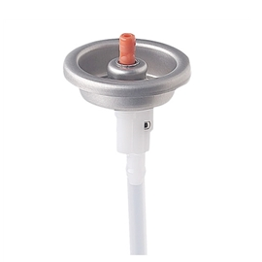

Continuous Valves for 360° use (Two Chamber) MF

Aerosol valve, Automobile cleaner, Lubricant, Detergent, Antirust agent

Technical
- Tinplate or Aluminium mounting cap
- Upright or inverted can be used normally
- Two-body combination housing design, assembly and adjustment more convenient
_________________________________________________________________________
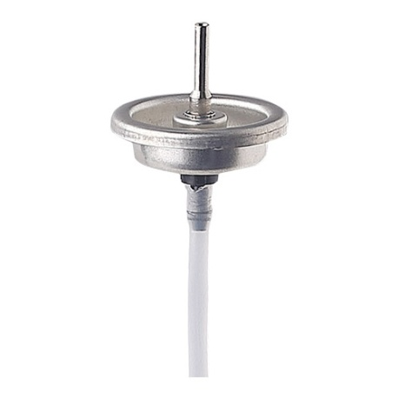

Gas Lighter Refilling Valves MS

Aerosol valve, Fire machine inflatable products

Technical
- Tinplate mounting cap
- A variety of orifices of stem and housing are available
- Inverted using
_________________________________________________________________________
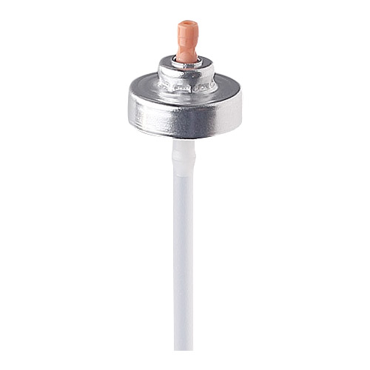

20mm Continuous Valves MV

Aerosol valve, Mouth freshener, Air freshener, Insecticides

Personal care/Pharmaceutical/Home care
- Aluminium mounting cap (Anodized)
- A variety of orifices of stem and housing are available
- Mature production technology, high cost-performance ratio, large output, strong applicability
- Small and easy to carry
________________________________________________________________________
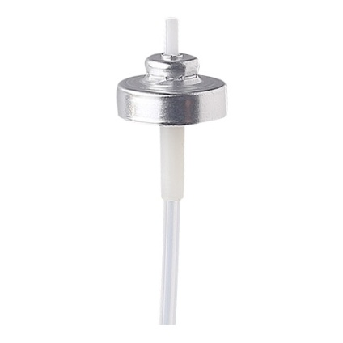

20mm Metered Dose Valves MT

Aerosol valve, Meter, Mouth freshener, Air freshener, Insecticides

Personal care/Pharmaceutical/Home care
- Aluminium mounting cap (Anodized)
- Dosage75mcl, 90mcl, 100mcl, 120mcl
- Small, easy to carry
- More accurate quantitative and more scientific
Bag-on-valves
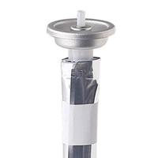

Bag-on-Valve MP

Bag-on-Valve (BOV), Moisturizing waters, Sunscreen spray, Shaving cream, Olive oil, Insecticides

Personal care/Pharmaceutical/Food/Home care
- Tinplate or Aluminium mounting cap
- A variety of bag sizes are available
360° continuous spray, easy to use, over 99% solutions emptying
Using compressed gas as propellant, it is more environmentally friendly and safer
Good compatibility, no need to consider the formulation recombination
GMP workshop production, is clean, health and safe to use
___________________________________________________________________________
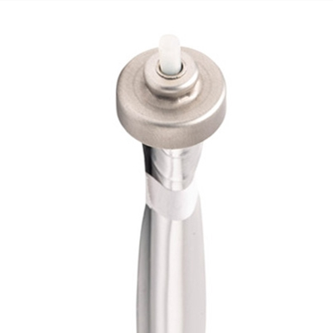

20mm Bag-on-Valve MD

Bag-on-Valve (BOV), Personal care products, Viscous gel products, Pharmaceutical products

Personal care/Pharmaceutical/Food/Home care
- Aluminium mounting cap
- A variety of bag materials are available
- 360° continuous spray, easy to use
- Using compressed gas as propellant, it is more environmentally friendly and safer
- Good compatibility, no need to consider the formulation recombination
- GMP workshop production, is clean, health and safe to use

