News



POWER CONTAINER CORPORATION

Bag-on-Valve & Airless Dispensing Solutions

Deliver your products perfectly every time with our innovative Bag-on-Valve and airless dispensing technologies, designed to enhance performance and sustainability.

Bag-On-Valve: Our Technology
Bag-On-Valve (BOV) technology is an advanced dispensing system that separates the product from the propellant, ensuring product purity, consistent performance and improved user experience.

How Bag-On-Valve Works: The Science Behind our Technology
At the heart of Bag-on-Valve technology is its advanced design, which involves a protective bag – attached to the valve – that holds the product. This system acts as a barrier packaging solution, ensuring the product remains separated from the propellant, protecting its purity and preventing contamination.
When the actuator is pressed, the eco-friendly propellant (compressed air or nitrogen) applies pressure to the bag, smoothly pushing the product through the valve for precise and continuous dispensing.
With our Power Pouch Bag-on-Valve system, Power Container Corporation redefines traditional BOV solutions by replacing the conventional multi-layer bag with a durable PET pouch. This innovation significantly enhances reliability and robustness while preserving all the benefits of Bag-on-Valve dispensing.
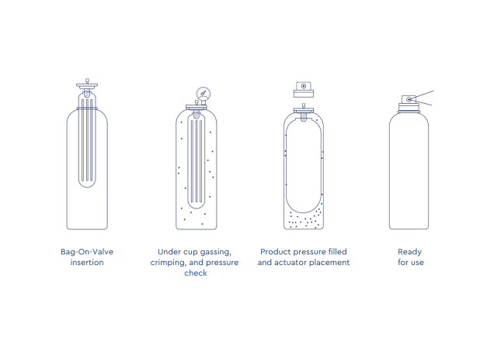
58 AEROSOL EUROPE VOL. 33, NO. 7/8-2025

Why Choose Bag-On-Valve Technology?
- 

Enhanced Product Preservation
Unlike traditional aerosol cans, Bag-On-Valve technology ensures the product is completely separated from the propellant, protecting it from contamination and oxidation. This makes it ideal for sensitive formulations, such as pharmaceuticals, cosmetics, and food products, preserving their quality and allowing extended shelf life.
- 

Optimized Consumer Experience
Bag-On-Valve systems provide a continuous and controlled spray pattern, delivering a smooth and even application every time. Designed to work at any angle, including upside down, they offer effortless and convenient use, enhancing the overall consumer experience across various applications.

- 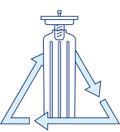

Eco-Friendly and Sustainable Design
While traditional aerosol cans rely mostly on chemical propellants and preservatives, Bag-on-Valve technology eliminates the need for chemical propellants, creating an environmentally friendly alternative with greater safety for users and reduced environmental impact.
VOL. 33, NO. 7/8-2025 AEROSOL EUROPE 59
- 

Power Container Corporation Innovation
Power Container Corporation has designed unique Bag-On-Valve system focus on high performance featuring a single-material PET pouch, unlike traditional BOV systems that rely on multi-layer bags. This innovative design allows for delivering sturdy and reliable systems, reduces the carbon footprint and enables the use of PCR (Post-Consumer Recycled) PET – providing a more eco-friendly solution that supports sustainability and waste reduction efforts.

Applications of Bag-On-Valve Technology
Bag-on-Valve technology provides a highly effective solution for industries that demand precise, reliable, and continuous dispensing. Power Container Corp’s BOV systems ensure optimal product performance, maintaining the highest standards of quality and consistency throughout every use.

Bag-on-Valve for Beauty
Impactful packaging solutions that will impress on the shelves in the aisle, as well as, the bathroom cabinet. Designed without propellants to deliver 360 degree spray-ability with no chill effect.

Bag-on-Valve for Household
Easy-to-use, continuous spray for household products in every room of the home. An eco-friendly alternative with unique packaging options.

60 AEROSOL EUROPE VOL. 33, NO. 7/8-2025

Bag-on-Valve for Pharmaceuticals

Ideal for healthcare products that need to be sprayed evenly and consistently at all angles. Our products meet all pharmaceutical industry packaging standards and offer controlled low pressure delivery for sensitive applications.

Bag-on-Valve for Personal Care
A sleek solution offering controlled delivery of gels and foams with or without compressed gas ensures easy use with no chill effect.

Bag-on-Valve for Food
Steady, even delivery of oils and flavoring products with or without compressed gas and no required squeezing or pumping.

VOL. 33, NO. 7/8-2025 AEROSOL EUROPE 61

