NEWS

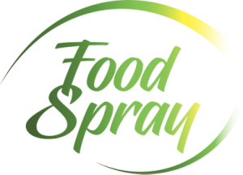

YOUR PRIVATE LABEL PARTNER IN COOKING AND FOOD SPRAYS
All food sprays can be filled in both conventional spray cans and bag-on-valve systems, but only a few companies are capable of filling both types, and we are one of them!
Would you like to have Food Spray product under your own brand? We are specialized in private label production and will assist you at every stage of product development. Our production is BRC certified, and we are remarkably strict when it comes to suppliers and raw materials to ensure the highest quality for our customers. We are highly flexible, and with our expertise, we can develop the perfect spray product by your specific needs. All you need to do is choose your product, whether it's a regular cooking spray or flavored oil maybe in a bag-on-valve solution without propellant?

Cooking & baking sprays
Cooking spray makes life easier in both big and small kitchens, for grilling, baking, and cooking. It's easy, convenient, and quick. Cooking spray prevents food from sticking to pans, pots, dishes and grills. A gentle mist on a cool surface simplifies the cooking process and makes cleaning up quick and easy. It is also a low-calorie alternative to traditional butter or oil. The calorie content of a single spray is almost negligible.
You can get our cooking spray in both regular aerosol form and as a bag valve product. Our cooking spray can be made with any type of oil, and we'll provide details about the oil options in the oil section.
Baking spray is similar to cooking spray, but it includes ingredients like flour in the mixture. It can provide additional help when greasing your baking sheets or pans. Of course, you can also add some flavor to the mixture if you prefer it that way!
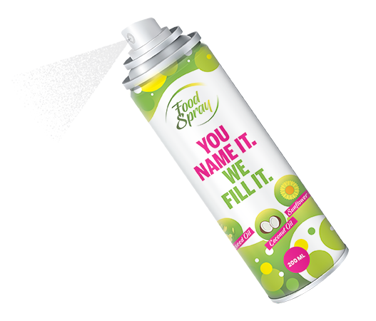

All food sprays can be filled in both conventional spray cans and bag-on-valve systems, but only a few companies are capable of filling both types, and we are one of them!
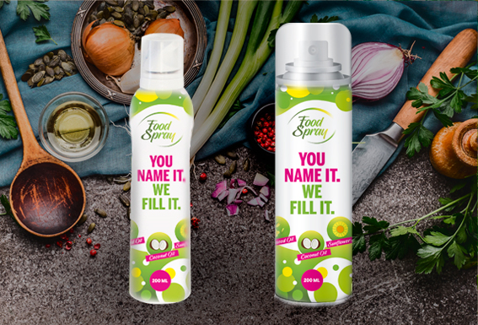
Bag-on-valve (BOV) technology ensures that only the pure product is dispensed, offering up to 100% product emptying, a longer shelf life, and the ability to be used at all angles. Compressed air is used as a propellant. In contrast, normal spray products release both the product and a food-grade propane-butane propellant, which dissipates immediately after spraying. These are available in sizes ranging from 150ml to 600ml.
Now, the choice between BOV or a normal aerosol:
- A normal aerosol spray provides a wider and broader spray pattern compared to a bag-on-valve product.
- Using conventional aerosol cans is generally more cost-effective than bag-on-valve technology.
We can offer both options and assist you in determining which one best suit your needs, or even provide both depending on your customer's requirements and target audience. It's important to be aware of the differences between a normal aerosol and BOV (Bag on Valve) systems before making a choice.

Flavored oils & seasoning sprays
Would you like to elevate the flavour of your oil? How about adding a touch of Italian herbs to your pasta, a spray of basil to your salad, or a hint of lemon to your fish? We offer a wide range of flavours for every occasion.
It is a bit difficult to pour and dispense olive oil directly from a glass bottle. Oil in a spray can makes it easier to dispense, the sensitive oil is protected against external damage and so the product keeps longer. This form of packaging is suitable for all oils and also balsamic vinegars. The product can be packed into a traditional spray can or a bag-on-valve (BOV) package from which only the liquid comes out, so no propellants are used. An excellent and handy product both at home and in restaurants.
