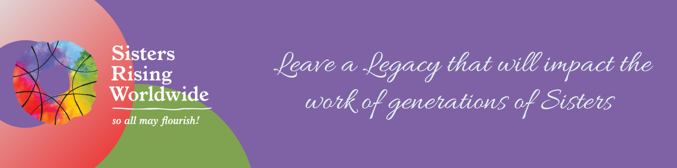

Legacy Society
Declaration of Intent

I, , wish to make my intentions known of a deferred gift that I have arranged for the benefit of Sisters Rising Worldwide. The fulfillment of this commitment will be made possible through the following instrument:

☐ Gift in will or trust
☐ Charitable remainder trust
☐ Charitable lead trust
☐ Retirement plan funds
☐ Life insurance policy
☐ Other:

☐ This gift is a specified amount* of $ .
☐ This gift is percent of my estate, which is an estimated present value* of $ .

Where is this account held: Name of Account:

Contact Information:

Is a copy of the documentation attached? ☐ Yes 󠇏☐ No

Use of Gift
My planned gift is to be directed toward:
☐ Unrestricted use/area of most need Amount:

☐ Other (See Note): Amount:

Note: Should any restriction on the use of these funds become unnecessary, impracticable, or impossible to carry out in the future, the Board of Directors may redirect the purpose and use of the gift assets for any related purpose which in the opinion of the Board of Directors will most nearly accomplish the donor’s wishes.

Recognition
☐ Please inspire others with my gift. Please list my name in any Sisters Rising Worldwide publications as:

☐ I prefer to remain anonymous. Please do not print my name in Sisters Rising Worldwide publications.

Donor Signature Date

Thank you for including Sisters Rising Worldwide in your estate planning!
Sisters Rising Worldwide Tax ID Number: 81-3868803
Please complete, sign, and email this form to Sister Irene O’Neill at irene@srw.org.

*It is understood by all parties that the ultimate amount of this gift could vary greatly from the current estimated value. This letter is not a guarantee of any particular dollar amount; rather, it is a confirmation of what my estate plans are at this time. Should I find it necessary to alter my plans, I will notify Sisters Rising Worldwide.

