Summit – Expo – Awards
DATA DIALOGUE & AI NXT 2026
Data Infrastructure, Security, Governance & Management
Empowered by Artificial Intelligence, Machine Learning & Blockchain
Friday, 6th February 2026, Jio World Convention Centre, Mumbai.

ABOUT THE EVENT:
In an era defined by digital transformation, data has become the lifeblood of modern enterprises, governments& societies. DATA DIALOGUE & AI NXT 2026, envisioned as a premier platform to explore the multifaceted dimensions of Data and Artificial Intelligence — from infrastructure, security & governance to advanced applications in AI, Machine Learning & Blockchain.

DATA DIALOGUE & AI NXT 2026 will offer an in-depth exploration of the future of data infrastructure, security, governance & management, while highlighting how Artificial Intelligence, Machine Learning& Blockchain are redefining the way organizations innovate, analyse & make decisions. As the world produces unprecedented volumes of data, the convergence of AI and data is unlocking new frontiers in automation, intelligence & value creation. The conference will convene thought leaders, industry pioneers & technology innovators to collaborate, share insights & chart the course toward an intelligent, data-powered future.

The conference seeks to:
- Explore the future of Data Infrastructure, AI Integration & Data Security.
- Foster global collaboration on Data Governance and Responsible AI.
- Unlock the power of Artificial Intelligence and Machine Learning in transforming data into actionable intelligence.
- Highlight Blockchain’s role in ensuring data security, integrity & transparency.
- Bridge the gap between technology innovation and business intelligence needs
- Encourage innovation, ethical AI adoption & thought leadership across industries.
- Provide practical frameworks, tools & AI-driven solutions for data management and security.
- Promote networking and strategic partnerships among data, AI & technology leaders.
- Offer a platform to discuss emerging trends, challenges & solutions in data and AI technologies, with a special focus on security and governance.
- Examine the evolving landscape of Data Security, Privacy & AI-driven Risk Management
- Delve into Data Governance & Privacy — navigating the complex challenges of compliance and AI ethics.
- Explore AI & Machine Learning as catalysts for turning data into predictive and cognitive intelligence.
- Discuss how Blockchain is revolutionizing data security, transparency & trust in digital ecosystems.
- Anticipate future trends in Data and AI — envisioning the next wave of intelligent transformation.
- Address Data Security & Cybersecurity — mitigating threats, securing assets & protecting sensitive information in an AI-enabled world.

Leading companies will showcase their groundbreaking case studies, demonstrate how data and Artificial Intelligence, when seamlessly integrate with cutting-edge technologies such as Blockchain, IoT & Advanced Analytics, are reshaping industries and setting new global benchmarks. These showcases will reveal how intelligent data ecosystems drive operational excellence, strengthen security frameworks & optimize governance models, all while ensuring agility and scalability across diverse sectors.
From harnessing AI to predict trends, automate decision-making & enhance customer intelligence, to leveraging Blockchain for unmatched transparency and trust, organizations will present real-world innovations addressing complex, data-centric challenges. By sharing best practices, AI-powered innovations & measurable outcomes, these case studies will offer a forward-looking roadmap for enterprises to embrace “AI – The Future” — a future that is data-driven, secure, efficient & intelligent.

In today’s digital-first world, Data Infrastructure, Data Security, Data Governance, Artificial Intelligence (AI) & Machine Learning (ML) form the backbone of innovation, decision-making& operational efficiency. These interdependent components are revolutionizing industries by providing the tools and frameworks necessary to manage, secure& leverage data effectively. Data has become the cornerstone of innovation and operational efficiency in the digital economy. From robust data infrastructure to advanced AI and blockchain technologies, businesses are leveraging a range of tools to enhance security, governance& management.



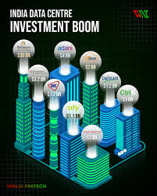

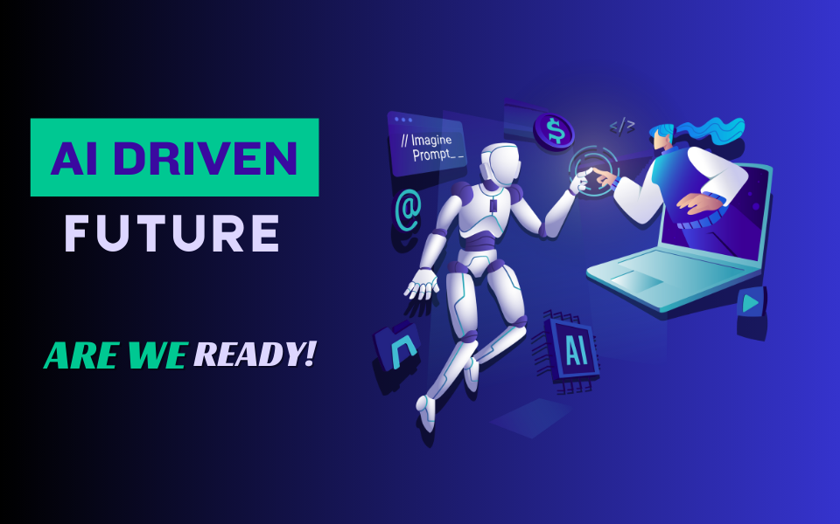

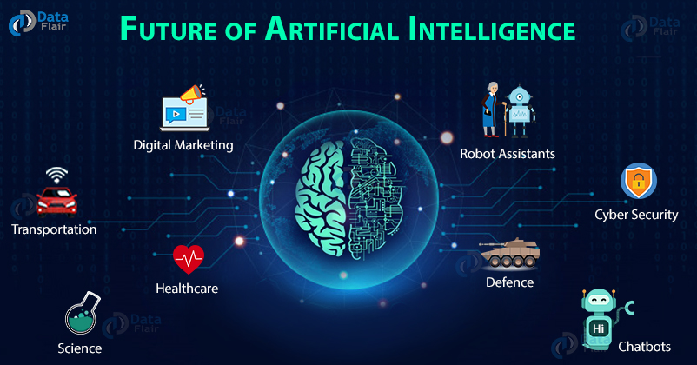

WHAT FACTORS ARE DRIVING DATA CENTER GROWTH IN INDIA?

India’s Data center and AI sectors are experiencing rapid growth, driven by a combination of technological, economic& policy factors. The surge in digital consumption, fueled by over 750 million internet users and increasing mobile adoption, is generating unprecedented volumes of data across e-commerce, social media & digital services, creating a strong demand for robust data infrastructure. Government initiatives such as Digital India and Atmanirbhar Bharat, along with policies mandating data localization and enhanced cybersecurity, have further accelerated investment in data centers. The rising adoption of AI, machine learning & blockchain technologies has created a need for high-performance computing and low-latency processing, while the proliferation of cloud services and edge computing has increased demand for scalable, distributed data solutions. Foreign direct investment and global partnerships are also fueling growth, with international tech giants establishing AI-ready data centers in India to cater to local and regional demand. India’s data center capacity is projected to quintuple by 2030, supported by significant infrastructure investments and a growing pool of skilled IT professionals driving innovation. Additionally, sustainability initiatives are shaping the sector, with an increasing emphasis on renewable energy and green data centers to meet the rising energy demands of AI and large-scale computing. Collectively, these factors position India as a rapidly emerging hub for data center development and AI innovation, attracting both domestic and international investments.

WHAT FACTORS ARE DRIVING AI GROWTH & WHAT LIES IN FUTURE?

AI growth in India is being driven by a powerful convergence of factors — a booming digital economy, widespread data availability, rapid cloud adoption & strong government initiatives such as Digital India and the National AI Mission. The rise of startups, increased investment in AI research&growing collaboration between academia and industry are further accelerating innovation. Sectors like healthcare, finance, agriculture & manufacturing are leveraging AI to boost efficiency, enhance decision-making & deliver personalized solutions. Looking ahead, India’s AI future lies in responsible and inclusive AI adoption, with a focus on ethical governance, skill development&indigenous AI innovation that supports both economic growth and social transformation.

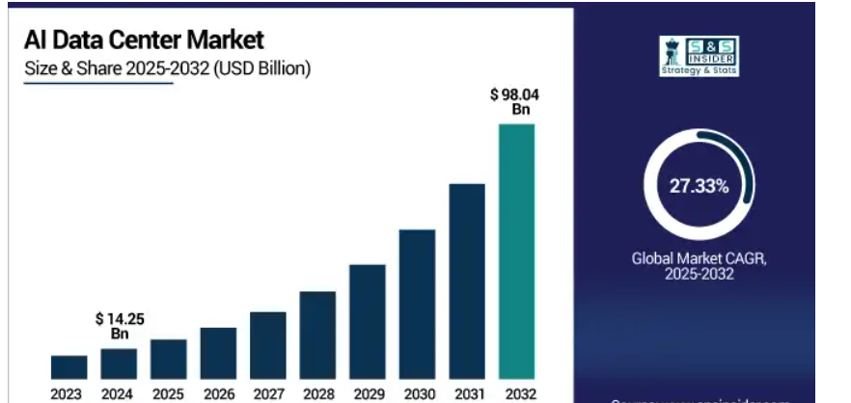

Against this background, TEFLA’s one of India’s distinctive players within the gambit of Conferences, Exhibitions & Awards catering to niche industry segments through an array of focused initiatives is happy to announce DATA DIALOGUE & AI NXT 2026 embodies the transformative potential of data and artificial intelligence as they evolve amid rapid technological advancements, global challenges&emerging opportunities for innovation.

DATA DIALOGUE & AI NXT 2026 aims to define the future of data and AI practices, tackling global challenges and seizing opportunities in an increasingly data- and AI-driven world.

WHY DATA DIALOGUE & AI NXT IS A MUST-ATTEND FOR YOU
DATA DIALOGUE & AI NXT 2026 is a must-attend event for anyone looking to stay ahead in the rapidly evolving world of data and artificial intelligence. It offers a unique platform to gain insights from global thought leaders, explore cutting-edge AI and data technologies & understand emerging trends shaping industries. Attendees will discover practical solutions to real-world challenges, learn best practices in data management, security, governance & AI adoption & witness innovative case studies showcasing transformative business impact. Beyond knowledge, the event fosters networking, collaboration & strategic partnerships, empowering professionals and organizations to embrace a future-ready, data- and AI-driven approach to growth and innovation.

WHO SHOULD ATTEND?
DATA DIALOGUE & AI NXT 2026 - Beyond Boundaries: Innovating Data for Tomorrow’s World. The participant profile will encompass:

- Data Scientists and Engineers
- Data Analysts and Engineers
- Machine Learning Engineers
- AI/ML Practitioners
- Data Architects

- Senior Executives and Decision-Makers
- Chief Information Officers (CIOs)
- Chief Technology Officers (CTOs)
- Chief Data Officers (CDOs)
- Chief Executive Officers (CEOs) of Tech Firms
- Senior Leaders from Government Agencies

- Blockchain and Distributed Ledger Technology Experts
- Blockchain Developers
- Blockchain Architects
- Smart Contract Developers
- Decentralized Application (DApp) Developers
- Data Governance and Compliance Officers
- Data Privacy Officers (DPOs)
- Compliance Managers
- Regulatory Affairs Experts
- Risk Management Leaders

- IT Infrastructure and Cloud Solutions Providers
- Cloud Architects
- IT Infrastructure Managers
- Data Center Operations Managers
- Cloud Service Providers
- Academics and Researchers
- University Professors
- Research Scientists
- Data Science and AI Researchers
- Tech Innovators and Solution Providers
- Startups and Entrepreneurs in Data Technologies
- AI/ML and Blockchain Solution Providers
- Tech Consultants
- Industry Leaders from Key Sectors
- Finance and FinTech Professionals
- Healthcare IT Professionals
- Retail and Supply Chain Executives
- Telecommunications and IoT Innovators
- Policy Makers and Regulators
- Government Officials
- International Standards Organizations
- Regulatory Bodies
- Students and Young Professionals
- Graduate Students in Data Science, AI& Blockchain
- Early-Career Data Enthusiasts and Technologists
- Investors and Venture Capitalists
- VCs and Angel Investors
- Investment Managers in Tech
These participants are interested in identifying emerging trends, cutting-edge technologies& investment opportunities in the data ecosystem, particularly in AI, Machine Learning& Blockchain startups.

Key Deliverables for Attendees:
- Cutting-Edge Knowledge and Insights.
- Actionable Strategies for Data Management & Data Security.
- Hands-on Experience with Emerging Technologies.
- Networking Opportunities with Industry Leaders.
- Exclusive Insights into Blockchain and AI Integration.
- Understanding Future Trends and Emerging Technologies.
- Tools to Drive Business Transformation.
- Certification and Recognition.
- Exposure to Innovative Solutions.

By attending DATA DIALOGUE & AI NXT 2026, participants will leave equipped with the knowledge, skills& connections needed to lead their organizations through the rapidly evolving data Dialogueand leverage new technologies to achieve strategic success.

DATA DIALOGUE & AI NXT 2026 EXPO will showcase leading companies, innovators& solution providers that are shaping the future of data infrastructure, governance, AI, Machine Learning& Blockchain technologies. Exhibitors will include a diverse range of organizations offering products, services& solutions across the following categories:

- Data Infrastructure Providers
- AI and Machine Learning Solution Providers
- Blockchain Technology Innovators
- Cybersecurity Firms & Service Providers
- Cloud Service Providers
- Data Analytics and Business Intelligence (BI) Tools
- IoT and Smart Data Solutions
- Data Governance and Compliance Platforms
- Advanced Hardware and Devices
- Consulting and Professional Services
- Startups and Innovators
- Education and Research Organizations

DATA DIALOGUE & AI NXT 2026 EXPO will provide a one-stop destination for attendees to explore the latest products, connect with leading solution providers.

Benefits and ROI for Exhibitors:
Exhibiting at Data Dialogue & AI NXT 2026 provides unparalleled opportunities for companies to showcase their products, network with decision-makers& solidify their position as leaders in the data-driven economy. The conference's global audience and focused themes ensure measurable benefits and a strong return on investment (ROI) for exhibitors.

Key Benefits for Exhibitors:
1. High-Quality Lead Generation
2. Brand Visibility and Market Positioning
3. Networking Opportunities
4. Showcase Cutting-Edge Innovations
5. Thought Leadership Platform
6. Industry Recognition and Credibility
7. Market Insights and Competitive Advantage
8. Global Media Exposure
9. Targeted Audience Engagement
10. Measurable ROI

By exhibiting at DATA DIALOGUE & AI NXT 2026, companies will not only amplify their market presence but also secure long-term business opportunities, making it a high-value investment in growth and innovation.

Potential Sponsors for Conference and Expo:
DATA DIALOGUE & AI NXT 2026 – Beyond Boundaries: Innovating Data for Tomorrow’s World. DATA DIALOGUE & AI NXT 2026 conference and expo will attract sponsors who are leaders, innovators& solution providers in the fields of data infrastructure, governance, AI, machine learning& blockchain. Sponsorship offers an unparalleled opportunity to align with a prestigious platform, gain high-profile visibility& engage with a global audience of decision-makers and industry professionals. Below is an outline of potential sponsors and why they might be interested:

1.Technology Giants and Cloud Service Providers
- Companies offering data infrastructure, cloud computing& storage solutions.
2. AI and Machine Learning Innovators
- Developers of AI and ML platforms, frameworks& tools.
3. Blockchain Technology Companies
- Providers of blockchain platforms, security protocols & DApp solutions.
4. Cybersecurity Firms
- Companies offering data security, encryption& compliance solutions.
5. Data Analytics and Business Intelligence Providers
- Vendors specializing in analytics platforms, visualization tools& BI software.
6. IoT and Edge Computing Leaders
- Providers of IoT platforms, devices& edge computing solutions.
7. Consulting Firms and System Integrators
- Organizations offering expertise in digital transformation, data strategy& implementation.
8. Financial Services and FinTech Leaders
- Sponsors from the banking, insurance& FinTech sectors driving data innovation.
9. Telecommunications and Networking Companies
- Sponsors specializing in network optimization and data communication technologies.
10. Education and Research Organizations
- Universities and institutions promoting data science, AI& blockchain education.
11. Media and Publishing Houses
- Publishers of technology, data& innovation-focused content.
12. Startups and Innovators
- Emerging companies showcasing niche solutions in AI, blockchain& data governance.
13. Hardware Providers
- Sponsors offering high-performance servers, GPUs& IoT devices.

Sponsorship Benefits
Potential sponsors will benefit from:
- Global Exposure.
- Brand Positioning.
- Lead Generation.
- Thought Leadership.
- Media Coverage.

Benefits and ROI for Sponsors
DATA DIALOGUE & AI NXT 2026: Beyond Boundaries: Innovating Data for Tomorrow’s World. Sponsoring DATA DIALOGUE & AI NXT 2026 offers an exceptional opportunity for companies to gain unparalleled visibility, establish thought leadership& engage with a global audience of decision-makers, innovators& industry experts. The sponsorship delivers tangible and intangible benefits, ensuring strong ROI by aligning with a premier platform for data, AI, machine learning, blockchain& emerging technologies.

Key Benefits for Sponsors:
1. Unparalleled Brand Visibility
2. Targeted Audience Engagement
3. Thought Leadership and Influence
4. Lead Generation and Business Development
5. Media and Marketing Exposure
6. Strategic Networking Opportunities
7. Customized Sponsorship Packages
8. Competitive Advantage

Sponsoring DATA DIALOGUE & AI NXT 2026 is not just an investment in visibility—it’s a strategic move to position your brand as a key player in shaping the future of the data ecosystem, ensuring long-term business growth and industry impact.

Award Categories and Descriptions:

DATA DIALOGUE & AI NXT 2026 Awards celebrate excellence, innovation& leadership in data infrastructure, governance, AI, machine learning& block chain. These prestigious accolades recognize organizations, individuals& teams driving transformative change and setting benchmarks in the data-driven economy.

1. Excellence in Data Infrastructure
2. Outstanding Data Security Innovation
3. Leadership in Data Governance
4. AI and Machine Learning Innovator of the Year
5. Blockchain Pioneer Award
6. Best Data Analytics Platform
7. Outstanding Use of Data in Business Transformation
8. Cybersecurity Excellence in Data Protection
9. IoT Data Innovator of the Year
10. Rising Star in Data Science
11. Best Collaboration for Data Innovation
12. Sustainable Data Management Award
13. Outstanding Contribution to Open Data
14. Smart City Data Innovation Award
15. Data Privacy Advocate of the Year
16. Women in Data Leadership Award
17. Best Data-Driven Customer Experience Initiative
18. Academic Excellence in Data Science and AI
19. Data Startup of the Year
20. Public Sector Data Champion
21. Lifetime Achievement in Data Innovation
22.IoT Security Pioneer Award

DATA DIALOGUE & AI NXT 2026 Awards are a hallmark of achievement celebrating the very best in data-driven innovation and leadership.

DATA DIALOGUE & AI NXT 2026: Join the Conversation
Be part of a global forum that is transforming how we manage, protect & harness data. Together, let’s shape a future where data and AI empower innovation, inspire solutions & drive meaningful progress.

