FOOTBALL COACH & YOUTH WORKER
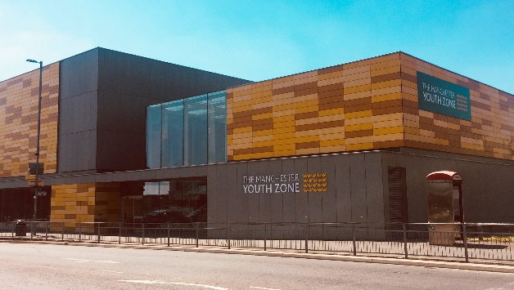
Harpurhey, Manchester
Salary £12.60 per hour
17 hours per week (Wednesday 3.15pm to 9.15pm, Thursday 3pm to 7.45pm, Friday 3.15pm to 9.15pm)
Reports to: Seniors Manager

Why work for Manchester Youth Zone
- Annual leave entitlement of 33 days (pro-rata)
- We are committed to training and developing our staff, that will include a full induction and access to internal and external training opportunities
- We care about your wellbeing – Access to our EAP, an extra holiday day for your birthday, and onsite gym and sports facilities
- 5% pension contribution
- You will be part of our mission to positively impact the lives of young people in North Manchester
The Manchester Youth Zone first opened to young people in 2012 as an independent charity. Located in Harpurhey enables the Manchester Youth Zone to reach those young people who need “Somewhere to go, something to do and someone to talk to”. At Manchester Youth Zone, we have a shared purpose to create passion and pathways for every young person we work with, we do this through providing a safe and welcoming environment, high quality youth work and promoting inclusion, resilience and aspirations.

We work with young people aged 8-19 and up to 25 for those with additional needs offering provision during the day (including weekends) for targeted young people, each evening for universal provision and residential provision for specific programmes. The Manchester Youth Zone has an excellent reputation in a number of areas including safeguarding, working with young people who are “at risk” of criminal exploitation, mentoring and employment skills. We have invested strongly in partnership working, becoming a community asset responding to the needs of young people and the local community of North Manchester.

Job Description
We’re looking for a Football Coach with a passion for football and multi-sport and excellent communication skills able to deliver football sessions and a range of other exciting activities to young people that challenge, stimulate and provide them with new opportunities. Our 3G Pitch is one of the most popular spaces in our centre, and as such is an integral part of our delivery.
Key Duties
- To work directly with young people aged 8-19 (up to 25 with additional needs) to facilitate safe, fun and structured football sessions within the Youth Zone.
- To take on responsibility for programming within the sports areas, bringing new ideas and developing resources to ensure that young people can engage in diverse and engaging activities during youth work sessions
- Deliver high-quality sports-offer, which is safe, fun, challenging and developmental. This will include planning and delivery of a regular programme of activities, special events and trips, team development and competitions/ showcases, and contribute towards the planning, delivery, and evaluation of specific projects.
- Encourage the participation of young people and that their ideas contribute fully to the planning, delivery and evaluation of sessions, projects, and activities.
- To establish positive and engaging relationships with young people from a range of backgrounds and provide interventions that achieve outcomes including helping them develop positive peer relationships, engagement in new activities, personal development, improved self-esteem, positive self-identity, acquisition of new skills, and developing wider networks of support.
- To provide safe good quality one-one mentoring support for young people who require additional support outside of youth work sessions where required.
- To be able to use your own initiative to flexibly meet the needs of young people, adapting sessions where required to ensure inclusion
- Effectively communicate at all levels both in terms of spoken conversations, planning and leading sessions, and developing short reports where required
- Ensure all recordings are well written for internal use and to be used to inform reports for external funders and interested parties.
- Maintain Salesforce with up-to-date information on young people who you have worked with (training provided)
- To complete MeAPPS, case studies, impact stories and session plans as instructed by management.
- To work effectively and positively alongside colleagues including staff, volunteers and young leaders. Ensure that all volunteers and trainee staff are made to feel an integral and valued part of Manchester Youth Zone family.
- Undertake regular training and development relevant to the role.
- Actively address any bullying, harassment, or discrimination, promoting cohesion, inclusion, and positive relationships.
- To understand and adhere to MYZ policies and procedures at all times with particular emphasis on equal opportunities, positive behaviour management, health and safety and safeguarding.
- Promote and safeguard the welfare of children and young people at all times, managing any safeguarding issues should they arise (training provided).
- To be an active member of the team and operate in line with the Charity’s expectations, values and principles. Work a flexible pattern including evenings and weekends in line with the role/team requirements.
- Carry out any other duties as may be reasonably determined by your line manager.
- Promote a positive image of MYZ through professionalism and good conduct with all our stakeholders and the public.

PERSON SPECIFICATION
 | Essential | Desirable | Identified by
Skills & Attributes
A level 2 or above youth work qualification or equivalent |  | Y** | CV
Relevant coaching qualification** OR  Proven track record in delivering high quality sessions in similar settings | Y |  | CV  References
Experience
Working with young people aged 11-19years (up to 25) from a diverse range of backgrounds | Y |  | CV  Interview
Working with children and young people who have experienced trauma or adversity through child focussed trauma responsive interventions* |  | Y | Interview
Planning and leading football sessions | Y |  | CV  Cover Letter
Working effectively as part of a team | Y |  | CV  Cover Letter  Interview
Working with large groups of young people and managing group dynamics | Y |  | Interview
Safeguarding children and young people* | Y |  | CV  Interview
Knowledge & Understanding
National Occupational Standards for Youth Work (2020) and how these should be implemented in a variety of youth work settings* |  | Y | CV  Interview
How to engage with young people effectively and understanding the issues affecting their lives | Y |  | CV  Interview
How to plan, deliver and evaluate high quality programmes of activity with an inclusive ethos | Y |  | CV  Interview
Ability to communicate effectively with young people, parents/carers and colleagues by talking, listening and writing factual and accurate recordings and reports* | Y |  | CV  Interview
Health and safety, equality, inclusion and diversity, safeguarding good practice and how these relate to children you work with | Y |  | CV  Interview
How to coach, encourage, motivate and support children and young people to reach their full potential | Y |  | CV  Interview
Effectively support and de-escalate children and young people exhibiting challenging or anti-social behaviour |  | Y | CV  Interview
Additional attributes
Organised and efficient | Y |  | CV  Interview
Excellent attention to detail | Y |  | CV
Calm under pressure | Y |  | CV  Interview
Commitment to personal & professional development |  | Y | Interview

*Training will be provided **Potential opportunity to complete qualification in future

