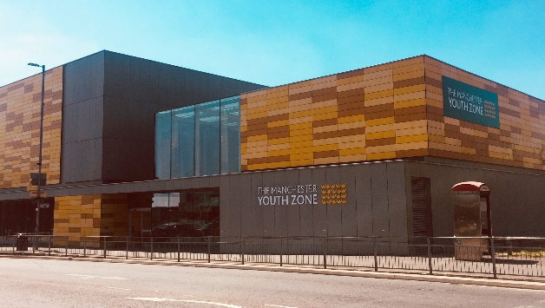
STEM YOUTH WORKER
Harpurhey, Manchester
Salary 12.60 per hour
20 hours per week – (to include some evenings and weekends)
Reports to: Arts Academy Manager

Why work for Manchester Youth Zone
- Annual leave entitlement of 33 days (pro-rata)
- We are committed to training and developing our staff, that will include a full induction and access to internal and external training opportunities
- We care about your wellbeing – Access to our EAP, an extra holiday day for your birthday, and onsite gym and sports facilities
- 5% pension contribution
- You will be part of our mission to positively impact the lives of young people in North Manchester
The Manchester Youth Zone first opened to young people in 2012 as an independent charity. Located in Harpurhey enables the Manchester Youth Zone to reach those young people who need “Somewhere to go, something to do and someone to talk to”. At Manchester Youth Zone, we have a shared purpose to create passion and pathways for every young person we work with, we do this through providing a safe and welcoming environment, high quality youth work and promoting inclusion, resilience and aspirations.
We work with young people aged 8-19 and up to 25 for those with additional needs offering provision during the day (including weekends) for targeted young people, each evening for universal provision and residential provision for specific programmes. The Manchester Youth Zone has an excellent reputation in a number of areas including safeguarding, working with young people who are “at risk” of criminal exploitation, mentoring and employment skills. We have invested strongly in partnership working, becoming a community asset responding to the needs of young people and the local community of North Manchester.

Job Description
We’re recruiting a STEM Youth Worker to work on our existing Makers Zone project. The successful applicant will be a part of Manchester Youth Zone’s STEM offer ensuring all young people (from the age of 8 to 19, or 25 with additional needs) have access to our range of projects within Science, Technology, Engineering, Art and Math. This post is key to supporting young people develop soft skills such as communication, confidence, trying and learning, work behaviours and patterns, and levelling up young people’s access to starting their own businesses. The successful applicant will be responsible for delivering targeted programmes in settings that include centre-based and one-to-one mentoring support, with particular targets set for funded projects, such as the Onside Makers Zone contract.
Key Duties
- To work directly with children aged 8-19 (or 25 with additional needs).
- To bring new ideas and develop resources to ensure that young people can engage in diverse and engaging activities within our Maker Zone.
- Plan and deliver high quality STEM sessions and support the planning of a calendar of sessions that incorporate young people’s ideas, corporate partner offers, alternative education providers, external programmes, and meet the KPIs set by a range of stakeholders.
- Encourage the participation of young people and that their ideas contribute fully to the planning, delivery and evaluation of sessions.
- Create an exciting and supportive environment that encourages young people to explore STEM concepts, ask questions, experiment, and develop a genuine interest in these fields.
- Guide young people through activities, explaining scientific principles, technological applications, engineering design processes and mathematical reasoning in an accessible and engaging manner.
- To ensure that STEM activities are accessible and appealing to all young people, identifying and removing barriers to participation, and promoting diversity within STEM.
- To help manage all necessary equipment, materials and resources for STEM activities, ensuring safety protocols are followed and equipment is maintained.
- To establish positive and engaging relationships with children from a range of backgrounds and provide interventions that will achieve outcomes such as development of soft skills, employability skills, confidence, and aspiration
- To establish strong relationships with a range of stakeholders that include corporate partners, external services, local schools and colleges, internal partners and more to recruit young people to programmes, deliver in line with project outcomes, job broker for young people and deliver a range of work experience and enterprise opportunities to our members
- To establish strong partnerships with other STEM providers, ensuring a diverse offering is available to young people, both in the centre and in the city
- To support in a range of projects and measure impact at each stage of the project. This will also include the development of reports (ensuring they meet project needs and are relevant to interested parties/commissioning bodies) and maintaining Salesforce with up-to-date information on young people who you have worked with (training provided)
- To be able to use your own initiative to flexibly meet the needs of children, adapting sessions where required to ensure inclusion
- To work effectively and positively alongside colleagues including staff, volunteers and young leaders. Ensure that all volunteers and trainee staff are made to feel an integral and valued part of Manchester Youth Zone family.
- Undertake regular training and development relevant to the role.
- Actively address any bullying, harassment, or discrimination, promoting cohesion, inclusion, and positive relationships.
- To understand and adhere to MYZ policies and procedures at all times with particular emphasis on equal opportunities, positive behaviour management, health and safety and safeguarding.
- Promote and safeguard the welfare of children and young people at all times, managing any safeguarding issues should they arise (training provided).
- To be an active member of the team and operate in line with the Charity’s expectations, values and principles. Work a flexible pattern including evenings and weekends in line with the role/team requirements.
- Carry out any other duties as may be reasonably determined by your line manager and be flexible to attend residential trips.
- Promote a positive image of MYZ through professionalism and good conduct with all our stakeholders and the public.

PERSON SPECIFICATION
 | Essential | Desirable | Identified by
Skills & Attributes
Youth Work Level 2 Certification or Equivalent | Y |  | CV  Cover Letter
A relevant qualification in a STEM field (E.g - degree, BTEC) | Y |  | CV  Cover Letter
First aid (training opportunities available) |  | Y | CV
Experience
Working with young people aged 8-25 years from a diverse range of backgrounds | Y |  | CV  Interview
Experience and knowledge of facilitating high quality STEM-related activities in similar settings | Y |  | CV  Interview
Planning and contributing to STEM related youth sessions and projects | Y |  | CV  Interview
Working effectively as part of a team | Y |  | CV  Interview
Working with large groups of children and young people with high energy and managing group dynamics | Y |  | CV  Interview
Safeguarding children and young people (mandatory training to be provided) | Y |  | CV  Interview
Knowledge & Understanding
National Occupational Standards for Youth work (2020) and how these should be implemented in a variety of settings |  | Y | CV  Interview
An understanding of how to use a range of STEM related machinery (e.g - 3D printers, laser cutters) | Y |  | CV  Interview
Awareness of current trends within STEM that appeal to young people | Y |  | CV  Interview
Knowledge of best practices in informal STEM education | Y |  | CV  Interview
An understanding in how to effectively support and de-escalate children exhibiting challenging or anti-social behaviour | Y |  | CV  Interview
An understanding of how to appropriately interact with young people aged 8-25 | Y |  | CV  Interview
Digital literacy | Y |  | CV  Interview
Additional attributes
Trustworthy and reliable | Y |  | CV  Interview
Organised and efficient | Y |  | CV  Interview
Excellent attention to detail | Y |  | CV  Interview
Patience | Y |  | CV  Interview
Resourceful |  | Y | CV  Interview
Commitment to personal & professional development |  | Y | CV  Interview
Commitment to safeguarding children and young people | Y |  | CV  Interview

