
2023 version

Terms and Conditions
Prime Healthcare Solutions
Contents
Verification of Terms and Conditions 2
12-week qualifying period (AWR) 2
Basic pay and basic working conditions 3
Agency Worker Handbook 3
Limited Company (PSC) 5
PSC Outside of IR35 6
Process for utilising Umbrella Companies 6
Umbrella Outside of IR35 8

Verification of Terms and Conditions
As part of the Prime Healthcare Solutions recruitment and registration process, candidates are issued with Terms and Conditions relevant to their job role and pay type. Prime Healthcare Solutions understands its obligations and responsibilities to ensuring that each agency worker receives Employment Rights in line with current legislation and regulations. All agency workers will be in receipt of the following rights:
- be paid the minimum wage
- not to have unlawful deductions made from their wages
- not to be discriminated against because of age, disability, gender reassignment, marriage and civil partnership, pregnancy and maternity, race, religion or belief, sex, or sexual orientation
- have a limit on the hours of their working weeks
- have paid holidays
- to be accompanied at a grievance or disciplinary hearing
- not to be picked on or dismissed for whistleblowing
- to work in a safe workplace
- to be able to take certain claims to an employment tribunal
In addition, our agency worker workforce will be in receipt of additional rights following changes to the law. These include (but are not limited to):
- from the first day in a temporary job they (the candidate) are allowed to use workplace facilities, such as the canteen and creche or nursery
- the right to information about workplace facilities and job vacancies where they are working
- after 12 weeks in the same job, they are entitled to the same basic pay and working conditions as permanent employees, unless they are working under a pay between assignments contract
- If they are pregnant, after completing 12 weeks in the same job they are allowed to take paid time off for ante-natal appointments.

12-week qualifying period (AWR)
The time that counts towards the 12 weeks started on 1 October 2011. If candidates started a job for an employer before 1 October 2011, any time they spent working on the job before this date will not count towards the 12-week qualifying period.

Basic pay and basic working conditions
After a candidate has completed a 12-week qualifying period in the same job with the same employer, they will be entitled to the same basic terms and conditions of employment as if they had been employed directly by the employer. These conditions will be written into the Terms and Conditions provided and signed by the candidate and cover things such as the hours they work, the amount of holiday they get, and how much money they are paid.

Agency Worker Handbook
Temporary workers receive an Agency Worker Handbook as part of the registration process. The purpose of the Agency Worker Handbook is to ensure that candidates are made are of the roles and responsibilities for both them and Prime Healthcare Solutions when taking up “employment” and being deployed into the provision of the services. The contents of the Agency Worker Handbook includes (but is not limited to): temporary worker rights, timesheet process, Pension, AWR, IR35, Payment terms, termination, obligations and WTR. To ensure candidates have received, read and understood the contents of the Agency Worker Handbook, a signed declaration is obtained and retained on file. Where the Agency Worker Handbook is updated, temporary workers are made aware and the changes cascaded to the workforce. This forms part of the recruitment and induction process.

The initial step is to seek clarification as part of the recruitment process as to how a candidate wishes to be paid by Prime Healthcare Solutions. This information is requested within the Application Form – with further supporting documentation required. Candidates can have the option to be paid:
- PAYE
- UMBRELLA
- PERSONAL LIMITED COMPANY
- CONTRACTOR
Once confirmation is obtained on the above, candidates will be required to complete the relevant contract. The terms set within these contracts will at all times be in line with the legislation set within the Employment Agencies Act – ensuring that all candidates are fully aware of their (and Prime Healthcare Solutions obligations and responsibilities. These contracts are to be signed and dated by the candidate prior to their deployment into the provision of the service to confirm their compliance towards the terms and conditions detailed. Evidence will be held on file at all times.

Prime Healthcare Solutions ensure that all relevant terms and conditions include the following:

- whether the candidate is employed under a contract for services or a contract of employment
- notice period
- pay
- holiday entitlement (if applicable)

Signed contracts are retained on file to confirm that the candidate has agreed to the terms and conditions.

Where a candidate wants to be paid via an Umbrella Company – Prime Healthcare Solutions will ensure that the Umbrella Company specified fully explains to the candidate their duties in relation to the latest IR35 legislation. All aspects of this legislation are dealt with between the Umbrella Company and the candidate.

Where a candidate indicates that they wish to be paid through their own Personnel Limited company, Prime Healthcare Solutions will initially obtain (in line with their recruitment process), the following documentation;

- Certificate of Incorporation
- Evidence of Business Bank Account
- Insurance Documents (where relevant)
- Checks completed via Companies House (https://www.gov.uk/government/organisations/companies-house)

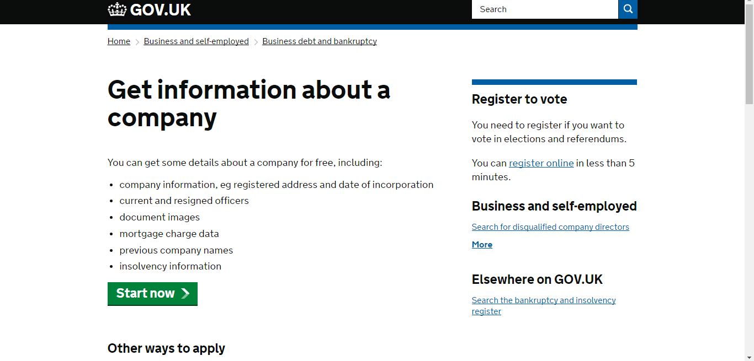

The above information will be made readily available for auditors in line with the framework requirements to confirm that the necessary checks have been completed.

To ensure that the individual is complying with IR35 legislation and therefore paying tax and national insurance and in accordance with current Treasury requirements, Prime Healthcare Solutions will need to:
- Seek assurance from the contractor that they have considered IR35 and
- Complete the specific Business Entity Tests prescribed by HMRC to determine the risk rating of the consultant and their limited company.

The IR35 legislation was intended to combat tax avoidance. It affects all contractors who do not meet HMRC’s definition of ‘self-employment’ and applies to anyone working via an intermediary such as a company or partnership. Over time, since the introduction of the legislation, tests have been developed from the results of legal cases which indicate whether or not an individual’s working practices are likely to fall inside or outside of IR35.

The aim is at all times for Prime Healthcare Solutions to adhere to all HMRC guidance, including clauses specified within the Framework Agreement (detailed below):

4.9 - The Parties acknowledge that the aim of the IR35 legislation is to eliminate the evasion of tax and National Insurance Contributions (“NICs”) through the use of intermediaries such as personal service companies.
4.10 - The Supplier must ensure that Temporary Agency Workers supplied for hire on Assignments with Contracting Authorities under this Framework Agreement are aware of their legal obligation to comply with the requirements of IR35.
Further guidance can be sought by both Prime Healthcare Solutions and the candidate via the following publications:

Limited Company (PSC)
Some candidates will request to be paid into their own PSC. Where this is the request, the following information must be provided and checked.

If the above requirements are presented in full and deemed satisfactory after checks completed by Prime Healthcare Solutions, the candidate can be paid via this means. However, Prime Healthcare Solutions will deduct TAX and NI contributions from source. This will be evident with the payslips/remittance issued to the candidate – made readily available as audit stage.

PSC Outside of IR35
In some cases, a vacant job role may be confirmed as sitting outside of IR35. Prime Healthcare Solutions are only able to process a job role confirmed as outside of IR35 with the written authorisation and consent from the NHS or Private Organisation. No other means will be deemed as acceptable in identifying a candidate’s job role as outside of IR35. For audit purposes, written confirmation will be retained on file for all relevant bookings and available to the auditor.

Once a job offer is made to a candidate, we will provide the following information in line with the Employment Agencies Act – ensuring that the candidate has received all necessary information in order to start their job role. This includes:

- your start date
- how long the contract is likely to last
- the type of work
- about any expenses you may have to pay
- the location
- your hours
- about any health and safety risks
- about any experience, training or qualifications needed for the role

Process for utilising Umbrella Companies
At the time of registration with Prime Healthcare Solutions, we identify from the temporary work seeker their preferred payment method, either Limited Company, Umbrella or PAYE. The following documentation is obtained and stored in an electronic format that cannot be altered or amended.

All Umbrella companies must provide Prime Healthcare Solutions, with an illustration of their services and a sample payslip showing correct TAX and NI deductions being made in line with IR35 legislation. All Umbrella Companies have to declare whether or not they have tax avoidance schemes and whether or not they are DOTAS registered.

Notwithstanding the above and as part of the ongoing audit process undertaken, Prime Healthcare Solutions will randomly ask the Umbrella provider for a copy of payslips sent to our contractor to further prove that they offer a HMRC compliant solution at all times.

Furthermore, Umbrella Companies must provide the following documentation and information. The below process is undertaken on all new suppliers to ensure that they fully meet current legislation and regulations.

Only Umbrella Companies that can provide sufficient information which we are able to verify are added to our PSL.

Past this, review and monitoring processes are in place which ensure that the Umbrella Companies utilised continue to meet the requirements as stipulated within the SLA, as well as meeting all current (and any future) legislation and regulations. Those who show non-compliance will be removed from our PSL until such a time that they are able to offer a compliant service.

At audit stage, we will obtain relevant remittance/payslips from the Umbrella Company, issued to the candidate in order to confirm that we are meeting the requirements as stipulated as part of our contractual obligations. The need for this is detailed in our SLA with the various Umbrella Companies.

Umbrella Outside of IR35
In some cases, a vacant job role may be confirmed as sitting outside of IR35. Prime Healthcare Solutions are only able to process a job role confirmed as outside of IR35 with the written authorisation and consent from the NHS or Private Organisation. No other means will be deemed as acceptable in identifying a candidate’s job role as outside of IR35. For audit purposes, written confirmation will be retained on file for all relevant bookings and available to the auditor.

