Archer Mobility & Access Guide
This guide is designed to reduce stress for visitors using mobility aids or requiring step-free access when visiting Archer at Level 3, 2 Ebenezer Place, Adelaide.
If you need assistance before arrival, or would like to discuss, please contact Archer on (08) 8102 2380.

Step 1: Entrance & Buzzer
The main entrance is located at 2 Ebenezer Place, Adelaide at the Union Street End and the door is metal with a stenciled design. If attending during business hours the door will automatically open, but please don’t enter and look for the buzzer on the right-hand side.
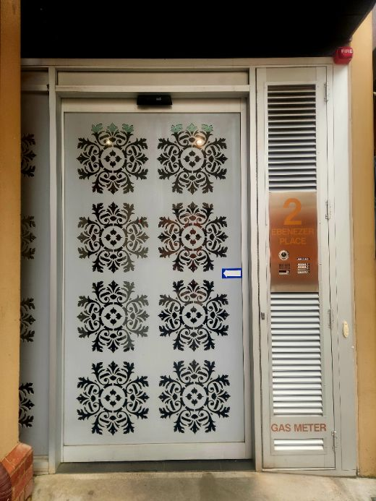
Metal door with a stenciled design

Press the 'Archer' buzzer on the intercom panel and wait for staff to acknowledge and unlock the lift for you. The lift is 90cm in width.

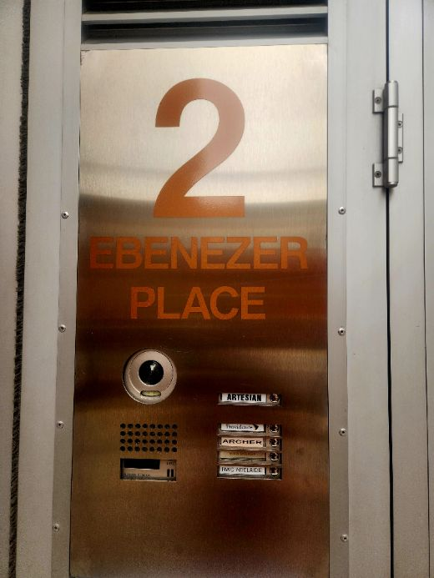
Intercom panel showing 'Archer' button. Press and wait for acknowledgment.

Step 2: Lift Access
Lift provides flat entrance and access to Level 3. Buttons are tactile and illuminated.
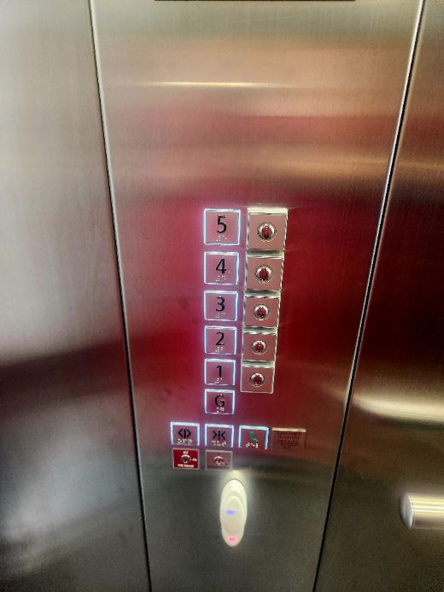
Lift control panel with floors G to 5 and door controls.

Step 3: Level 3 Landing
The landing is flat and you can proceed out of the lift. Someone will be there to greet you and lead you to a meeting room which also have flat access.
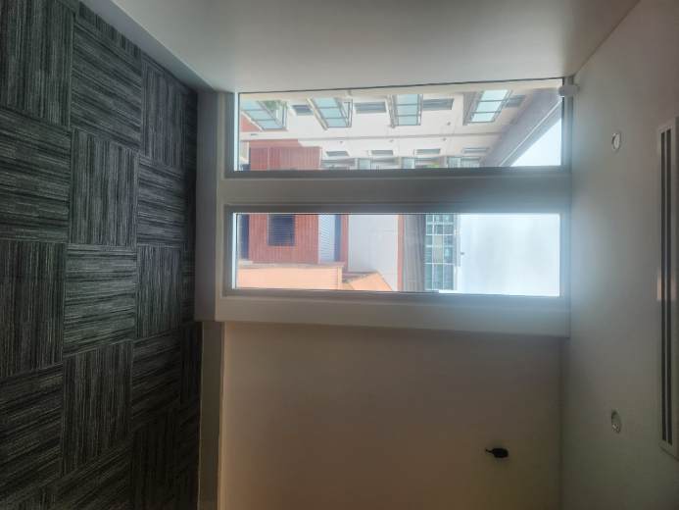
Landing area with natural light and flat carpeted flooring.

Step 4: Accessible Toilet
We have an accessible toilet with a door 70cm wide: The accessible toilet has grab rails, switch lock, and wide turning space

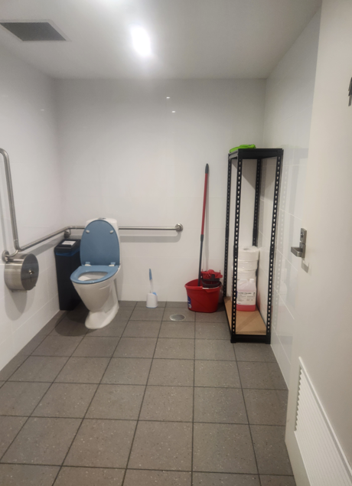
Accessible toilet with grab rails, switch lock, and wide turning space

Accessible Parking Information
Nearby accessible parking options include City of Adelaide on-street accessible bays (see Interactive Parking Map) and UPark Rundle Street (~1-3 min walk) with accessible spaces and lift access. Disability Parking Permit holders receive extended time concessions on-street and there is limited parking on Ebenezer and Union Streets, but there is a curb with small ramp sections. The UPark Accessibility Pass offers 2 hours free parking up to 52 times/year.
City of Adelaide Interactive Parking Map: https://www.cityofadelaide.com.au/services/parking/interactive-parking-map/

